**USE A GRAPHICAL USER INTERFACE (GUI)-BASED DATABASE APPLICATION TO SOLVE PROBLEM**

**UNIT STANDARD ID: 117927**

**NQF LEVEL: 4**

**CREDITS: 6**

**NOTIONAL HOURS: 60**

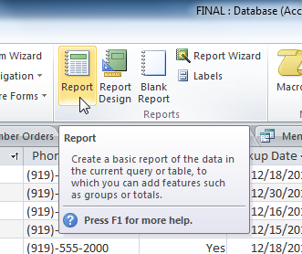

**LEARNER GUIDE**

|  |  |
| --- | --- |
| **Name** |  |
| **Contact Address** |  |
| **Telephone (H)** |  |
| **Telephone (W)** |  |
| **Facsimile** |  |
| **Cellular** |  |

|  |  |  |  |
| --- | --- | --- | --- |
| **SAQA UNIT STANDARD ALIGNMENT** | | | |
| **SPECIFIC OUTCOMES (SO)** |  | **LEVEL** | **CREDITS** |
| **UNIT STANDARD 117927:**  Use a Graphical User Interface (GUI)-based database application to solve a given problem | | | |
| |  | | --- | |  |  |  | | --- | | **SPECIFIC OUTCOME 1** |  |  | | --- | | Prepare a database to provide a solution to a given problem. | | **ASSESSMENT CRITERION 1**   |  | | --- | | A working plan is developed to meet the requirements of a supplied brief. |  |  | | --- | | **ASSESSMENT CRITERION 2** |  |  | | --- | | The plan identifies the purpose of the database. |  |  | | --- | | **ASSESSMENT CRITERION 3** |  |  | | --- | | The plan includes a basic outline of the database specifications and/or features required to provide a solution, with reasons for choices made. | | **Level 4** | **6 Credits** |
| |  | | --- | | **SPECIFIC OUTCOME 2** |  |  | | --- | | Create database tables and data entry forms to solve the given problem. | | |  | | --- | | **ASSESSMENT CRITERION 1** |  |  | | --- | | One or more database tables are created to solve the given problem. |  |  | | --- | | **ASSESSMENT CRITERION RANGE** |  |  | | --- | | At least 5 fields are included in one of the database tables created. The table definition data types needs to include at least the following: text, numeric, date, currency. |  |  | | --- | | **ASSESSMENT CRITERION 2** |  |  | | --- | | A form is created for each database table. |  |  | | --- | | **ASSESSMENT CRITERION 3** |  |  | | --- | | Formats of form fields are modified. |  |  | | --- | | **ASSESSMENT CRITERION RANGE** |  |  | | --- | | Font style, size and colour, background colour. |  |  | | --- | | **ASSESSMENT CRITERION 4** |  |  | | --- | | A header is added to a form. |  |  | | --- | | **ASSESSMENT CRITERION 5** |  |  | | --- | | A footer is added to a form. |  |  | | --- | | **ASSESSMENT CRITERION 6** |  |  | | --- | | Fields of the form are re-arranged. |  |  | | --- | | **ASSESSMENT CRITERION 7** |  |  | | --- | | A data entry form is saved and closed. |  |  | | --- | | **ASSESSMENT CRITERION 8** |  |  | | --- | | Data is entered into a database table using the form. |  |  | | --- | | **ASSESSMENT CRITERION 9** |  |  | | --- | | A data entry form is deleted. | |  |  |
| |  | | --- | | **SPECIFIC OUTCOME 3** |  |  | | --- | | Retrieve information from a database by applying a filter. | | |  | | --- | | **ASSESSMENT CRITERION 1** |  |  | | --- | | A filter is applied to the database table to filter out specific records. |  |  | | --- | | **ASSESSMENT CRITERION RANGE** |  |  | | --- | | Filter by selection, excluding selection, input, form, form window. |  |  | | --- | | **ASSESSMENT CRITERION 2** |  |  | | --- | | Remove a filter. |  |  | | --- | | **ASSESSMENT CRITERION 3** |  |  | | --- | | Create queries to select specific records to be extracted from a database table. |  |  | | --- | | **ASSESSMENT CRITERION RANGE** |  |  | | --- | | Single-field query, multi-field query, using the toolbar, using a wizard. |  |  | | --- | | **ASSESSMENT CRITERION 4** |  |  | | --- | | Retrieve information by running a query. |  |  | | --- | | **ASSESSMENT CRITERION 5** |  |  | | --- | | A query is saved. |  |  | | --- | | **ASSESSMENT CRITERION 6** |  |  | | --- | | Modify an existing query. |  |  | | --- | | **ASSESSMENT CRITERION 7** |  |  | | --- | | A field is added to a query. |  |  | | --- | | **ASSESSMENT CRITERION 8** |  |  | | --- | | A field is removed from a query. |  |  | | --- | | **ASSESSMENT CRITERION 9** |  |  | | --- | | Fields in a query are hidden. | |  |  |
| |  | | --- | | **SPECIFIC OUTCOME 4** |  |  | | --- | | Sort data in a database query. | | |  | | --- | | **ASSESSMENT CRITERION 1** |  |  | | --- | | Query data is sorted. | |  |  |
| |  | | --- | | **SPECIFIC OUTCOME 5** |  |  | | --- | | Create a report for a database table. | | |  | | --- | | **ASSESSMENT CRITERION 1** |  |  | | --- | | A report is designed to address the requirement of the given problem. |  |  | | --- | | **ASSESSMENT CRITERION 2** |  |  | | --- | | A report is created that meets the design. |  |  | | --- | | **ASSESSMENT CRITERION 3** |  |  | | --- | | A report is modified. |  |  | | --- | | **ASSESSMENT CRITERION RANGE** |  |  | | --- | | Header, Footer, font (size, type, colour). |  |  | | --- | | **ASSESSMENT CRITERION 4** |  |  | | --- | | Data is grouped in a report. |  |  | | --- | | **ASSESSMENT CRITERION 5** |  |  | | --- | | A selection is resized in a report. |  |  | | --- | | **ASSESSMENT CRITERION 6** |  |  | | --- | | A report is saved. |  |  | | --- | | **ASSESSMENT CRITERION 7** |  |  | | --- | | A report is deleted. | |  | |  |  |

|  |  |  |  |  |  |  |  |  |  |  |  |
| --- | --- | --- | --- | --- | --- | --- | --- | --- | --- | --- | --- |
| |  | | --- | | **SPECIFIC OUTCOME 6** |  |  | | --- | | Perform advanced print options for a database. | | |  | | --- | | **ASSESSMENT CRITERION 1** |  |  | | --- | | A database form is printed. |  |  | | --- | | **ASSESSMENT CRITERION 2** |  |  | | --- | | A query result is printed. |  |  | | --- | | **ASSESSMENT CRITERION 3** |  |  | | --- | | A database report is previewed to check that the presentation is in accordance with the given specification. |  |  | | --- | | **ASSESSMENT CRITERION 4** |  |  | | --- | | A database report is printed. | |

Table of Contents

Introduction 10

Lesson 1 – Developing a work plan 10

ELEMENTS OF A WORK PLAN 13

Activity 1 14

Lesson 2 – Creating database tables and data entry forms 15

CREATING DATABASE TABLES 15

CREATING A FORM FOR EACH DATABASE TABLE 18

CHANGING FORMATS IN A FORM 21

ADDING A HEADER AND FOOTER TO A FORM 23

REARRANGING FIELDS OF THE FORM 24

SAVING A DATA ENTRY FORM 26

ENTERING DATA INTO A DATABASE USING A FORM 26

DELETING A FORM 27

Activity 2 27

Lesson 3 – Retrieving information using filtering 28

CREATING FILTERS 28

REMOVING A FILTER 39

QUERIES 40

A. CREATE QUERIES 40

B. MODIFYING SAVED QUERIES 46

ADD AND REMOVE A FIELD FROM A QUERY 47

HIDING FIELDS WITHIN QUERIES 49

Activity 3 50

Lesson 4 – Sorting data in a database query 51

Activity 4 53

Lesson 5 – Creating a report for a database table 54

CREATING A REPORT 54

FORMATTING REPORTS 62

MODIFYING THE PAGE HEADER AND FOOTER 63

GROUPING DATA IN A REPORT 67

RESIZING ROWS AND COLUMNS 67

SAVING A REPORT 68

DELETING A REPORT 68

Activity 5 68

Lesson 6 – Performing advanced printing options 69

PRINTING A FORM 69

PRINTING QUERY RESULTS 69

PREVIEW AND PRINT A REPORT 69

Activity 6 71

# Introduction

Microsoft Access is a Relational Database Management System (RDBMS), designed primarily for home or small business usage. Access is known as a *desktop* database system because its functions are intended to be run from a single computer. This is in contrast to a *server* database application (such as SQL Server), where it is intended to be installed on a server, then accessed remotely from multiple client machines.

Microsoft (or MS) Access is a software package that you install just like any other software package, and is bundled as part of the Microsoft Office suite.

**Benefits**

You may be wondering what the benefits of using Access are compared with using an Excel spreadsheet. Well, it really depends on what you want to do with the data that you are storing and how much data you intend to store.

Excel may be fine if you have only got a small amount of data, and if you don't have many attributes against each piece of data. It may be fine if you don't have much in the way of relational data across multiple worksheets. Once you start storing many attributes against each piece of data, and perhaps you find yourself repeating information across multiple worksheets, then it's time to start using Access (or another database system if you prefer).

Another important reason for using Access over Excel is, if you need to generate a lot of queries and reports. Access is much better suited for doing this compared to Excel.

## Lesson 1 – Developing a work plan

The first step in creating a database is creating a work plan that serves both as a guide to be used when implementing the database and as a functional specification for the database after it has been implemented. The complexity and detail of a database design is dictated by the complexity and size of the database application as well as the user population.

The nature and complexity of a database application, as well as the process of planning it, can vary greatly. A database can be relatively simple and designed for use by a single person, or it can be large and complex and designed, for example, to handle all the banking transactions for hundreds of thousands of clients. In the first case, the database design may be little more than a few notes on some scratch paper. In the latter case, the design may be a formal document with hundreds of pages that contain every possible detail about the database.

In planning the database, regardless of its size and complexity, use these basic steps:

* Gather information.
* Identify the objects.
* Model the objects.
* Identify the types of information for each object.
* Identify the relationships between objects.

##### **1. Gathering Information**

Before creating a database, you must have a good understanding of the job the database is expected to perform. If the database is to replace a paper-based or manually performed information system, the existing system will give you most of the information you need. It is important to interview everyone involved in the system to find out what they do and what they need from the database. It is also important to identify what they want the new system to do, as well as to identify the problems, limitations, and bottlenecks of any existing system. Collect copies of customer statements, inventory lists, management reports, and any other documents that are part of the existing system, because these will be useful to you in designing the database and the interfaces.

##### **2. Identifying the Objects**

During the process of gathering information, you must identify the key objects or entities that will be managed by the database. The object can be a tangible thing, such as a person or a product, or it can be a more intangible item, such as a business transaction, a department in a company, or a payroll period. There are usually a few primary objects, and after these are identified, the related items become apparent. Each distinct item in your database should have a corresponding table.

##### **3. Modelling the Objects**

As the objects in the system are identified, it is important to record them in a way that represents the system visually. You can use your database model as a reference during implementation of the database.

For this purpose, database developers use tools that range in technical complexity from pencils and scratch paper to word processing or spreadsheet programs, and even to software programs specifically dedicated to the job of data modeling for database designs. Whatever tool you decide to use, it is important that you keep it up-to-date.

##### **4. Identifying the Types of Information for Each Object**

After the primary objects in the database have been identified as candidates for tables, the next step is to identify the types of information that must be stored for each object. These are the columns in the object's table. The columns in a database table contain a few common types of information:

* **Raw data columns:** These columns store tangible pieces of information, such as names, determined by a source external to the database.
* **Categorical columns:** These columns classify or group the data and store a limited selection of data such as true/false, married/single, VP/Director/Group Manager, and so on.
* **Identifier columns:** These columns provide a mechanism to identify each item stored in the table. These columns often have id or number in their names (for example, **employee_id**, **invoice_number**, and **publisher_id**). The identifier column is the primary component used by both users and internal database processing for gaining access to a row of data in the table. Sometimes the object has a tangible form of ID used in the table (for example, a social security number), but in most situations you can define the table so that a reliable, artificial ID can be created for the row.
* **Relational or referential columns:** These columns establish a link between information in one table and related information in another table. For example, a table that tracks sales transactions will commonly have a link to the **customers** table so that the complete customer information can be associated with the sales transaction.

##### **5. Identifying the Relationships between Objects**

One of the strengths of a relational database is the ability to relate or associate information about various items in the database. Isolated types of information can be stored separately, but the database engine can combine data when necessary. Identifying the relationships between objects in the design process requires looking at the tables, determining how they are logically related, and adding relational columns that establish a link from one table to another.

For example, the designer of the **pubs** database has created tables for titles and publishers in the database. The **titles** table contains information for each book: an identifier column named **title_id**;raw datacolumns for the title, the price of the book, and the publishing date; and some columns with sales information for the book. The table contains a categorical column named **type**, which allows the books to be grouped by the type of content in the book. Each book also has a publisher, but the publisher information is in another table; therefore, the **titles** table has a **pub_id** column to store just the ID of the publisher. When a row of data is added for a book, the publisher ID is stored with the rest of the book information.

### ELEMENTS OF A WORK PLAN

1. Describe the key issues or purpose of the database

* The key issues will have been determined in the needs assessment stage.
* Clearly describe the key issues.

**NOTE**: In the purpose include a description of what kinds of information will it store? How will I have to break that information down, so it can be stored in my database? How will I use the data once it's in there?

2. Set your goals and objectives

* Identify goals and objectives that are SMART; specific, measurable, acceptable, realistic and timely.

3. Identify key strategies

* How will you put your plan into action?
* List the major steps or milestones that need to take place.
* Identify obstacles you may encounter and how they will be managed.

4. Stakeholders/Partners/Audience

* Who are the key groups and/or individuals that need to be involved?
* What is the best way to involve them?
* Who are the groups and/or individuals that will benefit from the proposed activities?

5. Resources required

* What resources do you require to put your plan into action - do you have a team?
* Is your team representative?
* Budget?
* Facilities?
* Do you require support from other departments?
* Other business units?

6. Roles/Responsibilities

* Who will be involved in the various stages of putting the plan into action?
* What is their specific role?

7. Timelines

* When do you start?
* Are your timelines achievable?
* Have you considered other initiatives that are occurring simultaneously?

8. Basic outline of the database

* All components and models of the database must be outlined.
* What kinds of information will it store?
* How information will be broken down, so that it can be stored in the database?
* How the data will be retrieved once it's in there?

9. Indicators of Success

* Indicators should be identified at this time. How will you know if your program is a success?
* What indicators will tell you whether or not you have met your goals and objectives?

### Activity 1

1. Think of various reasons why a database can be created in an organisation.
2. Identify and describe elements of a work plan

## Lesson 2 – Creating database tables and data entry forms

Databases in Access 2010 are composed of four objects: **tables**, **queries**, **forms**, and **reports**. Together, these objects allow you to enter, store, analyze, and compile your data as you wish. Tables, queries, forms, and reports are the framework for any database you create in Access. Understanding how each of these objects works will help you create a database that will be useful and will help you retrieve the information you need.

**Tables**

In Access, all data is stored in **tables**, which put tables at the heart of any database. In Access, rows and columns are referred to as **Records** and **Fields**.

* A **field** is more than just a column: it’s a way of organizing information by the **type** of data it is. Every piece of information within a field is of the same **type**. For example, every entry in a field called “First Name” would be a name, and every entry in field called “Street Address” would be an address.
* A **record** is more than just a row; it’s a unit of information. Every cell in a given row is part of that row’s record.

While there are four types of database objects in Access 2010,**tables**are arguably the most important. Even when you're using forms, queries, and reports, you are still working with tables, since that's where all your **data** is stored. Tables are at the heart of any database, so it's important to understand how to use them.

### CREATING DATABASE TABLES

Access gives you several ways to create tables. There are 3 ways of doing this;

1. In Datasheet view, you build a table by entering field names and setting data types manually. All you have to do is click and type.
2. Quick start fields are pre-made tables that meet several common business needs. The fields capture data for common business needs, and all field names and data types are set for you.
3. Design view lets you control every field and property in the table. In this course, you'll use it to create a table and to change the values in a lookup field -a field that contains a list of choices.

**A. Datasheet view**

Datasheet view provides a visual way to create a table.

1. You start by creating a new, blank database or by adding a new table to an existing database. Either method opens a new table in Datasheet view.
2. Notice that the new table contains a field called ID. That's your primary key, so you don't need to create one.
3. To add your fields, click the first blank field header – the words **Click to Add**. That starts a menu of data types, and you select a data type for the field. After that, the field header then becomes available for writing, so...
4. You just type the field name and press ENTER. Doing that shifts the focus to the next field, where you repeat the process. As you work, remember that if your field names contain more than one word, don't use spaces between the words. Spaces make it harder to write Visual Basic for Applications code and a type of formula called an **expression**. It's a common practice to remove spaces entirely, or separate each word with an underscore. Also, at this stage, don’t add any foreign key fields or lookup fields. You’ll add one type of lookup field later in this course, and you’ll add foreign keys when you create your table relationships, and that’s the next course in this series.
5. When you have finished, press CTRL+S, or go to the Quick Access Toolbar and click **Save**-that starts a **Save As** dialog box. In the Save As dialog box, enter a name for the table and click OK.

See illustration that follows,

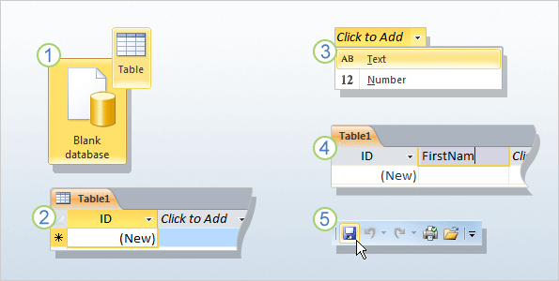

**B. Quick start fields**

Quick Start fields are a faster way to build parts of a new table. The fields capture data for common business needs, and all field names and data types are set for you.

1. With a table open in Datasheet view, click the **Fields** tab, and in the **Add & Delete** group, click **More Fields**. A list appears.
2. Scroll down the list until you see the **Quick Start** section, click the type of fields you want to use, such as **Address**, or **Name, and...**
3. Access adds the fields for you, with field names data types already set.

You can use the new fields right away- just start entering data- or you can rename them, and remove fields you don't need. Also, you may have noticed what seem to be spaces in the field names. Don’t worry; you are not looking at the actual field names. Instead, you are looking at captions, user-friendly text associated with each field name. You will see how to set captions, and how to add and remove fields, during the practice.

**C. Design view**

Design view allows you to build a table from scratch and set or change every available property for each field. You can also open existing tables in Design view and add, remove, or change fields.

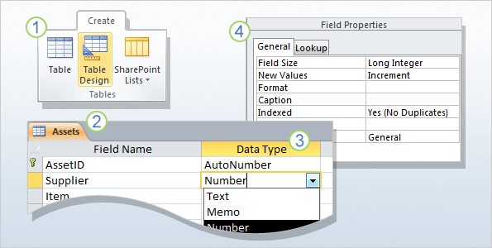

1. On the **Create** tab, in the **Tables** group, click **Table Design**.
2. In the **Field Name** column of the designer, enter the names of your table fields. As a rule, the first field you create should be your primary key field. And remember that you don't need to add any foreign key fields now. You can do that when you create your relationships.
3. In the **Data Type** column, use the list next to a field name to choose a data type for that field.
4. Optionally, use the **Field Properties** pane to set properties for individual fields. For example, you can use the pane to change the values in a lookup field, and you'll get a chance to do that in the practice session.

As always, save your changes and give your new table a name that describes the data it contains.

### CREATING A FORM FOR EACH DATABASE TABLE

A form is a screen that allows you to enter, change, and view the data in a database. Think of forms as windows into your data that help users understand and work with that data.

Let's take a quick look at what goes into a form:

* Forms are made up of **controls**, such as text boxes, buttons, document tabs, and drop-down lists, grouped in a way that makes them easy to use and helps you get work done.
* The controls in the form are usually **bound**, or connected, to the tables or queries in your database but not always. For example, a control that displays your corporate logo doesn't have to be bound to a table field. It can just point to the image it displays.

In addition to entering data, you can use forms in other ways. For example, you can create a form that asks for input, and then generates a custom report based on that input.

**Benefits of using a form**

* + Consistency and accuracy when adding data
  + An easy to use interface for editing, viewing and entering records

Access makes it easy to create a **form** from any table in your database. Any form you create from a table will let you**view the data**that's already in that table and **add new data**. Once you have created a form, you can also modify it by adding additional fields and **design controls** such as combo boxes.

**To Create a Form:**

1. In the **Navigation Pane**, **select** the table you would like to use to create a form. You do not need to open the table.
2. Select the **Create** tab on the Ribbon and locate the **Forms** group. Click the **Form** command.

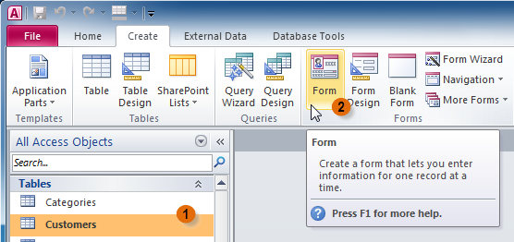

1. Your form will be created and opened in**Layout View**.

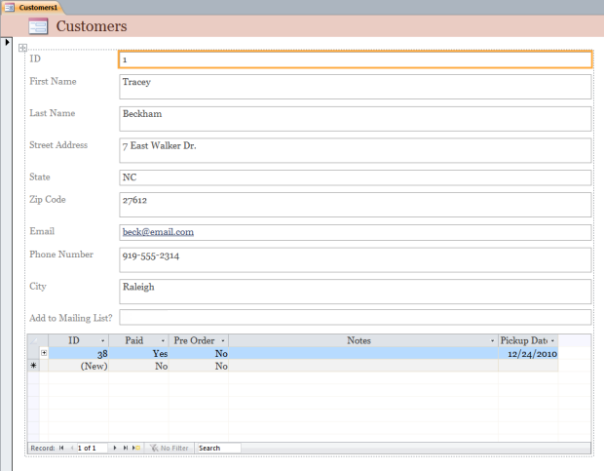

1. To **save** the form, click the **Save** command on the **Quick Access Toolbar**. When prompted, type a **name** for the form and then click **OK**.

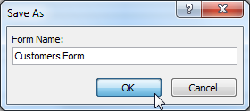

**About Subforms**

If you created a form from a table whose records are linked to another table, your form probably includes a **subform**. A subform is a **datasheet form** that displays linked records in a table-like format. For instance, the subform included in the**Customers** form we just created displays linked customer **orders**.

We probably don't need to include this subform, since we really just want to use the Customers form to enter and review contact information. If you find that you don't need a subform, you can easily **delete** it. Simply click it and press the **delete** key.

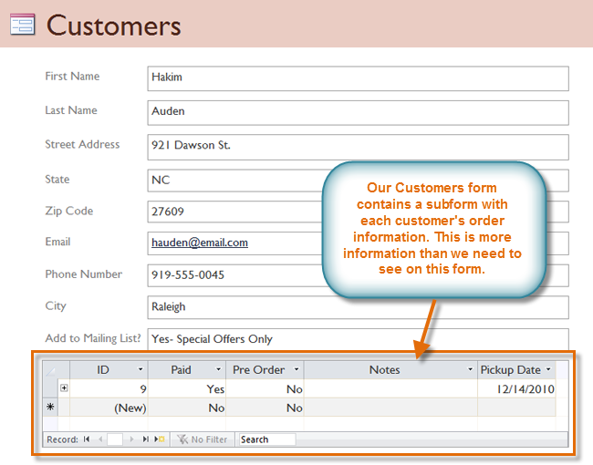

However, subforms aren't always useless. Depending on the content and source of your form, you might find that the subform contains useful information, as in the example below. In our **Orders**form, the subform contains the name, quantity, and price of each item contained in that order, which is all very useful information.

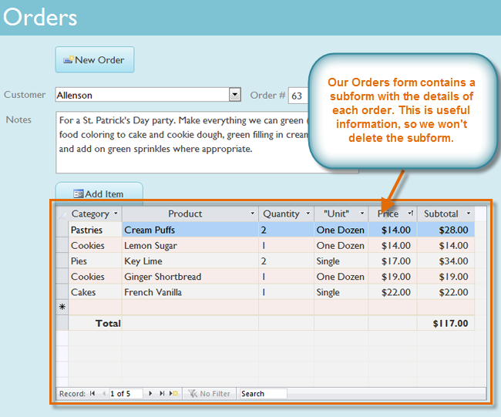

### CHANGING FORMATS IN A FORM

After creating a form, you might want to modify its appearance. **Formatting**your forms can help make your database look consistent and professional. Some formatting changes can even make your forms easier to use. With Access 2010's formatting tools, you can customize your forms to look exactly the way you want.

To change form fields font, size, colour and background colour simply;

* Select the object you want to modify while in **Layout** or **Design** view, and
* Use the formatting options on the **Format** tab to customize its appearance.

For instance, in the form below, **font** of our form **title** was modified. A new **fill** and **border colour** was applied to the form **fields**, and the same with the **command buttons**.

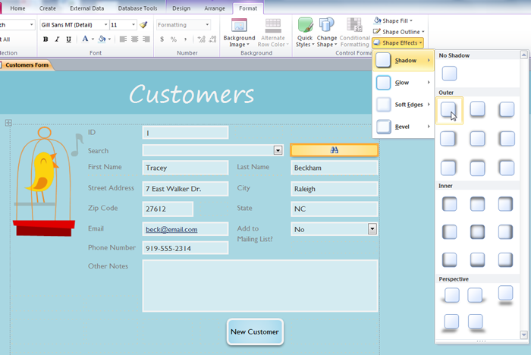

**To change the font size:**

1. Open the Form in **Layout/Design view**
2. Select the field box and head over to Form layout Tools, and
3. Under Conditional Formatting, click the drop down arrow to change the font size

**To change the font style:**

1. Open the Form in **Layout/Design view**
2. Select the field box and head over to Form layout Tools, and
3. Under Conditional Formatting, click the drop down arrow to change the font style

**To change the background colour:**

To add colours to control box

1. Open the Form in **Layout/Design view**
2. Select the field box and head over to Form layout Tools, and
3. Under Conditional Formatting, under Shape Fill options, select a colour. Select the desired **colour** from the list, choose **No Fill**, or choose **More Fill Colours** to choose a custom colour.

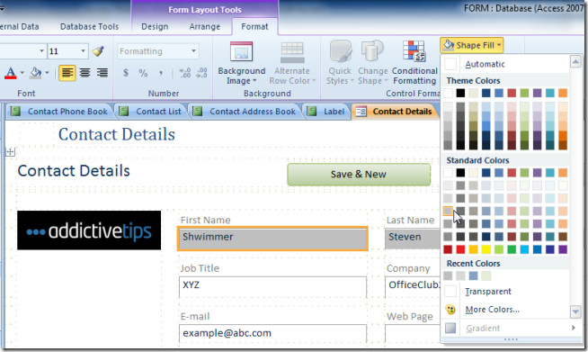

### ADDING A HEADER AND FOOTER TO A FORM

Besides the Detail section, a form can be equipped with a section on top and another section in its bottom part. To add these sections, you can right-click the middle of the form and click **Form Header/Footer** http://www.functionx.com/access/buttons/frmhdrftr1.gif

This would add two new sections to the form: the Form Header section on top and the Form Footer section at the bottom:

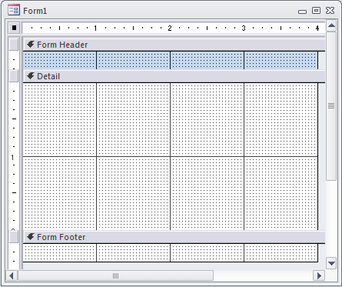

Although two sections are added, you can reduce one completely so it would not appear to the user. This means that you can keep one section and hide the other. If you create a form using the Form Wizard, both the header and the footer sections are added but the footer section is completely reduced so it would not appear to the user. If you want to display it to the user, you must expand it.

### REARRANGING FIELDS OF THE FORM

When you create a form, Access arranges the form components in a default layout where the fields are neatly stacked up on top of each other, all exactly the same width. While this layout is functional, you might find that it doesn't best fit your information. For instance, in the form below, most of the fields are almost completely empty, since the data stored there doesn't take up much room.

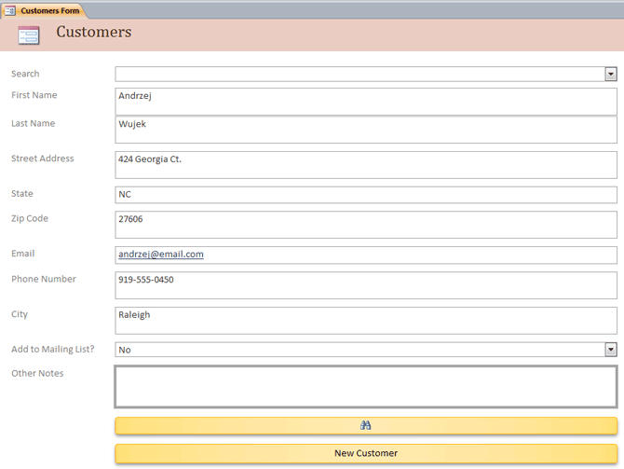

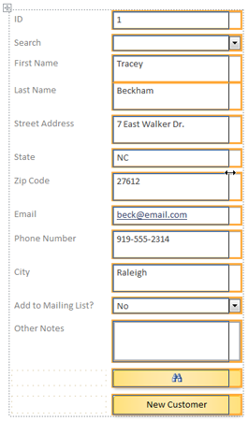The form would fit the data a little better if we made the fields and command buttons smaller, and even put some of them side by side. However, with the default layout, you won't be able to put two fields next to each other or resize one field or button without resizing them all. This is because Access lines up form components in rows and columns. When you resize a field, you are really resizing the column that contains it.

To resize and rearrange the fields the way we want, you will have to **modify the form layout**.

For instance, since the default layout for the form contains only two columns-one for the **field labels** and another for the **fields**- you need to **create a new column** to put two fields side by side.

To re-arrange form fields;

1. Click the **Arrange tab** in the **Design view**
2. Select the command on the **Arrange**tab, which contains all the tools you need to customize your form's layout.
3. Select the layout you need. You can choose **stacked** or **tabular** in order to split one layout into two layouts. Right-click the selected controls, point to **Layout**, and then click the layout type that you want for the new layout

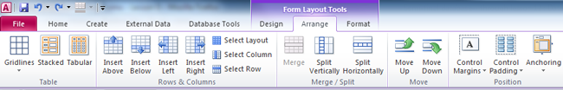

Access creates a new control layout and adds the selected controls to it.

**Move layouts**

After splitting one layout into two, the two layouts might overlap. To move a layout:

1. Select any control in the layout.
2. Press and hold the CTRL key.
3. Drag the layout by using the layout selector at the upper-left corner of the layout.

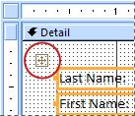

### SAVING A DATA ENTRY FORM

* Right-click on the tab above the form and select Save
* Enter a name for the form and click OK
* The name of the form will appear in the All Tables list on the left-hand side of the screen**.**

### ENTERING DATA INTO A DATABASE USING A FORM

Any data entered through the form is automatically added and saved to the appropriate table.

Type the data in the fields provided

* + To move between fields, press the Enter or Tab keys
  + Press Enter when you have completed the form. This sends the record to the table and the form displays a new blank record.

**Creating a new record through a form**

* + Click the button that has a triangle and a star
  + A new blank record will appear. Complete the appropriate fields

### DELETING A FORM

* + Select the form from the All Tables list on the left-hand side
  + Right-click on the name of the form and select Delete
  + You will be asked to confirm if you wish to delete the form, click OK

### Activity 2

* Create 2 **database tables** with at least 5 fields
* Create a **form** for each database table
* Change the **font size** and **style** for the form fields
* Change the **background colour** for the form fields
* Add a **header** to the forms
* Add **footer** to the forms
* Re-arrange the form fields
* Save and close a **data entry** form
* Use the **forms** to enter data into a **database tables**
* Delete a **data entry** form

## Lesson 3 – Retrieving information using filtering

A filter can be used to search for a specific value within a form or datasheet. There are four types of filter:

* Filter by selection: shows all instances of a selected piece of data
* Filter by exclusion: retrieves all data in the database except the data that has been chosen to be excluded from the search
* Filter by form: for searching an Access form.
* Advanced filter: allows you to add conditions across a number of fields in a table that the search must meet

**Filters** allow you to view **only the data you want to see**. When you create a filter, you set **criteria** for the data you want to display. The filter then **searches** all of the records in the table,**finds** the ones that meet your search criteria, and **temporarily hides**the ones that don't.

### CREATING FILTERS

**To Create a Simple Filter:**

1. Click the **drop-down arrow** next to the field you would like to filter by. Let’s filter by city, as we want to see a list of customers who live in a certain city.

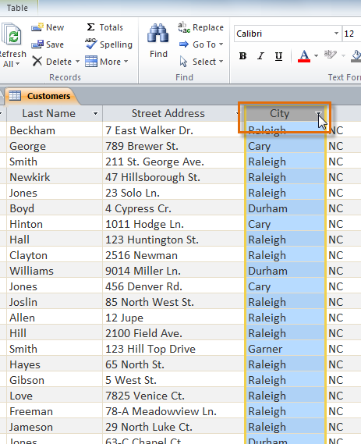

1. A drop-down menu with a checklist will appear. Only checked items will be included in the filtered results. Use the following options to determine which items will be included in your filter:  
   * **Select** and **deselect** items one at a time by clicking their checkboxes. Here, we will deselect all of the options except for **Cary**.
   * Click **Select All** to include every item in the filter. Clicking **Select All** a second time will deselect all items.
   * Click **Blank**to set the filter to find only the records with no data in the selected field.

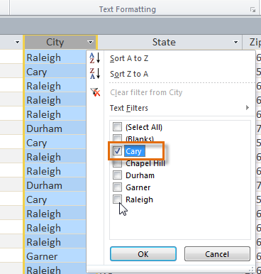

1. Click **OK**. The filter will be applied. Our customers table now displays only customers who live in Cary.

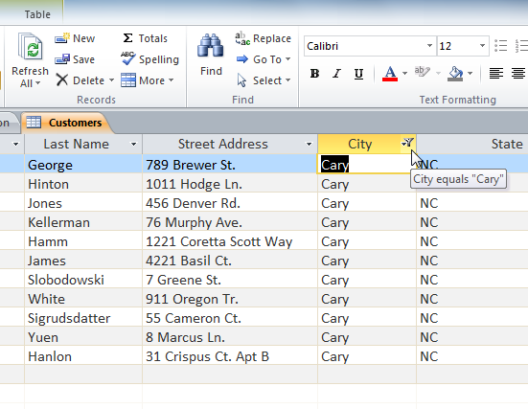

**Toggling** your filter allows you to turn it on and off. To view the records without the filter, simply click the **Toggle Filter**command. To restore the filter, simply click it again.

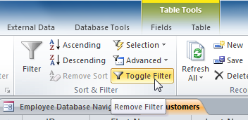

**Creating a Filter from a Selection**

**Filtering by selection** allows you to **select specific data** from your table and find data that is **similar** or **dissimilar** to it. For instance, if you were working with a bakery's database and wanted to search for all products whose names contained the word "chocolate," you could select that word in one product name and create a filter with that selection. Creating a filter with a selection can be more convenient than setting up a simple filter if the field you're working with contains many items.

**To Create a Filter from a Selection:**

1. **Select**the cell or data you would like to create a filter with. We want to see a list of all of our products that contain the word "chocolate" in their names, so we will select the word "chocolate" in the **Product Name** field.

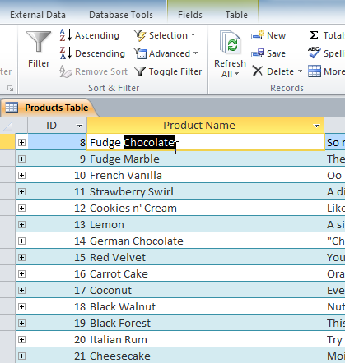

1. Select the **Home**tab on the Ribbon and locate the **Sort & Filter** group.
2. Click the **Selection** drop-down arrow.

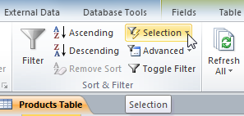

1. Select the type of filter you would like to set up:
   * Selecting **Equals**will include only records with data that is identical to the selected data.
   * Selecting **Does Not Equal** will include all records **except** the data that is identical to the selection.
   * Selecting **Contains**will include only records with cells that contain the selected data. We'll select this, since we want to see records that contain the word "chocolate" anywhere in the title.
   * Selecting**Does Not Contain** will include all records **except** those with cells that contain the selected data.

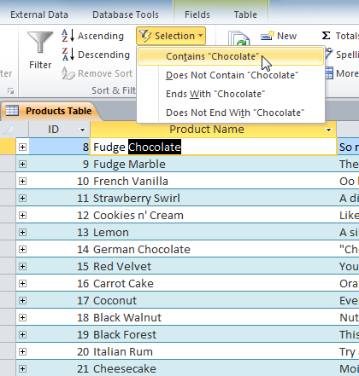

1. The filter will be applied. Our table now displays only products with the word "chocolate" in their names.

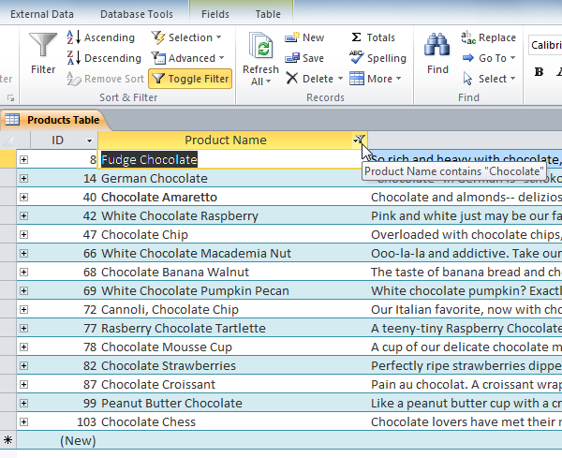

You can also create a filter by entering a**search term** and specifying the way Access should match data to that term. Creating a filter from a search term is similar to creating a filter from a selection.

**Filtering Text by a Search Term**

When filtering text by entering a search term, you can use some of the same options you use when filtering by a selection, like **Equals**, **Does not Equal**, **Contains**, and **Does Not Contain**. You can also choose from the following options:

* **Begins With**, which includes only records whose data for the selected field **begins** with the search term
* **Does Not Begin With**, which includes all records **except** those whose data for the selected field begins with the search term
* **Ends With**, which includes only records whose data for the selected field **ends** with the search term
* **Does Not End With**, which includes all records **except** those whose data for the selected field ends with the search term

**To Filter Text by a Search Term:**

1. Click the **drop-down arrow** next to the field you would like to filter by. We want to filter the records in our orders table to display only those that contain notes with certain information, so we'll click the arrow in the **Notes** field.

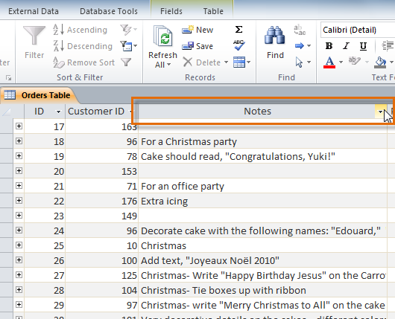

1. In the drop-down menu, hover your mouse over the words **Text Filters**. From the list that appears, select the way you would like the filter to match the term you enter. In this example, we want to view only records whose notes indicate the order was placed for a party. We will select **Contains**, so that we can search for records that contain the word "party."

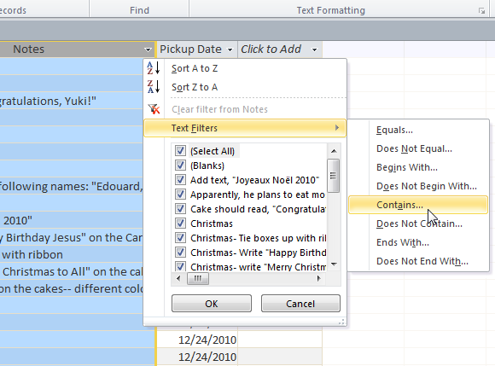

1. The **Custom Filter** dialog box will appear. Type in the word you would like to use in your filter.

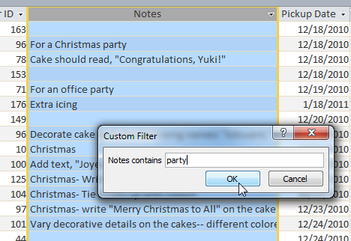

1. Click **OK**. The filter will be applied.

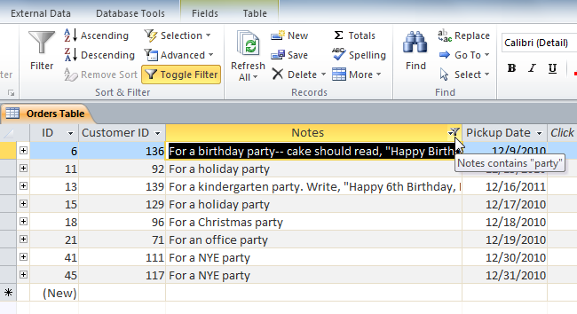

**Filtering Numbers with a Search Term**

The process for filtering numbers with a search term is very similar to the process for filtering text. However, different filtering options are available to you when working with numbers. In addition to the **Equals** and **Does not Equal**, you can also choose:

* **Greater Than** to include only records with numbers in that field **greater than or equal to** the number you enter
* **Less Than** to include only records with numbers in that field **less than or equal to** the number you enter
* **Between**to include records with numbers that fall within a certain range

**To Filter Numbers by a Search Term:**

1. Click the **drop-down arrow** next to the field you would like to filter by. We want to filter the records in our menu items table by price, so we'll click the arrow in the **Price** field.

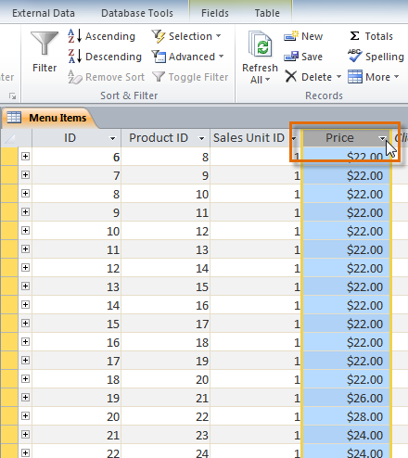

1. In the drop-down menu, hover your mouse over the words **Number Filters**. From the list that appears, select the way you would like the filter to match your search term. In this example, we want to create a filter that will show us inexpensive items only. We want to see items that are **under** a certain price, so we'll select **Less Than**.

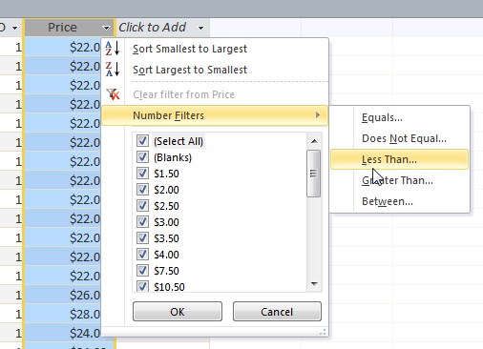

1. The **Custom Filter** dialog box will appear. Type in the number or numbers you would like to use in your filter. We'll type "5" so that the filter will show us only menu items that cost $5 or less.

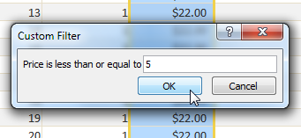

1. Click **OK**. The filter will be applied.

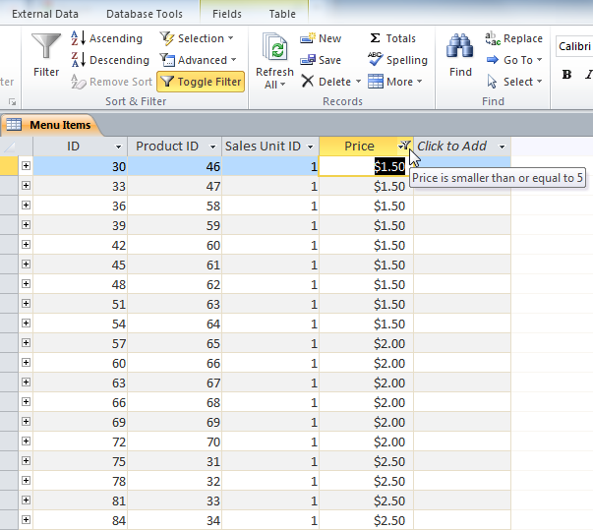

Specific types of numbers may include other filtering options. For instance,**dates** stored in numerical form (mm/dd/yy-e.g., 12/01/2010) include options to filter by periods of time.

**Filter by form**

This filter is useful when you want to filter on several fields in a form or datasheet, or if you are trying to find a specific record. Access creates a blank form or datasheet that is similar to the original form or datasheet, and then allows you to complete as many of the fields as you want to. When you are done, Access finds the records that contain the specified values.

NOTE: You cannot specify field values for multi-valued fields using filter by form, nor for fields with Memo, Hyperlink, Yes/No, or OLE Object data type, although you can specify values for other fields in the record set.

For example, if you want to find all Customer records where the contact person's title is **Owner**, and that person is located either in **Johannesburg** or in **Midrand**, open the Customers datasheet or form and, on the **Home** tab, in the **Sort & Filter** group, click **Advanced**, and then click **Filter by Form**.

Enter the first set of values, then click the **Or** tab at the bottom of the datasheet or form, and then enter the next set of values. Note that if you want a field value to operate as a filter independently of other field values, you must enter that value on the **Look for** tab and each **Or** tab. Each **Or** tab represents an alternate set of filter values.

**To see only the records matching your input:**    On the **Home** tab, in the **Sort & Filter** group, click **Toggle Filter.**

**Apply a filter by filling out a form**

1. Open a table or query in Datasheet view, or a form in Form view.
2. Make sure the view is not already filtered. On the record selector bar, verify that either the **Unfiltered** or the dimmed **No Filter** icon is present.
3. On the **Home** tab, in the **Sort & Filter** group, click **Advanced**, and then click **Filter by Form** on the shortcut menu.
4. Depending on whether you are working in Datasheet view or in Form view, do one of the following:

* **Datasheet view:**Click the first row in the column on which you want to filter, click the arrow that appears, and then select a value. To add additional values, just click the **Or** tab at the bottom of the datasheet and select another value.
* **Form view**: Click the arrow that appears in the control, and select a value on which to filter. To add additional values, click the **Or** tab at the bottom of the form and select another value.

1. If you want to specify two alternate sets of criteria, for example, to only see the names of contacts whose Country Region value is South Africa and whose birthdays fall in April, you can do any of the following:

* To retrieve all records that meet any one of multiple sets of criteria, specify the criteria by entering the first set of criteria, Click the **Or** tab, and then enter the next set of criteria. Note that if you want a field value to operate as a filter independently of other field values, you must enter that value on the **Look for** tab and each **Or** tab. In other words, the **Look for** tab and each **Or** tab represents an alternate set of filter values.
* Also note that each time you add a field criterion to the **Or** tab, Access creates another **Or** tab. This enables you to specify several "or" criteria. The filter returns any record that contains all of the values specified on the **Look for** tab, or all of the values specified on the first **Or** tab, or all of the values specified on the second **Or** tab, and so on.

### REMOVING A FILTER

1. In Datasheet view or Form view, click **Remove Filter** Button image on the **Filter/Sort** toolbar. If you are working on a shared database, click **Remove Filter/Sort** on the **Records** menu to remove filters and then immediately update your view. Note that removing a filter from a datasheet also removes filters from the subdatasheet.
2. In Page view, click **Filter Toggle** Button image on the record navigation toolbar so that it is not selected.

### QUERIES

The real power of a relational database is in the ability to quickly **retrieve**and **analyse** your data by running a query. **Queries** allow you to **pull information** from one or more tables based on a set of search conditions you define.

**Types of Queries**

Queries are a way of **searching**for and **compiling**data from one or more tables. Running a query is like asking a detailed **question** of your database. When you build a query in Access, you are **defining specific search conditions** to find exactly the data you want. You can use queries to view, change, and analyze data in different ways. In addition, you can use them as a source of records for forms, reports, and data access pages. There are several types of queries in Microsoft Access.

1. **Select Queries**

The most common type of query, select queries retrieve data from one or more tables (using criteria you specify) and display the results in a datasheet. Select queries may be used to group records as well as perform calculations including sums, counts and averages.

1. **Parameter Queries**

When run, a parameter query displays its own dialogue box prompting you for information, such as criteria for retrieving records or a value you wish to insert in a field.

1. **Crosstab Queries**

You can use crosstab queries to calculate and restructure data for easier analysis. Use a crosstab query to calculate a sum, average, count, or other type of total for data that is grouped by two types of information.

### A. CREATE QUERIES

To create a query you need to know something about the structure of your database.  The instructions below assume that you have already identified one or more tables that contain the information you would like to retrieve.

1. **Open your database.**  Go to the File tab, select Open and locate the database on your computer.
2. **Switch to the Create tab.** In the Access ribbon, change from the File tab to the Create tab. This will change the icons presented to you in the ribbon.
3. **Click the Query Wizard icon.** The query wizard simplifies the creation of new queries. We'll use it in this tutorial to introduce the concept of query creation. The alternative is to use the Query Design view, which facilitates the creation of more sophisticated queries but is more complicated to use.
4. **Select a Query Type**. Access will ask you to choose the type of query you wish to create. For our purposes, we will use the Simple Query Wizard. Select this and click OK to continue.
5. **Select the appropriate table from the pull-down menu.** The Simple Query Wizard will open. When you select the pull-down menu, you will be presented with a listing of all the tables and queries currently stored in your Access database. These are the valid data sources for your new query. Select the table you want.
6. **Choose the fields you wish to appear in the query results.** You can do this by either double-clicking on them or by single clicking first on the field name and then on the ">" icon. As you do this, the fields will move from the Available Fields listing to the Selected Fields listing. Notice that there are three other icons offered. The ">>" icon will select all available fields. The "<" icon allows you to remove the highlighted field from the Selected Fields list while the "<<" icon removes all selected fields.
7. **Repeat steps 5 and 6 to add information from additional tables, as desired.**  You not limited to using only one table. You can combine information from multiple tables and easily show relationships. All you have to do is select the fields-Access will line up the fields for you.
8. **Click on Next.** When you are finished adding fields to your query, click the Next button to continue.
9. **Choose the type of results you would like to produce.** For example, you can choose the Detail option and click the Next button to continue.
10. **Give your query a title.**  On the next screen you can give your query a title. Select something descriptive that will help you recognize this query later.
11. **Click on Finish.** You will be presented with the query results.

**Simple one-table query**

**To Apply a Simple One-Table Query:**

1. Select the **Create** tab on the Ribbon and locate the **Queries** group.
2. Select the **Query Design**command.

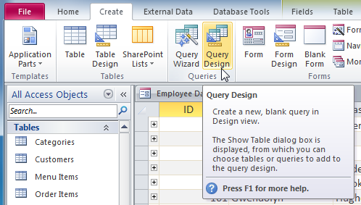

1. Access will switch to **Query Design view**. In the **Show Table** dialog box that appears, select the table you would like to run a query on. Click **Add**, then click **Close**.

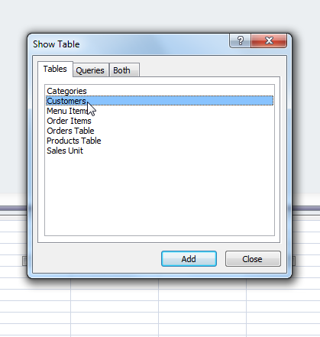

1. The selected table will appear as a small window in the **Object Relationship Pane**. In the table window, double-click the **field names** you would like to include in your query. They will be added to the **Design Grid**in the bottom part of the screen.

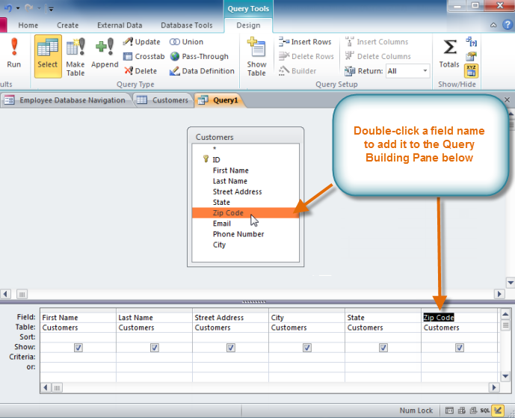

1. Set the **search criteria**by clicking on the cell in the **Criteria: row** of each**field** you would like to filter.  Typing criteria into more than one field in the Criteria: row will set your query to include only results that meet all the criteria. If you want to set multiple criteria, but don't need the records shown in your results to meet them all, type the first criteria in the Criteria: row and additional criteria in the **Or:** **row** and the rows beneath it.
2. After you have set your criteria, **run** the query by clicking the **Run** command on the **Query Tools Design** tab.

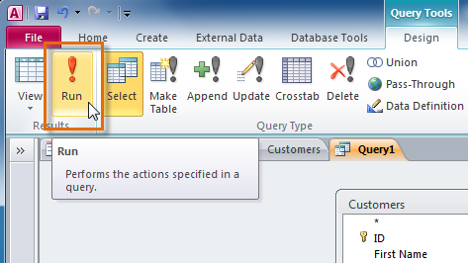

1. The query results will be displayed in the query's **Datasheet View**, which looks like a table. If desired, **save** your query by clicking the **Save**command in the Quick Access Toolbar. When prompted to name it, type in the desired name and click **OK**.

**Multi-Table Query**

**To Create a Multi-Table Query:**

1. Select the **Query Design Command** from the **Create** tab on the Ribbon.
2. In the **Show Table** dialog box that appears, select each table you would like to include in your query and click **Add**. After you have added all of the tables you wish, click **Close**.
3. The tables will appear in the **Object Relationship Pane**, linked by a **join line**. Double-click the thin section of the join line between two tables to edit its **join direction**.

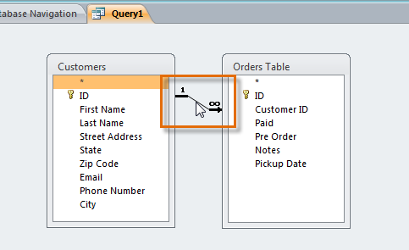

1. The **Join Properties** dialog box will appear. Select an option to choose the direction of your join.

* Choose option **2:** for a **Left** to **Right** join. In our query, the **left table** is the **Customers** table, so choosing this would mean that all of the customers, who met our location criteria, whether or not they had placed an order, would be included in our results. We don't want to choose this option for our query.
* Choose option **3:** for a **Right** to **Left** query.  Since our **right** table is our **Orders**table, selecting this option will let us work with records for **all** of the orders and **only** the customers who've placed orders. We'll choose this option for our query, since this is exactly the data we want to see.

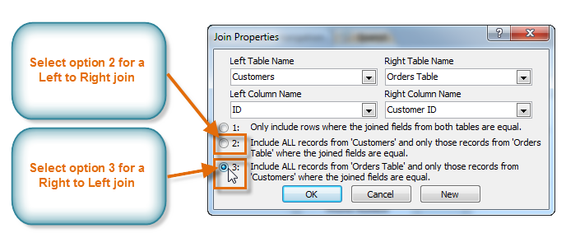

1. In the table windows, double-click the **field names** you would like to include in your query. They will be added to the **Design Grid**in the bottom part of the screen.

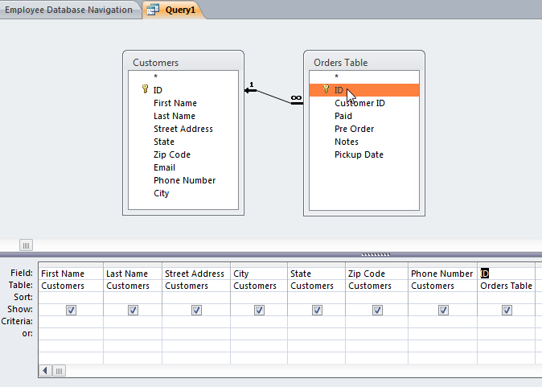

1. Set field **criteria** by entering the desired criteria in the criteria row of each field. We want to set two criteria:
   * First, to find customers who do **not** live in Raleigh, we will type **Not like ("Raleigh")** in the **City**field.
   * Second, to find customers who have a phone number beginning with the area code **919**, we'll type **Like ("919*")**in the **Phone Number** field.

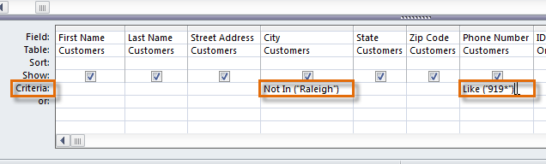

1. After you have set your criteria, **run** the query by clicking the **Run** command on the **Query Tools Design** tab.

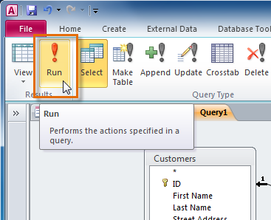

1. The query results will be displayed in the query's **Datasheet View**, which looks like a table. If desired, **save** your query by clicking the **Save**command in the Quick Access Toolbar. When prompted to name it, type in the desired name and click **OK**.

### B. MODIFYING SAVED QUERIES

When you open an existing query in Access, it is displayed in **Datasheet View**, meaning that you will see your query results in a table. To modify your query, you must enter **Design View**, the view you used when creating it. There are two ways to switch to Design View:

* On the **Home** tab of the Ribbon, click the **View** command. Select **Design View** from the drop-down menu that appears.

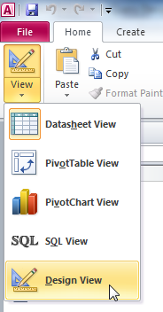

* In the bottom-right corner of your Access window, locate the small **view icons**. Click the **Design View** icon, which is the icon farthest to the right.

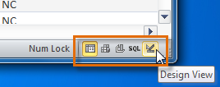

Once in **Design View**, make the desired changes, then select the **Run** command to view your updated results.

You may notice that Access offers other query views, like **Pivot Table View**, **Pivot Chart View**, and **SQL View**. You can ignore these-these views permit advanced functions that you will not need to use for this tutorial or for most Access functions.

### ADD AND REMOVE A FIELD FROM A QUERY

**Step 1: Create a select query to identify the records to update**

1. Open the database that contains the records you want to update.
2. On the **Design** tab, in the **Macros & Code** group, click **Query Design**.

The query designer opens, and the **Show Table** dialog box opens.

1. Click the **Tables** tab.
2. Select the table or tables that contain the records that you want to update, click **Add**, and then click **Close**.

The table or tables appear as one or more windows in the query designer, and the windows list all the fields in each table. This figure shows the query designer with a typical table.

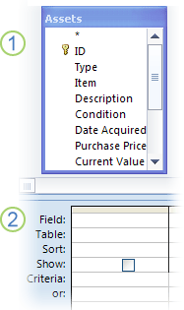

1. Table shown in the query designer
2. Query design grid
3. Double-click the fields that you want to update in the table windows. The selected fields appear in the **Field** row in the query design grid.

You can add one table field per column in the query design grid.

To add all the fields in a table quickly, double-click the asterisk (**\***) at the top of the list of table fields in the table window. This figure shows the query design grid with all the fields added.

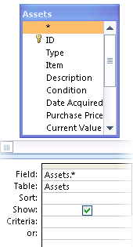

1. To limit the query results based on field values, in the query design grid, in the **Criteria** row, enter the criteria that you want to use to limit the results.
2. On the **Design** tab, in the **Results** group, click **Run**.
3. Verify that the query returns the records that you want to update.
4. To remove any fields that you do not want included in the query design, select the fields and then press DELETE.
5. To add any fields that you want to include in the query design, drag the additional fields to the query design grid.

**Step 2: Update the records**

1. On the **Design** tab, in the **Query Type** group, click **Update**.

This procedure shows you how to change a select query to an update query. When you do this, Access adds the **Update to** row in the query design grid. The following illustration shows an update query that returns all the assets purchased after January 5, 2005 and changes the location to "Warehouse 3" for all the records that meet that criterion.

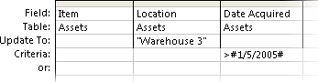

1. Locate the field that contains the data that you want to change, and then type your expression (your change criteria) in the **Update to** row for that field. You can use any valid expression in the **Update to** row.
2. On the **Design** tab, in the **Results** group, click **Run**. An alert message appears.
3. To run the query and update the data, click **Yes**.

 NOTE   When you run the query, you might notice that some fields are missing from your result set. If your query contains fields that you don't update, Access does not display those fields in the results, by default. For example, you might include ID fields from two tables to help ensure that your query identifies and updates the correct records. If you don't update those ID fields, Access does not display them in the results.

### HIDING FIELDS WITHIN QUERIES

Sometimes you might have fields that contain important criteria, but you might not need to actually see the information from that field in the final results.

**To Hide a Field within a Query:**

1. **Open** the query, and switch to **Design View**.
2. Locate the field you would like to hide.
3. Click the **checkbox** in the **Show**: row to uncheck it.

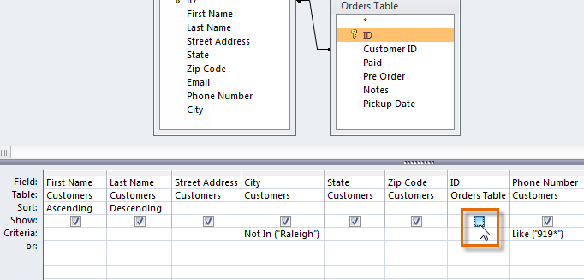

1. To see the updated query, select the **Run** command. The field will be hidden.

To **unhide** a hidden field, simply return to Design View and click the checkbox in the field's **Show:** row again.

### Activity 3

* Open a database
* Apply a **filter** to the database table (filter the table by selection)
* **Remove** a filter
* Create **queries** to select specific records from your database table
* **Run** the query
* **Save** the query
* **Modify** an existing query
* **Add** and **remove** a **field** to the query
* **Hide field** in the query

## Lesson 4 – Sorting data in a database query

Access allows you to apply multiple sorts at once while you are designing your query.  This allows you to view your data exactly the way you want; every single time you view it. A sort that includes more than one sorted field is called a **multi-level sort**. A multi-level sort allows you to apply an initial sort, then further organize that data with additional sorts.  For instance, if you had a table full of customers and their addresses, you might choose to first sort the records by city, then further sort them alphabetically by last name.

When more than one sort is included in a query, Access reads the sorts from **left to right**. This means that the leftmost sort will be applied first. So for instance, in the below example, the customers will be sorted first by the **City** they live in and then by the **Zip Code** within that city.

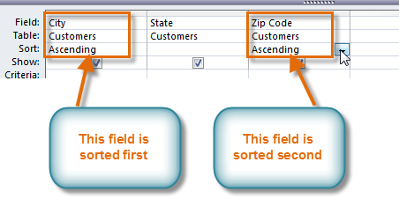

**To Apply a Multi-Level Sort:**

1. **Open** the query, and switch to **Design View**.
2. Locate the field you would like to sort first. In the **Sort:** row, click the drop-down arrow to select either an **ascending** or **descending** sort.

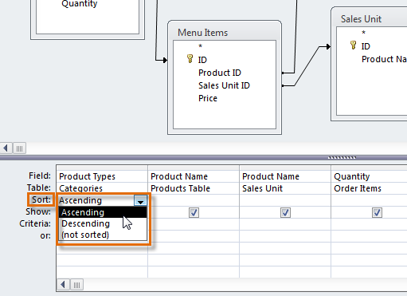

1. Repeat the process in the other fields to add additional sorts. Remember, the sorts are applied from left to right, so any additional sorts must be applied to fields located to the **right** of your primary sort. If necessary, you can **rearrange** the fields by **clicking** a field and **dragging** it to a new location.

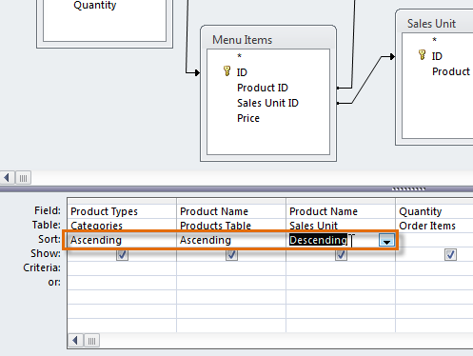

1. To apply the sort, click the **Run** command.

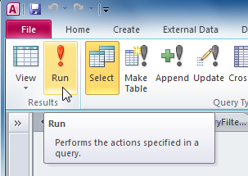

1. Your query results will appear with the desired sort.

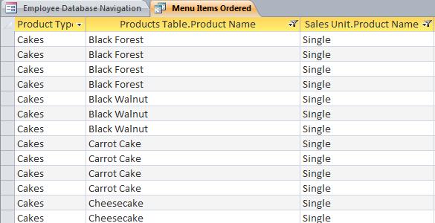

You can also apply multi-level sorts to tables that don't have queries applied to them. On the **Home** tab on the Ribbon, select the **Advanced** drop-down command in the **Sort & Filter** group. Select **Advanced Filter/Sort**, and create the multi-level sort as you normally would. When you are finished, click the **Toggle Filter** command to apply your sort.

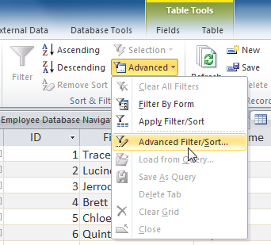

### Activity 4

Sort the results of the query you saved in the section above in ascending order.

## Lesson 5 – Creating a report for a database table

Why reports? Because they present complex data in a way that others can understand quickly and easily. For example, you can see what you spent on computers last year, with just a glance. A well designed report can let you see what's going right and what's going wrong, and help you make better decisions for your business -even if you're just managing the furniture in your house.

Reports are the end product of your database. They combine the raw facts in your database with enough information to give those facts meaning, and they present the results visually. For example, if you need to use charts or graphs, you use a report. Reports are also the best way to format and print your data, and they're a good way to summarize data. For example, you can group your assets by supplier and calculate a subtotal for each group, as well as a grand total for all groups.

**Reports** give you the ability to present components of your database in an easy-to-read, printable format. Access 2010 lets you create reports from both **tables** and **queries**.

### CREATING A REPORT

**To Create a Report:**

1. Open the table or query you would like to use in your report. We want to print out a list of last month's orders, so we will open up our **Orders Query**.

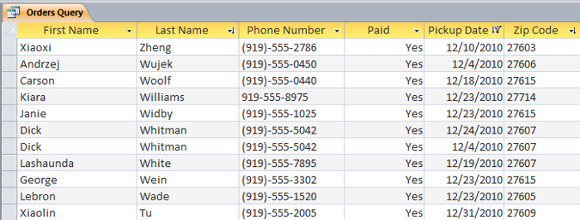

1. Select the **Create** tab on the Ribbon and locate the **Reports** group. Click the **Report** command.



1. Access will create a new report based on your object.
2. It's likely that some of your data will be located on the other side of the **page break**. To fix this, **resize** your fields. Simply select a field, then **click** and **drag** its edge until the field is the desired size. **Repeat** with additional fields until all of your fields fit.

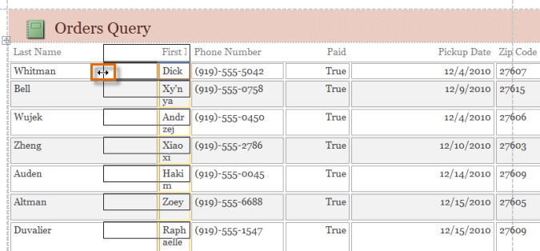

1. To **save** your report, click the **Save** command on the **Quick Access Toolbar**. When prompted, type a **name** for your report and then click **OK**.

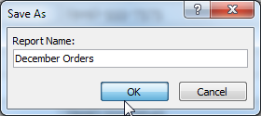

Just like tables and queries, reports can be **sorted**and **filtered**. Simply **right-click** the field you wish to sort or filter. Then, select the desired sorting or filtering option.

**To Create a Report using the Report Wizard:**

1. Select the **Create** tab and locate the **Reports** group. Click the **Report Wizard** command.

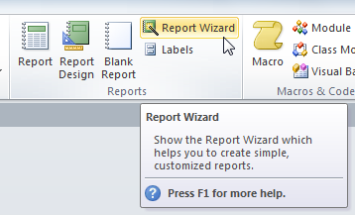

1. The **Report Wizard** dialog box will appear.

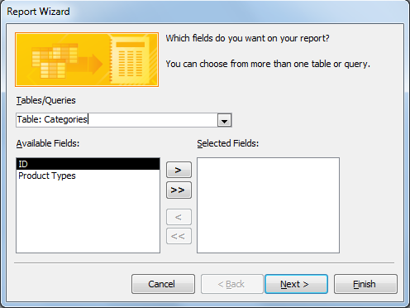

**Step 1: Select the Fields to Include in your Report**

1. Click the drop-down arrow to select the table or query that contains the desired field or fields.

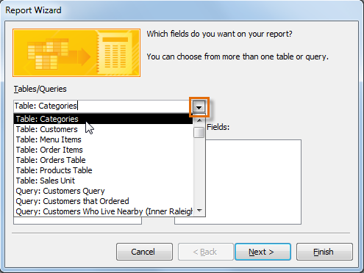

1. Select a field from the list on the left and click the **right arrow** http://content.gcflearnfree.org/topics/177/addarrow.png to add it to the report.

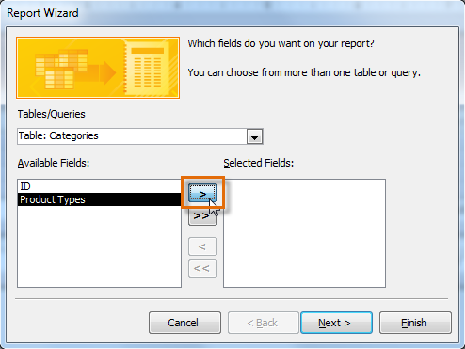

1. You can add fields from more than one table or query by repeating the above steps. Once you've added the desired fields, click **Next**

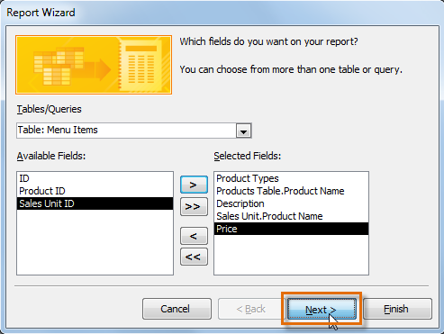

**Step 2: Organize the Report**

The Report Wizard will provide you with options that let you choose how to view and organize your data. These options **group**like data within your fields and **organize** those fields into multiple levels, like in an outline or bulleted list.

If you are building a report from only one table or query, you can skip to #3 in this section.

1. Access will offer a list of several organization options. Select an option from the list to preview it.

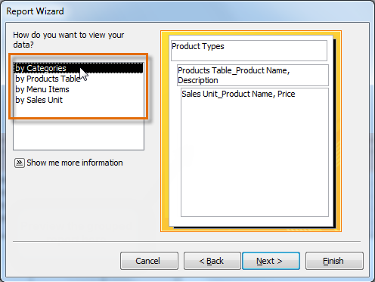

1. Click **Next** when you are satisfied with the basic organization of your data.
2. If you are not satisfied with the way your data is organized, you can now modify the grouping levels.
   * Select a field from the list and click the **right arrow** http://content.gcflearnfree.org/topics/177/addarrow.png to add it as a new level.

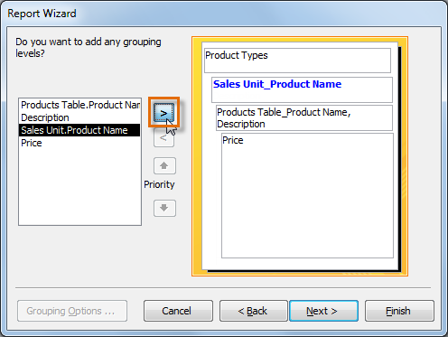

* + If necessary, modify the order of your grouped fields by selecting a field and clicking the **up** or **down Priority** arrow to move it up or down a level.

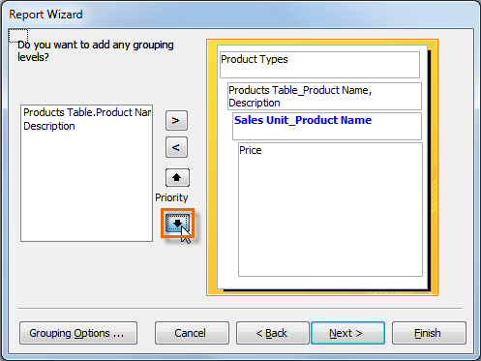

1. Once you are satisfied with the organization of your report, click **Next**.

**Step 3: Sort your Report Data**

1. Click the top drop-down arrow, and select the name of the first field you wish to sort.
2. Click the button on the right to change the sort to **ascending** or **descending**.

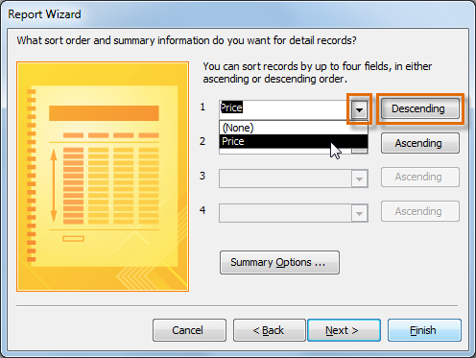

1. Add any additional sorts. You may sort up to **four fields**. The sort will be applied from top to bottom, meaning that the sort at the top of the list will be the main sort.
2. When you are satisfied with the way your data is sorted, click **Next**

Depending on the grouping you have chosen for your data, your sorting options may be limited.

**Step 4: Select a Layout and Title**

1. Click the various layout options to see how they look, then **select** one to use in your report.
2. Select either a **portrait**(tall) or **landscape**(wide) orientation for your report.

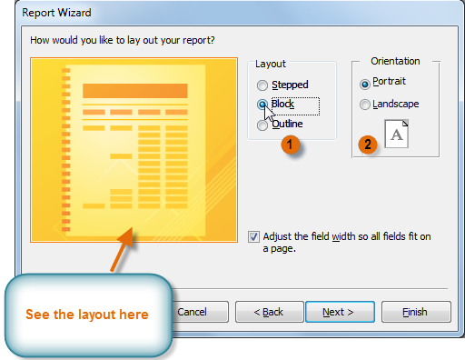

1. Once you are satisfied with your report layout, click **Next**
2. Place your cursor in the text box and type the **title** you would like for your report.
3. Select whether you want to **preview the** report or **modify** its design, then click **Finish**.

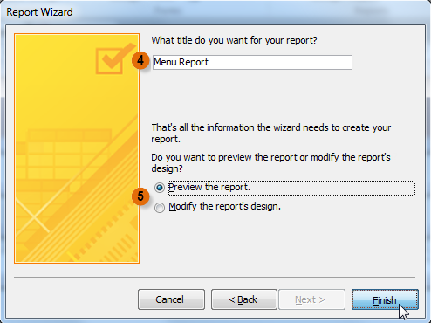

1. Your report will be created and saved.

Just as with other reports, you may have to adjust your field and row **size** and **location**to make sure that all your data fits the way you want it to.

### FORMATTING REPORTS

One of the strengths of reports is that you can modify their appearance to make them look how you want. You can add **headers**and **footers** to your report, apply new **colours** to the layout, and even add a **logo**. All of these things can help you create visually appealing reports.

**Modifying Report Text**

The bulk of the information in your report comes straight from the query or table you built it from, which means you can't edit it within the report. However, you can change, add, or delete label text, headers, and footers to make your report clearer and easier to read.

**To modify the Font Size:**

1. Select the text you wish to modify.
2. Click the **drop-down arrow** next to the **Font Size** box on the **Home** tab. A drop-down menu appears.
3. Move the mouse pointer over the various font sizes. A live preview of the font size will appear in the report.
4. Select the font size you wish to use.

**To modify the Font:**

1. Select the text you wish to modify.
2. Click the **drop-down arrow** next to the **Font** box on the **Home** tab. The **Font** drop-down menu appears.
3. Move the mouse pointer over the various fonts. A live preview of the font will appear in the report.
4. Select the font you wish to use. The font will change in the report.

**To Change the Font Colour:**

1. Select the text you wish to modify.
2. Click the **Font Colour** drop-down arrow on the **Home** tab. The **Font Colour** menu appears.
3. Move the mouse pointer over the various font colours. A live preview of the colour will appear in the report.
4. Select the font colour you wish to use. The font colour will change in the report.

### MODIFYING THE PAGE HEADER AND FOOTER

To view and modify the **header**and **footer** that appears on every page of your report, select the **View**command on the Ribbon and switch to **Design View**. The header and footer are located in the white space beneath the **Page Header** and **Page Footer** bars.

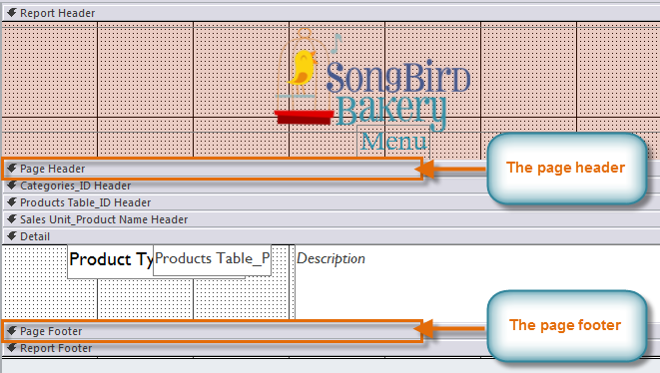

Depending on your report's design, sometimes you may find that there is no white space in the page header and footer, as in the image above. If this is the case, you must **resize**the header and footer before you can add anything to them. Simply **click**and **drag** the bottom border of the header or footer to make it larger.

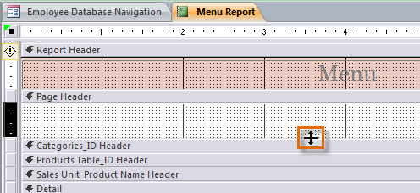

**To Add Text to a Header or Footer:**

1. On the Ribbon, select the **Design**tab in the **Report Design Tools** group and locate the **Controls** group.
2. Select the **Label**command.

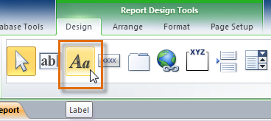

1. Place your cursor in the white space in your header or footer, and click and drag to create your label. **Release** the mouse when it is the desired size.

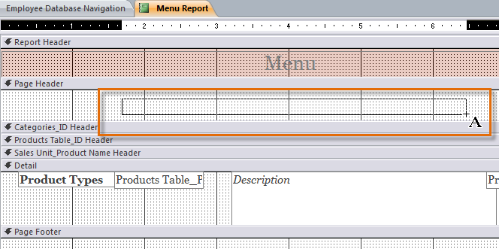

1. Place your cursor in the text box, click once, and**type** the desired text.

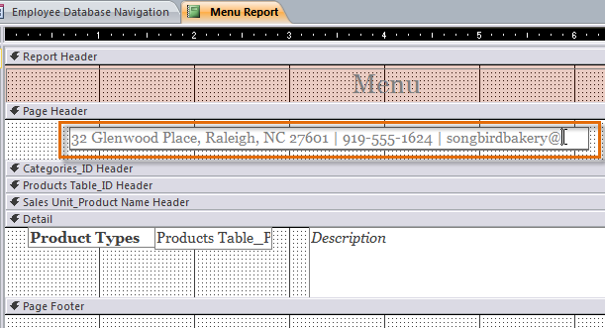

**To Add the Date and Time to a Header or Footer:**

1. On the Ribbon, select the **Design**tab in the **Report Design Tools** group and locate the **Header/Footer** group.
2. Select the **Date and Time** command.

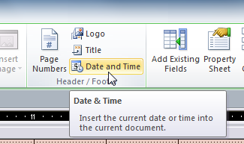

1. The **Date and Time** dialog box will appear. Select the desired formatting options. A preview of the text that will be included in your report will appear. When you are satisfied with the appearance of the date and time, click **OK**.

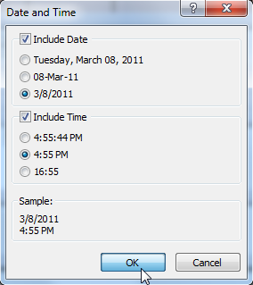

By default, the date and time appear in the **header**. If you would like to move them to the **footer** instead, simply **click** the date and time boxes and **drag** them to the desired location.

**To Add Page Numbers to a Header or Footer:**

1. On the Ribbon, select the **Design**tab in the **Report Design Tools** group and locate the **Header/Footer** group.
2. Select the **Page Numbers**command.

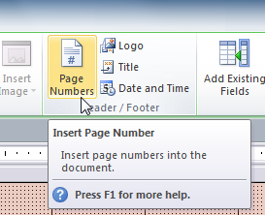

1. The **Page Numbers**dialog box will appear. Select the **format**of the page numbers.
   * Select **Page N** to display the number of only the current page.
   * Select **Page N of M** to display the number of the current page and the number of total pages.
2. Select whether to put your page numbers in the header or footer.
3. Click the drop-down arrow to select the **alignment** of the page numbers.

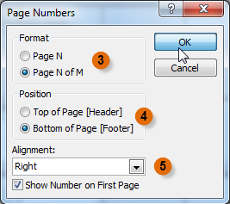

1. When you are satisfied with the settings, click **OK**.

### GROUPING DATA IN A REPORT

One of the more powerful things you can do in a report is group and sort your data. For example, if you want to know which supplier provided a given set of computers, then grouping your assets by supplier can give you that information quickly and easily.

You can group tabular or stacked reports.

* Open your report in Layout view, and on the **Format** tab, in the **Grouping & Totals** group, click **Group & Sort**. The **Group, Sort and Total** pane appears below your report.
* Click **Add a group**, and then select the field by which you want to group your data. Access groups your data to reflect your choice.
* If you want to sort your data, click **Add a sort**, select a field, and again Layout view shows you your changes.

You can add 10 grouping levels to a report, and you can sort each level, if you need to.

**Grouping data in a field**

* Right-click any value in the field on which you want to group.
* On the shortcut menu, click **Group On**.

Access adds the grouping level and creates a group header for it. If the **Group, Sort, and Total** pane is open, you can see that a new **Group on** line for the field is added.

### RESIZING ROWS AND COLUMNS

1. **Select** a cell in the row or column that you want to **resize**. If resizing multiple rows or columns, hold down the SHIFT key and select a cell in each row or column.
2. Position the **pointer** over the edge of one of the selected cells, and then **click and drag** the edge until the cell is the size you want.
3. The field or column/row, as well as every other item in line with it, will be **resizeD**

### SAVING A REPORT

After you create a report, you can save it.

1. Click the Save button on the Quick Access toolbar. Access saves the report unless you are saving for the first time. If you are saving for the first time, the Save As dialog box appears.
2. Type the name you want to give your report.
3. Click OK. Access saves the report. You can now access the report by using the Navigation pane.

As with other objects, you can also save a report by right-clicking the reports tab and selecting Save. Saved reports appear in the Navigation pane.

### DELETING A REPORT

1. Select the report you want to delete
2. Press the **delete** key.

### Activity 5

* Create 2 r**eports** in Access 2010
* Add **header** and **footer** to the reports
* Change the **font size** and **colour** of the reports
* **Group data** in the reports
* Resize a **selection** in a reports
* **Save** your reports
* **Delete** 1 report

## Lesson 6 – Performing advanced printing options

When you print data from your Microsoft Office Access 2010 database, the options you set depend on what kind of object you are printing and how you want your data to appear when printed.

### PRINTING A FORM

1. Open the form and click file, point to **Print**, and then click **Print Preview**.
2. Make any necessary page layout changes, and then click **Print**.

### PRINTING QUERY RESULTS

You can print the results of the query by selecting the Datasheet View and choosing the Print command from the File ribbon. The output will be presented in table form with no formatting.

### PREVIEW AND PRINT A REPORT

While you can print reports using commands in the Backstage view, you can also use Print Preview. Print Preview shows you how your report will appear on the printed page. It also allows you to modify the way your report is displayed, print it, and even save it as a different file type.

**To preview a report:**

Because datasheets and forms are not as easy to format for printing, previewing such objects can help you see how the data appears when printed. For example, you can change the page orientation or the margin settings. To preview a report

1. Open the report you want to preview, or just select it in the Navigation Pane.
2. On the **File** tab, click **Print**, and then click **Print Preview**.

Access opens the report in Print Preview. You can use the commands on the **Print Preview** tab to do any of the following:

* Print the report
* Adjust page size or layout
* Zoom in or out, or view multiple pages at a time
* Refresh the data on the report
* Export the report to another file format.

1. To return to the database workspace, on the **Print Preview** tab, in the **Close Preview** group, click **Close Print Preview**.

**To Print a Report:**

1. On the **Home** tab of the **Ribbon**, click the **View**command and select **Print Preview** from the drop-down list. Your report will be shown as it will appear on the printed page.

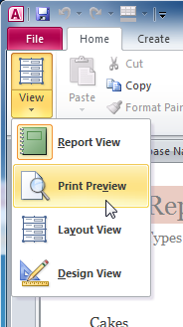

1. If necessary, modify the **page size**, **margin width**, and **page orientation** using the related commands on the Ribbon.

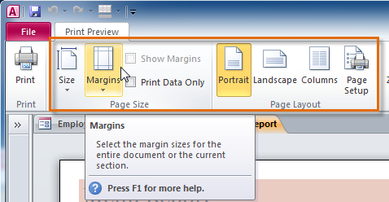

1. Click the **Print** command.

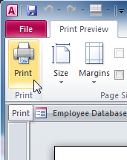

1. The **Print** dialog box will appear. Set any desired print options, then click **OK**.

### Activity 6

* Print a database **form**
* Print **query results**
* **Preview** a database report and make **changes** before printing
* Print a database **report**