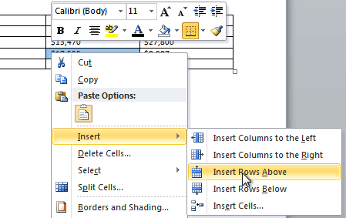

**LEARNER GUIDE**

**USE A GUI-BASED WORD PROCESSOR TO ENHANCE A DOCUMENT THROUGH THE USE OF TABLES AND COLUMNS**

**US 119078**

**NQF LEVEL:** 3

**CREDITS: 5**

**NOTIONAL HOURS: 50**

|  |  |
| --- | --- |
| **Name** |  |
| **Contact Address** |  |
| **Telephone (H)** |  |
| **Telephone (W)** |  |
| **Facsimile** |  |
| **Cellular** |  |

|  |  |  |  |
| --- | --- | --- | --- |
| **SAQA UNIT STANDARD ALIGNMENT** | | | |
| **SPECIFIC OUTCOMES (SO)** | **ASSESSMENT CRITERIA (AC)** | **LEVEL** | **CREDITS** |
| **UNIT STANDARD 119078 :**  Use a GUI-based word processor to enhance a document through the use of tables and columns | | | |
| |  | | --- | | **SPECIFIC OUTCOME 1** |  |  | | --- | | Create and edit a table. | | |  | | --- | | **ASSESSMENT CRITERION 1** |  |  | | --- | | A table is created. |  |  | | --- | | **ASSESSMENT CRITERION RANGE** |  |  | | --- | | Table to have at least 4 columns and 4 rows, and at least two of the following methods of creating a table are demonstrated: Insert Table on Standard Toolbar, Insert/Draw Table from Table Menu, and Convert Text to Table from Table Menu. |  |  | | --- | | **ASSESSMENT CRITERION 2** |  |  | | --- | | Data is entered into the table. |  |  | | --- | | **ASSESSMENT CRITERION 3** |  |  | | --- | | Text is selected in the table. |  |  | | --- | | **ASSESSMENT CRITERION RANGE** |  |  | | --- | | A word, a sentence, a Cell, a Row, a Column, the Entire Table. |  |  | | --- | | **ASSESSMENT CRITERION 4** |  |  | | --- | | Text is deleted from a table. |  |  | | --- | | **ASSESSMENT CRITERION RANGE** |  |  | | --- | | Text to be deleted includes:  • In a single cell, in an entire row, in an entire column. |  |  | | --- | | **ASSESSMENT CRITERION 5** |  |  | | --- | | Table cells are inserted and deleted. |  |  | | --- | | **ASSESSMENT CRITERION RANGE** |  |  | | --- | | A single cell, a whole column, a whole row. |  |  | | --- | | **ASSESSMENT CRITERION 6** |  |  | | --- | | Text is copied from one cell range to another. |  |  | | --- | | **ASSESSMENT CRITERION RANGE** |  |  | | --- | | A cell, a column, a row. |  |  | | --- | | **ASSESSMENT CRITERION 7** |  |  | | --- | | Text is moved from one cell range to another. |  |  | | --- | | **ASSESSMENT CRITERION RANGE** |  |  | | --- | | A cell, a column, a row. | | **3** | **5** |
| |  | | --- | | **SPECIFIC OUTCOME 2** |  |  | | --- | | Format a table according to given requirements. | | |  | | --- | | **ASSESSMENT CRITERION 1** |  |  | | --- | | The width of a column is changed. |  |  | | --- | | **ASSESSMENT CRITERION RANGE** |  |  | | --- | | Methods of changing a column width:  • Manually using drag, and automatically using Table Menu. |  |  | | --- | | **ASSESSMENT CRITERION 2** |  |  | | --- | | The height of a row is changed. |  |  | | --- | | **ASSESSMENT CRITERION RANGE** |  |  | | --- | | Methods of changing a row height:  • Manually using drag, and automatically using Table Menu. |  |  | | --- | | **ASSESSMENT CRITERION 3** |  |  | | --- | | The alignment of text in a cell range is changed. |  |  | | --- | | **ASSESSMENT CRITERION RANGE** |  |  | | --- | | Left, Center, Right, Justified, Direction. |  |  | | --- | | **ASSESSMENT CRITERION 4** |  |  | | --- | | Borders are added to a cell range. |  |  | | --- | | **ASSESSMENT CRITERION RANGE** |  |  | | --- | | A single cell, a column, a row, the entire table, at least two methods of adding a border to be demonstrated. |  |  | | --- | | **ASSESSMENT CRITERION 5** |  |  | | --- | | The background shading of a cell range is changed. |  |  | | --- | | **ASSESSMENT CRITERION RANGE** |  |  | | --- | | Shading:  • Colour.   Cell range:  • A single cell, a column, a row, the entire table, at least two methods of adding shading to be demonstrated. |  |  | | --- | | **ASSESSMENT CRITERION 6** |  |  | | --- | | The text colour is changed in a cell range. |  |  | | --- | | **ASSESSMENT CRITERION RANGE** |  |  | | --- | | A single cell, a column, a row, the entire table, at least two methods of changing the text colour to be demonstrated. |  |  | | --- | | **ASSESSMENT CRITERION 7** |  |  | | --- | | Borders are changed in a cell range. |  |  | | --- | | **ASSESSMENT CRITERION RANGE** |  |  | | --- | | Change:  • Line colour, line style, line width.   Cell range:  • A single cell, a column, a row, the entire table, at least two methods of changing the border colour to be demonstrated. |  |  | | --- | | **ASSESSMENT CRITERION 8** |  |  | | --- | | A table is formatted automatically using the features of the word processing application. |  |  | | --- | | **ASSESSMENT CRITERION 9** |  |  | | --- | | Cell attributes are changed. |  |  | | --- | | **ASSESSMENT CRITERION RANGE** |  |  | | --- | | Merge cells, split cells. |  |  | | --- | | **ASSESSMENT CRITERION 10** |  |  | | --- | | Data in a table is sorted. |  |  | | --- | | **ASSESSMENT CRITERION 11** |  |  | | --- | | Numeric calculations are applied to achieve a given scenario. | |  |  |
| |  | | --- | | **SPECIFIC OUTCOME 3** |  |  | | --- | | Create and Edit Columns in a document. |  |  | | --- | | **OUTCOME RANGE** |  |  | | --- | | Columns referred to here are not columns in a table (see definition in the notes section). | | |  | | --- | | **ASSESSMENT CRITERION 1** |  |  | | --- | | A document column is inserted. |  |  | | --- | | **ASSESSMENT CRITERION RANGE** |  |  | | --- | | At least two. |  |  | | --- | | **ASSESSMENT CRITERION 2** |  |  | | --- | | Edit a column in a document. |  |  | | --- | | **ASSESSMENT CRITERION RANGE** |  |  | | --- | | Resize, Line in between, Adjust column length. |  |  | | --- | | **ASSESSMENT CRITERION 3** |  |  | | --- | | A column break is inserted and deleted. | |  |  |
| |  | | --- | | **SPECIFIC OUTCOME 4** |  |  | | --- | | Format a column in a document. |  |  | | --- | | **OUTCOME RANGE** |  |  | | --- | | Columns referred to here are not columns in a table (see definition in the notes section). | | |  | | --- | | **ASSESSMENT CRITERION 1** |  |  | | --- | | A heading is added for a column. |  |  | | --- | | **ASSESSMENT CRITERION RANGE** |  |  | | --- | | Above column break, inside column. |  |  | | --- | | **ASSESSMENT CRITERION 2** |  |  | | --- | | A text box is added inside a column. |  |  | | --- | | **ASSESSMENT CRITERION RANGE** |  |  | | --- | | At least two in separate columns. |  |  | | --- | | **ASSESSMENT CRITERION 3** |  |  | | --- | | Text boxes are linked between different columns. |  |  | | --- | | **ASSESSMENT CRITERION RANGE** |  |  | | --- | | At least two. | |  | |  | |  |  |

Table of Contents

Introduction to Microsoft Word 2010 3

Lesson 1 – Introduction to tables 3

Lesson 2 - Creating and editing tables 4

Inserting a table 4

Entering data into a table 6

Selecting text in a table 7

Deleting text from a table 8

Inserting and deleting table cells 8

Move or copy text in a table 11

Activity 1 11

Lesson 3 – Formatting tables 12

Changing the width of column 12

Changing the row height 12

Resize a column or table automatically with AutoFit 13

Align Cell Text 13

To Add Borders to a Table 15

Apply table styles 18

Adding background colour to a cell 20

To Change the Font Colour 21

Table AutoFormat 22

Merging and Splitting cells in a table 23

Sort Table Data 24

Use Formulas in a Table 26

Activity 2 27

Lesson 4 – Create and edit column 28

Inserting Columns 28

Editing columns 29

Adding Column Breaks 30

To delete column breaks 31

Activity 3 33

Lesson 5 – Format a column in a document 34

Inserting a heading 34

Adding a textbox inside a column 35

Linking textboxes between different columns 35

Activity 4 36

Introduction to Microsoft Word 2010

MS Word 2010 is the word processing software in the Microsoft 2010 Office Suite. It allows you to easily create a variety of professional-looking documents using features such as themes, styles, Smart Art, and more.

## Lesson 1 – Introduction to tables

Word 2010, part of the Microsoft Office 2010 suite, has many built-in features that can enhance your documents and the manner in which you communicate information to your audience. One of the most common and yet still useful features in this category is the table format. Creating and formatting tables in Word 2010 is different from how you did it earlier versions of Word, but you may actually find it easier.

A table is a grid of cells arranged in rows and columns. Tables can be customized and are useful for various tasks such as presenting text information and numerical data. Tables can be created either by;

* Creating from scratch or,
* Converting text into a table.

**Below is an example of a table**:

|  |
| --- |
| The Table |

The above table has two rows and 9 columns

## Lesson 2 - Creating and editing tables

In Word, you can create a **blank** table, **convert text** to a table, and apply a variety of **styles** and **formats** to existing tables.

# Inserting a table

**To Insert a Blank Table:**

1. Place your insertion point in the document where you want the table to appear.
2. Select the **Insert** tab.
3. Click the **Table** command.
4. Hover your mouse over the diagram squares to select the number of **columns** and **rows** in the table.

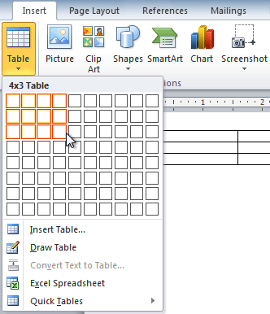

1. Click your mouse, and the table appears in the document.
2. You can now place the insertion point anywhere in the table to add text.

**To Convert Existing Text to a Table:**

1. Select the text you wish to convert.
2. Select the **Insert** tab.
3. Click the **Table** command.
4. Select **Convert Text to Table** from the menu. A dialog box will appear.

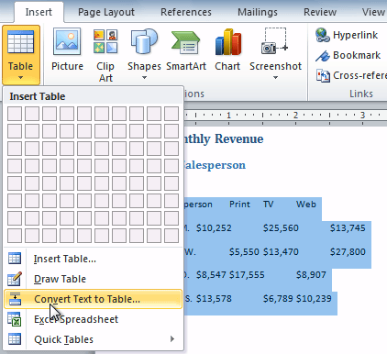

1. Choose one of the options in the **Separate text at:** section. This is how Word knows what text to put in each column.

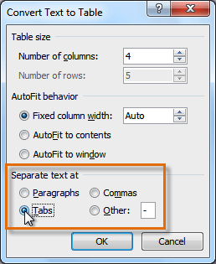

1. Click **OK**. The text appears in a table.

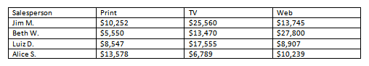

**Draw a table:**

If you want a table with rows and columns in different sizes, you can use the cursor to draw it. Here’s how:

1. Click where you want to create the table.
2. Click the **Insert** tab, click **Table**, and then click **Draw Table**.

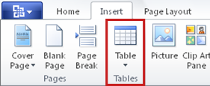

The pointer changes to a pencil.

1. Draw a rectangle to make the table’s borders. Then draw lines for columns and row inside the rectangle.

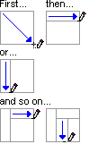

1. To erase a line, click the **Table Tools Design** tab, click **Eraser**, and then click the line that you want to erase.

# Entering data into a table

To populate a table with text, simply type. All the text you type fits into a single cell. Cells grow taller to accommodate long bits of text. Certain keys and key combos perform special functions within the table:

* **Tab:**To move to the next cell, press the Tab key. You move from cell to cell, from left to right. Pressing Tab in a table’s last (rightmost) column moves you down to the next row.
* **Shift+Tab:** To move backward to the previous cell, press Shift+Tab.
* **Arrow keys:** The up, down, left, and right keys also move you around within the table, but they still move within any text in a cell. Therefore, using the arrow keys to move from cell to cell is rather inefficient.
* **Enter:**The Enter key adds a new paragraph to a cell.
* **Shift+Enter:**The Shift+Enter key combination can break up long lines of text in a cell by inserting a soft return.
* **Ctrl+Tab:** To use tabs or indentation within a cell, press Ctrl+Tab rather than Tab.

By the way, pressing the Tab key in the table's last, lower-right cell automatically adds another row to the table.

# Selecting text in a table

In Word 2010, you can select text or items in a table by using the mouse or the keyboard. You can also select text or items that are in different places. For example, you can select a paragraph on one page and a sentence on a different page.

Select items in a table

|  |  |
| --- | --- |
| **TO SELECT** | **DO THIS** |
| A word | Double-click anywhere in the word. |
| A Sentence | Hold down CTRL, and then click anywhere in the sentence. |
| The contents of a cell | Click in the cell. Under **Table Tools**, click the **Layout** tab. In the **Table** group, click **Select**, and then click **Select Cell**. |
| The contents of a row | Click in the row. Under **Table Tools**, click the **Layout** tab. In the **Table** group, click **Select**, and then click **Select Row**. |
| The contents of a column | Click in the column. Under **Table Tools**, click the **Layout** tab. In the **Table** group, click **Select**, and then click **Select Column**. |
| The contents of multiple cells, rows, or columns | Click in a cell, a row, or a column and then hold the left mouse button down while you drag across all of the cells, rows, or columns that contain the content that you want to select. To select the contents of cells, rows, or columns that are not next to each other, click in the first cell, row, or column, press CTRL, and then click the additional cells, rows, or columns that contain the content that you want to select. |
| The contents of an entire table | Click in the table. Under **Table Tools**, click the **Layout** tab. In the **Table** group, click **Select**, and then click **Select Table**. |

# Deleting text from a table

1. Select the text in a single cell, row or column that you want to **clear**.

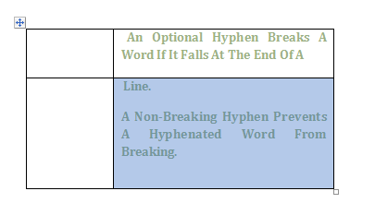

1. **Press Backspace**or**Delete**

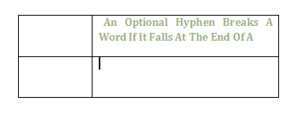

# Inserting and deleting table cells

**To Add a Row Above an Existing Row:**

1. Place the insertion point in a row **below** the location where you wish to add a row.

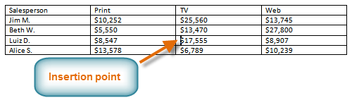

1. Right-click the mouse. A menu appears.
2. Select **Insert**  **Insert Rows Above**.



1. A new row appears **above** the insertion point.

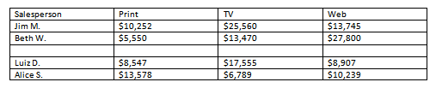

You can also add rows below the insertion point. Follow the same steps, but select Insert Rows Below from the menu.

**To Add a Column:**

1. Place the **insertion point** in a **column** **adjacent** to the location you wish the new column to appear.
2. Right-click the mouse. A menu will appear.

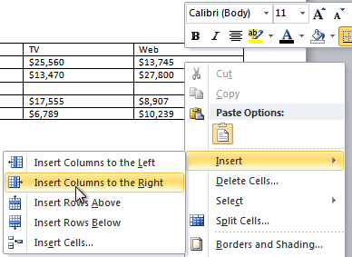

1. Select **Insert**  **Insert Columns to the Left** or **Insert Columns to the Right**. A new column appears.

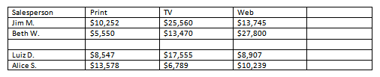

**To Delete a Row or Column:**

1. Select the row or column.
2. Right-click your mouse. A menu will appear.
3. Select **Delete Cells**.

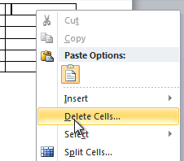

1. Select **Delete entire row** or **Delete entire column** and click **OK**.

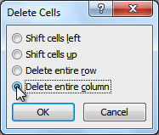

# Move or copy text in a table

You can move or copy text and graphics from one table cell to another by;

1. Clicking the **Cut** or **Copy** and **Paste** buttons on the **Backstage view**, or
2. Choosing Cut or Copy and Paste from the Edit menu, or
3. Using **drag** and **drop** editing with the mouse

To move or copy cells, rows or columns in a table:

1. Select the item that you want to move or copy.
2. Do one of the following:
3. To **move** the selected item, **drag it** to the new location.
4. To copy the selected item, hold down **CTRL** while you drag it to the new location

OR

Select the text and click copy or paste on the backstage view

### Activity 1

1. **Open** MS Word 2010
2. Using the any two methods discussed above, **create a table** **with 4 columns and 4 rows**.
3. **Enter data** into the table
4. **Select** a word, sentence, row, column and an entire table
5. **Delete text** in a **column**
6. **Insert** a **new row**
7. **Delete** a **column**
8. **Copy text** from one cell to another
9. **Move text** from one cell to another
10. Save your table

## Lesson 3 – Formatting tables

After you create a table, Microsoft Office Word 2010 offers you many ways to format that table. You can create a custom look for tables by splitting or merging cells, adding or deleting columns or rows, or adding borders.

# Changing the width of column

To change the column width, do one of the following:

* To use your mouse, rest the cursor on right side of the column boundary you want to move until it becomes a resize cursorTBD, and then drag the boundary until the column is the width you want.
* To change the width to a specific measurement, click a cell in the column that you want to resize. On the **Layout** tab, in the **Cell Size** group, click in the **Table Column Width** box, and then specify the options you want.
* To make the columns in a table automatically fit the contents, click on your table. On the **Layout** tab, in the **Cell Size** group, click **AutoFit**, and then click **AutoFit Contents**.
* To use the ruler, select a cell in the table, and then drag the markers on the ruler. If you want to see the exact measurement of the column on the ruler, hold down ALT as you drag the marker.

# Changing the row height

To change the row height, do one of the following:

* To use your mouse, rest the pointer on the row boundary you want to move until it becomes a resize pointerTBD, and then drag the boundary.
* To set the row height to a specific measurement, click a cell in the row that you want to resize. On the **Layout** tab, in the **Cell Size** group, click in the **Table Row Height** box, and then specify the height you want.
* To use the ruler, select a cell in the table, and then drag the markers on the ruler. If you want to see the exact measurement of row on the ruler, hold down ALT as you drag the marker.

# Resize a column or table automatically with AutoFit

Automatically adjust your table or columns to fit the size of your content by using the AutoFit button.

1. Select your table.
2. On the **Layout** tab, in the **Cell Size** group, click **AutoFit**.

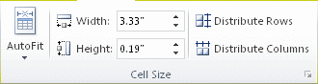

1. Do one of the following.

* To adjust column width automatically, click **AutoFit Contents**.
* To adjust table width automatically, click **AutoFit Window**.

 NOTE: Row height automatically adjusts to the size of the content until you manually change it.

# Align Cell Text

You can change the alignment of text within the table cells. Like paragraph alignment, you can align text horizontally to the left, center, or right side of cells. You can also align text vertically, choosing from top, center, or bottom. By default, text is aligned top left. You can find all of the alignment options on the Layout tab in the Alignment group of tools.

To align text,

1. Select the text that you want to align, or press CTRL+A to select all the text in the document.
2. Then, on the **Home** tab, in the **Paragraph** group, click **Align Left** (Button image ) or **Align Right** (Button image ), **Center** (Button image ), or **Justify** (Button image ).

**Example 1: Right alignment**

By changing the **alignment** of a cell, you can control exactly where the text is located. In the example below, the cell text is aligned to the **bottom right**.

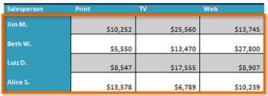

**Example 2: Centre alignment**

1. With your data highlighted, locate the **Alignment** panel on the **Layout** tab:

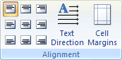

1. From the Alignment panel, choose the **Align Centre** option:

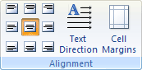

1. All your table data will then be centred:

Table Data has been centred

# To Add Borders to a Table

1. Select the cells you wish to add a border to.

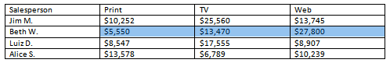

1. From the **Design** tab, select the desired **Line Style**, **Line Weight**, and **Pen Color**.

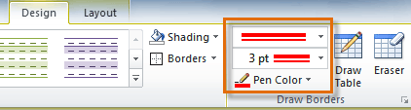

1. Click the **Borders** drop-down arrow.
2. From the drop-down menu, select the desired **border type**.

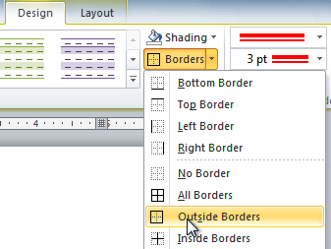

1. The border will be added to the selected cells.

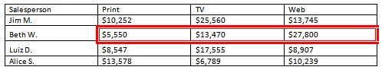

OR

To add a border for table, do the following.

* Highlight your entire table (To highlight the entire table, click inside the first cell. Hold your left mouse button down, and drag your mouse to the bottom right cell)
* With the entire cell highlighted, click on **Table** from the menu bar

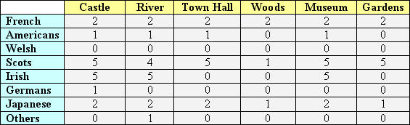

* From the drop down menu, click on **Table Properties**
* The **Table Properties** dialogue box appears
* Click the **Table** tab strip, then click the **Borders and Shading** button at the bottom
* The **Borders and Shading** dialogue box appears
* Make sure you have the **Border** tab strip selected, as in the image below:

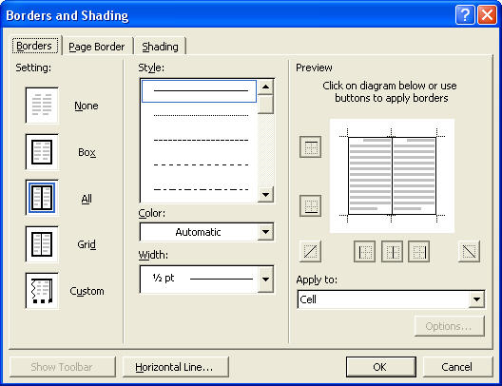

Have a closer look at the left hand side of the Borders dialogue box:

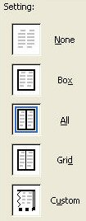

We want a border to go right around our table, so click on **Box** with the left hand mouse button.

To add a colour and a thicker border, we need the Style section of the Border dialogue box. Change your Style section to match the image on the right of the two below:

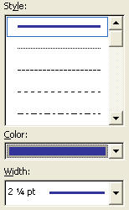

Obviously, you can choose any settings you like for the Border colour. Feel free to change them from the ones above.

Once you have chosen a border colour and a line style, click the OK button to return to the **Table Properties** dialogue box. Click the OK button on the Table Properties box to see your borders.

You final table should now look something like this:

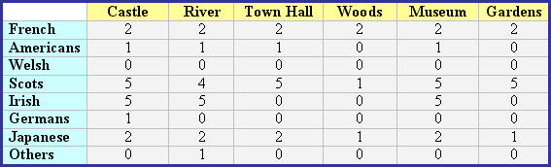

**To format boarders**

1. Select the border you wish to format.
2. From the **Design** tab, select the desired **Line Style**, **Line Weight**, and **Pen Colour**.



1. The colour of the cell, row, column or table border will be changed.

# Apply table styles

Table styles in Microsoft Word 2010 allow you to change the format of a table at any time and still maintain a cohesive, professional-looking document.

A table style provides a consistent look to borders, shading, alignment and fonts in tables.

And, if you use table styles instead of direct formatting to format the content of a table cell and then you switch to a different table style, the content is automatically updated to match the new table style.

To apply a table style:

1. Click anywhere on the table. The **Design** tab will appear on the Ribbon.
2. Select the **Design** tab and locate the **Table Styles**.
3. Click the **More** drop-down arrow to see all of the table styles.

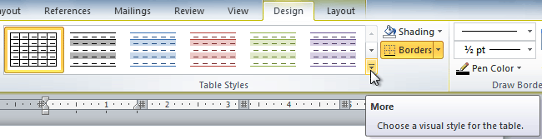

1. Hover the mouse over the various styles to see a live preview.
2. Select the desired style. The table style will appear in the document.

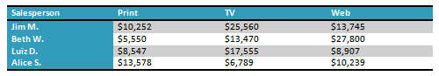

**To Change the Table Style Options:**

Once you have chosen a table style, you can turn various options **on** or **off** to change the appearance of the table. There are six options: **Header Row**, **Total Row**, **Banded Rows**, **First Column**, **Last Column**, and **Banded Columns**.

1. Click anywhere on the table. The **Design** tab will appear.
2. From the **Design** tab, **check** or **uncheck** the desired options in the **Table Style Options** group.

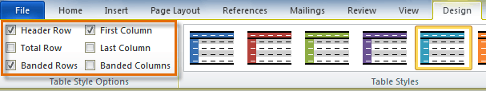

Depending on which **Table Style** you are using, certain **Table Style Options** may have a somewhat different effect. You may need to **experiment** to get the exact look you want.

# Adding background colour to a cell

1. Select a single cell, a column, a row or the entire table you wish to add background colour to.



1. From the **Design** tab, click the **shading** drop-down arrow.
2. From the drop-down menu, select the desired **colour type**.
3. The background colour will be added to the selected cells

OR

1. Select cells.
2. Click Home tab.
3. On the paragraph tab, Click the Shading buttonhttp://www.znanje.org/ebooks/wordMMXEngl/55button/w_10075.bmp.
4. Select a colour.

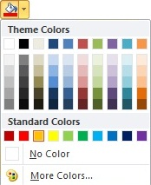

1. Background colour will be added to your column, row or cell

# To Change the Font Colour

1. Select a single cell, a column, a row or the entire table with the text you wish to modify.
2. Click the **Font Colour** drop-down arrow on the **Home** tab. The **Font Colour** menu appears.
3. Move the mouse pointer over the various font colours. A live preview of the colour will appear in the table.
4. Select the font colour you wish to use. The font colour will change in the cell.

Your colour choices aren't limited to the drop-down menu that appears. Select **More Colours** at the bottom of the list to access the Colours dialog box. Choose the colour that you want and click OK.

OR

Highlight the cell and right click, from the colour drop down arrow, select the font colour you like.

# Table AutoFormat

Word 2010 offers an AutoFormat option to easily apply borders, shading, special fonts, and color to a table. Click on the **Design** tab under **Table Tools**. When you click on the downward arrow a drop down menu will appear with many options to choose from.



# Merging and Splitting cells in a table

To change the layout of a table, you can **merge cells** together to form a larger cell or **split** a cell into several smaller **cells**. Merging is useful when you need to create a single large cell from two or more smaller cells, while splitting lets you create multiple **cells** within a single existing column.

**Merging multiple cells into a single cell**

To merge cells together,

1. **Select** the cells
2. Choose table tools **Layout** Merge
3. Click **Merge cells**

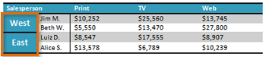

**Splitting one or more cells into multiple cells**

1. Click in the cell you want to split. If you want to split multiple cells the same way, select each of the cells
2. Choose **Table Tools Layout -Merge-Split Cells** to display the Split Cells dialog window

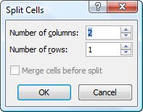

1. In the “**Number of columns**” box, enter the number of columns you want to create within the cell
2. In the “**Number of rows**” box, enter the number of rows you want to create, and then click the **OK button**.
3. If you selected multiple cells in step 1, select the “**Merge cells before split**” check box to make Word treat them all as one cell. For example, if you select two cells, select the “**Merge cells before split**” check box and specify five columns, you get five columns total. If you select two cells, clear the “**Merge cells before split**” check box and specify five columns, you get five columns from each cell, giving ten columns altogether.
4. Click the **OK button** to close the Spit Cells dialog box. Word splits the cells as you specified.

# Sort Table Data

Word can sort a table’s data numerically, alphabetically or chronologically in an ascending or descending order.

**Sort the contents of a table**

1. In Print Layout view, move the pointer over the table until the table move handle Four-headed arrow handle appears.
2. Click the table move handle to select the table that you want to sort.
3. Under **Table Tools**, on the **Layout** tab, in the **Data** group, click **Sort**.

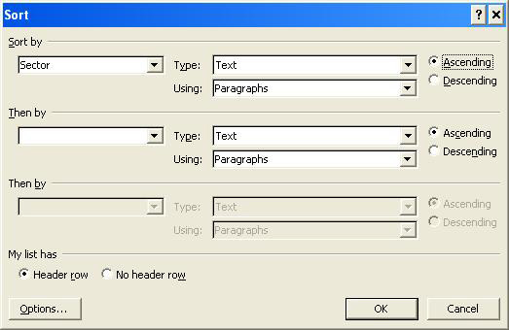

1. In the **Sort** dialog box, select the options that you want.
2. Click **OK**

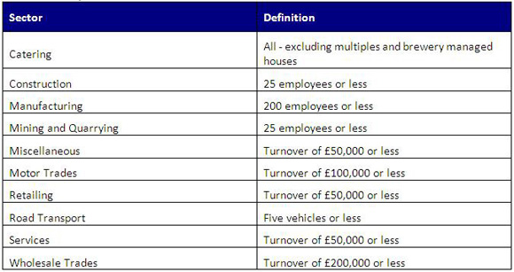

You can apply up to three sorts on a table

**Sort a single column in a table**

1. Select the column that you want to sort.
2. Under **Table Tools**, on the **Layout** tab, in the **Data** group, click **Sort**.
3. Under **My list has**, click **Header row** or **No header row**.
4. Click **Options**.
5. Under **Sort options**, select the **Sort column only** check box.
6. Click **OK**.

**Sort by more than one word or field inside a table column**

To sort the data in a table that is based on the contents of a column that includes more than one word, you must first use characters to separate the data-including data in the header row. For example, if the cells in a column contain both last and first names, you can use commas to separate the names.

1. Select the column that you want to sort.
2. Under **Table Tools**, on the **Layout** tab, in the **Data** group, click **Sort**.
3. Under **My list has**, click **Header row** or **No header row**.
4. Click **Options**.
5. Under **Separate fields at**, click the type of character that separates the words or fields that you want to sort, and then click **OK**.
6. Under **Sort by**, in the **Using** list, select which word or field you want to sort by.
7. In the first **Then by** list, enter the column that contains the data that you want to sort by, and then in the **Using** list, select which word or field you want to sort by.

If you want to sort by an additional column, repeat this step in the second **Then by** list.

1. Click **OK**.

# Use Formulas in a Table

It is possible to use formulas and some basic functions in tables in Microsoft Word. It is not as powerful at calculating as Excel, and the table does not have the row and column headers like a spreadsheet, however table cells can still be referenced by using a cell reference such as B1.

1. Click in the cell where you want to insert the formula
2. Click on the **Layout** tab of the Ribbon
3. Click the **Formulas** button

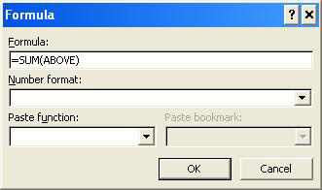

1. Enter the formula in the **Formula** box

The image above shows the Sum function being used to add the values in a column

1. Select the required format from the **Number format** drop down list such as currency or whole number
2. The **Paste function** drop down list can be used to insert basic functions into the formula
3. Click **OK**

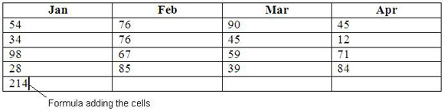

If any of the values being used in a formula changes, the formula will need to be manually updated. Formulas use fields which can be updated by selecting the field and pressing the**F9** key.

When inserting functions the direction of the cells can be used as an alternative to the cell references in Word. For example, =SUM (ABOVE) is used instead of =SUM (B2:B5) in the formula shown above. This is because the formula adds all the values in the cells above.

### Activity 2

1. **Open** the table you created in MS Word above
2. Change the **column width**
3. Change the **row height**
4. **Centre** your text
5. Add a **border** to your table
6. Change the **background shading** of a row
7. Change the **text colour** of a column
8. Change **width** of the table border
9. A**utoFormat** a table
10. **Merge** cells
11. **Split** cells
12. **Sort data** in descending order
13. **Calculate** the totals of values in your table
14. Save changes with a different file name

## Lesson 4 – Create and edit column

**Columns** are used in many types of documents, but are most commonly used in newspapers, magazines, academic journals, and newsletters. In this lesson you will learn how to **insert columns** into a document, edit columns and create and delete **column breaks**.

# Inserting Columns

**Columns** can improve your document's organisation and increase its readability. They also allow you to utilize all of the available space on the page.

**To Add Columns to a Document:**

1. Select the text you want to format.
2. Click the **Page Layout** tab.
3. Click the **Columns** command. A drop-down menu will appear.

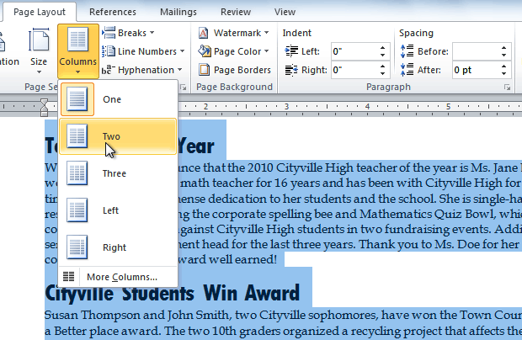

1. Select the number of columns you would like to insert. The text will then format into columns.

If you want to remove the columns, just click the **Columns** command and select **One** for the number of columns.

# Editing columns

1. Click the "Page Layout" tab.
2. Click the "Columns" icon. A menu will drop down; click "More Columns."

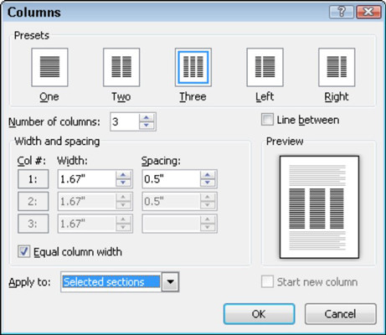

1. Under "Width and Spacing", change the "Spacing" value as you wish
2. Type the desired column width, in the Width field under Width and Spacing. Or, use the up and down arrows next to the field to change the number. Uncheck "Equal column width" if you want the columns to have different sizes.
3. Choose the presets you want
4. Make other changes you want
5. Click "OK" at the bottom of the dialog box once you have made the changes to your preferred specifications

# Adding Column Breaks

Once you have created columns, the text will automatically flow from one column to the next. Sometimes, though, you might want to control exactly where each column begins. You can do this by creating **column breaks**.

**To Add Column Breaks:**

1. Place the **insertion point** where you would like to add the break.
2. Click the **Page Layout** tab.
3. Click the **Breaks** command in the **Page Setup** group. A drop-down menu will appear.
4. Select **Column** from the list of break types.

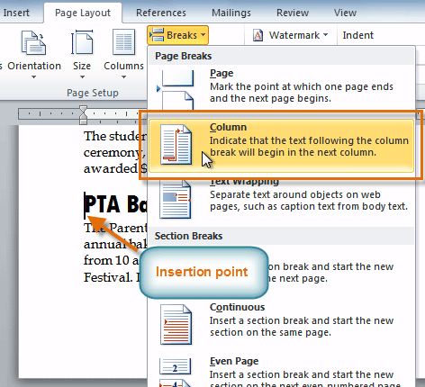

1. The text will shift to reflect the column break.



# To delete column breaks

1. To show column break marks in the document, please click **Home** > **Show/Hide Editing Marks** as shown in the below screenshot.

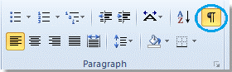

2. Select the column break that you want to remove

http://www.extendoffice.com/images/stories/doc-word/dot-column-break.png

3. Press the **Delete** key on your keyboard.

Hold “**Ctrl**” key to select all column breaks one by one, and press Delete key. But selecting column breaks one by one is arduous and painful if the document covers more than 200 pages.

**Remove all column breaks with the Find and Replace**

1. Click **Home** > **Replace** to enable this utility.

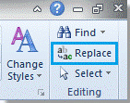

2. Click **More>>**button to show more options. See diagram:

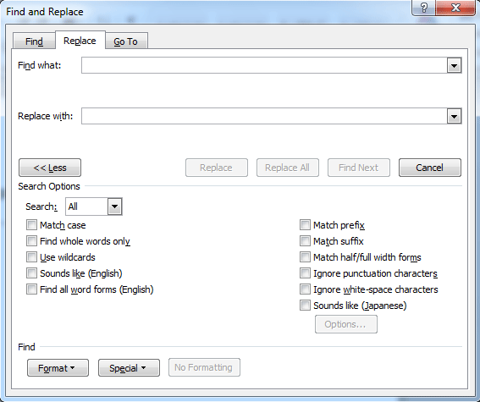

3. Place the cursor in the**Find What** field, and select the **Column Break** from the **Special** pull-down menu.

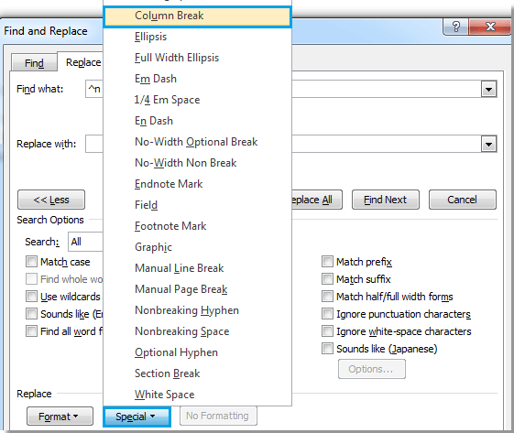

4. There will be a “**^n**” character in the**Find What** field, and click **Replace All**.

### Activity 3

1. Open an **existing Word document**.
2. Select the **text** you want to format into columns.
3. Format the selected text into **two columns**.
4. Adjust **column length**
5. **Add** a **column break**.
6. **Delete** a **column break**

## Lesson 5 – Format a column in a document

One can insert headings, text boxes and link two text boxes when using columns in Microsoft word 2010.

# Inserting a heading

If you want a heading to span all of your columns, you need only leave it in the single-column section before your multicolumn section. If there isn't a single-column section there already, you'll need to create one. This is easily done by selecting the heading paragraph, clicking on the **Columns** button on the Page Layout tab, and selecting 1 column; Word will then create the necessary section breaks for you.

But what if you want a heading to span just some of the columns? In a four-panel brochure, for example, suppose you want text to span two of the four panels. Once you have four columns, you can’t re-divide just part of the page into two or three columns. You will therefore need to put your heading text into a text box or frame and position it as needed (the problems of positioning text boxes and frames could provide material for another article, so I won’t go into that here).

Whether you use a frame or a text box, it will have a border by default. Remove this as follows:

* Remove a border from a frame using the **Borders and Shading**dialog. Access this dialog by clicking the arrow beside the border button in the **Paragraph** group on the **Home** tab. In the dialog, choose **None**. Alternatively, choose **No Border** from the  **Home | Paragraph** tab.
* Remove the border from a text box- selecting a text box will display the contextual **Text Box Tools Format** tab; in the **Text Box Styles** group, click **Shape Outline** and choose No Outline.

If you use a frame, it doesn’t seem to matter whether you set wrapping to None or Around. For a text box, the default wrapping style in many versions is None of In front of Text, which will not work (nor will through). Any other wrapping style seems to be satisfactory. You will need to experiment with the other layout options to find which ones work best for your situation.

You may want to wait till you’re fairly far along in entering text before you insert a text box or frame because the effect of doing this is to reduce the text boundaries to the amount of text you have entered (instead of showing the four rectangles you saw when you first created the columns). This can be rather disconcerting.

OR

* Type heading normally
* Place the insertion line just below the heading
* From Page layout tab, choose Columns. Columns dialog box will open.
* Choose number of columns in dialog box (3 in this example)
* Choose “This point forward” in Apply to drop down list
* Click OK to close the dialog box
* Now, start typing the text for columns.

Heading is on single column layout and the body text in 3 columns.

# Adding a textbox inside a column

Columns are a wonderful feature in Microsoft Word 2010, and so is the use of text boxes. Combining these two features gives the user the flexibility to create professional-looking documents in a style that meets their individual needs. The best part about using these two features in tandem is how simple it is to do it.

**Instructions**

1. Open Microsoft Word 2010.
2. Create your columns. Click the "Page Layout" tab. Select the down-arrow next to "Columns" in the "Page Setup" group. Select the column format you want to use.
3. Insert the text box. Click the "Insert" tab. Place the cursor at the location you want to insert the text box. Click the "Text Box" icon. A drop-down menu will appear. Select the type of text box you want to insert.
4. Configure the text box. Place your mouse pointer over the outer edge of the text box until you see the four-arrowed cursor appear. Right-click it. A drop-down menu will appear. Select the "Format Text Box..." option. Click the "Layout" tab. Select the Wrapping Style you prefer, and your Horizontal Alignment preference.
5. Click the "OK" button.

# Linking textboxes between different columns

When you want text to flow through a document but not placed neatly in snaking columns and perhaps with other text interspersed with it, linked text boxes are a good choice. To create these,

1. Choose Insert, Text Box and drag to create a text box on the page.
2. Type the text into the text box. If there is too much text to fit in the text box click Insert, Text Box and draw a second textbox. It doesn't matter where in the document you do this, except that the second text box should appear after the first.
3. To link the two text boxes ensure the Text Box toolbar is visible and, if not, choose View, Toolbars, Text Box to display it.
4. Click on the first text box and click the Create Text Box link button on the Text Box toolbar.
5. Now click in the middle of the second text box to link the two. Overflow text now flows from one text box to fill the other.

### Activity 4

1. Open an **existing Word document**.
2. Add a heading above **column break** and **inside column** to a column
3. Add 2 **text boxes** to two columns
4. **Link text boxes** between 2 different columns
5. Save