Name
Contact Address
Telephone (H)
Telephone (W)
Facsimile
Cellular
USING A GRAPHICAL USER INTERFACE (GUI)-BASED SPREADSHEET APPLICATION, ENHANCE THE FUNCTIONALITY AND APPLY GRAPH /CHARTS TO A SPREADSHEET
UNIT STANDARD ID: 116943
NQF LEVEL: 4, CREDITS: 3
NOTIONAL HOURS: 30

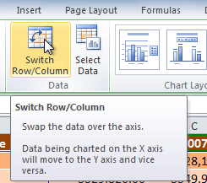
LEARNER GUIDE

UNIT STANDARD 116943 :
Using a Graphical User Interface (GUI)-based spreadsheet application, enhance the functionality and apply graph /charts to a spreadsheet
  SPECIFIC OUTCOME 1
  Create and edit a graph.
  OUTCOME RANGE
  Graph refers to all types of graphs and/or charts.
  ASSESSMENT CRITERION 1
  The major graph types are defined in terms of their purpose.
  ASSESSMENT CRITERION RANGE
  At least 3 of: Pie, Bar, Column, Line, Scatter, Area.
  ASSESSMENT CRITERION 2
  A graph is created from a given data source.
  ASSESSMENT CRITERION RANGE
  At least 2 of: Pie, Bar, Column, Line, Scatter, Area.
  ASSESSMENT CRITERION 3
  A graph is edited.
  ASSESSMENT CRITERION RANGE
  At least 3 of: Graph title, axis titles, data labels, background colour, line or bar colour.
  ASSESSMENT CRITERION 4
  The graph type is changed.
  ASSESSMENT CRITERION 5
  A graph is copied and moved based on given specifications.
  ASSESSMENT CRITERION RANGE
  Within a worksheet, to a different worksheet, to a different spreadsheet file.
  ASSESSMENT CRITERION 6
  A graph is resized.
  ASSESSMENT CRITERION 7
  A graph is deleted from a spreadsheet.
  SPECIFIC OUTCOME 2
  Load data from an external data source to produce a given spreadsheet result.
  ASSESSMENT CRITERION 1
  The external data file is checked to ensure that the input into a spreadsheet will achieve the required results.
  ASSESSMENT CRITERION 2
  The format of the input file is determined to ensure correct input into a spreadsheet.
  ASSESSMENT CRITERION RANGE
  Tables from another source.
  ASSESSMENT CRITERION 3
  The data is copied into the spreadsheet.
  ASSESSMENT CRITERION 4
  The resulting spreadsheet is in accordance with the given spreadsheet result.
  SPECIFIC OUTCOME 3
  Insert and edit objects into a spreadsheet.
  OUTCOME RANGE
  Any 2 of the following objects: pictures, images, charts, auto-shapes.
  ASSESSMENT CRITERION 1
  An object is inserted into a spreadsheet.
  ASSESSMENT CRITERION RANGE
  At least 2 of the following: picture, image, chart, autoshape.
  ASSESSMENT CRITERION 2
  A selected object is manipulated in a spreadsheet.
  ASSESSMENT CRITERION RANGE
  At least 2 of the following: move, copy, resize.
  ASSESSMENT CRITERION 3
  Use a drawing tool to draw an object in the spreadsheet.

Table of Contents
Introduction to graphs and charts 6
Lesson 1 – Types of graphs 6
Activity 1 11
Lesson 2 - Working with Charts 12
Identifying the Parts of a Chart 12
Creating a Chart 14
Chart Tools 16
To Change the Chart Style 24
Moving a chart 25
Resize a chart 26
Deleting a graph 28
Activity 2 28
Lesson 3 – Importing data from an external source 29
Activity 3 32
Lesson 4 – Insert and edit objects 33
Inserting an object 33
To copy and paste an object 36
To Cut and Paste an object 36
To resize an object 36
Drawing an object in a spreadsheet 37
Activity 4 40

Introduction to graphs and charts
Excel 2010 allows users to create and edit graphs. In computer science, a graph is an abstract data type that is meant to implement the graph and hypergraph concepts from mathematics. (Wikipedia)

A graph data structure consists of a finite (and possibly mutable) set of ordered pairs, called edges or arcs, of certain entities called nodes or vertices. As in mathematics, an edge (x, y) is said to point or go from x to y. The nodes may be part of the graph structure, or may be external entities represented by integer indices or references.

A graph data structure may also associate to each edge some edge value, such as a symbolic label or a numeric attribute (cost, capacity, length, etc.).

Lesson 1 – Types of graphs

There are a number of graphs in use, but for the purpose of this course we shall limit ourselves to the following;
- Pie charts
- Bar graphs
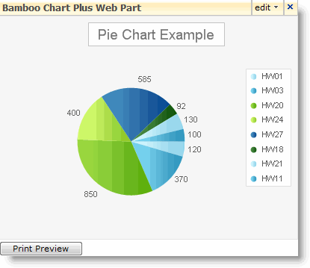
- Line
- Scatter graphs
- Area graphs

Let’s look at each graph one by one;

1. Pie chart

The pie chart is actually a very clever visual design that conveys one fact above all others with a minimum of visual cues: that the circle (the “pie”) represents some kind of whole, which is made up of the slices. Add up all the slices and you get the complete pie. Take out one slice, and the whole will be missing exactly this part. Enlarge one part, and other parts will need to shrink.
What this means is that the pie chart first and foremost represents the size relationship between the parts and the entire thing. If a company has five divisions, and the pie chart shows profits per division, the sum of all the slices/divisions is the total profits of the company.
If the parts do not sum up to a meaningful whole, they cannot be represented in a pie chart, period. It makes no sense to show five different occupations in a pie chart, because there are obviously many missing. The total of such a subsample is not meaningful, and neither is the comparison of each individual value to the artificial whole.
When to use a pie chart
There are some simple criteria that you can use to determine whether a pie chart is the right choice for your data.
- Do the parts make up a meaningful whole? If not, use a different chart. Only use a pie chart if you can define the entire set in a way that makes sense to the viewer.
- Are the parts mutually exclusive? If there is overlap between the parts, use a different chart.
- Do you want to compare the parts to each other or the parts to the whole? If the main purpose is to compare between the parts, use a different chart. The main purpose of the pie chart is to show part-whole relationships.
- How many parts do you have? If there are more than five to seven, use a different chart. Pie charts with lots of slices (or slices of very different size) are hard to read.
2. Bar graph
Bar graphs are suitable when we want to compare quantities in different categories. Bar graphs use spaces between the bars to distinguish the categories. The heights of the bars across the vertical (or occasionally, horizontal) axis allow us to compare the value of the categories. These values may represent frequencies, sums, averages, or even percentages. Example: The heights of the bars in the example below allow us to compare rainfall amounts, in centimeters

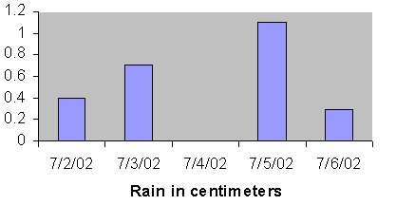
3. Line graph

A Line Chart compares two typically numerical aspects of a single object. For example, a marketing department may plot the change in the amount of money the company has over time.
- The Line Chart consists of an x-axis, which is horizontal, and a y-axis, which is vertical. Most Line Charts only deal with positive number values, so these axes typically intersect near the bottom of the y-axis and the left end of the x-axis.
- The point at which the axes intersect is always (0, 0).
- Each axis is labelled with a data type. To carry the example from before, the x-axis would be a unit of time (this could be days, weeks, quarters, years, and so on) and the y-axis would be the amount of money in dollars (or thousands of dollars, and so on).
- There would be a corresponding set of data. For example, on week 1, the company had ten thousand dollars. Then a point would be plotted over the "Week 1" part of the x-axis and next to the "R10, 000" part of the y-axis. After all points are plotted in this same manner, they are connected by a line in a "dot-to-dot" fashion.
- The x-axis is also called the independent axis because its values do not depend on anything. For example, time is always placed on the x-axis since it continues to move forward regardless of anything else.
- The y-axis is also called the dependent axis because its values depend on those of the x-axis: at this time, the company had this much money.
- The result is that the line of the chart always progresses in a horizontal fashion and each x values only has one y value (the company cannot have two amounts of money at the same time).

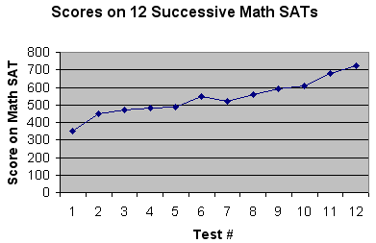

4. Scatter graphs
Scatter plots are similar to line graphs in that they use horizontal and vertical axes to plot data points. However, they have a very specific purpose. Scatter plots show how much one variable is affected by another. The relationship between two variables is called their correlation. Scatter plots usually consist of a large body of data. The closer the data points come when plotted to making a straight line, the higher the correlation between the two variables, or the stronger the relationship.
If the data points make a straight line going from the origin out to high x- and y-values, then the variables are said to have a positive correlation. If the line goes from a high-value on the y-axis down to a high-value on the x-axis, the variables have a negative correlation.
When to use it:
- Use a scatter diagram to examine theories about cause-and-effect relationships and to search for root causes of an identified problem.
- Use a scatter diagram to design a control system to ensure that gains from quality improvement efforts are maintained.

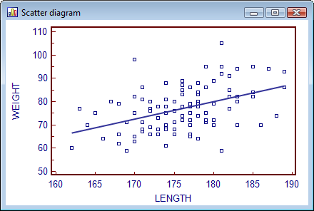

5. Area graph
Area Graphs combine the features of Line Graphs and Stacked Bar Graphs by coloring the areas underneath each line. These area segments are stacked on top of each other, as in a Stacked Bar graph, so that the total size of the area at each category reflects the cumulative value of all data items in that category. Each data series in the graph corresponds to a colored segment of the total area. The first series is always the top area segment.

The example below shows how Area graphs work.
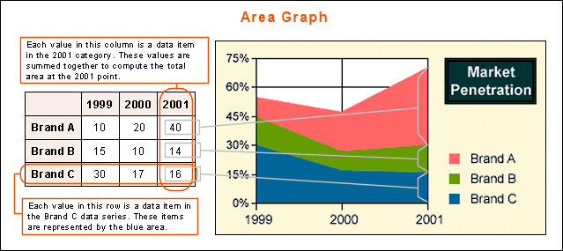

Activity 1
- What is a graph?
- Give 4 examples of graphs and explain their purposes.

Lesson 2 - Working with Charts

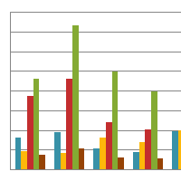
A chart is a tool you can use in Excel to communicate your data graphically. Charts allow the audience to see the meaning behind the numbers in the spreadsheet, and they make showing comparisons and trends a lot easier. In this lesson, you will learn how to insert and modify excel charts and see how they can be an effective tool for communicating information.

Identifying the Parts of a Chart
Have you ever read something you didn't fully understand but when you saw a chart or graph, the concept became clear and understandable? Charts are a visual representation of data in a worksheet. Charts make it easy to see comparisons, patterns, and trends in the data.
The typical chart (or graph) in Excel 2010 comprises several distinct parts, including the chart area, data series, axes, legend, plot area, gridlines, data markers, and more. The following list summarizes the parts of a typical Excel chart, some of which appear in the illustration.
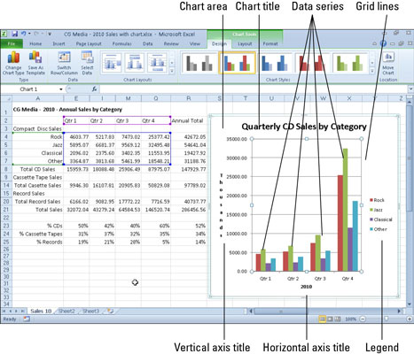
- Chart area: Everything inside the chart window, including all parts of the chart (labels, axes, data markers, tick marks, and other elements listed here).
- Data marker: A symbol on the chart that represents a single value in the worksheet. A data marker (or data point) may be a bar in a bar chart, a pie in a pie chart, or a line on a line chart. Data markers with the same shape or pattern represent a single data series in the chart.
- Data series: A group of related values, such as all the values in a single row in the chart. A chart can have just one data series (shown in a single bar or line), but it usually has several.
- Axis: A line that serves as a major reference for plotting data in a chart. In two-dimensional charts there are two axes- the x-axis (horizontal/category) and the y-axis (vertical/value). In most two-dimensional charts (except bar charts), Excel plots categories (labels) along the x-axis and values (numbers) along the y-axis. Bar charts reverse the scheme, plotting values along the x-axis. Pie charts have no axes. Three-dimensional charts have an x-axis, a y-axis, and a z-axis. The x- and y-axes delineate the horizontal surface of the chart. The z-axis is the vertical axis, showing the depth of the third dimension in the chart.
- Tick mark: A small line intersecting an axis. A tick mark indicates a category, scale, or chart data series. A tick mark can have a label attached.
- Plot area: The area where Excel plots your data, including the axes and all markers that represent data points.
- Gridlines: Optional lines extending from the tick marks across the plot area, thus making it easier to view the data values represented by the tick marks.
- Chart text: A label or title that you add to the chart. Attached text is a title or label linked to an axis such as the Chart Title, Vertical Axis Title, and Horizontal Axis Title that you can't move independently of the chart. Unattached text is text that you add with the Text Box command button on the Insert tab of the Ribbon.
- Legend: A key that identifies patterns, colours, or symbols associated with the markers of a chart data series. The legend shows the data series name corresponding to each data marker such as the name of the blue columns in a column chart.

Creating a Chart
Charts can be a useful way to communicate data. When you insert a chart in Excel, it appears in the selected worksheet with the source data, by default.

To Create a Chart:
- Select the cells that you want to chart, including the column titles and the row labels. These cells will be the source data for the chart.
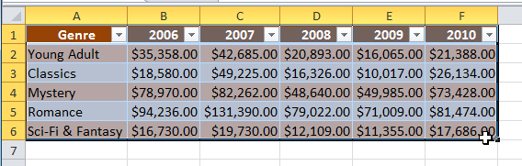
- Click the Insert tab.
- In the Charts group, select the desired chart category (Column, for example).
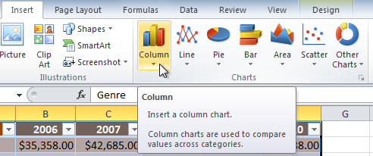

- Select the desired chart type from the drop-down menu (Clustered Column, for example).
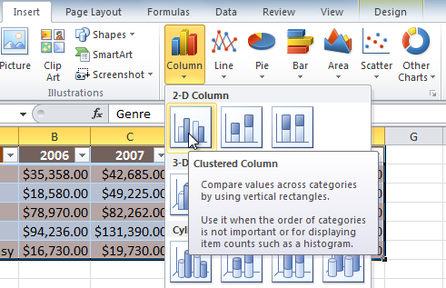
- The chart will appear in the worksheet.

How to create a pie chart
- Select the data that you want to display in the Pie of Pie or Bar of Pie chart.
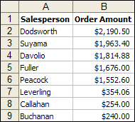
- On the Insert tab, in the Charts group, do one of the following:
  - Click the pie chart, and then under chart subtype click Pie of Pie or Bar of Pie
  - To see all available chart types, click to launch the Insert Chart dialog box, and then click the arrows to scroll through the chart types.

For a quick preview of the chart you are creating, click Press and Hold to View Sample.
- Click Next, and continue with Steps 2 through 4 of the Chart Wizard.

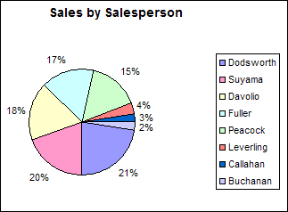

Chart Tools
Once you insert a chart, a set of Chart Tools, arranged into three tabs, will appear on the Ribbon. These are only visible when the chart is selected. You can use these three tabs to modify your chart.
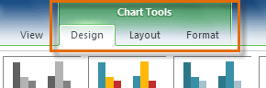
To Change the Chart Type:
- From the Design tab, click the Change Chart Type command. A dialog box appears.
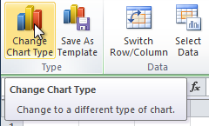
- Select the desired chart type and click OK.
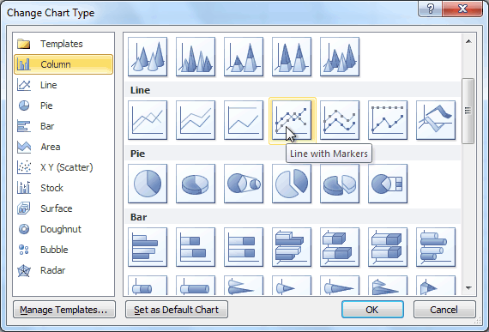
To Switch Row and Column Data:
Sometimes when you create a chart, the data may not be grouped the way you want it to be. In the clustered column chart below, the Book Sales statistics are grouped by Fiction/Non-Fiction, with a column for each year. However, you can also switch the row and column data so that the chart will group the statistics by year, with columns for Fiction and Non-Fiction. In both cases, the chart contains the same data; it's just organized differently.
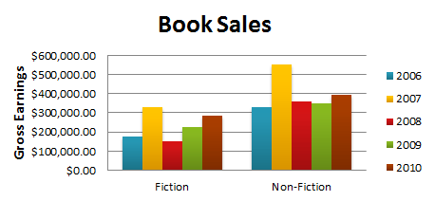
- Select the chart.
- From the Design tab, select the Switch Row/Column command.
- The chart will then readjust.
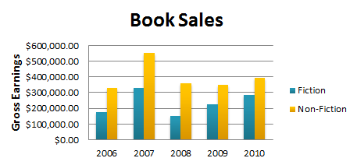
To Change the Chart Layout:
- Select the Design tab.
- Click the More drop-down arrow in the Chart Layouts group to see all of the available layouts.
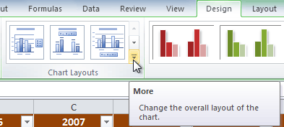
- Select the desired layout.
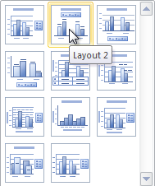
- The chart will update to reflect the new layout.
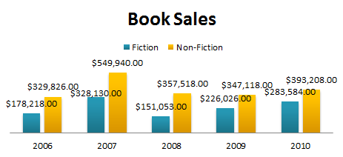
Some layouts include chart titles, axes, or legend labels. To change them, just place the insertion point in the text and begin typing.
To change the scale of the vertical (value) axis in a chart
- In a chart, click the value axis that you want to change, or do the following to select the axis from a list of chart elements:
  - Click anywhere in the chart.
This displays the Chart Tools, adding the Design, Layout, and Format tabs.
- On the Format tab, in the Current Selection group, click the arrow next to the Chart Elements box, and then click Vertical (Value) Axis.
- On the Format tab, in the Current Selection group, click Format Selection.
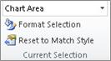
- In the Format Axis dialog box, click Axis Options, and then do one or more of the following:
Important The following scaling options are available only when a value axis is selected.
- To change the number at which the vertical (value) axis starts or ends, for the Minimum or Maximum option, click Fixed and then type a different number in the Minimum box or the Maximum box.
- To change the interval of tick marks and chart gridlines, for the Major unit or Minor unit option, click Fixed and then type a different number in the Major unit box or Minor unit box.
- To reverse the order of the values, select the Values in reverse order check box.
How to Change the Chart Title
To change the title of your chart, click on the title to select it:
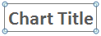
The circles surrounding the title tell you that it is selected. Once the title is selected, click on the letter "C" of Chart. Hold your left mouse button down and highlight the two words, as in the image below:
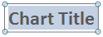
Once your title is highlighted, you can change it by simply typing a new one:
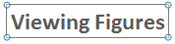
While the title is highlighted, you can select a different font and font size, if you want (on the Home panel in the Excel Ribbon at the top.)
To change the Chart Background
Format the background of a chart by showing or hiding the chart wall or floor with a default color fill, or by changing the 3-D view of a chart. The plot area is bounded by the axes, which includes all data series. The chart wall is the background, and the chart floor is the bottom in a 3-D chart. The 3-D view allows you to change the rotation of a 3-D chart using the x-, y-, or z-axis, and apply a 3-D perspective to the chart.
Change the Chart Background
- Select the chart element you want to modify.
- Click the Layout tab under Chart Tools.
- Click any of the following buttons:
- Plot Area to show or hide the plot area.
- Chart Wall to show or hide the chart wall with the default color fill.
- Chart Floor to show or hide the chart floor with the default color fill.
- 3-D Rotation to change the 3-D viewpoint of the chart.
In the Format Chart Area dialog box, click 3-D Rotation or 3-D Format in the left pane, select the 3-D options you want, and then click Close.
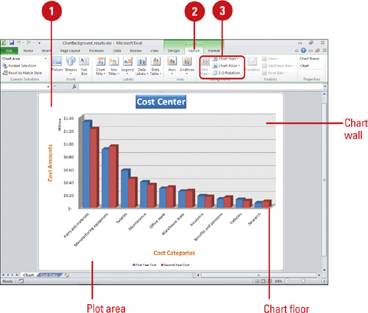
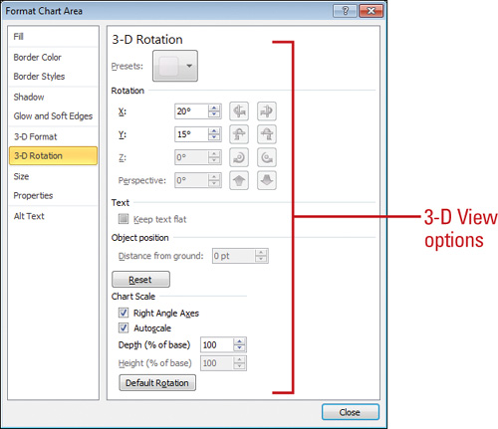
Enhancing a Chart
If you want to further enhance a chart, you can insert a picture, shape or text annotation to add visual appeal. In the same way you insert a picture, shape, or text box into a worksheet, you can insert them into a chart. The Picture, Shapes, and Text Box button are available on the Layout tab under Chart Tools.
Insert a Picture, Shape, or Text
- Select the chart element you want to modify.
- Click the Layout tab under Chart Tools.
- Use any of the following:
- Picture. Click the Picture button, select a picture, and then click Insert.
- Shapes. Click the Shapes button, click a shape, and then drag to draw the shape.
- Text Box. Click the Text Box button, drag to create a text box, and then type the text you want.
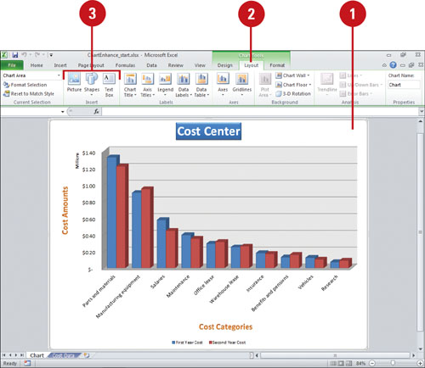
- Use the Format tab under Drawing Tools to format the shape or text box.
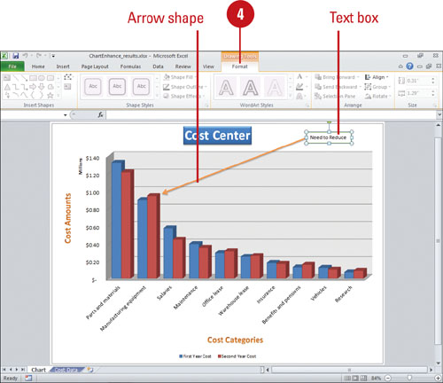

You can edit shape text. Right-click the shape or text object, click Edit Text, modify the text, and then click outside the object to deselect it.

To Change the Chart Style
- Select the Design tab.
- Click the More drop-down arrow in the Chart Styles group to see all of the available styles.
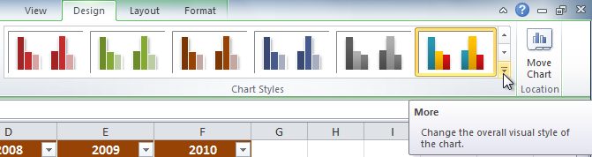
- Select the desired style.
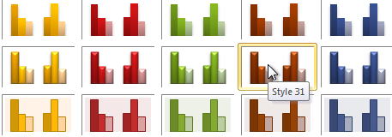
- The chart will update to reflect the new style.
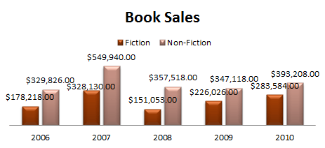

Moving a chart
You can move a chart to any location on a worksheet or to a new or existing worksheet. You can also change the size of the chart for a better fit.
Move a chart within a worksheet
- Select a chart you want to move.
- Position the mouse pointer over a blank area of the chart, and then drag the pointer to move the outline of the chart to a new location.
- Release the mouse button
To Move the Chart to a Different Worksheet
- Select the Design tab.
- Click the Move Chart command. A dialog box appears. The current location of the chart is selected.
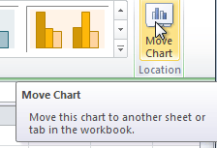
- Select the desired location for the chart that is, choose an existing worksheet, or select New Sheet and name it.
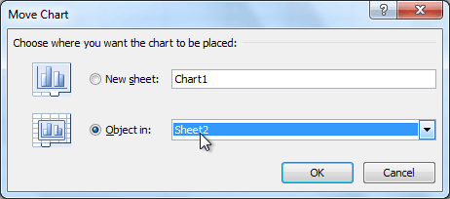
- Click OK. The chart will appear in the new location.

Resize a chart
- Select a chart you want to resize.
- Position the mouse pointer over one of the handles.
- Drag the handle to the new chart size.
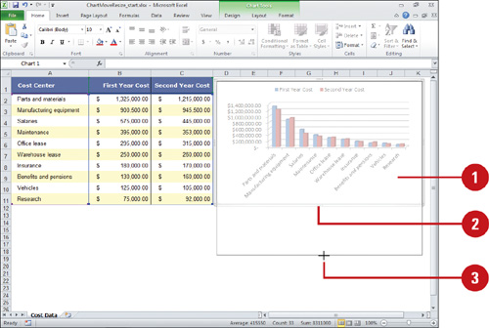
- Release the mouse button.
OR
To resize a chart, do one of the following:
- Click the chart, and then drag the sizing handles to the size that you want.
- On the Format tab, in the Size group, enter the size in the Shape Height and Shape Width box.
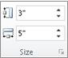
Tip For more sizing options, on the Format tab, in the Size group, click to launch the Format Chart Area dialog box. On the Size tab, you can select options to size, rotate, or scale the chart. On the Properties tab, you can specify how you want the chart to move or size with the cells on the worksheet.

Deleting a graph
Click the chart object. Then press Delete.

Activity 2
Use the Company Sales workbook or any other workbook to complete this challenge.
- Use worksheet data to create a bar and pie and line chart.
- Edit the Graph title, axis titles, data labels and background colour
- Change the bar chart to a column chart.
- Move the bar chart to a different worksheet
- Move the pie chart to a different spreadsheet file
- Resize the column chart
- Delete the line chart
- Apply a chart style.
- Move the chart to a separate worksheet.
- Save your spreadsheet

Lesson 3 – Importing data from an external source

If you have data from an alternative source, you may be able to import it into Excel 2010 instead of having to re-enter all the information again. Depending on the type of data you would like to import, you can select from a number of options. We will look at one of the most common import types- a text file. You can import tables from Word (.txt file) or Access.
Note
- The source data is called internal data source if it is located in files or folders in your own personal computer.
- Before importing data, check the external data file to ensure that the input into a spreadsheet will achieve the required results
How to import data from external source
- Open the worksheet you would like to import the data to and select the cell where you would like to data import to start.
- Click the Data tab and choose from the options in the Get External Data group.
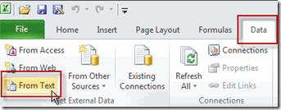
- Click From Text. This will allow text file types such as prn, txt and csv to be imported.
- Browse to find the file you would like to import, select it and click Import.
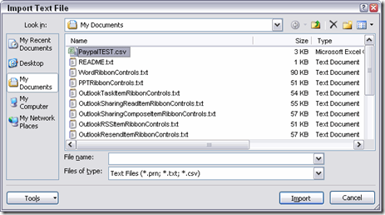
- The Text Import Wizard appears to guide you through the process of importing your data.
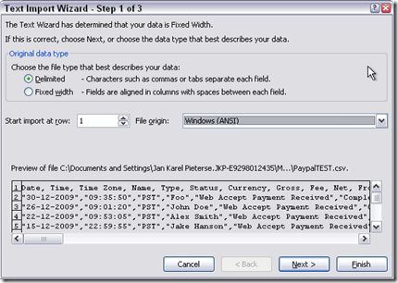
- ﻿Select Delimited if the text contains a character such as a comma, tab, space or semi-colon to separate the various fields. Otherwise select Fixed Width if there are a certain number of spaces between each field.
- A preview of the file is displayed below. If you would like to start the import at a row other than 1, enter the selected row number in the Start import at row field.
- Click Next.
- Select type of character that separates the various fields. You can select as many as are applicable. If you would like to include your own characters that aren’t listed, select the Other checkbox and enter the specific character in the field provided.
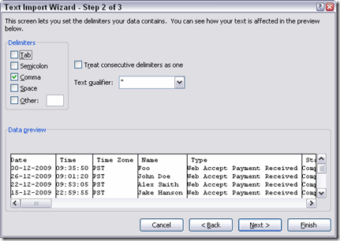
NOTE: If you have some fields where the selected delimiter appears several times in a row, you should select the Treat consecutive delimiters as one checkbox. This ensures that you won’t have several blank fields where only the delimiter character was found.
- A preview of the data in columns appears below, according to the delimiter selected. Click Next.
- You now need to choose the format for each of the columns. Select the column heading in the Data preview and then select a data type from the Column data format options.
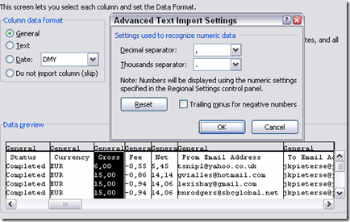
NOTE: If there are some columns that you don’t want to have included in the text to columns conversion, select the Do not import column (skip) option for the data type of those specific columns.
- Once you have selected the data type for each column, click Finish.
- Select where you would like the imported data to be in the workbook and click OK.
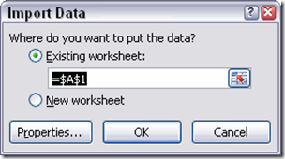
- Your imported data will now appear in your selected worksheet.
Results after importing the text file
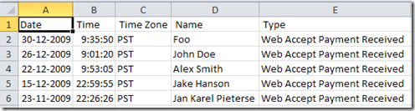

Activity 3

Import data from Microsoft word and insert it in a worksheet. The data must be in the form of a table. Before importing check if the data is compatible with excel.

Lesson 4 – Insert and edit objects

You can insert or copy pictures and clip art into an Excel worksheet or a PowerPoint presentation from many different sources, including downloading from a clip art Web site provider, copying from a Web page, or inserting from a folder where you save pictures. You can also use pictures and clip art as backgrounds for your slides in PowerPoint. In this lesson you will learn how to insert and edit objects like;
- Pictures
- Images
- Charts and
- Auto shapes

Inserting an object
Insert clip art
- Open the spreadsheet that you want to add clip art to.
- On the Insert tab, in the Illustrations group, click Clip Art.
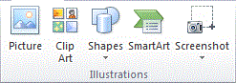
- In the Clip Art task pane, in the Search for text box, type a word or phrase that describes the clip art that you want, or type all or some of the file name of the clip art.
To narrow your search, in the Results should be list, select the check boxes next to Illustrations, Photographs, Videos, and Audio to search those media types.
- Click Go.
- In the list of results, click the clip art to insert it.
Insert a picture from a file
- Click where you want to insert the picture.
- On the Insert tab, in the Illustrations group, click Picture.
- Locate the picture that you want to insert, and then double-click it. For example, you might have a picture file located in My Documents.
To add multiple pictures, press and hold CTRL while you click the pictures that you want to insert, and then click Insert.
- To resize a picture, select the picture you have inserted in the spreadsheet. To increase or decrease the size in one or more directions, drag a sizing handle away from or toward the center, while you do one of the following:
  - To keep the center of an object in the same location, press and hold CTRL while you drag the sizing handle.
  - To maintain the object's proportions, press and hold SHIFT while you drag the sizing handle.
  - To both maintain the object's proportions and keep its center in the same location, press and hold both CTRL and SHIFT while you drag the sizing handle.
Note
- To insert a picture from your scanner or camera, use the scanner or camera software to transfer the picture to your computer. Save the picture, and then insert it by following the instructions above.

- Adding pictures can significantly increase the file size of your workbook. You can control this file size by making choices about the resolution of a picture and the quality or compression of a picture.
- If you insert a picture using the Link to File or Insert and Link options, make changes such as adding artistic effects, select the Discard editing data under Image Size and Quality options (under Options, Advanced tab) and then save the file, when you reopen the file, you will see the original picture. This occurs because the picture editing data has been deleted. To keep both the link and the edits, do not select the Discard editing data check box.
Link to File adds a link to the picture and that is the only source for the picture. If you open the workbook without access to the file location you will see a red X instead of your picture. Insert and Link links to the picture, but also adds a copy to the file. If you open the workbook without access to the file location you see the embedded picture.
Insert an autoshape to your spreadsheet
- On the Insert tab, in the Illustrations group, click Shapes.
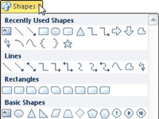
- Click the shape that you want, click anywhere in the workbook, and then drag to place the shape.
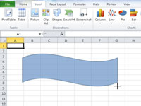
- Release the mouse button.
The shape appears in the worksheet

To copy and paste an object
- Select the object you wish to copy.
- Click the Copy command.
- Select the cell or cells where you want to paste the content.
- Click the Paste command. The copied object will be entered into the highlighted cells.

To Cut and Paste an object
- Select the object you wish to cut.
- Click the Cut command.
- Select the cells where you want to paste the object
- Click the Paste command. The cut object will be removed from the original cells and entered into the highlighted cells.

To resize an object
Step 1: Select the object for example, a picture in active worksheet.
Step 2: Right click the selected picture, and select the Format Object item in the context menu.
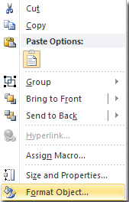
Step 3: Format Picture dialog box pops up, click the Size category in the left bar.
Step 4: Now enter the height and width under the Size section. See the following screenshot:
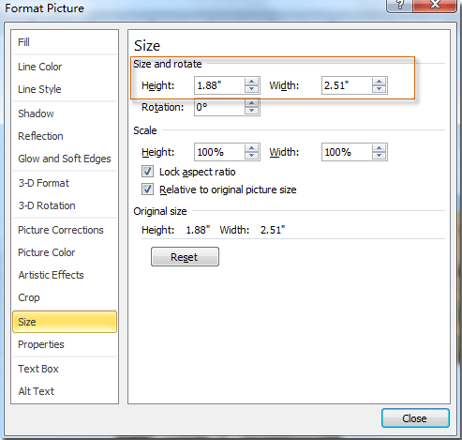
Step 4: Click OK. Now the picture in active worksheet is resized.

Drawing an object in a spreadsheet
To draw a shape on your spreadsheet, do the following;
- From the Excel Ribbon, click on Insert
- Locate the Shapes panel:
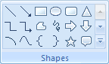
- On the Shapes panel, click the drop down arrow to see all the available shapes:
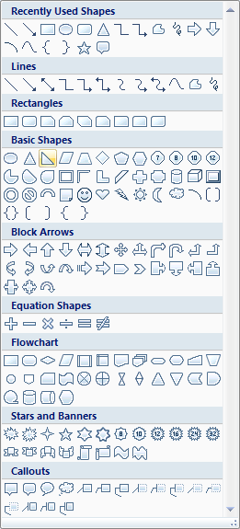
- Under Basic Shapes, select the Right Triangle
- Hold down your left mouse button on your spreadsheet, and drag to create your shape. Let go when you have a decent sized triangle. You will see something like this:
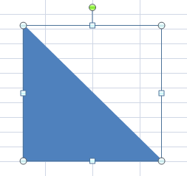
- Hold your mouse down on the green circle, and drag to rotate your triangle:
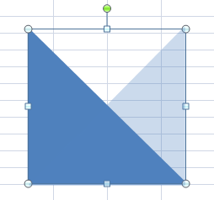
- You should see an outline, like the one above. Let go of your left mouse button when it is in position:
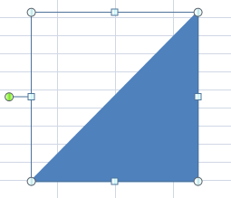
As you can see, the green circle is now on the left hand side.

If you look on the Excel Ribbon at the top, you will notice that it has changed - a Format tab has appeared. You will see all the various options for shapes.
- Locate Shape Fill on the Shape Styles panel, and click to see the Fill options:
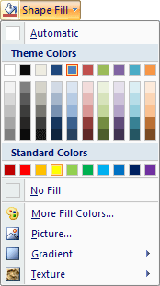
- Select a colour for your triangle. You will also want to select a Shape Outline, underneath Shape Fill. Select the same colour as your Fill, and your triangle will look something like this one:
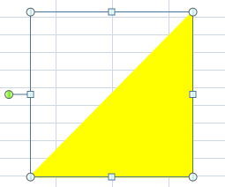

Activity 4
- Insert pictures from clipart into excel spreadsheet
- Insert images from my pictures into a worksheet.
- Copy and insert a picture from the internet into a worksheet.
- Insert an autoshape into a worksheet.
- Change the size of the pictures, images and autoshapes.
- Use the drawing tool to draw an object in your spreadsheet
- Save

