**USE A GUI-BASED WORD PROCESSOR TO CREATE MERGED DOCUMENTS**

**UNIT STANDARD ID: 116942**

**NQF LEVEL:** 3

**CREDITS: 3**

**NOTIONAL HOURS: 30**

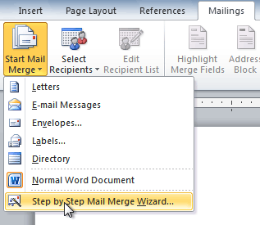

**LEARNER GUIDE**

|  |  |
| --- | --- |
| **Name** |  |
| **Contact Address** |  |
| **Telephone (H)** |  |
| **Telephone (W)** |  |
| **Facsimile** |  |
| **Cellular** |  |

|  |  |  |  |
| --- | --- | --- | --- |
| **UNIT STANDARD 116942 :**  Use a GUI-based word processor to create merged documents | | | |
| |  | | --- | | **SPECIFIC OUTCOME 1** |  |  | | --- | | Describe the uses of merged documents. | | |  | | --- | | **ASSESSMENT CRITERION 1** |  |  | | --- | | Merging of documents is described in terms of its usage. |  |  | | --- | | **ASSESSMENT CRITERION RANGE** |  |  | | --- | | Main document, data source, merged document. |  |  | | --- | | **ASSESSMENT CRITERION 2** |  |  | | --- | | Applications for merged documents are described in term of their benefits. |  |  | | --- | | **ASSESSMENT CRITERION RANGE** |  |  | | --- | | Benefits include but are not limited to at least three of:  • Mass-producing letters, mass-producing labels, mass-producing forms, mass-producing contracts, creating a catalogue. | |  |  |
| |  | | --- | | **SPECIFIC OUTCOME 2** |  |  | | --- | | Create a merged document. | | |  | | --- | | **ASSESSMENT CRITERION 1** |  |  | | --- | | A data source is created and saved that will be merged with various documents. |  |  | | --- | | **ASSESSMENT CRITERION RANGE** |  |  | | --- | | Data source to contain at least 5 fields and 5 records. |  |  | | --- | | **ASSESSMENT CRITERION 2** |  |  | | --- | | Documents that suitable for merging with data sources (referred to as main documents) are identified and created with given reasons for suitability. |  |  | | --- | | **ASSESSMENT CRITERION RANGE** |  |  | | --- | | Main document to have: at least 4 of fields of the data source, one field to appear more than once. |  |  | | --- | | **ASSESSMENT CRITERION 3** |  |  | | --- | | A merged document is created and saved thru the use of the merge function of a word processing application. |  |  | | --- | | **ASSESSMENT CRITERION RANGE** |  |  | | --- | | At least two of: letters, labels, forms, envelopes using an existing data source within a word processor, using an external database. |  |  | | --- | | **ASSESSMENT CRITERION 4** |  |  | | --- | | Edit a data source and re-produce a merged document to prove the purpose of document merging. |  |  | | --- | | **ASSESSMENT CRITERION RANGE** |  |  | | --- | | Add record, delete record, sort record, and change record. | |  |  |

Table of Contents

Introduction 2

Lesson 1- Concept of merging documents 3

Activity 1 3

Lesson 2- Benefits of merging documents 4

Lesson 3 – Merging process 5

1. Merging documents 5

2. Mail merge 8

Editing data source 16

Activity 2 16

# Introduction

While working on documents using Microsoft Office Word 2010, sometimes users may need to combine and merge a number of separate documents into one single document. Let’s look at some of the examples where merging is useful.

**Example 1**

When one is writing a manual and he/she saves each chapter as individual documents, creating lots of document files for a single training manual. When the novel is finished and completed, the author may wish to combine and merge all separate documents into one single document in order to create table of contents and indexes for the whole manual in one go.

**Example 2**

In any working environment, there are situations when a similar type of letter or document is to be sent to many persons who reside at different locations. The letters may contain the address of each recipient, in addition to the standard information contained in the letter. One way of doing this is to print the letters by changing the address each time in the document after printing such letter. But this would mean lot of effort and time and also results in bad organisation.

## Lesson 1- Concept of merging documents

In word processing, merging documents is the process of transferring selected information from one document to another document. In essence, merging documents is a useful tool that will allow you to easily produce multiple letters, labels, envelopes and more using information stored in a list, database, or spreadsheet.

**Concept of merging documents and its components**

Merging documents is the facility which requires the following information

* Main document
* Data source
* Merged document

Merge option of Word reads this data and physically merges it with Main document to generate other useful documents.

1. **Main Document:**  the main document is the common document, which contains the common information for each of the merged document. It also contains the field names, which contain the instructions for carrying out the merge.
2. **Data Source:** Data Source is also called the Data File. It stores information to be brought into the Main document. The data file table contains a column for each category of information, or data field, in the data file. The Header Row is the first row of the table. It contains field names, which indicate the type of information in each column. For example list of names and addresses. Each field name must be unique and must begin with an alphabet/letter.
3. **Merged document:** the merged document is the final document you will get after completing the merging process. This is the resultant document of the mail merge operations, which contains the copy of the main document along with each piece of information stored in the data file.

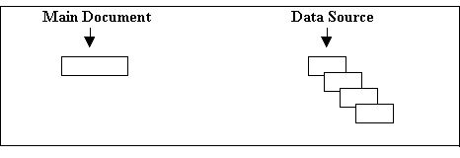

### Activity 1

1. Give examples of documents that are required in order to merge documents and describe their uses.
2. What are the benefits of merging documents?

## Lesson 2- Benefits of merging documents

The Compare and Merge Documents feature available in Microsoft Office is useful for comparing and combining separate versions of a document. If you are writing a paper, for example, and want separate documents to end up in a master document, merging will be helpful. Instead of having to type in a specific name or other applicable data multiple times, with document merging facility a business needs only set the given field with the relevant data one time and it will be applied to all areas within the document in which it needs to be shown. Multiple documents can even be created at the same time, further reducing the time spent in this necessary process even more. Other benefits of merging documents include,

* **Saving time**: Saving time can save money for you and people with whom you communicate. If you have a folder full of Word documents that you need to review, archive or email, you may save time by combining them into a single file. Microsoft Word 2010 does not have a "Combine Files" button, but it does allow you to merge multiple files quickly. After creating a merged Word document, you can email it as a single attachment or save it for future use.
* **Reduced employment of less skilled employees:** Due to the built in rules for the creation of a document, your business will have less of a need to employ less skilled employees or temp workers to input the data. The results of this is even less potentiality of error resulting from the employment of individuals with below par expertise, as well as less money spent in the hiring and employing process.
* **Reduced chance of human error:** Let's face it; people are inherently capable of making errors. Whether it is due to carelessness, lack of knowledge as to the importance of a document, or any endless list of reasoning behind this, the fact of the matter withstands. Document generation moderates these types of errors by reducing the quantity of manual contribution on the part of this individual inputting the data. This leads to increased compliance in your documents and decreased time of having to recreate forms that have your business has put time and effort into creating already.
* **Ease of use:** Using document merging software is as easy as answering some questions. A questionnaire style is used to input the data and, subsequent to answering all of the questions, the document creation process is finished. This can be saved for later use or printed right then.

The following are some of the benefits of merging documents in general;

* Mass producing letters
* Mass producing labels
* Mass producing forms
* Mass producing contracts
* Creating catalogues

## Lesson 3 – Merging process

Thus by now it is clear that to Merge document, you need to

* Create the main document
* Create data source
* Merge the data with document

### 1. Merging documents

**Creating a data source**

Before creating a mail merge, one must have the data source created in any Microsoft application e.g Microsoft excel, Word, PowerPoint etc. you can create a data source by typing text in your document. For example, your data source may be a spreadsheet as shown in the diagram below.



From the spreadsheet it can be seen that the first row was used to name the fields. As you will see later, naming your rows is very important when it comes to merging documents. Also, notice how there is two worksheets in the spreadsheet; this will also be important later.

**Creating the main document**

As explained earlier, merging requires the main document. This document can be in any Microsoft application. The main document may be in the form of a letter in Microsoft Word 2010. The letter has been inserted on the next page.

|  |
| --- |
|  |

**How to merge documents**

**Step 1**: Create a new blank document, and then configure to set the page layout settings so that the settings are similar to the documents that going to be merged.

**Step 2**: click **Insert** on the ribbon toolbar. "**Insert**" tab allows you to subtly merge documents.

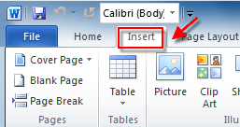

**Step 3**: Locate "**Object**", press a small triangle next to it, and click "**Text from File**" from the dropdown menu to bring up the dialog below

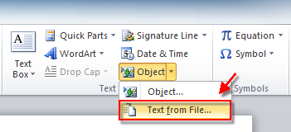

After that, you can select files to be merged into the current document. By pressing and holding **Ctrl** to select more than one document.

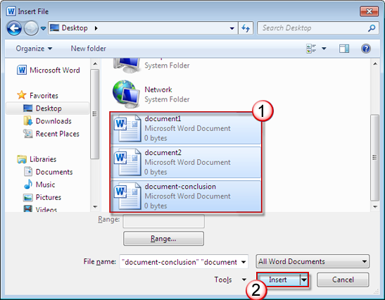

Note: Documents placed at the top will be merged in the first place. Therefore, please sort and number each target document in case that you want to keep a certain sequence for your documents.

**Step 4**: click **Insert** to insert the selected files into the new blank document.

Your document will be merged.

### 2. Mail merge

Mail merge is a useful tool that will allow you to easily produce multiple letters, labels, envelopes, name tags and more using information stored in a list, database, or spreadsheet. In this section, you will learn how to use the **mail merge wizard** to create a **data source** and a form **letter**, and explore other wizard features.

When you are performing a **Mail merge**, you will need a **Word document** (you can start with an existing one or create a new one), and a **recipient list**, which is typically an **Excel workbook**.

**Example: Letter**

|  |
| --- |
| As you may know, 2010 marks our **10th year of doing business**. Over the last decade, AdWorks has grown from a tiny startup into a robust company with over 200 employees throughout the Southeast. Our growth would not have been possible without loyal customers like you. Therefore, we would like to extend to you a **20% discount on your next order**. It’s our way of saying “thanks” for your continued business. We’ll keep working hard to provide the best possible customer service along with innovative products, just as we’ve always done. Thanks again for choosing AdWorks!  Sincerely,  Liz Doe  President and CEO |

**Example, recipient list/data source**

|  |  |  |  |  |  |  |  |  |  |  |  |  |  |  |  |  |  |  |  |  |  |  |  |  |  |  |  |  |  |  |  |  |  |  |  |  |  |  |  |  |  |  |  |  |  |  |  |  |  |  |  |  |  |  |
| --- | --- | --- | --- | --- | --- | --- | --- | --- | --- | --- | --- | --- | --- | --- | --- | --- | --- | --- | --- | --- | --- | --- | --- | --- | --- | --- | --- | --- | --- | --- | --- | --- | --- | --- | --- | --- | --- | --- | --- | --- | --- | --- | --- | --- | --- | --- | --- | --- | --- | --- | --- | --- | --- | --- |
| |  |  |  |  |  |  | | --- | --- | --- | --- | --- | --- | | **Title** | **Last Name** | **First Name** | **Address** | **City** | **State** | | Ms. | Albertson | Kathy | 1024 Lakeview Cir | Peachtree City | GA | | Mr. | Brennan | Michael | 1123 Main St | Wilmington | NC | | Mr. | Davis | William | 540 W 4th St, Apt 121 | New York | NY | | Ms. | Forest | Eliza | PO Box 4551 | Reno | NV | | Mr. | Jones | Dan | PO Box 805 | Raleigh | NC | | Ms. | Post | Melissa | 3202 Maplewood Ave | Richmond | VA | | Ms. | Thompson | Shannon | 500 Acme Ln, Apt 3C | Springfield | IL | | Mr. | Walters | Chris | 436 Church St | Columbia | SC | |

**To Use Mail Merge:**

1. Open an **existing** Word document, or create a **new** one.
2. Click the **Mailings** tab.
3. Click the **Start Mail Merge** command.
4. Select **Step by Step Mail Merge Wizard**.



The Mail Merge task pane appears and will guide you through the **six main steps** to complete a mail merge. The following is an example of how to create a form letter and merge the letter with a **recipient list**.

**Step 1:**

1. Choose the type of document you wish to create. In this example, select **Letters**.

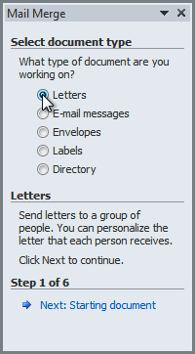

1. Click **Next: Starting document** to move to Step 2.

**Step 2:**

1. Select **Use the current document**.

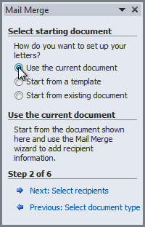

1. Click **Next: Select recipients** to move to Step 3.

**Step 3:**

Now you will need an address list so that Word can automatically place each address into the document. The list can be in an existing file, such as an **Excel workbook**, or you can **type a new address list** from within the Mail Merge Wizard.

1. From the **Mail Merge** task pane, select **Use an existing list** and then click **Browse**.

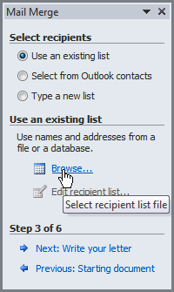

1. Locate your file in the dialog box (you may have to navigate to a different folder) and click **Open**.

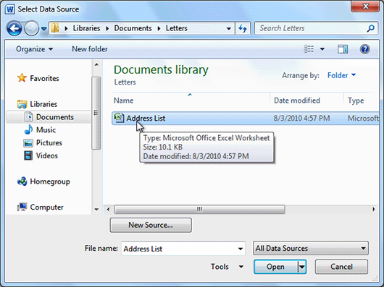

1. If the address list is in an Excel workbook, select the **worksheet** that contains the list and click **OK**.

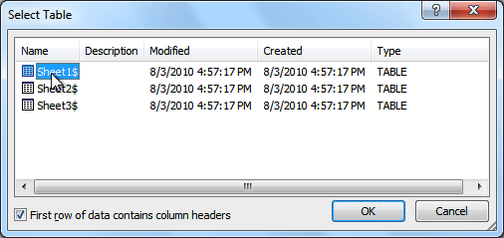

1. In the **Mail Merge Recipients** dialog box, you can **check** or **uncheck** each recipient to control which ones are used in the mail merge. When you're done, click **OK** to close the dialog box.

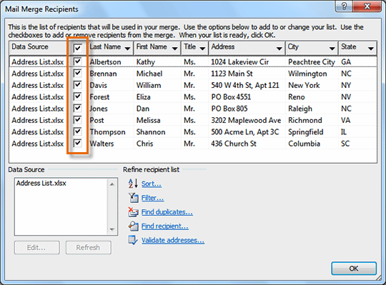

1. From the **Mail Merge** task pane, click **Next: Write your letter** to move to Step 4.

If you don't have an existing address list, you can click the **Type a new list** button and click **Create**. You can then type your address list.

**Step 4:**

Now you are ready to write your letter. When it's printed, each copy of the letter will basically be the same, except the **recipient data** (such as the **name** and **address**) will be different on each one. You will need to add **placeholders** for the recipient data, so that mail merge knows exactly where to add the data. If you are using mail merge with an existing letter, make sure that the file is open now.

**To Insert Recipient Data:**

1. Place the insertion point in the document where you wish the information to appear.
2. Select **Address block**, **Greeting line**, **Electronic postage**, or **More items** from the task pane.

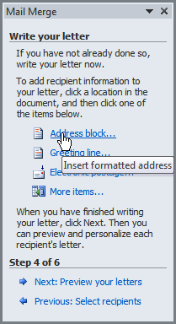

1. Depending on your selection, a dialog box may appear with various options. Select the desired options and click **OK**.

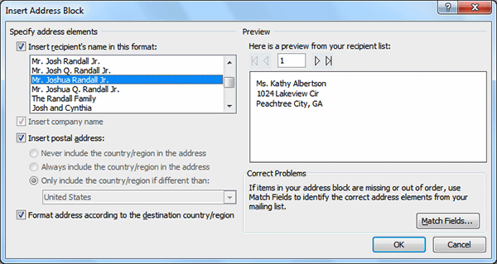

1. A placeholder appears in your document. For example: **«AddressBlock»**.
2. Repeat these steps each time you need to enter information from your data record.
3. From the **Mail Merge** task pane, click **Next: Preview your letters** to move to Step 5.

For some letters, you will only need to add an **Address block** and **Greeting line**. Sometimes, however, you may wish to place **recipient data** within the body of the letter to **personalize it** even further.

**Step 5:**

1. Preview the letters to make sure the information from the recipient list appears correctly in the letter. You can use the left and right scroll arrows to view each document.

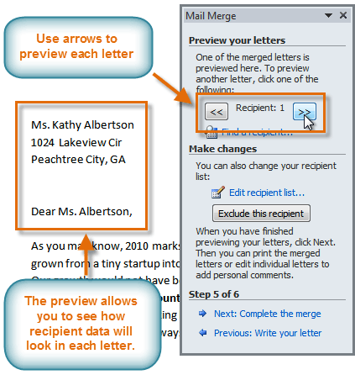

1. Click **Next: Complete the merge** to move to Step 6.

**Step 6:**

1. Click **Print** to print the letters.

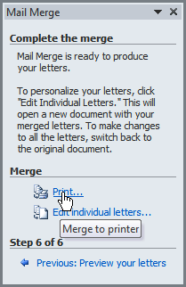

1. The **Merge to Printer** dialog box opens. Click **All**, and then click **OK**.

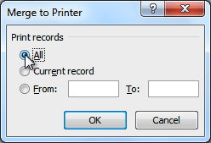

1. The **Print** dialog box will appear. Adjust the print settings if needed, and then click **OK**.

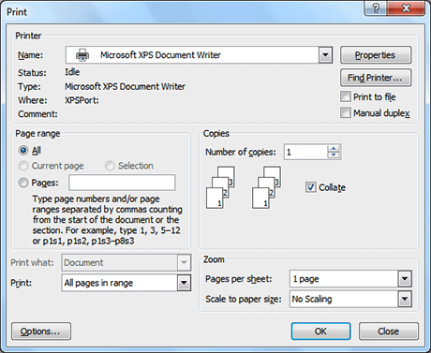

### Editing data source

Edit your data source by,

* Adding record to your data source for example, add new name and address.
* deleting record for example, select and delete one row or column
* Sorting record, for example, sort data in ascending or descending order.
* Changing record, for example, create a new data source by following steps discussed above and use it during mail merge.

### Activity 2

**Use the Report or any Word document you choose to complete this challenge.**

* Open a new, blank Word document.
* Create a **data source** that contains at least 5 fields and 5 records
* Create **main document**
* **Merge** at least 2 documents
* Save
* **Add record to your data source** and **re-produce** a merged document
* Save