**APPLY BASIC INVOICING AND ACCOUNTING PRINCIPLES**

**US 252435/11241**

**NQF LEVEL:** 3

**CREDITS: 6**

**NOTIONAL HOURS: 60**

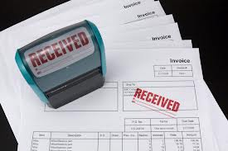

**LEARNER GUIDE**

|  |  |
| --- | --- |
| **Name** |  |
| **Contact Address** |  |
| **Telephone (H)** |  |
| **Telephone (W)** |  |
| **Facsimile** |  |
| **Cellular** |  |
| **E-mail** |  |

TABLE OF CONTENTS

HOW TO USE THIS GUIDE 3

ICONS 3

PROGRAMME OVERVIEW 4

PURPOSE 4

LEARNING ASSUMPTIONS 4

HOW YOU WILL LEARN 4

HOW YOU WILL BE ASSESSED 4

SECTION 1: UNDERSTANDING EXPENDITURE AND REVENUE 5

1.1 INTRODUCTION 6

1.2 THE CONCEPT OF EXPENDITURE 8

1.3 CONCEPT OF REVENNUE 9

1.4 DIFFERENCE BETWEEN REVENNUE AND EXPENDITURE 10

SECTION 2: UNDERSTANDING FIXED AND VARIABLE COSTS 11

2.1 INTRODUCTION 12

2.2 FIXED COSTS 15

2.3 VARIABLE COSTS 16

SECTION 3: INVOICING OPERATIONS 18

3.1 INTRODUCTION 19

3.2 INVOICES 19

3.3 POSTING TO RELEVANT ACCOUNTS 23

SECTION 4: RECONCILING TRANSACTIONS 28

4.1 FREIGHT FORWARDING 29

4.2 CARTAGE 31

4.3 LANDSIDE AND SURFACE CHARGES 32

4.4 CUSTOMS CHARGES 34

4.5 DISBURSEMENT CHARGES 38

4.6 SUPPLEMENTARY CHARGES 39

4.7 RECONCILIATION 40

SECTION 5: DISBURSING ITEMS FOR RECOVERY 41

5.1 INTRODUCTION 42

5.2 DISBURSING CARTAGE CHARGES 46

5.3 DISBURSING STORAGE CHARGES 48

5.4 DISBURSING SPECIAL CHARGES 49

## HOW TO USE THIS GUIDE

This workbook belongs to you. It is designed to serve as a guide for the duration of your training programme and as a resource for after the time. It contains readings, activities, and application aids that will assist you in developing the knowledge and skills stipulated in the specific outcomes and assessment criteria. Follow along in the guide as the facilitator takes you through the material, and feel free to make notes and diagrams that will help you to clarify or retain information. Jot down things that work well or ideas that come from the group. Also, note any points you would like to explore further. Participate actively in the skill practice activities, as they will give you an opportunity to gain insights from other people’s experiences and to practice the skills. Do not forget to share your own experiences so that others can learn from you too.

## ICONS

For ease of reference, an icon will indicate different activities. The following icons indicate different activities in the manual.



**Learning Activities**

**Outcomes**







**Note**

**Note!**

**Reflection**

**References**

**Example**

**Summaries**

**Definition**

**Notes (Blank)**

**Course Material**

**Assessment Criteria**



**Stop and Think!**

## PROGRAMME OVERVIEW

# 

## PURPOSE

At the end of this training session you will be able to apply basic invoicing and accounting principles

## LEARNING ASSUMPTIONS

The credit calculation is based on the assumption that learners are already competent in

* Communication at NQF Level 2 or equivalent.
* Mathematical Literacy at NQF Level 2 or equivalent.

## HOW YOU WILL LEARN

The programme methodology includes facilitator presentations, readings, individual activities, group discussions, and skill application exercises.

## HOW YOU WILL BE ASSESSED

This programme has been aligned to registered unit standards. You will be assessed against the outcomes of the unit standards by completing a knowledge assignment that covers the essential embedded knowledge stipulated in the unit standards. When you are assessed as competent against the unit standards, you will receive a certificate of competence and be awarded 6 credits towards a National Qualification.

# SECTION 1: UNDERSTANDING EXPENDITURE AND REVENUE





**Specific Outcome**

On completion of this section you will be able to explain items of expenditure and revenue

**Assessment Criteria**

On completion of this section you will be able to:

* A definition of expenditure is provided in the context of freight forwarding and customs clearing (SO 1, AC 1)
* A definition of revenue is provided in the context of freight forwarding and customs clearing.  (SO 1, AC 2)
* The difference between expenditure and revenue are explained as they apply to freight forwarding. .  (SO 1, AC 3)

## 1.1 INTRODUCTION

In all activities (whether business activities or non-business activities) and in all organisations (whether business organisations like a manufacturing entity or trading entity or non-business organisations like schools, colleges, hospitals, libraries, clubs, churches, political parties) which require money and other economic resources, accounting is required to account for these resources. In other words, wherever money is involved, accounting is required to account for it. Accounting is often called the language of business. The basic function of any language is to serve as a means of communication. Accounting also serves this function.

**1.1.1 DEFINITION OF ACCOUNTING**

Accounting, as an information system is the process of identifying, measuring and communicating the economic information of an organisation to its users who need the information for decision making. It identifies transactions and events of a specific entity. A transaction is an exchange in which each participant receives or sacrifices value (e.g. purchase of raw material). An event (whether internal or external) is a happening of consequence to an entity (e.g. use of raw material for production). An entity means an economic unit that performs economic activities.

American Institute of Certified Public Accountants (AICPA) defines accounting as the art of recording, classifying and summarising in a significant manner and in terms of money, transactions and events, which are, in part at least, of a financial character and interpreting the results thereof.

**1.1.2 OBJECTIVE OF ACCOUNTING**

Objective of accounting may differ from business to business depending upon their specific requirements. However, the following are the general objectives of accounting.

1. To keep systematic record: It is very difficult to remember all the business transactions that take place. Accounting serves this purpose of record keeping by promptly recording all the business transactions in the books of account.
2. To ascertain the results of the operation: Accounting helps in ascertaining result i.e., profit earned or loss suffered in business during a particular period. For this purpose, a business entity prepares either a Trading and Profit and Loss account or an Income and Expenditure account which shows the profit or loss of the business by matching the items of revenue and expenditure of the some period.
3. To ascertain the financial position of the business: In addition to profit, a businessman must know his financial position i.e., availability of cash, position of assets and liabilities etc. This helps the businessman to know his financial strength. Financial statements are barometers of health of a business entity.
4. To portray the liquidity position: Financial reporting should provide information about how an enterprise obtains and spends cash, about its borrowing and repayment of borrowing, about its capital transactions, cash dividends and other distributions of resources by the enterprise to owners and about other factors that may affect an enterprise’s liquidity and solvency.
5. To protect business properties: Accounting provides up to date information about the various assets that the firm possesses and the liabilities the firm owes, so that nobody can claim a payment which is not due to him.
6. To facilitate rational decision-making: Accounting records and financial statements provide financial information which help the business in making rational decisions about the steps to be taken in respect of various aspects of business.
7. To satisfy the requirements of law: Entities such as companies, societies, public trusts are compulsorily required to maintain accounts as per the law governing their operations such as the Companies Act etc. Maintenance of accounts is also compulsory under the Income Tax Act.

**1.1.3 BUSINESS TRANSACTIONS**

A transaction is an event which gives rise to an entry in accounting records. It is an event which results in change in the balance sheet equation. That is, which changes the value of assets and equity.

In a simple statement, transaction means the exchange of money or money’s worth from one account to another account. Events like purchase and sale of goods, receipt and payment of cash for services or on personal accounts, loss or profit in dealings etc. are the transactions. Cash transaction is one where cash receipt or payment is involved in the exchange.

|  |
| --- |
| **NOTE**  Business transactions can be classified into;   * Expenditure transactions and * Revenue transactions |

## 1.2 THE CONCEPT OF EXPENDITURE

For the purpose of this module, expenditure is defined as the costs that have been incurred within a specified financial period of a business. In accounting terms, one should include expenditure in the period in which it was incurred even if no money was paid. This ensures that you have an accurate statement of income and expenditure of real expenditures incurred within the period.

For the accounting purpose expenditures are classified in three types:

1. Capital Expenditure is an amount incurred for acquiring the long term assets such as land, building, equipments which are continually used for the purpose of earning revenue. These are not meant for sale. These costs are recorded in accounts namely Plant, Property, Equipment. Benefits from such expenditure are spread over several accounting years.

E.g. Interest on capital paid, Expenditure on purchase or installation of an asset, brokerage and commission paid.

1. Revenue Expenditure is the expenditure incurred in one accounting year and the benefits from which is also enjoyed in the same period only. This expenditure does not increase the earning capacity of the business but maintains the existing earning capacity of the business. It included all the expenses which are incurred during day to day running of business. The benefits of this expenditure are for short period and are not forwarded to the next year. This expenditure is on recurring nature.

Eg: Purchase of raw material, selling and distribution expenses, Salaries, wages etc.

1. Deferred Revenue Expenditure is a revenue expenditure which has been incurred during an accounting year but the benefit of which may be extended to a number of years. And these are charged to profit and loss account. E.g. Development expenditure, Advertisement etc.



|  |
| --- |
| **LEARNING ACTIVITY**  List expenditures that a business involved in shipping computer consumables can incur in one financial period. |

## 1.3 CONCEPT OF REVENNUE

In business, revenue or turnover is income that a company receives from its normal business activities, usually from the sale of goods and services to customers.

Some companies receive revenue from interest, royalties, or other fees. Revenue may refer to business income in general, or it may refer to the amount, in a monetary unit, received during a period of time, as in "Last year, Company X had revenue of R62 million.

For non-profit organizations, annual revenue may be referred to as gross receipts. This revenue includes donations from individuals and corporations, support from government agencies, income from activities related to the organization's mission, and income from fundraising activities, membership dues, and financial investments such as stock shares in companies.

In general usage, revenue is income received by an organization in the form of cash or cash equivalents. Sales revenue or revenues is income received from selling goods or services over a period of time.

**NB:** For purposes of this module, revenue is income that a business receives from normal business, after selling goods and services to customers.



|  |
| --- |
| **LEARNING ACTIVITY**  List sources of revenue for a computer sales and repair shop. |

## 1.4 DIFFERENCE BETWEEN REVENNUE AND EXPENDITURE

|  |  |
| --- | --- |
| **REVENUE** | **EXPENDITURE** |
| Money coming into the business | Money going out of the business |
| Revenue is earned after the business sells goods and services to customers | Expenditures are incurred when the business buys things from suppliers. |
| Revenue increases the profit of the organisation | Expenditures reduce the profit of the organisation |
| Revenue is a direct result of selling and marketing | Expenditure is a result of operational activities in a business |
| Examples of revenue to a computer shop are income from sale of laptops, repair fees | Expenditure for a computer shop can be rent, salary and electricity |



|  |
| --- |
| **LEARNING ACTIVITY**  Differentiate revenue and expenditures using examples. |

# SECTION 2: UNDERSTANDING FIXED AND VARIABLE COSTS





**Specific Outcome**

On completion of this section you will be able to explain fixed and variable costs.

**Assessment Criteria**

On completion of this section you will be able to:

* Fixed cost is defined with examples.  (SO 2, AC 1)
* Variable cost is defined with examples.  (SO 2, AC 2)
* Three examples are provided where fixed costs could happen.  (SO 2, AC 3)
* Examples are provided where variable costs could be confused as fixed costs. (SO 2, AC 3)
* The consequences of a variable cost being confused as a fixed cost is explained with examples. (SO 2, AC 3)

## 2.1 INTRODUCTION

There are three fundamental relationships in business:

1. Revenue varies directly with the number of units sold and the price the sales units are sold at.
2. Some costs vary directly with the number of units sold but, some costs in the business are fixed for a period and do not vary directly with sales levels.
3. These costs do not automatically increase if sales increase and do not reduce if sales are lower than expected.

This creates a cost volume profit relationship which can be seen by the graph below:

Revenue and costs (R000)

[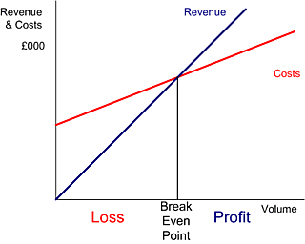](http://businesscoaching.typepad.com/.a/6a00e54eda5912883300e553278c348833-popup)

* As you can see the Revenue line starts from zero (if you don't sell anything, you don't generate any revenue) while the Cost line starts from a point on the R000 axis which represents the fixed costs of the business.
* Where the Revenue line and the cost line meet, the business does not make a profit or loss and is said to be at the breakeven point.
* To the left of the breakeven point, the business is making a loss because costs are greater than revenue. While the angle of the revenue line is steeper than the cost line, it takes single sales to pay for the fixed costs.
* To the right of the breakeven point, the business is making a profit because revenue is greater than costs.

|  |
| --- |
| **Note:**  PROFIT = REVENUE - COST |

|  |
| --- |
| **Example 1:**  A shopkeeper buys scientific calculators in bulk for R15 each. He sells them for R40 each. Calculate the profit on each calculator in Rands, and as a percentage of the cost price.    **Given**: cost price = R15,  selling price = R40               Profit = selling price - cost price                         =   R40 - R15                         =   R25    Expressing the profit as a percentage of the cost price:                                      R profit           Profit % =  ------------------------ × 100%                                  R cost price                                          R25                                    =  -------- × 100%    =    166.7%                                          R15 |

|  |
| --- |
| **Example 2:**  A school bookshop sells an outdated biology text book for R49.35, making a 6% loss. What was the cost price of the book, and what is the cash value of the loss?  **Given**: selling price = R49.35,                            loss = 6% of cost price      but,  (cost price) = (selling price) + loss    Expressing as percentages of the cost price:             (cost price) = (selling price)    +    loss                  100%                    x%               +      6%    This means that the selling price is (100-6) = 94% of the cost price.                                           94            selling price  =  -------- × (cost price)                                          100  So:                                         100               cost price  =  -------- × (selling price)                                           94                                           100                                    =  -------- × 49.35                                           94                                     =  R52.50    So:                     loss  =  (cost price) - (selling price)                                     =  R52.50 - R49.35                                     =  R3.15 |

**NB:** There are two main types of costs in business i.e

* Fixed costs
* Variable costs

## 2.2 FIXED COSTS

Fixed costs are those business costs that are not directly related to the level of production or output. In other words, even if the business has a zero output or high output, the level of fixed costs will remain broadly the same.

In the long term fixed costs can alter - perhaps as a result of investment in production capacity (e.g. adding a new factory unit) or through the growth in overheads required to support a larger, more complex business.

Examples include: Rent, rates, salary and Depreciation

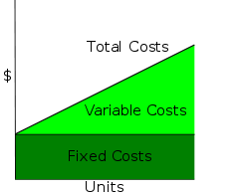

Where fixed costs can happen

1. An example of a fixed cost for a business making a product such as a bakery would be the business rates.
2. For a business producing a service such as massage therapy would be any costs associated with the rent or ownership of premises, insurance, and costs associated with the ownership of equipment.
3. In a logistics business where truck drivers are paid a basic salary every month.

## ****2.3 VARIABLE COSTS****

Variable costs are those costs which vary directly with the level of output. They represent payment output-related inputs such as raw materials, direct labour, fuel and revenue-related costs such as commission.

A distinction is often made between "Direct" variable costs and "Indirect" variable costs.

* Direct variable costs are those which can be directly attributable to the production of a particular product or service and allocated to a particular cost centre. Raw materials and the wages those working on the production line are good examples.
* Indirect variable costs cannot be directly attributable to production but they do vary with output. These include depreciation (where it is calculated related to output - e.g. machine hours), maintenance and certain labour costs.

In a service business, there are often fewer variable costs. Often the main variable cost in providing a service is the cost of wages for an employee working directly in providing the service.

Other variable costs in a service business would be anything directly ‘used up’ during the provision of the service. For example with massage therapy, oil may be used and there may be the cost of laundering one or two towels. Variable costs should be able to be expressed per item of output or sales. If this proves to be very difficult, you may need to classify such costs as fixed.

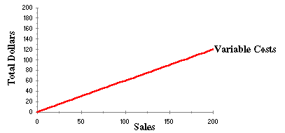

|  |
| --- |
| **LEARNING ACTIVITY**  Consider the following scenarios. Determine if each scenario is a Fixed or variable cost?   1. Employee paid a basic wage for 37hours per week 2. Employee paid a set amount per item produced (e.g. per therapy treatment or per floral wreath) 3. Employee paid for number of hours worked but no minimum hours guaranteed (e.g. housekeeping staff paid to service holiday accommodation only when let) |

**CASES WHERE VARIABLE COSTS CAN BE CONFUSED FOR FIXED COSTS**

1. Depreciation is typically treated as a fixed cost, not a variable cost. The exception is when the business uses the units-of-production depreciation method, which allocates depreciation based on how much the asset is being used for production. For example, a shoe-making machine may be good for 100,000 shoes. If you use the units-of-production depreciation method, the depreciation expense will be spread out based on how many shoes you make the more you make, the more it depreciates, while the less you make, the less it depreciates. Since this ties the depreciation expense directly to the production level, this depreciation expense is a variable cost not a fixed cost.
2. A company decide to pay its labourers R3000 per month if the output is 2000. If the output falls between 1000-2900, the employees are paid R2000. For the past 20 years, the output has never fallen below 3000 units. Salary is usually a fixed cost. But, in this case it is a variable cost since the salary depends on output.

**CONSEQUENCES**

Consequences of a variable cost being confused for a fixed cost include;

* Wrong pricing decisions: The total product cost and cost per unit of product are important in deciding selling price of a product. Costing thus provides information regarding the cost to make and sell product or services. If variable costs are not accounted for, products can be sold at a price lower than the actual price resulting in losses.
* Difficulties in controlling costs.
* Wrong management decisions: Costing helps the management in providing information for managerial decisions for formulating operative policies. These policies relate to the following matters:
* Determination of cost-volume-profit relationship.
* Make or buy a component
* Shut down or continue operation at a loss
* Continuing with the existing machinery or replacing them by improved and economical machines.

Therefore if variable costs are misappropriated, managers can make wrong decisions that can cost the organisation.

|  |
| --- |
| **LEARNING ACTIVITY**  Identify and describe situations in which variable costs can be confused for fixed costs. |

# SECTION 3: INVOICING OPERATIONS





**Specific Outcome**

On completion of this section you will be able to perform invoicing operations and post amounts to the appropriate accounts.

**Assessment Criteria**

On completion of this section you will be able to:

* An invoice is prepared which has items of expenditure and items revenue for a sea freight shipment for a full container load and import which has paid customs duty, duty schedule, and the ocean freight is on a collect basis.  (SO 3, AC 1)
* An invoice is prepared for an air freight export shipment which has items of expenditure and items of revenue where the master airway bill is collected, insurance must be invoiced as well as cartage collection charges.   (SO 3, AC 2)
* The expenditure items must be posted to the appropriate accounts for both the sea freight and airfreight invoices.  (SO 3, AC 3)
* A record is made up of the over-recoveries of the items of expenditure which must later be taken to profit. (SO 3, AC 3)

## 3.1 INTRODUCTION

All accounting transactions come from source documents. Source documents is an accounting terms to describe the original records that contain the details that substantiate the financial transactions that are entered into the internal accounting system of a business. Typical source documents include sales invoices, cash receipts, cash register slip, credit notes and deposit slip. Source documents provide the documentary evidence of a business deal or accounting event and are a critical part of an audit trail that establishes the authenticity and tracking history of an accounting system's financial records.

The most common source documents are

* Invoices
* Credit note
* Receipts,
* Delivery notes,

## 3.2 INVOICES

Invoice is a bill which indicates the amount that is to be paid by the buyer to the seller. There is no standard form or style of invoice and as such it can be designed as per the requirements of the seller. It can be prepared in three or more copies as required by the parties concerned. The invoice may be sent along with the goods or at a later date. When cash is paid at the counter of the shop then cash memo is issued by the seller to the buyer.

The functions of Invoice are as follows:-

* The buyer comes to know about the amount to be paid to the seller.
* He can check the invoice price against the quotation/proforma invoice price. If any difference he can sort it out with the seller.
* It helps the buyer to fix the price for resale.
* The invoice helps the buyer to verify the actual goods received.
* It helps to prepare debit note or credit note.
* It can be used as an evidence in the court of law.
* Invoice facilitates the seller in checking up the total volume of sales and in verifying the stock balance.
* It enables the buyer to make entries in the books of account.
* It enables the seller to make necessary entries in his sales book and customer’s ledger amount.
* It helps the buyer to know the exact due date of payment to the seller.

**Contents of an invoice**

The invoice contains following main items:-

* The name and address of the seller.
* The name and address of the buyer.
* The description of goods i.e quantity, quality, weight, size, etc.
* The value of goods, less discounts, if any.
* The net amount payable by the buyer.
* Terms and conditions of payment.
* Country of origin (in case of export trade)
* Mode of transport.
* Freight charges.
* Insurance premium.
* Bill of Landing or Railway Receipt Number.
* Signature of the seller.
* Date on which the goods are despatched.
* E. & O.E. (Errors and Omissions expected).
* Any other details, if required.

General invoice

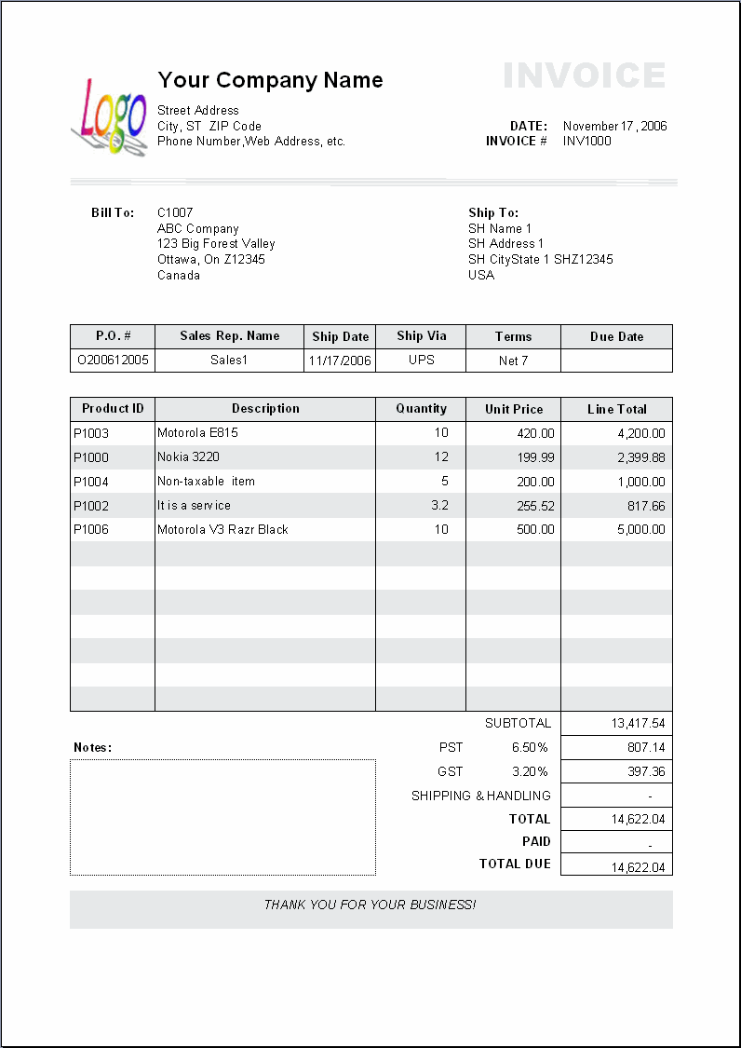

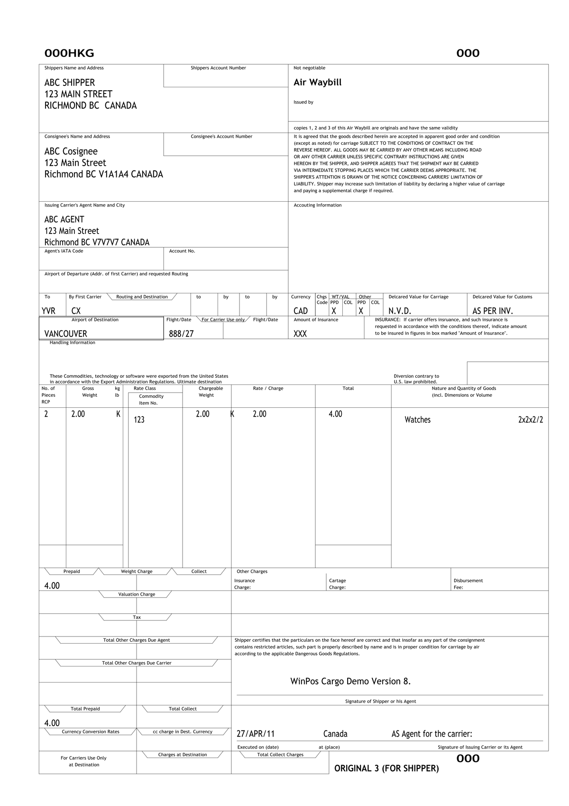

Sample: airfreight invoice

## 3.3 POSTING TO RELEVANT ACCOUNTS

When source documents are received, the first step is to record the same in the books of original entry or subsidiary books or books of prime or journal.

Thus journal is a simple book of accounts in which all the business transactions are originally recorded in chronological order and from which they are posted to the ledger accounts at any convenient time. Journalising refers to the act of recording each transaction in the journal and the form in which it is recorded, is known as a journal entry.

Below is an example of a journal

|  |  |  |  |  |
| --- | --- | --- | --- | --- |
| Date | Particular |  | Ledger folio | Amount |
| 1 | 2 |  | 3 | 5 |

**3.1.1 TYPES OF JOURNALS**

The original entry becomes inadequate. Thus, the number and the number and type of journals required are determined by the nature of operations and the volume of transactions in a particular business. There are many types of journals and the following are the important ones:

* Sales Day Book (Sales Journal) - to record all credit sales.
* Purchases Day Book (Purchases Journal) - to record all credit purchases.
* Cash Book- to record all cash transactions of receipts as well as payments.
* General Journal-to record transactions on credit that do not enter into the sales and purchases ledger e.g. purchases of a motor vehicle on credit

Once transactions have been entered into the subsidiary book of accounts, they must be posted to the ledger accounts using the double-entry accounting system.

**3.1.2 THE PURPOSES OF JOURNALS**

1. Transactions which occur infrequently and adjustments necessary at the close of an accounting period require evidence as a basis of recording. Journal vouchers are used to support such transactions and by being signed by responsible officials, they constitute entries for the General Journal. It is therefore easier to detect fraud or errors.
2. Journals being book of Prime Entry, journal entries reduce the risk of omitting to record any transaction
3. The narrations given to all general journal entries explain the nature of the transactions.
4. Each narration provides a record of entries made in the ledgers.

**3.1.3 INPUTS TO THE SUBSIDIARY BOOKS**

Subsidiary books depend on source documents as inputs. The following are some of the source documents

1. **Inward Invoice:**

This is the document sent by the suppliers of goods giving details of goods sent, price, value, discount etc. It is the basis for entries in purchases book.

1. **Outward Invoice:**

This is a document sent by the firm to the customers, showing the details of goods supplied, their price and value, discounts etc., it is the basis for writing sales book.

|  |
| --- |
| **NOTE**  All invoices made to customers must be recorded in the sales journal and the cash book. |

**SALES JOURNAL**

This book is used to record all credit sales effected by the business to its customers. This book is also called as ‘Sales Book’, ‘sales Journal’ or ‘Sold Book’. It contains five columns, viz., Date, Particulars, L.F., Outward Invoice Number and Amount. When any credit sales is effected, the date is entered in the ‘Date Column’, the name of the party to whom the sale is made in the ‘Particulars Column’, the invoice number with which the sales have been effected in the ‘Out-ward Invoice Number Column’ and the money value of the sales in the ‘Amount Column’, The LF column is entered while posting is effected.

**Posting:** The total of the Sales Book for a specified period is credited to the Sales Account in the Ledger. The personal account is posted by debiting the individual accounts.

The specimen ruling of a Sales Book is as follows:

Sales Journal

|  |  |  |  |  |
| --- | --- | --- | --- | --- |
| Date | Particulars | L.F. | Outward invoice number | Amount |
|  |  |  |  |  |
|  |  |  |  |  |

**Illustration**

Enter the following transactions in Sales Book and post the same in the relevant ledger accounts as at 2002.

Aug. 15 Sold goods to D on credit 2,000, invoice number 20811

Aug. 18 Sold goods to E on credit 1,500, invoice number 30991

Aug. 22 Sold goods to F on credit 1,000, invoice number 29335

**Sales Journal**  2002

|  |  |  |  |  |
| --- | --- | --- | --- | --- |
| Date | Particulars | L.F. | invoice number | Amount |
| Aug 15 | D |  | 20811 | 2,000 |
| Aug 18 | E |  | 30991 | 1,500 |
| Aug 22 | F |  | 29335 | 1,000 |
|  |  |  |  | **3,500** |

**CASH BOOK**

Cash Book is a sub-division of Journal recording transactions pertaining to cash receipts and payments. Firstly, all cash transactions are recorded in the Cash Book wherefrom they are posted subsequently to the respective ledger accounts. The Cash Book is maintained in the form of a ledger with the required explanation called as narration and hence, it plays a dual role of a journal as well as ledger. All cash receipts are recorded on the debit side and all cash payments are recorded on the credit side. All cash transactions are recorded chronologically in the Cash Book. The Cash Book will always show a debit balance since payments cannot exceed the receipts at any time.

The cash book can be divided into a cash receipts journal and a cash payments journal. Below is an example of a cash receipts journal

**Illustration**

Enter the following into the cash payments

Dec 4 The business received case from J.J Jack for invoice (201325) R 50 000

Dec 6 Sold goods for cash R 6 000 (invoice number 232025)

Dec 10 Received cash R10 000 from one of the cu and allow customers and a discount of 500 (invoice 28689)

Dec 13 Sold consignment for cash (invoice 125558) R20 000 cash

**Cash receipts Journal –December 2013**

|  |  |  |  |  |  |  |  |  |  |  |
| --- | --- | --- | --- | --- | --- | --- | --- | --- | --- | --- |
| Invoice No. | DATE | DETAILS | FO | BANK | SALES | DEBTORS | DISCOUNT ALLOWED | SUNDRY | | |
| 201325  232025  28689  125558 | 4  6  10  13 | sales  Sales  sales  sales |  | 50 000  6 000  10 000  20 000  **86 000** | 50 000  6 000  10 000  **20 000**  **86 000** |  | 500  **500** | Amount | Fol | Details |
|  |  | Rent |



|  |  |
| --- | --- |
| **LEARNING ACTIVITY**  Record the following sales in the cash book. All sales include a discount of 15% | |
| **Invoice** | **Marked price** |
| 253682 | 100 000 |
| 253589 | 500 000 |
| 36826 | 300 000 |
| 200583 | 200 500 |

**OVER- RECOVERIES OF EXPENDITURE**

Recoveries are a general accounting term used to describe different types of record keeping. When an accountant needs to adjust an account because a bad debt has been repaid, that debt is though of as recovered and requires a new entry.

Likewise, businesses often make new entries for various expense recoveries to show how expenses have changed over time. Recovery can also pertain to a broader type of practice associated with matching costs to value for accurate record keeping.

**Expense Recovery**

In other cases, expenses can be recovered. A good example of this is a rebate. The company pays for a particular asset, such as a computer program, and records the full expense in its books. However, if the computer programme costs above a certain amount the vendor may allow a 10 percent rebate.

The business fills out documentation and receives the rebate. The accountant will then make a recovery entry on the expense account to show part of the money was returned and the actual expense has been lowered.

To record the rebate: Debit the cashbook with the rebate.

|  |
| --- |
| **LEARNING ACTIVITY**  TX company bought a software for cash at a price of R200 000. The vendor KK holdings and TX company later on agreed to 10%. The rebate that was received was R21 000. Record the over-recovery in the cash book. |

# SECTION 4: RECONCILING TRANSACTIONS





**Specific Outcome**

On completion of this section you will be able to reconcile and identify individual transactions with statements of accounts.

**Assessment Criteria**

On completion of this section you will be able to:

* Ocean freight or air freight is identified as items of the organisations invoices. .  (SO 4, AC 1)
* Cartage is identified as an item of the company's invoices and statements from the transporter taking into account all over-and-under recoveries.    (SO 4, AC 2)
* All landside and surface charges are identified including port authority charges, airline charges, depot charges and carrier's handling.  (SO 4, AC 3)
* All customs and charges are identified and reconciled with bills of entries, statements and deferment accounts.  (SO 4, AC 4)
* Other disbursements charges are identified and reconciled with invoices from those parties taking into account all over-and-under recoveries. .  (SO 4, AC 5)
* Supplementary charges from outside parties are identified and reconciled to the organisations invoice taking into account all over-and-under recoveries. .  (SO 4, AC 6)
* Supplementary invoices are disbursed by the organisation and account for all disbursement items which have been invoiced.   (SO 4, AC 7)
* Reconciliation is made between the invoices and statement of accounts.  (SO 4, AC 8)

## 4.1 FREIGHT FORWARDING

Most organisations use freight forwarding services to send their consignments to customers or receive supplies from vendors. Therefore, freight forwarding is an item that appears in invoices for many companies. See the invoice below;

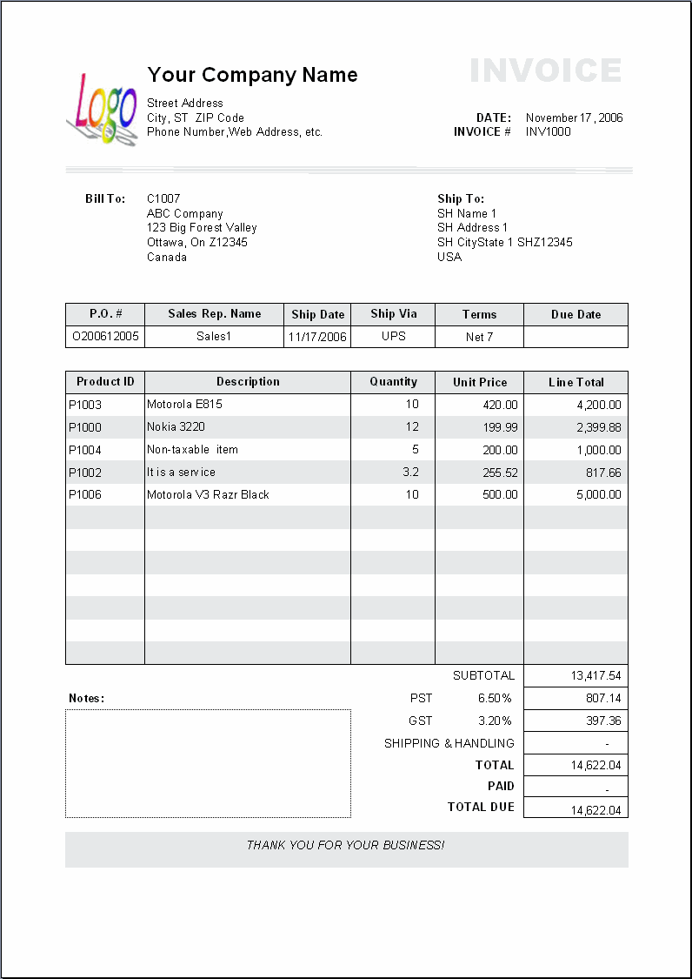

**FREIGHT FORWARDING**

Freight forwarding is a service used by companies that deal in international or multi-national import and export. While the freight forwarder doesn't actually move the freight itself, it acts as an intermediary between the client and various transportation services. Sending products from one international destination to another can involve a multitude of carriers, requirements and legalities. A freight forwarding service handles the considerable logistics of this task for the client, relieving what would otherwise be a formidable burden.

**1. Air freight**

Air freight forwarding is the process of transporting the goods to its destination using the aeroplane cargo.  Air freight forwarding can ship up to 43,000 lbs of cargo. An air freight forwarder can be a firm or an individual in line with the business of transporting goods.  An air freight forwarder specifically uses airplanes as carriers for cargo dispatching.

An air freight forwarder functions to settle documents in the transportation of cargo from its origin to destination.  The air freight forwarder should be competent and is able to deliver good service.  The air freight forwarder should assume accountability and be experienced enough.  Selecting the right air freight forwarder is very important.

**2. Ocean freight**

Ocean freight forwarding is the process of transporting goods to its destination using the ship cargo. A freight forwarder e.g a ocean freight forwarder is a firm specializing in arranging storage and shipping of merchandise on behalf of its shippers.

It usually provides a full range of services including: tracking inland transportation, preparation of shipping and export documents, warehousing, booking cargo space, negotiating freight charges, freight consolidation, cargo insurance, and filing of insurance claims. Freight forwarders usually ship under their own bills of lading or air waybills (called house bill of lading or house air waybill) and their agents or associates at the destination (overseas freight forwarders) provide document delivery, deconsolidation, and freight collection services.

|  |
| --- |
| **LEARNING ACTIVITY**  Identify air freight and ocean freight forwarders in South Africa. |

## 4.2 CARTAGE

Cartage is the charge for transporting goods for short distances, such as within a commercial area or town. Also called drayage or haulage. Cartage/freight outward is the same as transportation-out or delivery expense and is a selling or distribution expense. It's among the operating expenses which come after the gross profit line.

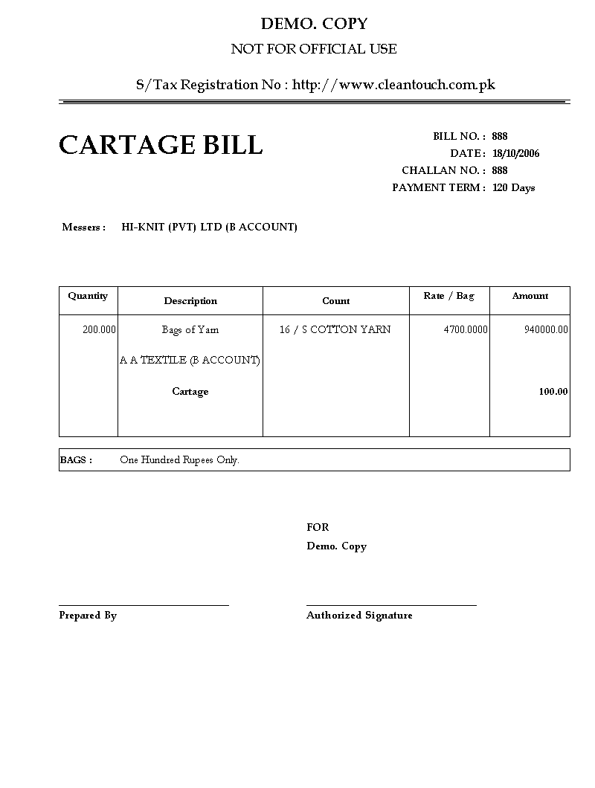

**NOTE:** Cartage can be added to the invoice just like shipping fees.

## 4.3 LANDSIDE AND SURFACE CHARGES

When preparing invoices were goods are subject to freight, landside and surface charges must be included. These charges include;

* Port authority charge
* Airline charges
* Depot charges and
* Carrier handling

**1. Port authority charge**

These are taxes and surcharge which apply to a **ship** and/or the cargo on board the **ship** once it has reached **port**.The port charges consist of:

* Vessel related charges consisting of port dues, pilotage, berth hire charges and anchorage charges.
* Cargo handling charges consisting of wharfage and storage.
* Other charges like the hire charges for the use of port equipments, etc.

The port tariff does not include the following:

* Charges paid to the transhipper owners for handling ores.
* Labour paid to the Cargo handling labour dept, handling agent's association.
* Charges paid for the services of cargo handling agents towards cost of gear, supervision, hire of machinery and trucks, and other incidental expenses.
* Charges paid to ship agents, custom house agents etc.

**2. Airline charges**

These are costs that the cargo owner pays to the airline for using a particular airline to transport the cargo. The air freight will be quoted per weight. With this it means that a shipment of 1 kg will probably be more expensive per kg than a shipment of 500 kg. Elements of the airline charge;

* Fuel (FUE): the fuel charge is normally the price for fuel/kg actual weight.
* Security (SCC): This is a charge for the security measures they need to take. This is normally also charged per kg actual weight.
* The local charges are charges like the customs clearance, pick-up, handling, screening, etc..
* Unit Load Device charges: These rates are charged per container/ULD without reference to the commodity loaded therein.

|  |
| --- |
| **NOTE:** Air freight calculations  The airline calculates freight based on weight or volume, which ever yields the greatest amount. Airlines quote freight rates based on the following rate structures:   * A basic minimum charge per shipment. * General cargo rates quoted for per kilogram. This rate applies without reference to the nature or description of the parcel, which is to be freighted. * Specific commodity rates apply to certain goods of specific descriptions, such as fresh produce. These rates are lower than the general cargo rate, and they provide breakpoints at which the level of the rate reduces further. |

**3. Depot charges**

These are fees that storage companies charge to store cargo at a port terminal. The charge is based on;

* The nature of goods in the cargo
* Time period
* Weight
* Space occupied.

**4. Carrier handling charge**

Carrier’s pay customs to release the goods upon importation, this allows for a rapid speed up the clearance procedures so as the carrier is paying this revenue on your behalf they do not do this for nothing, you are charged a small fee to cover their unique costs.

|  |
| --- |
| **LEARNING ACTIVITY**  Discuss the various landside and surface charges that must be paid during shipment of goods. |

## 4.4 CUSTOMS CHARGES

**Customs** is an authority or agency in a country responsible for collecting and safeguarding customs duties and for controlling the flow of goods including animals, transports, personal effects and hazardous items in and out of a country. A fee is charged by the customs known as customs duty.

Customs duties are imposed by the Customs and Excise Act 91 of 1964. They are levied on imported goods with the aim of raising revenue and protecting the local market.

**4.4.1 TYPES OF DUTIES**

Three kinds of duties are levied on imported goods:

* customs duties (including additional ad valorem duties on certain luxury or non-essential items);
* anti-dumping and countervailing duties; and
* VAT (which is also collected on goods imported and cleared for home consumption).

**1. Customs duty**

Customs duty is levied on imported goods and is usually calculated as a percentage on the value of the goods (set in the schedules to the Customs and Excise Act). However meat, fish, tea, certain textile products and certain firearms attract rates of duty calculated either as a percentage of the value or as cents per unit (for example, per kilogram or metre).

Additional ad valorem customs duties are levied on a wide range of luxury or non-essential items such as perfumes, firearms and arcade games.

**2. Anti-dumping and countervailing duty**

Anti-dumping and countervailing duties are levied:

* on goods considered to be "dumped" in South Africa; and
* on subsidised imported goods.

These goods are the subject of investigations into pricing and export incentives in the country of origin; the rate imposed will depend on the result of the investigations. These duties are either levied on an ad valorem basis (as a percentage of the value of the goods) or as a specific duty (as cents per unit).The amount and type of duty imposed on a product is determined by the following main criteria:

* the value of the goods (the customs value);
* the volume or quantity of the goods; and
* the tariff classification of the goods (the tariff heading).

**3. Value-Added Tax**

Section 7(1)(b) of the Value-Added Tax Act 89 of 1991 levies VAT at a rate of 14% on the importation of goods into South Africa from export countries - including Botswana, Lesotho, Namibia and Swaziland. However, certain goods imported into South Africa are – under Section 13(3) read with Schedule 1 - exempt from VAT on importation.

Section 13(2)(a) of the VAT Act sets the value to be placed on the importation of goods into South Africa. The value is deemed to be: the value of goods for customs duty purposes; plus any duty the Customs and Excise Act levies on the importation; plus 10% of that value. However, Section 13(2)(b) provides that the value is not increased by the factor of 10% if the goods have their origin in Botswana, Lesotho, Namibia or Swaziland.

**4.4.2 CUSTOMS DECLARATIONS**

A declaration made to Customs on a bill of entry at the time of importation and exportation must be accurate and correct. Acceptance of the bill of entry by Customs does not mean that the information provided has been accepted as being correct.

These bills of entry and related documents must normally be retained for five years. If errors are detected by Customs - whether duties were payable or not - the Act provides for penalties of up to three times the value of the goods, in addition to the forfeiture of the goods.

Importers importing commercial goods into South Africa, and exporters exporting commercial consignments from South Africa, must register with SARS. Non-commercial consignments are, however, excluded from registration, provided that this is limited to three importations per year.

|  |
| --- |
| **Rebates**  Certain rebates, such as industrial rebates, are available on goods that meet specific criteria and have been imported for a specific industry.  General rebates may apply if goods have been imported:   * temporarily; * for repair; * as passengers’ baggage; or * For local manufacturing destined for the export market only. |

**4.4.3 BILL OF ENTRY**

Before the recent 2006 introduction of the SAD 500, the document required by Customs & Excise from exporters, was known as the Bill of Entry Export (DA550). This has been replaced by the SAD500.

|  |
| --- |
| **THE CUSTOMS DECLARATION FORM (SAD 500)**  The Customs Declaration Form (SAD 500) is a South African document required by the South African Revenue Service (SARS). The purpose of this document is to ensure that exported goods are properly declared to SARS. In effect the document is submitted to the Commissioner of Customs - a sub-department of SARS - at the time that the goods are exported. The document(s) will need to be approved by Customs before the goods will be allowed to be exported. There are several types of Customs declaration forms (previously referred to as Bills of Entry Export), divided up as follows:   * SAD 500 - This common document needs to be submitted in the case of the export of South African goods, the re-export of imported goods, and the export of ships/aircraft stores. * SAD 501 - This document is required when the SAD 500 is not long enough and you need a continuation sheet to get all the items listed. * SAD 502 - This document is to be used for Transit Control (cross border movements). * SAD 505 - This document is required for Bond Control (internal bonded movements). * SAD 507 - This form is to be used to reflect any additional information in cases where the space provided on the SAD 500 is not sufficient.   All of these forms require the exporter or his/her agent to indicate the foreign consignee, the place of export (port or airport), the form of transportation and the estimated date of departure, on the forms. , Customs & Excise will require an original and one copy of the SAD 500 for non ex warehouse exports and one original and two copies in the case of export of goods from bond. |

View <http://www.sars.gov.za/home.asp?pid=4153&tid=60&s=forms&show=1084#SAD 500 Goods Declaration> for a copy of SAD 500

**4.4.4 DEFERMENT ACCOUNT**

If a company intends to import on a frequent basis, a Deferment Account is an efficient method of paying the duty and VAT due.

To get a deferment account, you will need to provide financial security (from a bank or insurance company) to cover each and every sum you defer up to an overall maximum amount in any calendar month. This amount is your deferment limit for the month and must not be exceeded. You will also need to complete a direct debit mandate to enable us to take a payment from your bank account of the total charges deferred.

Upon successful deferment application, you will be allocated a Deferment Approval Number (DAN) that must be quoted on the import declaration if you wish to pay for charges due by duty deferment.

|  |
| --- |
| **NOTE**  The charges you defer during one calendar month (the deferment accounting period for customs duties and import VAT) must be paid as a total sum on the 15th of the next month, or if the 15th is not a working day, on the next working day after it. |

## 4.5 DISBURSEMENT CHARGES

Other disbursements charges can include;

* Packing
* Fumigation
* Inspection
* Insurance

These charges must be identified and reconciled with invoices from those parties taking into account all over and under recoveries.

**1. Packing fee**

These are charges that are levied by companies that do packaging of cargo to ensure that goods are secured and properly packed in the cargo.

**2. Fumigation fee**

Some goods must be fumigated before shipment to avoid the spread of pests to other countries. These goods can include; e.g. wooden pallets and crates, wood, wool etc have been fumigated or sterilized prior the international shipment. Companies that fumigate levy a charge for their fumigation services.

**3. Inspection fee**

This is the fee that must be paid for inspectors to check if your goods comply with the legislations of both the exporting country and the importing country.

**4. Insurance fee**

This is a premium that one pays to an insurance company to safeguard himself against damage, or loss to goods in the cargo.

|  |
| --- |
| **NOTE**  The above costs must be invoiced and reconciled were necessary. |

## 4.6 SUPPLEMENTARY CHARGES

Defines and maintains charges that can be added to a Customer Invoice/Credit Note that are over and above Product sales, like;

* freight charges,
* insurance
* Packaging

These charges must be invoiced and necessary accounts created for proper recording. Below is a diagram which shows the process that takes place between the accounting side of the supplier and the customer.

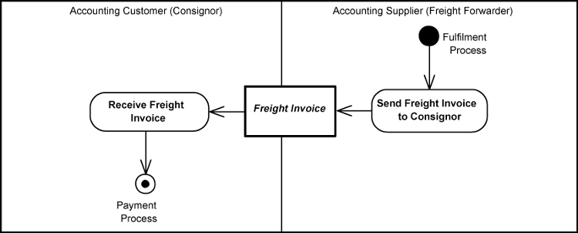

|  |
| --- |
| **LEARNING ACTIVITY**  Assume you are shipping computers to Asia; identify examples of supplementary charges that you may pay. |

## 4.7 RECONCILIATION

Reconciling your vendor statements allows you to ensure that there are no mistakes or inaccuracies between what the vendor is charging you and the inventory, services or supplies you received. Statements typically arrive around the same time each month. Reconciliation requires matching the statement's line items with your invoices.

**Step 1**

Organize your invoices for the vendor by date. If you use a computer program for your accounting, click on the option to organize by date. If you perform your accounting tasks by hand, pull the invoices and stack them with the oldest date on top.

**Step 2**

Match the line items on your vendor statement to your invoices. Typically, businesses reconcile the invoices as shipments arrive, so your invoices should reflect the correct count and dollar amount of each shipment.

**Step 3**

Place check marks on your statement when the invoice matches the line item. For example, if you have an invoice for 12 cases of widgets you received on the 10th, there should be a line item on the statement corresponding to that shipment. Compare the statement's invoice number for that item and, if they match, place a check beside the statement item.

**Step 4**

Circle any items that you do not have invoices to match. Make a note of the invoice number on the statement. Call the vendor and request a copy of any invoices you are missing by fax or email. If the vendor mistakenly put the wrong invoice number on your statement, mark through the line item and add a note for the vendor's accounts receivable department about the inaccuracy. Subtract any erroneous charges from the statement total.

**Step 5**

Add all of the relevant invoices and compare the amount with your statement total. If the amounts do not match, check your math. Often you will find the problem in a transposed number or inaccurate calculation.

|  |
| --- |
| **LEARNING ACTIVITY**  Explain the importance of reconciling statements and invoices. |

# SECTION 5: DISBURSING ITEMS FOR RECOVERY





**Specific Outcome**

On completion of this section you will be able to identify and disburse the items on behalf of the organisation to be recovered in the invoicing process.

**Assessment Criteria**

On completion of this section you will be able to:

* Cartage charges as disbursed by the organisation, are identified and posted to the cartage disbursement account. .  (SO 5, AC 1)
* Storage charges as disbursed by the organisation are identified and posted to the storage disbursement account.  (SO 5, AC 2)
* All special charges such as extra attendance are disbursed by the organisation are identified and posted to the disbursement accounts.  (SO 5, AC 3)

## 5.1 INTRODUCTION

Inorder for one to be able to disburse accounting items to their appropriate accounts, knowledge of double entry accounting system is crucial.

According to the double entry system, every business transaction involves receiving aspect and giving aspect. If capital is brought in by the owner of the business unit, the owner is the giver of the benefit and the business unit is the receiver of the benefit. It is a liability to the business unit and it is equally balanced by an asset in the business unit, in the form of cash received towards capital. Therefore every liability is represented by an asset. This is also expressed as every debit has an equivalent credit.

**5.1.1 T- ACCOUNT FORMAT**

T account is a simple format used to aid in understanding account posting. This format shows a continuous balance that eliminates the need to total the debit and credit columns to find the correct balance of an account. The same principle of posting rand amounts to the left or debit column and the right or credit column applies whether a manual or computerised system is being used. A modified T format shows the key elements of a ledger account. The use of this format is more than adequate for academic understanding. Below is the illustration of the T-Format.

| **Account Title** | |
| --- | --- |
| Decreases & Increases | Increases & Decreases |

On the top of the horizontal bar there is the account title. Account decreases and increases are placed on the either side of the vertical bar: The left side of the T account is called a *debit*, and the right side is called a *credit*.

**Debit**is the left side of a T account.

**Credit**is the right side of a T account.

Often these two terms are abbreviated as Dr and Cr. It is common to say that an account has been debited when an amount is placed on the left side of an account, and credited if an amount is placed on the right side of the account.

**Account balance** is the difference between the debit side and the credit side of a T account.

The two important rules about the double-entry recording system are as follows:

|  |
| --- |
| **Assets = Claims (Liabilities and Owner's Equity)** |

And

|  |
| --- |
| **Total Debits = Total Credits** |

3. Effects of d

**5.1.2 EFFECT OF DEBITS AND CREDITS**

As we mentioned earlier, a debit is the left side and a credit is the right side of an account. Increases and decreases are recorded differently for asset and claim accounts. Here is what we mean:

1. Debit entries increase asset accounts, and decrease liability and equity accounts.
2. Credit entries increase liability and equity accounts, and decrease asset accounts.

**Illustration 1: Effects of debits and credits in T accounts**

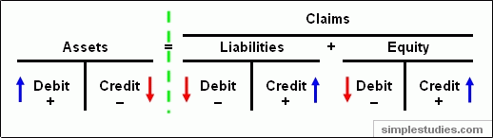

An easy way to remember these rules is to learn that increases are posted on the outsides (see plus signs above) and decreases are posted on the insides (see minus signs above). That rule holds true for asset as well as liability and equity accounts.

**ILLUSTRATIONS**

**Event No. 1** (Analysis of cash contribution transaction)

On January 1, 20X6 the owner made a R10, 000 cash contribution. This accounting event acts to increase both assets (Cash) and equity (Contributed Capital). The increase in the Cash account is recorded as a debit and the increase in the Contributed Capital account (equity) is recorded as a credit:

**Illustration 2: Effect of a capital contribution in T accounts**

|  |  |  |  |  |  |  |  |
| --- | --- | --- | --- | --- | --- | --- | --- |
| **Assets** | | **=** | **Liabilities** | | + | **Equity** | |
| **Cash** | |  |  | |  | **Contributed Capital** | |
| Debit (1) + 10,000 |  |  |  |  |  |  | Credit (1) + 10,000 |

This is an asset source transaction:

**Illustration 3: Effect of a capital contribution in the horizontal model**

| **Assets** | **=** | **Liabilities** | **+** | **Equity** | **Rev.** | **-** | **Exp.** | **=** | **Net Inc.** | **Cash Flow** | |
| --- | --- | --- | --- | --- | --- | --- | --- | --- | --- | --- | --- |
| 10,000 | = | n/a | + | 10,000 | n/a | - | n/a | = | n/a | 10,000 | FA |

**Event No. 2** (Analysis of supplies purchase on account transaction)

On May 15, HEY Consultants purchased R400 worth of office supplies from a local supply company on account (i.e., agreed to pay for them on a later date). Purchasing supplies on account acts to increase assets (Supplies) and liabilities (Accounts Payable). The Supplies account is debited and the Accounts Payable account is credited:

**Illustration 4: Effect of a supplies purchase in T accounts**

|  |  |  |  |  |  |  |  |
| --- | --- | --- | --- | --- | --- | --- | --- |
| **Assets** | | **=** | **Liabilities** | | + | **Equity** | |
| **Supplies** | |  | **Accounts Payable** | |  |  | |
| Debit (2) + 400 |  |  |  | Credit (2) + 400 |  |  |  |

This is an asset source transaction:

**Effect of a supplies purchase in the horizontal model**

| **Assets** | **=** | **Liabilities** | **+** | **Equity** | **Rev.** | **-** | **Exp.** | **=** | **Net Inc.** | **Cash Flow** | |
| --- | --- | --- | --- | --- | --- | --- | --- | --- | --- | --- | --- |
| 400 | = | 400 | + | n/a | n/a | - | n/a | = | n/a | n/a |  |

**Event No. 4:** (Analysis of paying cash for expenses transaction)

On May 25, 20X6 the company paid R600 cash for operating expenses. The expense recognition acts to decrease assets (Cash) and equity (Operating Expenses). The Cash account is credited and the Operating Expense account is debited:

**Illustration 8: Effect of paying operating expenses in T accounts**

|  |  |  |  |  |  |  |  |
| --- | --- | --- | --- | --- | --- | --- | --- |
| **Assets** | | **=** | **Liabilities** | | + | **Equity** | |
| **Cash** | |  |  | |  | **Operating Expense** | |
|  | Credit (4)  - 600 |  |  |  |  | Debit + Expense [ - Equity] (4)  - 600 |  |

An increase in expenses results in a decrease in equity. That's why we showed expenses with a plus sign and equity underneath them with a minus sign.

This is an asset use transaction:

**Effect of paying operating expenses in the horizontal model**

| **Assets** | **=** | **Liabilities** | **+** | **Equity** | **Rev.** | **-** | **Exp.** | **=** | **Net Inc.** | **Cash Flow** | |
| --- | --- | --- | --- | --- | --- | --- | --- | --- | --- | --- | --- |
| (600) | = | n/a | + | (600) | n/a | - | (600) | = | (600) | (600) | OA |

Note the R600 cash outflow. The company paid cash for expenses so there is a cash decrease related to this transaction.

**Worked example**

Transaction 1: R280 is received for merchandise sold.

Transaction 2: A R65 utility bill is paid.

Transaction 3: A truck costing R10, 000 is purchased on credit.

Transaction 4: The owner deposits a R1000 personal check into the business bank account.

Transaction 5: A R500 payroll tax liability is paid.

Transaction 6: The owner buys R35 in groceries with a business cheque.





As each transaction is posted, with the exception of entry (3), the cash account balance goes up and down accordingly. The end result in this example is a debit (positive) cash balance of R680.

## 5.2 DISBURSING CARTAGE CHARGES

If you sometimes pay suppliers on behalf of your customers and you pass on the cost to your customers then you must treat these payments as 'disbursements'. Let’s look at the following example;

**WORKED EXAMPLE**

01/02/2012 We sold R20 000 worth of computers to CBX, a company in Zambia. We paid cartage charges of R2 000 cash on their behalf.

1. Show the double entry transaction for the payment
2. Show the double entry transaction for the transfer to the disbursement account

**Cash Account**

|  |  |
| --- | --- |
| **DR** | **CR** |
|  | 01/02/2012Cartage fee 2 000 |

**Cartage charges account**

|  |  |
| --- | --- |
| **DR** | **CR** |
| 01/02/2012 Cash 2 000 | Cartage disbursement account 2 000 |

**Cartage Disbursement account- CBX**

|  |  |
| --- | --- |
| **DR** | **CR** |
| Cartage charges 2 000 |  |



|  |
| --- |
| **LEARNING ACTIVITY**  01/087/2012 We sold R100 000 worth of computers to Netwok, a company in Zimbabwe. We paid cartage charges of R20 000 cash on their behalf.   1. Show the double entry transaction for the payment 2. Show the double entry transaction for the transfer to the disbursement account |

## 5.3 DISBURSING STORAGE CHARGES

The producer can also pay for storage charges on behalf of a customer and recover the money through invoicing. To this end, a disbursement account must be created for each transaction. Let us look at the worked example below.

**WORKED EXAMPLE**

On the 30/03/2013 we received an order from our usual client T&D computers for the purchase of 100 computers (each costing R6000). We sent the computers to the airport for shipment the next day. Since the computers had to be stored until the next day we had to pay storage fee of R10 000. We paid with a cheque

1. Show the double entry transaction for the payment
2. Show the double entry transaction for the transfer to the disbursement account

**Bank Account**

|  |  |
| --- | --- |
| **DR** | **CR** |
|  | **30/03/2013** storage fee 10 000 |

**Storage expense account**

|  |  |
| --- | --- |
| **DR** | **CR** |
| **30/03/2013** cash 10 000 | Storage charges disbursement 10 000 |

**Storage charges disbursement account**

|  |  |
| --- | --- |
| **DR** | **CR** |
| **30/03/2013** storage expense 10 000 |  |



|  |
| --- |
| **LEARNING ACTIVITY**  On the 20th of Feb 2013 we sold 300 computers to Ajex wholesalers. The cost per unit was R8000. We paid a storage fee on their behalf through our bank account. The storage fee was 2 % of the total purchase price.   1. Show the double entry transaction for the payment 2. Show the double entry transaction for the transfer to the disbursement account |

## 5.4 DISBURSING SPECIAL CHARGES

The seller can also pay on behalf of the client, special charges such as extra attendance and recover the paid sum via the invoicing system. The special charge disbursement account must be created. Let us look at the following example.

**WORKED ACTIVITY**

Computer World bought R500 000 worth of laptops and tablets from our company on the 1st of May 2013. Since the consignment required extra security during delivery we hired CTM security to escort the cargo. We paid CTM security R25 000 (cash) on behalf of Computer Word.

1. Show the double entry transaction for the payment
2. Show the double entry transaction for the transfer to the disbursement account

**Cash Account**

|  |  |
| --- | --- |
| **DR** | **CR** |
|  | 01/05/2013 security fee 25 000 |

**Security expense account**

|  |  |
| --- | --- |
| **DR** | **CR** |
| 01/05/2013 cash 25 000 | 01/05/2013Security disbursement 25 000 |

**Security disbursement account**

|  |  |
| --- | --- |
| **DR** | **CR** |
| 01/05/2013Security disbursement 25 000 |  |

