Name
Contact Address
Telephone (H)
Telephone (W)
Facsimile
Cellular
DESCRIBE THE CONCEPTS OF INFORMATION AND COMMUNICATION TECHNOLOGY (ICT) AND THE USE OF ITS COMPONENTS IN A HEALTHY AND SAFE MANNER
UNIT STANDARD ID
117925
LEVEL 2
CREDITS 3

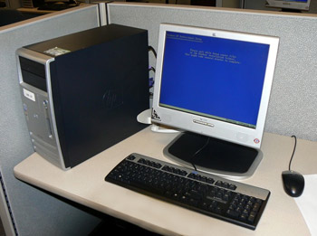
LEARNER GUIDE

SAQA UNIT STANDARD ALIGNMENT
SPECIFIC OUTCOMES (SO) |  | LEVEL | CREDITS
UNIT STANDARD 117925:
Use Describe the concepts of information and Communication Technology (ICT) and the use of its components in a healthy and safer manner
 |  | 2 | 3
  SPECIFIC OUTCOME 1
  Describe the components of Information and Communication Technologies.
  ASSESSMENT CRITERION 1
  Types of computers are described in terms of their size, application, and relation to each other.
  ASSESSMENT CRITERION RANGE
  Types of computers - at least five of: mainframes, minicomputers, personal computers, network computers (thin clients), laptop computers, multimedia computers, personal digital assistants (PDA).
  ASSESSMENT CRITERION 2
  The components of a personal computer are described in terms of their role in the system as a whole is described.
  ASSESSMENT CRITERION RANGE
  Input, output, storage, peripherals, ROM, Ports (Serial, Parallel, USB).
  ASSESSMENT CRITERION 3
  The major components of ICT are described in terms of their relationship to each other.
  ASSESSMENT CRITERION RANGE
  Components include but is not limited to: Client computers (typically PCs), Various Networks (LANs & WANs), server computers, the Internet.
  SPECIFIC OUTCOME 2
  Describe the hardware components of a personal computer.
  ASSESSMENT CRITERION RANGE
  At least two of: Memory types: RAM ROM, ROM-BIOS, Video memory, PROM.
  ASSESSMENT CRITERION 3
  Input devices are identified and described in terms of their purpose and functions.
  ASSESSMENT CRITERION 1
  The Central Processing Unit (CPU) is described in terms of its purpose and functions.
  ASSESSMENT CRITERION 2
  The Memory of a personal computer is defined in terms of memory size, the types of memory and their purpose.
  ASSESSMENT CRITERION RANGE
  At least six of: Mouse, keyboard, trackball, microphone, touchpad, light pen, scanner, joystick, digital camera.
  ASSESSMENT CRITERION 4
  Output devices are identified and described in terms of the variety, their purpose and functions.
  ASSESSMENT CRITERION RANGE
  At least four of: Monitors (Visual Display Units (VDU)), printers, plotters, speakers, speech synthesisers, microfilm (microfiche).
  ASSESSMENT CRITERION 5
  Input/output devices are identified and described in terms of their purpose and function.
  ASSESSMENT CRITERION RANGE
  Touch screen, modem.
  ASSESSMENT CRITERION 6
  Storage devices are identified and described in terms of their purpose, capacity and functioning.
  ASSESSMENT CRITERION RANGE
  At least three of: Floppy/stiffy disks, hard disks, magnetic tape streamers, CD-ROM, ZIP drives and cartridges, flash disks.
  SPECIFIC OUTCOME 3
  Describe software for personal computers.
  ASSESSMENT CRITERION 1
  The types of software are described in terms of purpose.
  ASSESSMENT CRITERION RANGE
  Operating system software, applications software.
  ASSESSMENT CRITERION 2
  Operating system software is defined in terms of its function, providing examples of current OS software commonly in use.
  ASSESSMENT CRITERION RANGE
  Functions include but not limited to: Interface to hardware, interface between application software, and interface to printing.OS software include but is not limited to: MS Windows, UNIX, Linux, and Macintosh.
  ASSESSMENT CRITERION 3
  Applications software is defined and examples of applications software types and the specific application for each is described.
  SPECIFIC OUTCOME 4
  Describe information networks in relation to ICT.
  ASSESSMENT CRITERION 1
  "Data communication" is defined in terms of its different forms of data communication and examples given.
  ASSESSMENT CRITERION 2
  The networking of computers are explained in terms of its use, advantages and disadvantages.
  ASSESSMENT CRITERION 3
  The terms LAN and WAN are explained in terms of their scope and usage.
  ASSESSMENT CRITERION RANGE
  Distinguish between same graphical area and wide spread area.
  ASSESSMENT CRITERION 4
  Different types of telephone network connections used for access to the Internet are explained with examples.
  ASSESSMENT CRITERION RANGE
  Any 2 of: Analogue (Pulse), Digital (Tone), ADSL (Direct), Wireless.
  SPECIFIC OUTCOME 5
  Describe ergonomic principles for computer workstations.
  ASSESSMENT CRITERION 1
  The ergonomic principles for computer workstations are explained in terms of their application and purpose.
  ASSESSMENT CRITERION 2
  Environmental conditions relating to ergonomics of computer workstations are explained in terms of their impact on personal well being.
  ASSESSMENT CRITERION RANGE
  At least two of the following: environmental conditions: lighting, ventilation, VDU positioning, VDU glare, seating, position and use of input devices (e.g. keyboard, mouse), breaks away from the computer.
  SPECIFIC OUTCOME 6
  Explain health and safety when working with computers.
  ASSESSMENT CRITERION 1
  Current legislation related to health and safety in the ICT environment are identified and explained with examples.
  ASSESSMENT CRITERION 2
  Personal injuries related to incorrect ergonomics when working with computers are explained with examples.
  ASSESSMENT CRITERION RANGE
  At least two of the following: back pain, neck pain, repetitive strain injury (RSI), eye strain.
  ASSESSMENT CRITERION 3
  Common precautions that can be taken when working with computers are explained in terms of how they ensure safe working environment.
  ASSESSMENT CRITERION RANGE
  At least two of the following: trailing power leads and/or cables, insecure power leads, worn or frayed power leads, overloaded power points.
  ASSESSMENT CRITERION 4
  ICT working practices are explained in terms of ways to minimise the effect of working practices on the immediate environment.
  ASSESSMENT CRITERION RANGE
  At least two of the following: recycling paper, recycling ink/toner cartridges, redundant peripheral devices, low power options on devices, use of "standby" or "sleep" modes for devices, digital formats for communication and storage of documents. Effects can be harmful or positive.
  SPECIFIC OUTCOME 7
  A computer workstation is set up taking ergonomic principles and health and safety issues into account.
  ASSESSMENT CRITERION 1
  The computer workstation is set up taking ergonomic principles into account.
  ASSESSMENT CRITERION RANGE
  Ergonomic principles include but are not limited to: lighting, VDU position, seating, position and use of input devices (e.g. keyboard, mouse).
  ASSESSMENT CRITERION 2
  A computer workstation is set up taking health and safety issues into account.
  ASSESSMENT CRITERION RANGE
  Health and safety issues include but are not limited to: Power leads, cables, power points.

Table of Contents
Introduction to Computer Basics 15
Lesson 1 - What is a computer? 15
Computers Simplified 15
What are the Different Types of Computers? 15
Types of Personal Computers 17
Activity 1 18
Lesson 2 - What is an operating system? 19
The Operating System's Job 19
Types of Operating Systems 20
Microsoft Windows 21
Apple Mac OS 22
Linux 23
Activity 2 24
Lesson 3 - What are the basic parts of a desktop computer? 25
Basic Parts of a Desktop Computer 25
Activity 3 29
Lesson 4 - What are all the buttons, sockets, and slots used for? 30
Front of Computer Case 30
Back of Computer Case 31
Peripherals You Can Use in Various Ports 34
Activity 4 36
Lesson 5 - What is inside a desktop computer? 37
A Look Inside a Desktop Computer 37
Activity 5 42
Lesson 6 - How do I connect to the Internet? 43
Types of Internet Access 43
Choosing an Internet Service Provider (ISP) 44
Hardware Needed 45
Activity 6 46
Lesson 7 - What are the basic parts of a laptop computer? 47
Basic Parts of a Laptop Computer 47
Activity 7 49
Lesson 8 - What are all the buttons, sockets, and slots used for? 50
Laptop Buttons, Drives, and Ports 50
Peripherals You Can Use in Various Ports 54
Activity 8 56
Lesson 9 - What is inside a laptop computer? 57
A Look inside a Laptop Computer 57
Activity 9 60
Lesson 10 - How do I connect to the Internet? 61
Types of Internet Access 61
Dial-up Access 61
DSL Access 61
Cable Access 61
Satellite Access 62
Choosing an Internet Service Provider (ISP) 62
Wireless Connections 63
Activity 10 64
Lesson 11 - How do I set up a computer 65
Setting Up a Desktop Computer 65
Set Up Complete 72
After the Hardware... 72
Activity 11 74
Lesson 12 - How do I keep my computer healthy? 75
Keep Your Computer Physically Clean 75
Keep Your Computer Physically Clean 76
Keep Your Computer Physically Clean 78
Cleaning the Monitor 78
To Clean an LCD/Flat-Panel Screen 79
Tips for Cleaning Other Computer Surfaces 79
Keep Your Computer Safe 80
Viruses, Trojan Horses, and Worms 80
Protect Your Computer 80
Tips to Stay Safe 80
Deleting Files 81
Emptying the Recycle Bin 82
Disk Cleanup for Windows 83
Windows XP 83
Windows Vista 84
Activity 12 85
Lesson 13 - What are some troubleshooting techniques? 86
Basic Troubleshooting Tips 86
Specific Troubleshooting Problems 87
Activity 13 93
Lesson 14 - What is a network? 94
Why Would You Use a Home Network? 94
What Do I Need to Create a Home Network? 94
What Types of Networks Are There? 96
Terms to Know 97
Activity 14 98
Lesson 15-Health, Safety and Environment 99
Ergonomics 99
Health Issues 100
Precautions 101
The Environment 101
Security 102
Vulnerability of data (Data Backup) 105
Implications of Theft 106
Computer Viruses 107
Lesson 16- Copyright and the Law 109
Copyright 109
Copyright Issues 109
Licensing Issues 110
Data Protection Legislation 111
Lesson 17- Working with files and folders 112
Using libraries to access your files and folders 113
Creating a new file 116
Applies to Windows Vista 116
Create a new folder 116
Viewing and arranging files and folders 123
Finding files 124
Copying and moving files and folders 125

Introduction to Computer Basics
Are you new to using the computer? Do you want to learn about desktops and laptops? Wish you knew more how your computer does its job? Introduction to Computer Basics introduces the basic concepts you need to know.

Lesson 1 - What is a computer?

A computer is an electronic device that manipulates information or "data." It has the ability to store, retrieve, and process data. You can use a computer to type documents, send email, and surf the Internet. You can also use it to handle spreadsheets, accounting, database management, presentations, games, and more.
Whether you realize it or not, computers play an important role in our lives. When you withdraw cash from an ATM, scan groceries at the store, or use a calculator, you're using a type of computer

Computers Simplified
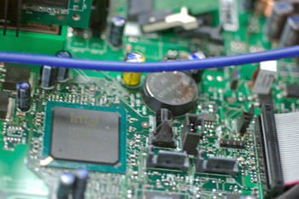
Inside a Computer -- Part of the Computer Motherboard For beginning computer users, the computer aisles at an electronics store can be quite a mystery, not to mention overwhelming. However, computers really aren't that mysterious. All types of computers consist of two basic parts – hardware and software.
Hardware is any part of your computer that has a physical structure, such as the computer monitor or keyboard. If you can touch it, it is hardware. Software is any set of instructions that tells the hardware what to do. It is what guides the hardware and tells it how to accomplish each task.
Anything you buy for your computer can be classified as either hardware or software. Once you learn more about these items, computers are actually very straightforward.
The first electronic computer, the Electronic Numerical Integrator and Computer (ENIAC), was developed in 1946. It measured 18 feet by 80 feet and weighed 30 tons.

What are the Different Types of Computers?
There are many types of computers, but personal computers such as desktop and laptop computers are probably the two type of computers that you think of first.

Desktop Computers
Example Desktop Computer
Many people use desktop computers, or desktops as they are often referred to, at work, home, school, or the library. They can be small, medium, or large in style, and usually sit on a desk. The term desktop actually refers to the casing, or the tower. Once you add a monitor, mouse, and a keyboard, you have what is typically known as a desktop computer.
Most desktop computers are easy to upgrade and expand, or add new parts. In addition to expandability, another benefit of desktop computers is the cost. If you compare a desktop computer with 128 MB of RAM and a 2 GB hard drive to a laptop with the same features, you will most likely find that the desktop computer is priced lower.
The term desktop computer originated when the computer case was wide and flat, and was designed specifically to fit on your desktop with the monitor on top.

Laptop Computers
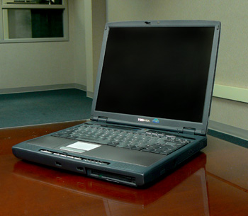
Example Laptop Computer
The second type of computer that you may be familiar with is a laptop computer, or laptops as they are often referred to. Laptops are battery or AC-powered personal computers that can be easily carried and used in a variety of locations.
A quick glance at the size of a laptop and you might guess that it would be difficult to expand or upgrade. While the desktop computer case is relatively easy to open and access internal components, the small laptop case makes this more difficult in comparison; however, the primary benefit of a laptop computer is its small size and easy portability.
A laptop computer is sometimes called a notebook computer because of its size.

Types of Personal Computers
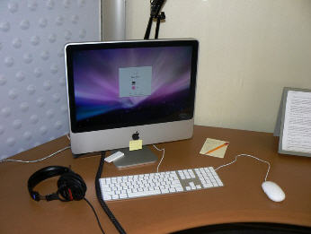
iMac all-in-one computer Two popular types of personal computers are the IBM compatible and Macintosh computers. The first personal computer was produced by IBM in 1981 and was called the IBM PC. In 1984, Apple Computer introduced the Macintosh, or Mac, and it became the first widely sold personal computer with a graphical user interface or GUI (pronounced gooey). Although both IBM and Apple computers are personal computers, the term PC came to refer to IBM or IBM-compatible personal computers.
Apple now produces a Macintosh computer called the iMac, which is a desktop computer that features an all-in-one design. This means all the internal components are located behind the monitor, rather than in a tower case, which is customary in desktop computers.
While our training is intended for people who use PCs and the Windows operating system, some of our information also applies to Macintosh computers.

Other Types of Computers
You may hear someone refer to a computer as a workstation or a server, especially at work. You may wonder how these two items are different from desktop computers.
Workstations are similar to desktop computers, but are more powerful and are usually connected to a network. Servers are specialized computers that store and deliver, or “serve up,” information to other computers on a network.
There are many different types of servers such as file servers, database servers, and web servers. For example, employees at a company might store all the business documents on a file server so that they can share files and access then from any computer on the network. When you use your browser to click a link, a web server delivers the page you requested on the Internet, the biggest network in the world.

Activity 1
- Think about the activities you perform or want to perform using a computer (email, online shopping, etc.).
- Think about all the computers that are necessary for you to complete your normal activities.
  - Is it a computer that controls the stoplights so you can drive to work?
  - How did the cashier scan and calculate your grocery items?
  - Does the coffee store you visit use a computer to order their inventory?
  - How does the department store manage their merchandise?

Lesson 2 - What is an operating system?

An operating system is the most important software that runs on a computer. You might be thinking, “OK, but what is software?” Software is any set of instructions that performs some task on a computer. The operating system performs many essential tasks for your computer.
It controls the memory needed for computer processes, manages disk space, controls peripheral devices, and allows you to communicate with the computer without knowing exactly how a computer works. Without an operating system, a computer is useless.

The Operating System's Job
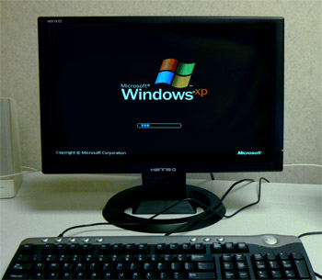
Windows Operating System Loading You've probably heard the phrase boot your computer, but do you know what that means? Booting is the process that occurs when you press the power button to turn your computer on. At the end of at process, the operating system loads.
From this point, the operating system begins to do its job of controlling the way in which the computer functions. The operating system is responsible for managing the computer's hardware and software resources.
Basically, the operating system serves as the boss, or manager, and makes sure all the various parts of the computer get what they need.

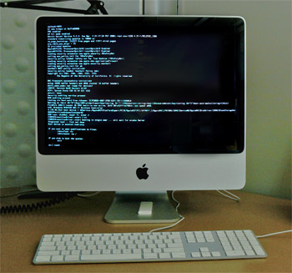
Mac OS Loading When you use your personal computer, you may work on a Word document, print an email, and have your Internet browser open for web surfing, all at the same time. These three programs need attention from the central processing unit (CPU) to do whatever task that you, the user, are telling it to do.
These programs need memory and storage, and need to be able to send messages to devices such as the mouse and the printer to accomplish these tasks.
The operating system is responsible for handling these areas, as well as processor and network management.

What Makes This Job So Difficult?
Let's say you went to your local electronics store and bought language software to learn Spanish. How did the computer programmer who developed the software know that it would work on your computer?
The operating system provides a consistent way for software applications to work on various computers without needing to know specific details about each computer's hardware. It doesn't matter that each computer may have a different amount of memory or processor speed.

Types of Operating Systems

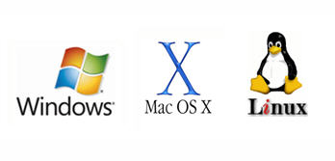
Microsoft Windows, Mac OS X, and Linux Logos Operating systems usually come preloaded on the desktop and laptop computers that you can buy today. Most people use the operating system that comes with their computer, but it is possible to upgrade or even change operating systems.
The three most common operating systems for personal computers are Microsoft Windows, Apple Mac OS X, and Linux.
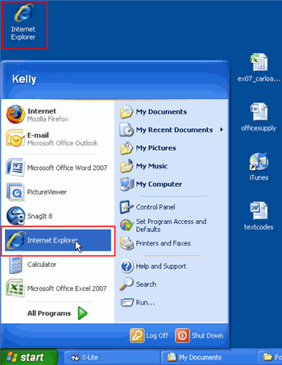
Start Menu on Windows GUI Each of these operating systems uses a graphical user interface (GUI), which allows the user to interact with the computer. Instead typing a command that tell the computer what to do, you can use graphical icons and text on the GUI to instruct the computer to perform a task.
For example, if you want your computer to open the browser, Internet Explorer, simply double-click the Internet Explorer icon on the desktop, or select it from the Start menu.
Many users associate the operating system with the GUI because this is the part of the operating system that the user interacts with on a daily basis.
Let's take a look at the graphical user interfaces of three popular operating systems.

Microsoft Windows
Microsoft created the operating system, Windows, in the mid-1980s. They have a version of the operating system that is designed for the home user, and a professional version, which is intended for businesses. The versions differ in the depth of networking, security, and multimedia support.
Windows is a proprietary software, which means that Microsoft has placed restrictions on how people can use or copy the software. Windows comes preloaded on most of the PCs sold today, and can also be purchased separately Various versions of the software are priced from $79 to $399 for home users.
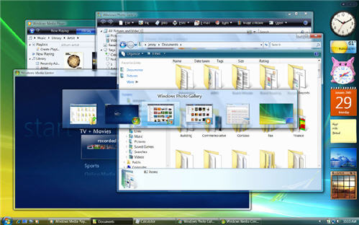

Windows Vista Desktop
Microsoft has a big share of the operating system market. According to web analyst Net Solutions, over 90% of computer users have one of the Windows operating systems, such as Windows 98, Windows 2000, Windows XP, or the most recent Windows Vista, as of March 2008.
Windows Vista and Windows XP are often referred to as Vista and XP, respectively.
Visit the Windows section of the Microsoft website to learn more about this operating system.

Apple Mac OS
Mac OS is a line of operating systems created by Apple Inc. The Mac operating system is proprietary software that comes preloaded on all new Macintosh computers, or Macs. The most recent version of the operating system is called Mac OS X (pronounced Mac O-S Ten). Like Microsoft, Apple offers a professional version of the operating system that is intended for use on servers and a version of the operating system that is developed for home users.

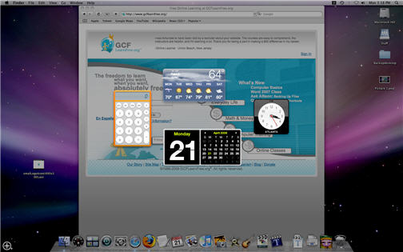

Mac OS X Desktop
According to web analyst Net Solutions, Mac OS users account for almost 7.5% percent of the operating systems market as of March 2008. Although the percentage of users is low, especially in comparison to Windows users, Mac operating systems have seen a dramatic jump in growth in 2007. Mac computers are sleek and modern looking, which has started to appeal to many home users.
Two of the common version names of Mac OS X are Leopard and Tiger.
To learn more about the Macintosh computers visit the Apple Inc. website, and explore the Mac computers available, as well as the Support center for information about the Mac OS.

Linux
Linux is an open source, or free, operating system. Unlike Windows and Mac OS, Linux is not proprietary software and all the computer code that is part of the operating system can be used and modified by any user. Linux was started in the 1990s when Linus Torvalds, a person interested in creating a free operating system, developed the Linux (pronounce lynn-ux) kernal, which is computer code that is a central part of an operating system.
As an open source software, any individual or company can take the Linux kernal and modify and add to it. Hundreds of companies and individuals have taken the Linux kernal and added additional computer programs to create various versions of the Linux operating system. These versions are known as distributions and are available to download for free.

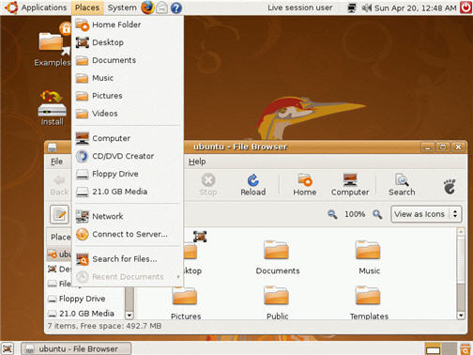

Ubuntu Desktop: A Version of Linux
Linux is extremely popular in businesses, especially for servers, because it is adaptable. According to Net Application statistics, Linux represents under 1% of the market share for home users, but it does offer an alternative to commercial operating systems.
Despite being used in many businesses for servers, you do not have need to have special programming skills to download and use Linux. In fact, if you want to try Linux, you don't have to actually install it on your computer. Several versions of the operating system can be downloaded and burned to a CD.
Two popular distributions of the software are Ubuntu and Red Hat. Ubuntu is completely free and is available in a version geared specifically for home users. Red Hat is a company that offers technical and training support for businesses that use its version of the operating system, Red Hat Linux.
To learn more about Linux and how this open source software works, visit Linux Online.

Activity 2
- What is an operating system? Is it software?
- You are viewing this lesson on a computer. Do you know what operating system the computer is using? If not, find out.
- Visit the Microsoft, Apple, and Linux websites to learn more about each operating system.
- Search the Internet for articles that compare Windows Vista and Mac OS X.
- If you have a PC and currently use an older version of Windows, such as Windows XP, search for articles comparing Windows Vista with Windows XP. Gather information from Microsoft and other reputable sources to determine if an upgrade is right for you.

Lesson 3 - What are the basic parts of a desktop computer?
All of the basic parts of a desktop computer are considered hardware. The computer case, monitor, keyboard, mouse, and power cord are considered the basic parts. These items are the things you notice right away when you look at a desktop computer.
Beyond these parts are the hardware items that are located inside the computer case and the peripherals, which are optional pieces of hardware that make the computer system more useful, or enable you to accomplish additional tasks. Let's take a look at the basic hardware components, or the things required in order to let you and the computer interact.

Basic Parts of a Desktop Computer
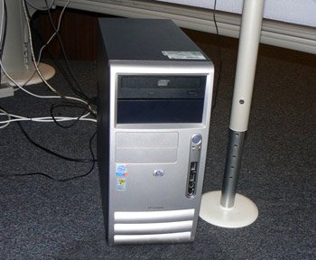
Computer Case Computer Case
The computer case is the metal and plastic box that contains the main components of the computer. It houses the motherboard, central processing unit (CPU), the power supply, and more.
Computer cases come in different shapes and sizes. A desktop case lies flat on a desk, and the monitor usually sits on top of it. A tower case is tall and sits next to the monitor or on the floor. The front of the case usually has an on/off switch and two or more drives.
Most of the personal computers you can purchase today include tower cases, rather than desktop cases; however, some computers are being made with all of the internal components built into the monitor, which completely eliminates the tower.

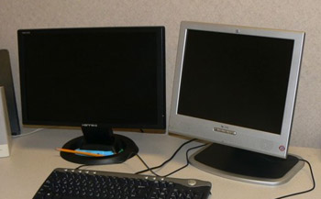
Computer with Two LCD Monitors Monitor
The monitor works with a video card, located inside the computer case, to display images and text on the screen. The two main types are cathode ray tube (CRT) and liquid crystal display (LCD) monitors.
The CRT monitor is big, like a tube television, and takes up a lot of desk space; however, it is the least expensive monitor option. The LCD monitor is thin and saves energy, but costs more. Over the years you can expect to see fewer CRT monitors as LCD monitors become the standard.
Your monitor has an on/off button and control buttons that allow you to change your monitor's display. Control buttons are either visible or located behind a small panel. Additionally, some monitors have built-in speakers.
Power Cord
The power cord is the link between the power outlet and the power supply unit in the computer casing. If the power cord is not plugged in, the computer will not power on. It is a good idea to keep the power cord plugged into an Uninterruptable Power Supply (UPS), which serves as a surge protector with its own temporary power source.
Keyboard
The keyboard is a piece of hardware that resembles a typewriter keyboard. It is one of the primary ways we communicate with the computer and enter data. There are many different types of computer such as wired, wireless, ergonomic, multimedia, and more. Although there may be differences in the location of some keys or features, keyboards are very similar and allow you to accomplish basically the same tasks. The images below show you three different types of keyboards.
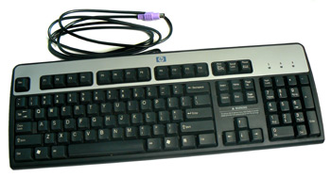

Standard Keyboard About the Keyboard
- The main part of a computer keyboard has alpha-numeric (letter and number) keys similar to a typewriter. However, the keyboard also features keys that cause the computer to perform specific tasks.
- The Escape key, labeled Esc, allows you to stop a function or action. For example, if your computer suddenly freezes up, you may be able to resume by pressing Esc.
- The Function keys, along the top of the keyboard, are labeled F1, F2, up to F12. These shortcut keys allow you to quickly complete a specific task within certain programs. For example, F1 opens Help in Microsoft Office.
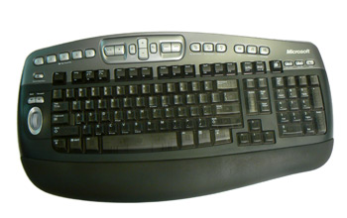
Wireless Ergonomic Keyboard
- The Print Screen, Scroll Lock and Pause/Break keys are at the far right end of the keyboard. The Print Screen key takes a "picture" of your screen that you can edit or save using a graphics program.
- The Enter key carries out commands. For example, while on the Internet, you can type in a website address, called a URL, and press Enter to go to the site.
- The Control (Ctrl), Alternate (Alt), and Shift keys are designed to work with other keys. For example, if you press Ctrl + S at the same time, you can save a file.
- The Backspace key erases the character to the left of
the cursor.
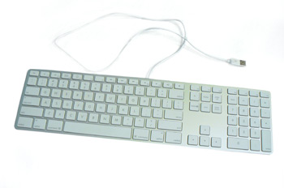

iMac USB Keyboard
- To the right of the regular keys is the cursor control pad. At the bottom are four arrow keys. Pressing any one of these keys moves the cursor in the direction of the arrow.
Depending on the keyboard you are using, there are five to six keys above the arrows including:
  - The Delete key erases the character to the right the cursor.
  - The Insert key switches between the insert mode and overtype mode. The insert mode is the normal mode for word processing.
  - The Home key moves the cursor to the left or beginning of the current line.
  - End moves the cursor to the right end of the current line.
  - Page Up and Page down take you to the top or bottom of the screen.
- The Number pad, at the far right end of the keyboard, resembles a calculator keypad. Similar to the curser keys, you can use the arrow keys on this keypad to move the cursor.

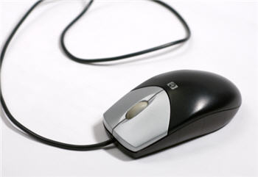
Mouse
The mouse is a peripheral that is known as a pointing device. It lets you point to objects on the screen, click on them, and move them. Previously, it was considered an optional device, but now all desktop computers will come with a mouse.
There are two main types of mice -- optical and mechanical. The optical mouse uses an electronic eye to detect movement and is easier to clean. The mechanical mouse uses a rolling ball to detect movement and is more difficult to clean; however, it is less expensive, so many computers come with a mechanical mouse.
Another decision you have when choosing a mouse is wired versus wireless. Wireless everything is popular right now, so it will be up to you to decide which type will work best for you.

To properly use the mouse:
- Using your right hand, place your thumb on the desk or table top on the left side of the mouse
- Your index (pointer) finger should rest on the left button of the mouse.
- Place your middle finger on the right button of the mouse.
- Your ring finger and little finger should rest on the right side of the mouse.
- The base of your wrist should rest on the mouse pad or desktop, for stability.
Left-handed computer users sometimes use their right hand to maneuver the mouse. However, if you're left-handed and want to use your left hand, the mouse buttons can be switched.

To Switch the Mouse Buttons for a Left-Handed User:
- Click Start.
- Choose SettingsControl Panel.
- Double-click the Mouse icon in the Control Panel window.
- Click Left-handed.
- Click OK.

To properly use the mouse:
- Click. Select an object on the screen by pressing the left mouse button down with your index finger and then release the button.
- Drag an object on the screen by pressing and holding down the left mouse button with your index finger while moving the mouse. When the object is where you want it, release the button.
- To double-click, rapidly press and release the left mouse button with your index finger.
- To right-click, press and release the right mouse button with your middle finger.
A trackball is similar to a mouse, but the ball that helps maneuver the cursor is on top instead of underneath.

Activity 3
- Think about the desktop computers you've seen at work, school, the library, a store, or a friend's house.
- Do all the desktops look the same?
- What pieces of hardware do they have in common?

Lesson 4 - What are all the buttons, sockets, and slots used for?

Take a look at the front and back of your computer case and count the number of buttons, sockets, and slots you see. Now, look at your monitor and count any that appear there. You probably counted approximately 20.
Each computer is different, therefore the buttons, slots, and sockets will vary from computer to computer; however, there are certain features you can expect to find on most desktop computers. Being familiar with the names of each and how they are commonly used will help you when the time comes for you to connect that new printer, mouse, digital camera, or other device.

Front of Computer Case
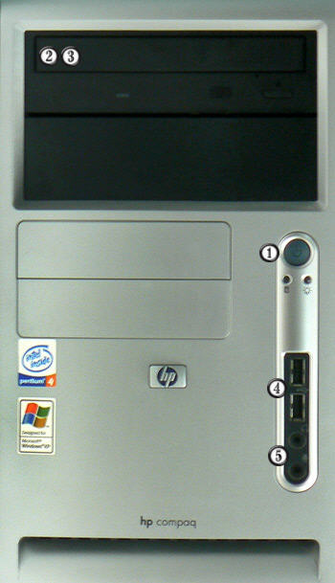

Labelled Front of Computer Case

- Power Button
The power button is used to power the computer on and off. Additionally, you can use the power button on some computers to place the computer in different energy-saving modes such as hibernate, sleep, and standby. It is a good idea to read your manual to learn how these features work on your computer.

- CD-ROM (Compact Disk Read-Only Memory) Drive
A CD-ROM drive, also known as an optical drive, allows you to play a CD-ROM , just like a CD player allows you to listen to music. With a CD-ROM drive you can listen to music (if your computer is sound-enabled), view files, and install software that is located on a CD.
A CD writer is a device that can be used in conjunction with a CD-ROM drive and allows you to copy or burn information onto specific types of CDs called CD-RW (Compact Disk ReWritable) and CD-R (Compact Disk-Recordable) discs.

- DVD-ROM (Digital Versatile Disc Read-Only Memory) Drive
A DVD-ROM drive, also known as an optical drive, reads DVD discs, all types of CDs, and can display movies from digital video discs. DVDs can hold more data than a CD, so they are a good storage option. A DVD burner is a device that can be used in conjunction with a DVD-ROM and allows you to copy information onto DVD discs. It is considered a type of storage.
In many of the computers you can purchase today, the CD and DVD-ROM and/or burners are combined.
- USB Port
The Universal Serial Port typically appears on the back of the computer case, but can sometimes be found on the front of the case, or hidden under a panel on the front of the case.

- Audio In/Audio Out Every computer has a bank of audio ports where you can connect various devices, including speakers, microphones, headsets, and more.

Back of Computer Case
On the back of the computer case are connection ports that are made to fit specific devices. The arrangement of these vary from computer to computer, and many companies have their own special connectors for the specific devices. Some of the ports are color coded to match a color on the device, which will help you determine which port is used with a particular device.
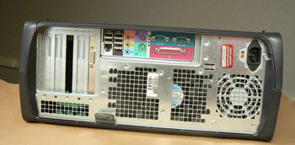

Sample Computer Case
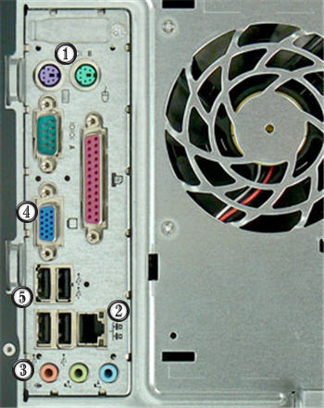

Labelled Back View of Computer Case

- PS/2 Port
These ports are called PS/2 ports and are used for the mouse and keyboard. Many people refer to them as the mouse port or the keyboard port.

- Ethernet Port
This port looks a lot like the modem or telephone port but it is actually wider. You can use this port for networking and also connecting to the Internet. Ethernet

- Audio In/Audio Out
Every computer has a bank of audio ports where you can connect various devices, including speakers, microphones, headsets, and more.Audio

- VGA Port
Your monitor can is connected to this port.

- USB Port
The Universal Serial Bus port is one of the newest ports, but is also one of the most useful. These USB ports let you attach a variety of devices such as mice, printers, keyboards, web cameras, USB/flash drives, and digital cameras to your computer quickly. Almost every peripheral made comes in a USB version, and installing the devices using USB ports is much easier than connecting devices using parallel and serial ports. This is primarily because USB ports do not require you to reboot your computer before you can use the new device.
Now you try it! Practice connecting the cables with an interactive game.
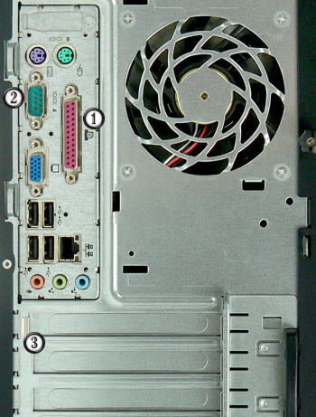

Labelled Back View of Computer Case

- Parallel Port
The parallel port is one of the two original ports on the first personal computer. It is commonly known as the printer port since this port is used to connect your printer to your computer; however, with the rise in use of the USB ports, you can expect to see a decrease in the use of this port. Currently, a large number of parallel port printers are still manufactured and used on older computers that don’t have USB support.

- Serial Port
The serial port is the other original port on the first personal computer. Serial ports can be used to plug in devices such as dial-up modems and other devices. On recent computers, the serial port has been replaced by the USB port. This is due to the fact that most peripherals use the USB drive.

- Expansion Slots
These empty slots are where expansion cards are added to computers. For example, if your computer did not come with a video card, you could purchase one and insert it here.

- FireWire Port
FireWire is actually the Apple brand name for the IEEE 1394 port, but the term caught on and it this port is commonly referred to as the FireWire port. It is the standard port used with digital video cameras and high-resolution scanners. FireWire replaced the Parallel SCSI, but it is not on every computer; however, you can buy an adapter card to add FireWire ports to your computer. The labeled image does not include a FireWire port.

Peripherals You Can Use in Various Ports
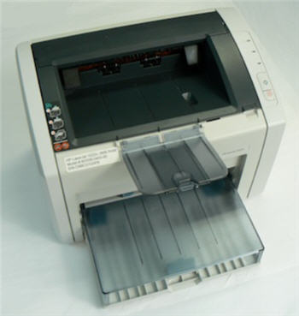

Printer

- Printers: A printer is a peripheral that is used to print, or produce, a version of what appears on the screen in a hardcopy format. There are many types of printers available including ink-jet, laser-jet, and photo printers. Also, combination printers that include scanners and copiers are increasing in popularity.

- Scanners: A scanner allows you to copy an image or document and save it in electronic form onto your computer. While you can purchase a hand-held and flatbed scanners, you are more likely to purchase a scanner as an all-in-one option that combines a scanner, printer, and copier into one product.
Scanners vary in resolution, or sharpness, so when shopping for one, be sure to compare the resolution of the products. A scanner is connected to the computer via a parallel port, a USB port, or a SCSI connection. No matter which connection is used, the images are stored on your PC's hard drive in a digital format.
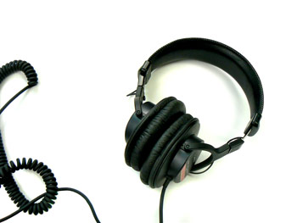

Headphones

- Speakers/Headphones: Speakers and headphones are output devices, which means that they are devices that communicate information from the computer to the user. They allow you to hear sound and music. Both speakers and headphones connect to a computer; however, some computers are designed with speakers built into the monitor.

- Microphones: A microphone is a type of input device, or a device that receives information from a user. You connect the microphone to the computer and use the computer to record sound or to communicate with another computer user via the Internet. Many computers come with built-in microphones.
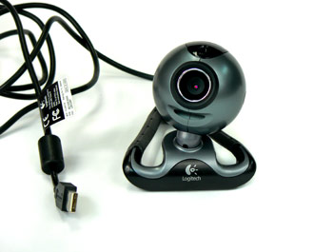

Web Camera

- Web Cameras: Web cameras, or web cams, are devices that connect to a computer and display a video image of whatever it is recording. This video image can be transmitted over the Internet, allowing a user in another location the ability to see the video in real-time. Web cameras are used often in business for video conferences, and are also a great tool for families to use to stay connected from different parts of the world.

- Joystick or Game Controller: A joystick is a lever used while playing a computer game.

- Digital Cameras: A digital camera lets you capture a picture in digital (computer-readable) form. You can transfer that image directly from the camera to the computer. When you use a digital camera, you can also preview your pictures before printing them. If you don't like what you see, you can edit or delete them.
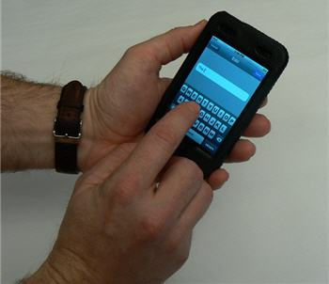

Personal Digital Assistant

- Personal Digital Assistant (PDA): A PDA is a handheld computer that can have a variety of features including a calendar, Internet access, video recording, word processing, email access, phone, media player, and more. Most PDAs can be synchronized with a PC to allow up-to-date contact information stored on software such as Microsoft Outlook, RSS feeds, or other web updates.

- MP3 Players: An MP3 player is a portable device that stores, organizes, and plays audio files. The player can read files that are recorded from a CD using a computer, or downloaded from various sites via the Internet.

Activity 4
- Find out what types of drives are on your computer (e.g, CD-ROM, DVD-ROM)
- Count the number is USB Ports on your computer.

Lesson 5 - What is inside a desktop computer?

Have you ever looked inside a computer case before? Or seen pictures of the inside of one? The small parts look very complicated, but the inside of a computer case really isn't that mysterious. This lesson will help you master some of the basic terminology and understand a little about what goes on inside the four walls of the computer casing.

A Look Inside a Desktop Computer
Let's explore the inside of a computer tower.
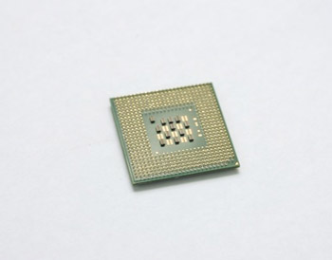
Central Processing Unit (CPU) CPU/Processor
The Central Processing Unit (CPU), also called a processor, is located inside the computer case on the motherboard. It is often called the brain of the computer, or the computer's engine. Its job is to carry out commands. Whenever you press a key, click the mouse, or start an application, you're sending instructions to the CPU.
The processor determines how fast a computer can execute instructions. A processor's speed is measured in megahertz (MHZ), or millions of instructions per second, and gigahertz (GHZ), or billions of instructions per second. So, the higher the hertz, the faster the computer can process instructions. The power of the processor is measured in bits. The more bits a processor can handle, the more data it can handle, and therefore, the more powerful the processor.

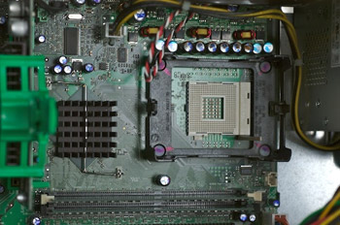

CPU Socket

The CPU is generally a 2 inch ceramic square with a silicon chip located inside. The chip usually about the size of a thumbnail.
The CPU fits into the CPU socket, which is covered by the heat sink, an object that absorbs heat from the CPU.
There are many processor manufacturers for personal computers including Intel, Cyrix, VIA, and AMD.
Many processor chip designers include funny or interesting hidden artwork, such as images, phrases, initials, and logos on the chips. This artwork is only visible when the chip is open and magnified, so it's really a joke among the chip developers, rather than something intended for everyone to see.
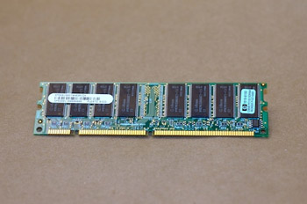
Random Access Memory (RAM) RAM
RAM (Random Access Memory) is your system's short-term memory. Data is temporarily stored here until you save your work to the hard disk. RAM is used by the system to store data that is processed by a computer's CPU.
The computer's work takes place in RAM. This is where programs run when you are using Word to create a letter, or Excel to produce a company spreadsheet.
This short-term memory disappears when the computer is turned off, so always save your file before turning off the machine. When you save a file, you are saving it to long-term storage that does not disappear when the computer is turned off.
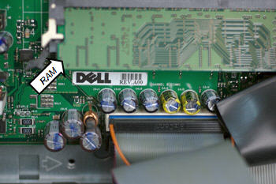
RAM on motherboard
The more RAM you have, the more things your computer can do at the same time, and the faster your computer performs certain tasks. RAM is measured in megabytes (MB) or gigabytes (GB).
To understand megabytes and gigabytes, you need to know about bits and bytes. A bit is the smallest unit of data in computer processing. A byte is a group of eight bits. A megabyte is about one million bytes. A gigabyte is 1,024 megabytes.
To put this into perspective, consider that a printed page of single-spaced text contains about 3,000 characters. One MB holds about 400 pages of single-spaced text.
Motherboard
The motherboard is the computer's main circuit board. It's a thin plate that holds the CPU (Central Processing Unit), memory, connectors for the hard drive and optical drives, expansion cards to control the video and audio, as well as various external ports and peripherals. The motherboard connects directly or indirectly to every part of the computer.
If you decide to open the computer case and take a look, be sure to touch a grounded metal object to discharge any static buildup. Static electricity can be transmitted through the computer circuits and ruin them.
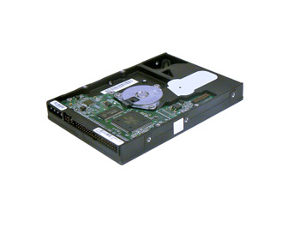
Hard Disk Drive Hard Disk Drive
The hard disk drive is the data center of the computer. All of your programs are stored here. The hard disk drive is long-term storage where information is stored permanently. When you use a word processing program, the computer loads the instructions from long-term storage (your hard disk) into short-term memory.
Hard disk speed determines how fast your computer starts up and loads programs. The hard disk is called the C drive on most computers.
Optical Disc Drive
An optical disc drive is a peripheral device that reads data stored on optical discs. Some drives can only read from discs, but often drives are both readers and burners. CD and DVD drives are common optical drives. From inside the computer, optical drives look very similar to hard disk drives.
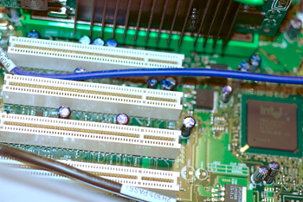
Expansion Slots Expansion Card
An expansion card is a card which you can install to expand a computer's capabilities. Expansion cards are inserted into expansion slots on the motherboard. For example, your computer's video card is an expansion card which plugs into the expansion slots.
Video card
The video card is responsible for what you see on the monitor. If you like playing graphic-intense games on the computer, a good video card is important to you. The main function of the video card is to generate and output images to the computer screen. Better graphics card equals better performance when playing games or working on a high resolution monitor.
Sound Card
The sound card, also called an audio card, is another type of expansion card. It lets the computer play sounds through speakers. Some motherboards feature integrated sound, and do not require a separate sound card..
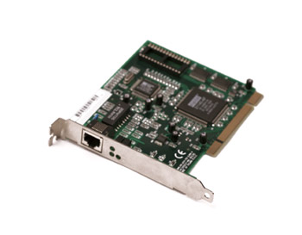
Network Card Network card
The network card allows your computer to communicate over a network. With the network card you can set up a home network with a few computers and connect them by via Ethernet cords or wirelessly. Network cards used to be expansion cards that plugged into the motherboard; however, most newer computers have a network interface built into the motherboard.

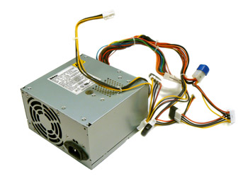
Power Supply Unit Power Supply Unit
The power supply unit in a computer converts the power from the wall outlet to the type of power needed by the computer. It sends power through the cables to the motherboard and other components.

Activity 5
- Review the parts of the computer identified in this lesson. Make sure you know the function of each part.
Think Creatively! In the lesson and videos, we compared the CPU to a brain, the hard drive to a closet, and the motherboard to a blue print. Can you think of any other good analogies, or comparisons? Do any of the computer parts listed remind you of something else?

Lesson 6 - How do I connect to the Internet?
You have all the basic parts of your computer set up and want to start surfing the Internet. You might even see an Internet Explorer icon on your desktop. You may be wondering if getting online is as simple as clicking that icon. Well, yes and no.
There are basically three things you need to use your computer to become active online -- an Internet Service Provider (ISP), a modem, and an Internet browser. Before you can connect to the Internet, you have some decisions to make about these three topics.

Types of Internet Access
Before you can connect to the Internet, you need to determine the type of Internet access you would like, and which Internet Service Provider (ISP) you want to provide you with this access. An ISP is the company that provides you with your connection to the Internet for a fee. Often ISPs offer different types and tiers of access, so it is a good idea to consider the common types of service before exploring specific companies.

Dial-up Access
Dial-up access is usually the least expensive way to access the Internet; however, it is also the slowest. With dial-up service, you need a phone line and PC modem to dial-up and be connected to the Internet by your ISP. A modem ties up the phone line so can't use the phone and computer at the same time.
While dial-up access can be an affordable option, the web pages load slowly due to the limitations of the modem. Some websites with a lot of videos or graphics may have a difficult time loading, if they load at all. Additionally, with dial-up access, your Internet connection isn't immediate. Since you have to use the telephone line to dial into a server, it can take from several seconds to minutes before you can access the Internet.
If you only use the Internet to check your email and occasionally view other websites, a dial-up connection may serve your needs. If you are going to spend any significant amount of time online, you should consider another option. Keep in mind that some ISPs have increased the fee for dial-up access in an effort to transition more people to broadband access.

DSL Access
DSL, or Digital Subscriber Line, provides high-speed, Internet access through a phone line. With DSL service, you can talk on the telephone and access the Internet at the same time. It is considered a type of broadband Internet access, which refers to high-speed Internet connections that allow for transmission of data at rates 10 to 50 times faster than dial-up service. Verizon and AT & T are two popular DSL providers.
A DSL modem and an Ethernet card are required for installation. A splitter may also be required to filter the DSL signal from the low frequency voice signal; however, this is handled by the Internet Service Provider.

Cable Access
Cable access is provided through your local TV cable company and transferred through your TV cables. Like DSL access, it is considered broadband, high-speed Internet access. If you don’t have cable TV, you can still purchase cable Internet service as long as it is available in your area.
With cable access, web pages load quickly and you will find it easy to download and upload files. One thing to be aware of though is that cable access is a shared service and can be affected by others who use the same cable lines. For example, if it is a holiday and everyone in your neighbourhood is at home surfing the web, you may notice that some aspects of service are slower than normal. In most areas, this won’t be an issue.

Satellite Access
Satellite access can be used in locations where there is no broadband cable or DSL Internet available. Satellite access is available across the world and can provide you with a broadband connection that is equal to a high speed connection. Satellite service is the most expensive and will require costs such as installation and satellite equipment, which will cost several hundred dollars.

Choosing an Internet Service Provider (ISP)
Once you have decided which type of Internet access you are interested in, you can determine which ISPs are available in your area that offer the type of Internet access you want. Then, you need to choose the ISP that best meets your needs based on their prices and service packages, and secure Internet access through that company. Talk to friends, family members, and neighbors to see what ISP they use.
Some things to consider as you research ISPs:
- Speed
- Price
- Billing
- Installation Software
- Physical Service
- Service Record
- Extras such as email accounts and web space
- Technical Support
- Remote Access
- Contract Terms

Hardware Needed
Network Card Modem
Once you have your computer, you really don't need much additional hardware to connect to the Internet. The primary piece of hardware you need is a modem.
The type of Internet access you choose will determine what type of modem you need. Dial-up access uses a telephone modem, which may come installed on your computer. DSL service uses a DSL modem, cable access uses a cable modem, and satellite service uses a satellite adapter. These modems are usually included as part of the start-up hardware from your ISP when you sign a contract for service.
Network Card
A network card is a piece of hardware that allows computers to communicate over a computer network. Most newer computers have a network card built into the motherboard, so it probably is not something you will need to purchase. Some modems use an Ethernet connection and network card to access the Internet, while other modems may use a USB port.
Router
A router is a hardware device that allows you to use several computers on a single Internet connection from your ISP. With a router, all the computers in your home can connect to the Internet and all you pay for is one account with an Internet Service Provider and one IP address. Additionally, cable, DSL, and satellite users can use a router as a hardware firewall. Some people believe that a router provides better protection from hackers than a software firewall. Many routers are easy to install, priced reasonably, and can be used for wired or wireless networks.

Internet Browser
A browser is the tool that allows you to view and interact on the Internet. Once you have an account with an ISP and can access the Internet, you'll need to use a browser to access web pages. Browsers can be referred to the window of the web because they allow you to view all the pages on the Internet.
Most computers come preloaded with Microsoft Internet Explorer, so you don't have to worry about purchasing a browser; however, you don't have to use Internet Explorer. If you would prefer to try another browser option, you can. For example, Mozilla Firefox is a free browser that you can download and use.

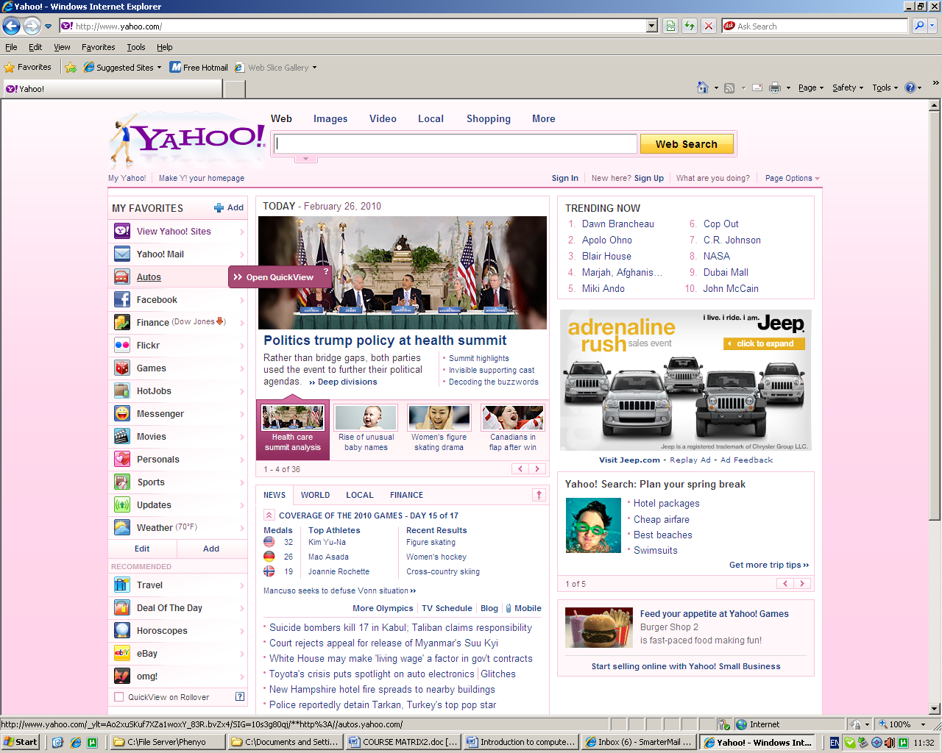
Yahoo Website Viewed Through Internet Explorer

Activity 6
- Research 2 or more Internet Service Providers and compare their service packages.
- Determine which provider and service package would be best for you, based on your needs.

Lesson 7 - What are the basic parts of a laptop computer?
The basic parts of a laptop computer are the screen, keyboard, touchpad, speakers, battery, and AC adaptor. Beyond these basic parts are the hardware items located inside the laptop, and the peripherals, which are optional pieces of hardware that enables the computer to accomplish additional tasks.

Basic Parts of a Laptop Computer
Let's take a look at the basic laptop components.
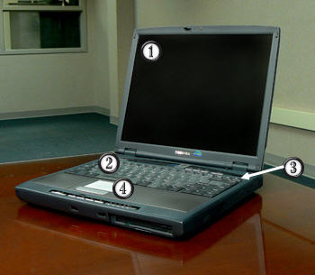

Laptop Parts Labelled

- Monitor
The monitor, which resembles a television screen, is where the computer displays text and pictures.

- Keyboard
The keyboard is a piece of hardware that resembles a typewriter keyboard. It is one of the primary ways you communicate with the computer and enter data.

- Speakers
Speakers are usually small and built into the screen or the body of the laptop. In the image, the example laptop has speakers in the body, or laptop casing. The speakers allow you to hear computer sounds, audio streamed from the Internet, CDs and DVDs, and more.

- Touchpad
On a laptop, a touchpad is a substitute for the mouse. Move your finger on the touchpad to move around the screen and select text and objects. The buttons below the touchpad operate like mouse buttons.

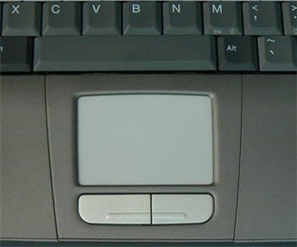

Touchpad
Using the Touchpad:
- Click. Select an object on the screen by pressing the left button down with your index finger and then release the button.
- Drag an object on the screen by pressing and holding down the left button with your index finger while moving another finger on the touchpad. When the object is where you want it, release the button.
- To double-click, rapidly press and release the left button with your index finger.
- To right-click, press and release the right button with your middle finger.
- 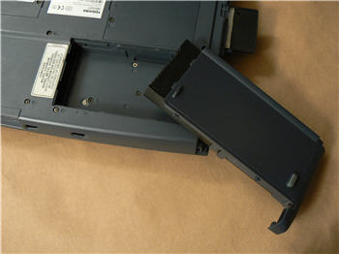
Laptop Battery Removed from Casing Battery
The battery on a laptop serves as its life-line. A laptop will work without a battery if it is receiving power from a power adapter.
The battery allows you to be more mobile without having to be near a power outlet for an extended period of time. Most laptop batteries will last for about 1.5-2 hours before needing to be recharged. If your battery dies or has a defect you can buy a new one from your computer’s manufacturer or a local computer or electronics store.
AC Adaptor
The AC Adaptor is the source of electric power for a laptop. The power adapter does two jobs when it is plugged in. It powers the laptop and charges the battery.

Activity 7
- Think about the laptop computers you've seen at work, school, the library, a store, or a friend's house.
- Did all the laptops look the same?
- What did they have in common?

Lesson 8 - What are all the buttons, sockets, and slots used for?

Take a look at a laptop and count the number of buttons, sockets, and slots you see. You probably counted more than 10. There aren't quite as many as you'll find on a desktop computer, but still, all of these can be overwhelming for a new laptop user.
Each laptop computer is different, therefore the buttons, slots, and sockets will vary from computer to computer. However, there are certain features that are common and you can expect to find on most laptop computers.

Laptop Buttons, Drives, and Ports
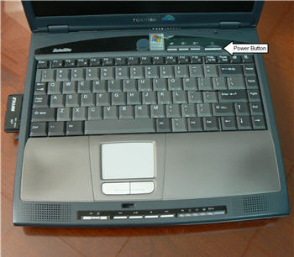
Power Button
The power button is used to power the computer on and off. It is usually directly above the keyboard, but can also be located on any of the four sides of the laptop casing. In addition to turning the computer on and off, you can use the power button on some computers to place the computer in different energy-saving modes such as hibernate, sleep, and standby. It is a good idea to read your manual to learn how these features work on your computer.
CD-ROM (Compact Disk Read-Only Memory) Drive
A CD-ROM drive, also known as an optical drive, allows you to play a CD-ROM , just like a CD player allows you to listen to music. With a CD-ROM drive you can listen to music (if your computer is sound-enabled), view files, and install software that is located on a CD.

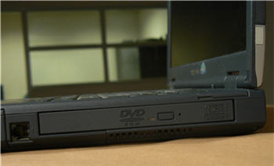
Example Optical Drive -- DVD
A CD writer is a device that can be used in conjunction with a CD-ROM drive and allows you to copy or burn information onto specific types of CDs called CD-RW (Compact Disk ReWritable) and CD-R (Compact Disk-Recordable) discs.
DVD-ROM (Digital Versatile Disc Read-Only Memory) Drive
A DVD-ROM drive, also known as an optical drive, reads DVD discs, all types of CDs, and can display movies from digital video discs. DVDs can hold more data than a CD, so they are a good storage option. A DVD burner is a device that can be used in conjunction with a DVD-ROM and allows you to copy information onto DVD discs. It is considered a type of storage.
In many of the computers you can purchase today, the CD and DVD-ROM or burners are combined.
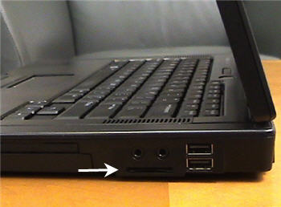
SD Port
Memory Card Port
This port is for placing memory cards that are associated with your digital camera or PDA device. It is usually located on the left or right side of the laptop When a memory card is placed in the port, you can view the material on that card using your laptop.
On the sides of the laptop computer are connection ports that are made to fit specific plug-in devices, as well as assorted drives and buttons. The arrangement of these vary from computer to computer, and many companies have their own special connectors for the specific devices. Some of the ports are color coded to match a color on the device, which will help you determine which port is used with a particular device.
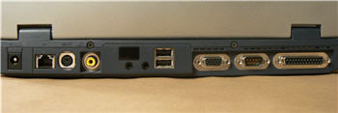

View of Back Laptop Ports
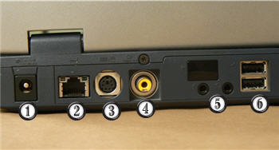

Back of Laptop Labelled

- Power Cord Connector
This is where you connect your AC power adapter.

- Ethernet Port
This port looks a lot like the modem or telephone port but it is actually wider. You can use this port for networking and also connecting to the Internet.

- PS/2 Port
This port is the mouse and keyboard port.

- Composite Video Port
Some laptops include a composite video port that allows you to connect your laptop to a television. This port may look familiar to you because many home electronic devices, such as television sets and camcorders, include this port. The composite video port is seen less on new laptops as other ports become more popular for the same tasks.

- Audio In/Audio Out
Every computer has a bank of audio ports where you can connect various devices, including speakers, microphones, headsets, and more.

- USB Port
Almost every laptop computer on the market today comes with two or more Universal Serial Bus (USB) ports. These USB ports let you attach a variety of devices such as mice, printers, keyboards, web cameras, USB/flash drives, and digital cameras to your computer quickly. Almost every peripheral made comes in a USB version, and installing the devices using USB ports is much easier than connecting devices using parallel and serial ports.
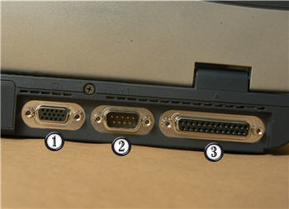

Back of Laptop Labelled

- Monitor Port
An external monitor can be connected to this port. Even though the laptop comes with a built-in screen, some users like to turn their laptop into a desktop unit by connecting external parts such as a monitor, keyboard, and printer.

- Serial Port
The serial port is the other original port on the first personal computer. On recent computers, the serial port has been replaced by the USB port, as both ports can be used to plug in external devices such as a mouse or keyboard. Most peripherals use the USB drive because USB drives do not require you to reboot your computer when a new device is added, whereas serial ports do.

- Parallel Port
The parallel port is one of the two original ports on the first personal computer. It is commonly known as the printer port since this port is used to connect your printer to your computer; however, with the rise in use of the USB ports, you can expect to see a decrease in the use of this port. Currently, a large number of parallel port printers are still manufactured and used on older computers that don’t have USB support.

- FireWire Port
FireWire is actually the Apple brand name for the IEEE 1394 port, but the term caught on and it is commonly referred to as the FireWire port. It is the standard port used with digital video cameras and high-resolution scanners. It is commonly used to upload audio/video from the device to the computer using a FireWire cable. FireWire ports are not on every computer; however, you can buy an adapter card to add them. The laptop in the image does not have a FireWire port.

Peripherals You Can Use in Various Ports

Printer
- Printers: A printer is a peripheral that is used to print, or produce, a version of what appears on the screen in a hardcopy format. There are many types of printers available including ink-jet, laser-jet, and photo printers. Also, combination printers that include scanners and copiers are increasing in popularity.

- Scanners: A scanner allows you to copy an image or document and save it in electronic form onto your computer. While you can purchase a hand-held and flatbed scanners, you are more likely to purchase a scanner as an all-in-one option that combines a scanner, printer, and copier into one product.
Scanners vary in resolution, or sharpness, so when shopping for one, be sure to compare the resolution of the products. A scanner is connected to the computer via a parallel port, a USB port, or a SCSI connection. No matter which connection is used, the images are stored on your PC's hard drive in a digital format.

Headphones
- Speakers/Headphones: Speakers and headphones are output devices, which means that they are devices that communicate information from the computer to the user. They allow you to hear sound and music. Both speakers and headphones connect to a computer; however, some computers are designed with speakers built into the monitor.

- Microphones: A microphone is a type of input device, or a device that receives information from a user. You connect the microphone to the computer and use the computer to record sound or to communicate with another computer user via the Internet. Many computers come with built-in microphones.

Web Camera

- Web Cameras: Web cameras, or web cams, are devices that connect to a computer and display a video image of whatever it is recording. This video image can be transmitted over the Internet, allowing a user in another location the ability to see the video in real-time. Web cameras are used often in business for video conferences, and are also a great tool for families to use to stay connected from different parts of the world.

- Joystick or Game Controller: A joystick is a lever used while playing a computer game.

- Digital Cameras: A digital camera lets you capture a picture in digital (computer-readable) form. You can transfer that image directly from the camera to the computer. When you use a digital camera, you can also preview your pictures before printing them. If you don't like what you see, you can edit or delete them.

Personal Digital Assistant

- Personal Digital Assistant (PDA): A PDA is a handheld computer that can have a variety of features including a calendar, Internet access, video recording, word processing, email access, phone, media player, and more. Most PDAs can be synchronized with a PC to allow up-to-date contact information stored on software such as Microsoft Outlook, RSS feeds, or other web updates.

- MP3 Players: An MP3 player is a portable device that stores, organizes, and plays audio files. The player can read files that are recorded from a CD using a computer, or downloaded from various sites via the Internet.

Activity 8
- Find out what types of drives are on your computer (e.g, CD-ROM, DVD-ROM).
- Count the number is USB Ports there are on your computer.

Lesson 9 - What is inside a laptop computer?

Have you ever looked inside a desktop computer case before? There is a lot of extra room in there. That is not true with laptops. Laptops are smaller, so there is less room for parts. Everything is smaller and grouped tightly together so it fits into the notebook-sized case.
Laptop parts are basically the same as desktops, often just smaller. Let's take a look.

A Look inside a Laptop Computer
Central Processing Unit (CPU) CPU/Processor
The Central Processing Unit (CPU), also called a processor, is located inside the laptop on the motherboard. It is often called the brain of the computer, or the computer's engine. Its job is to carry out commands. Whenever you press a key, click the mouse, or start an application, you're sending instructions to the CPU.
The processor determines how fast a computer can execute instructions. A processor's speed is measured in megahertz (MHZ), or millions of instructions per second, and gigahertz (GHZ), or billions of instructions per second. So, the higher the hertz, the faster the computer can process instructions. The power of the processor is measured in bits. The more bits a processor can handle, the more data it can handle, and therefore, the more powerful the processor. The CPU is generally a 2 inch ceramic square with a silicon chip located inside. The chip usually about the size of a thumbnail.
There are many processor manufacturers for personal computers including Intel, Cyrix, VIA, and AMD.
Many processor chip designers include funny or interesting hidden artwork, such as images, phrases, initials, and logos on the chips. This artwork is only visible when the chip is open and magnified, so it's really a joke among the chip developers, rather than something intended for everyone to see.
Random Access Memory (RAM) RAM
RAM (Random Access Memory) is your system's short-term memory. Data is temporarily stored here until you save your work to the hard disk. RAM is used by the system to store data that is processed by a computer's CPU.
The computer's work takes place in RAM. This is where programs run when you are using Word to create a letter, or Excel to produce a company spreadsheet.
This short-term memory disappears when the computer is turned off, so always save your file before turning off the machine. When you save a file, you are saving it to long-term storage that does not disappear when the computer is turned off.
RAM on motherboard
The more RAM you have, the more things your computer can do at the same time, and the faster your computer performs certain tasks. RAM is measured in megabytes (MB) or gigabytes (GB).
To understand megabytes and gigabytes, you need to know about bits and bytes. A bit is the smallest unit of data in computer processing. A byte is a group of eight bits. A megabyte is about one million bytes. A gigabyte is 1,024 megabytes.
To put this into perspective, consider that a printed page of single-spaced text contains about 3,000 characters. One MB holds about 400 pages of single-spaced text.
Motherboard
The motherboard is the computer's main circuit board. It's a thin plate that holds the CPU (Central Processing Unit), memory, connectors for the hard drive and optical drives, expansion cards to control the video and audio, as well as various external ports and peripherals. The motherboard connects directly or indirectly to every part of the computer.
If you decide to open the computer case and take a look, be sure to touch a grounded metal object to discharge any static buildup. Static electricity can be transmitted through the computer circuits and ruin them.
Hard Disk Drive Hard Disk Drive
The hard disk drive is the data center of the computer. All of your programs are stored here. The hard disk drive is long-term storage where information is stored permanently. When you use a word processing program, the computer loads the instructions from long-term storage (your hard disk) into short-term memory.
Hard disk speed determines how fast your computer starts up and loads programs. The hard disk is called the C drive on most computers.
Optical Disc Drive
An optical disc drive is a peripheral device that reads data stored on optical discs. Some drives can only read from discs, but often drives are both readers and burners. CD and DVD drives are common optical drives. From inside the computer, optical drives look very similar to hard disk drives.
Video card
The video card is responsible for what you see on the monitor. If you like playing graphic-intense games on the computer, a good video card is important to you. The main function of the video card is to generate and output images to the computer screen. Better graphics card equals better performance when playing games or working on a high resolution monitor.
Sound Card
The sound card, also called an audio card, is another type of expansion card. It lets the computer play sounds through speakers. Some motherboards feature integrated sound, and do not require a separate sound card..
Network card
The network card allows your computer to communicate over a network. With the network card you can set up a home network with a few computers and connect them by via Ethernet cords or wirelessly.
Expansion Card
An expansion card is a card which you can install to expand a computer's capabilities. For example, your computer's sound card is an expansion card which plugs into the motherboard.

Activity 9
- Review the parts of the computer identified in this lesson. Make sure you know the function of each part.
Think Creatively! In the lesson and videos, we compared the CPU to a brain, the hard drive to a closet, and the motherboard to a blue print. Can you think of any other good analogies, or comparisons? Do any of the computer parts listed remind you of something else?

Lesson 10 - How do I connect to the Internet?

You have all the basic parts of your computer set up and want to start surfing the Internet. You might even see an Internet Explorer icon on your desktop. You may be wondering if getting online is as simple as clicking that icon. Well, yes and no. There are basically three things you need to use your computer to become active online -- an Internet Service Provider (ISP), a modem, and an Internet browser. Before you can connect to the Internet, you have some decisions to make about these three topics.

Types of Internet Access
Before you can connect to the Internet, you need to determine the type of Internet access you would like, and which Internet Service Provider (ISP) you want to provide you with this access. An ISP is the company that provides you with your connection to the Internet for a fee. Often ISPs offer different types and tiers of access, so it is a good idea to consider the common types of service before exploring specific companies.

Dial-up Access
Dial-up access is usually the least expensive way to access the Internet; however, it is also the slowest. With dial-up service, you need a phone line and PC modem to dial-up and be connected to the Internet by your ISP. A modem ties up the phone line so can't use the phone and computer at the same time.
While dial-up access can be an affordable option, the web pages load slowly due to the limitations of the modem. Some websites with a lot of videos or graphics may have a difficult time loading, if they load at all. Additionally, with dial-up access, your Internet connection isn't immediate. Since you have to use the telephone line to dial into a server, it can take from several seconds to minutes before you can access the Internet.
If you only use the Internet to check your email and occasionally view other websites, a dial-up connection may serve your needs. If you are going to spend any significant amount of time online, you should consider another option. Keep in mind that some ISPs have increased the fee for dial-up access in an effort to transition more people to broadband access.

DSL Access
DSL, or Digital Subscriber Line, provides high-speed, Internet access through a phone line. With DSL service, you can talk on the telephone and access the Internet at the same time. It is considered a type of broadband Internet access, which refers to high-speed Internet connections that allow for transmission of data at rates 10 to 50 times faster than dial-up service. Verizon and AT & T are two popular DSL providers.
A DSL modem and an Ethernet card are required for installation. A splitter may also be required to filter the DSL signal from the low frequency voice signal; however, this is handled by the Internet Service Provider.

Cable Access
Cable access is provided through your local TV cable company and transferred through your TV cables. Like DSL access, it is considered broadband, high-speed Internet access. If you don’t have cable TV, you may be able to purchase cable Internet service as long as it is available in your area.
With cable access, web pages load quickly and you will find it easy to download and upload files. One thing to be aware of though is that cable access is a shared service and can be affected by others who use the same cable lines. For example, if it is a holiday and everyone in your neighbourhood is at home surfing the web, you may notice that some aspects of service are slower than normal. In most areas, this won’t be an issue.

Satellite Access
Satellite access can be used in locations where there is no broadband cable or DSL Internet available. Satellite access is available across the world and can provide you with a broadband connection that is equal to a high speed connection. Satellite service is the most expensive and will require costs such as installation and satellite equipment, which will cost several hundred dollars.

Choosing an Internet Service Provider (ISP)
Once you have decided which type of Internet access you are interested in, you can determine which ISPs are available in your area that offer the type of Internet access you want. Then, you need to choose the ISP best meets your needs based on their prices and service packages, and secure Internet access through that company. Talk to friends, family members, and neighbors to see what ISP they use.
Some things to consider as you research ISPs:
- Speed
- Price
- Billing
- Installation Software
- Physical Service
- Service Record
- Extras such as email accounts and web space
- Technical Support
- Remote Access
- Contract Terms

Internet Browser
A browser is the tool that allows you to view and interact on the Internet. Once you have an account with an ISP and can access the Internet, you'll need to use a browser to access web pages. Browsers can be referred to the window of the web because they allow you to view all the pages on the Internet.
Most computers come preloaded with Microsoft Internet Explorer, so you don't have to worry about purchasing a browser; however, you don't have to use Internet Explorer. If you would prefer to try another browser option, you can. For example, Mozilla Firefox is a free browser that you can download and use.

Yahoo Website viewed Through Internet Explorer

Wireless Connections
If you want to use your laptop at home, work, the local coffee shop, or at any public place, you can do this if your computer is configured for a wireless connection and there is Internet access available.

What Does Your Laptop Need?
The first thing you need to do is make sure your computer is configured for wireless access. Most new laptops include built-in wireless adapters. If your laptop does not have the wireless adapter, you can buy and install one that plugs into a port on your computer.
Once your computer is configured for wireless access, all you need to do is turn your computer on. It should be able to automatically locate the existing networks. A couple of clicks later and you'll be surfing the web.

Where Can You Use Wireless Internet Access?
You can access the Internet wirelessly from any location that has an existing network. If you go to a public place that advertises free wireless access, or free WiFi, and turn on your laptop, the computer will display a list of existing networks, and ask whether you want to connect to one of them. If so, just click on the network name listed on the screen, and you will then be able to open your browser and surf the web.

What about Wireless Access from Home?
If you want to use a wireless Internet connection from home, you will need to install a wireless router. A wireless router is a device that receives the signal sent by your computer and decodes it. It The router sends the information to the Internet using a wired Ethernet connection. Even when we talk about connecting to the Internet wirelessly, there is a wired connection somewhere that makes it all happen.
Another benefit to a wireless home network is the ability to connect multiple computers. They allow you to easily connect multiple computers to the Internet using only one IP address.

Activity 10
- Research 2 or more Internet Service Providers and compare their service packages.
- Determine which provider and service package would be best for you, based on your needs.

Lesson 11 - How do I set up a computer

You have a new computer and are ready to set it up. While this may seem like an overwhelming and difficult task, it is really very simple. It does not matter what name brand of computer you have, as most computers are set up in a very similar way.
If you are setting up a newly purchased computer that is still in the box, you will probably find a how-to guide in the packaging that includes step-by-step details. If it is poorly written, doesn't include pictures, or you don't have a guide, this lesson will help you get that new computer set up easily.

Setting Up a Desktop Computer
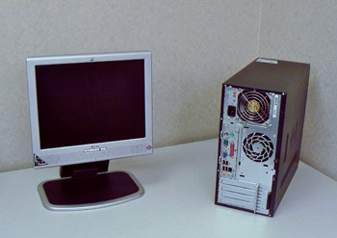
Monitor and Computer Case on Desk
Step 1
Unpack the monitor and computer case from the box. Remove any plastic covering or protective tape. Place the monitor and the computer case where you wish on the desk or work area.
Think about where you want your desk or work area to be located, and where in that area you want your monitor, computer case, and other hardware. Be sure to place your computer case in an area that is well ventilated and that has good air flow. It is important that the computer stay cool, as overheating is a concern, especially if you plan on leaving your computer turned on for long periods of time.
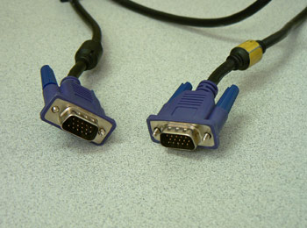
Monitor Cable
Step 2
Locate the monitor cable. With PC computers, the ends of the monitor cable are often blue.
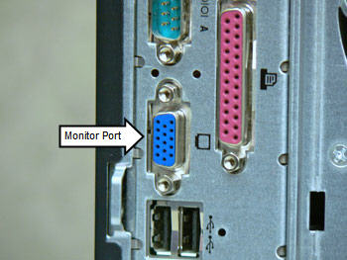
Monitor Port on Back of Computer Case
Step 3
Locate the monitor port on the back of the computer case, and on the monitor. You may have to look under the screen to locate the port on the monitor. These ports are also called VGA ports and are usually blue.
Note: While blue VGA ports are common, monitors can be connected with other ports, such as the beige DVI port. Read the owner's manual if you have any questions about the type of monitor port your computer uses.
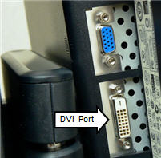DVI Port
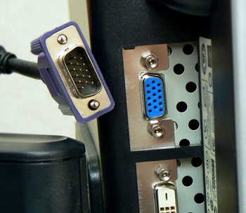
Monitor Port Under Monitor Screen
Step 4
Connect the cable into the monitor port on the monitor. The pins on the cable fit the port in a specific way, so line up the cable connector and the port. Be careful not to force or bend the pins. If you have misaligned the pins, then they will bend very easily without much resistance.
Once the pins in the cable connector are pushed into the port, turn the plastic-covered screws on each side of the cable to secure it to the monitor.

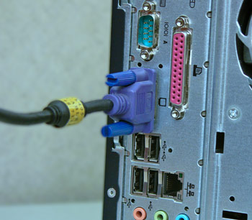
Monitor Port on Back of Computer Case
Step 5
Connect the cable into the monitor port on the back of the computer case. Like with the monitor, be careful not to misalign the pins with the port. Once the pins in the cable connector are pushed into the port, turn the plastic-covered screws on each side of the cable to secure it to the computer case.

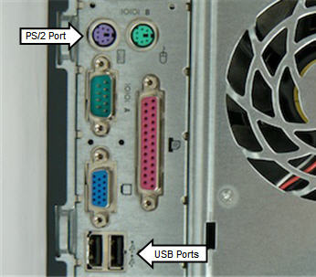
PS/2 and USB Ports for Keyboards
Step 6
Unpack the keyboard and locate the PS/2, or keyboard, port on the back of the tower. Plug the cable on the end of the keyboard into the PS/2 port. If the keyboard has a USB connector, locate a USB port on the back of the case and connect the keyboard.
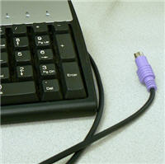
Keyboard with PS/2 Connector
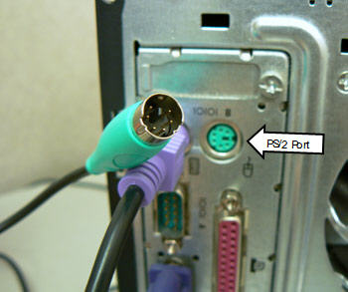
PS/2 and USB Ports for a Mouse
Step 7
Unpack the mouse and locate the PS/2, or mouse, port on the back of the computer case. Plug the cable on the end of the mouse into the PS/2 port. If the mouse has a USB connector, locate a USB port on the back of the tower and connect the mouse.
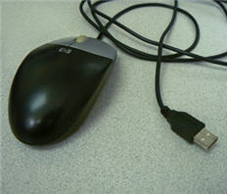
USB Mouse

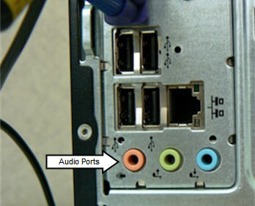
Audio Ports
Step 8
If your computer uses external speakers, locate the bank of audio ports on the back of the tower and connect the speakers. In this example, the speakers are located in the monitor so speakers do not have to be connected.
The audio ports are often confusing. If your computer has color-coded peripherals that match the colors on the back of the computer case, then connecting the audio components is generally very easy. If the peripheral does not have a color-coded cable, then remember that the speakers will always go in the green port. Headphones connect to the pink port, and various other devices will connect to the blue port, which is the Line In port.
Additionally, many devices, including headphones, now come with USB connectors. In most computers, the USB ports are located directly above the bank of audio ports.
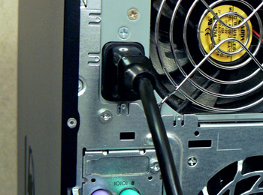
Plug Power Supply Cord into Computer Case
Step 9
Plug the power supply cable into the back of the tower, and then into a surge protector power strip.

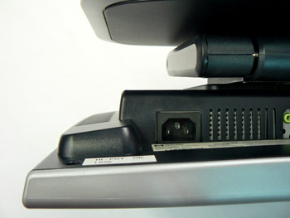
Power Supply Socket on Monitor
Step 10
Plug the second power supply cable into the monitor, and then into the power strip with surge protection. The power supply port may be located beneath the screen on the monitor.
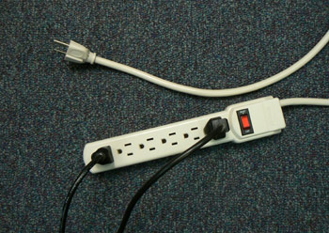
Power Supply Cable Plugged into Power Strip
Step 11
Plug the power strip into a wall outlet, and turn the power on to the monitor, tower, and any external speakers.
It is not a good idea to plug the computer directly into a wall outlet, due to the possibility of electrical surges. A power strip with surge protection is a good investment because it helps protect your computer from this. Some warranties may even exclude electrical damage, so a power strip is really important. Additionally, special power strips with noise filtration can be purchased if interference from multiple appliances is an issue.
You have other sources of protection, like an Uninterruptible Power Supply (UPS), which not only protects your computer from surges, but also serves as an alternate source of power in the event of power loss. As these decrease in price, some home users are finding a UPS a worthwhile investment.

Set Up Complete
Your basic computer hardware is now set up. You might be ready to start working, but before you do, spend a little time arranging your workspace. It needs to promote your productivity, but also be arranged in way that is comfortable and promotes health. The design and arrangement of our computer equipment is not simply a question of what looks nice, but how it can impact our bodies. Computer ergonomics is the science of equipment design and how specific equipment usage and placement can reduce the user's discomfort and increase productivity.
For example, to decrease injuries associated with the soft tissue in the wrists, keep your mouse at the same level as the keyboard and do not use wrist pads while typing. Additionally, to decrease eye strain and neck injuries, position your monitor screen so that your eyes are level with the top of the screen. There are numerous other guidelines regarding chair height, equipment placement, and more that can help you create an efficient and comfortable work area.
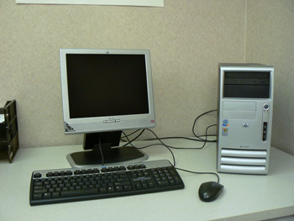

Basic Computer Setup Complete
Visit the U.S. Center for Disease Control website for more information about computer work area ergonomics.

After the Hardware...

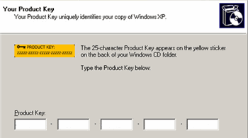
Part of Windows Setup Wizard
The computer box is empty, but your computer isn't fully set up yet. If you are working with a new computer, the manufacturer usually includes a guide to help you with the next steps.
Here are some of the things you can expect to do when you turn the computer on for the first time.
Customize Windows
Once you turn on your computer, you will be prompted to customize Windows to meet your needs. You will have to enter your product key, make decisions regarding the region and language settings, set the computer's date and time, and other administrative-type tasks.
Network Decisions
If you have a home network, you should probably select the typical installation setting, which is best for beginners, and enter a domain name. If you aren't connecting your new computer to a network, you'll be able to skip these steps.

Printer
Automatic Updates
The Windows installation wizard will complete the install process. You will be prompted to decide whether you would like to turn on automatic updates. This is up to you, but if you think you may forget to seek out updates, it is not a bad idea to have them prompted automatically.
Register Software
At the end of the installation process, a dialog box will appear that asks you how you connect to the Internet. You need to provide this information so that Windows can be activated and your copy of the software registered.
Connect Other Devices
Once Windows is running, you can connect your printer and other devices. Each printer and other peripherals install differently, so review the related instruction manual before connecting a device. For example, a printer from company A may require software to be loaded before the printer can work, while a printer from company B may simply require the device be plugged into a USB port.

Activity 11
- If you have a desktop computer that is already set up at home, take a look at it.
  - Look at the monitor cable and see where it connects to the computer case and monitor.
  - Locate the power cords for the monitor and computer case.
  - Locate the bank of audio ports.
- Do you have a USB or PS/2 mouse?
- Do you have a USB or PS/2 keyboard?

Lesson 12 - How do I keep my computer healthy?

Computers are expensive, and with all big purchases, you probably want to protect your investment. Luckily, it is not difficult to keep your computer healthy and in good working order.
Basically, there are 3 areas that you need to maintain. You need to:
- Keep the physical components of your computer clean
- Protect your computer from threats such as viruses, and
- Keep your files in order to make day-to-day use of your computer efficient and easy.

Keep Your Computer Physically Clean
When dealing with computers, dust isn't just unattractive, it can potentially destroy parts of your computer. And while the problems that arise because of poorly cleaned computers can usually be fixed, it involves maintenance fees that no one really wants to spend. One of the best things you can do to keep your computer working properly is to clean it regularly.

Cleaning the Keyboard
A dirty keyboard doesn't look nice, and can cause your keyboard to not work properly. If dust, food, liquid, or other particles get stuck underneath the keys, they might not work. If you need to clean your keyboard, check your owner's manual to see if the manufacturer has provided you with instructions for your specific keyboard. If so, you should follow them. If not, the following steps are basic cleaning tips that will help you keep your keyboard clean.

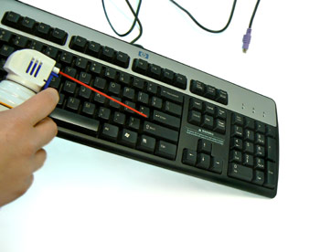
Tilt Keyboard and Spray Compressed Air Can of Compressed Air

- Shut down the computer and unplug it.
- Disconnect the keyboard from the PS/2 or USB port.
- Use a can of compressed air to clean between the keys.
- Spray the air at an angle to best reach any particles beneath the keys.
- Turn the keyboard upside down and move back and forth to loosen dust. Also, tap the bottom of the keyboard while upside down to dislodge any other particles.
- Turn the keyboard right-side up.
- Pour rubbing alcohol on a paper towel or anti-static wipe.
- Wipe the keys and keyboard.
- Reconnect the keyboard to the computer once it is dry.
You can use an electronics cleaning fluid if you wish, but rubbing alcohol works just as well as specialized products and is usually less expensive. Whether using rubbing alcohol or another cleaning fluid, never pour the liquid directly on the keyboard. Always wet a anti-static wipe, or paper towel, and use it to clean the keyboard.
You may want to use a plastic keyboard cover to protect the keyboard if dust or other particles are an issue.

What About Liquids?
If you spill liquid on the keyboard, quickly shut down the computer, and disconnect and turn the keyboard upside down to allow the liquid to drain.
If the liquid is sticky, you will need to hold the keyboard on its side under running water to rinse the sticky liquid away. Then, turn the keyboard upside down to drain for two days. The keyboard may not be repairable at this point, but rinsing the sticky liquid off the keyboard is the only chance for it to be usable again. Keep in mind, the best way to avoid this situation is to keep drinks away from the computer area.

Keep Your Computer Physically Clean
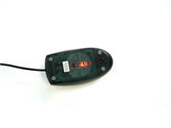Optical Mouse 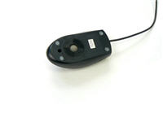Mechanical Mouse

Cleaning the Mouse
There are two main types of mice, mechanical and optical. Each is cleaned in basically the same way, although the mechanical mouse requires a few extra steps.
Mechanical mice are especially susceptible to dust and particles that can accumulate inside the mouse, which can make it difficult to track, or move, properly.
Optical mice require no internal cleaning since there aren't any rotating parts; however, they can get sticky over time as dust collects near the light emitter or on sticky pads, if your mouse has these. This can cause erratic cursor movement or the mouse to not work at all.
Before you clean your mouse, check your owner's manual to see if the manufacturer has provided you with instructions for your specific mouse. If so, you should follow those instructions. If not, the following steps are basic cleaning tips that will help you keep your mouse clean.
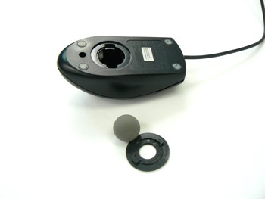
Mechanical Mouse with Ball-Cover Ring Removed

To Clean a Mechanical Mouse:
- Shut down the computer and unplug it.
- Disconnect the mouse from the PS/2 or USB port.
- Turn the mouse upside down.
- Push and turn the ball-cover ring in the direction indicated on the mouse to unlock the ring. If you don't see any arrows, push the ring and turn counterclockwise. If your mouse uses screws, use a screwdriver to unscrew the ring.
- Turn the mouse sideways to remove the ring and tracking ball.
- Rinse the tracking ball with water.
- Use an anti-static wipe, paper towel, or cotton swab dampened with rubbing alcohol to remove the dust from inside and outside the mouse.
- Let all the parts dry.
- Reassemble all the parts of the mouse.
- Reconnect the mouse to the computer.

To Clean an Optical Mouse:
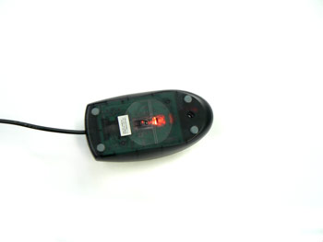
Optical Mouse Turned Upside Down
- Shut down the computer and unplug it.
- Disconnect the mouse from the PS/2 or USB port.
- Turn the mouse upside down.
- Use an anti-static wipe or paper towel damped with rubbing alcohol to lightly wipe the bottom of the mouse. Be sure the wipe is only lightly dampened.
OR, if specific areas are noticeably sticky,
- Use an anti-static wipe or paper towel damped with water to wipe the areas.
- Place the mouse on a clean, white sheet of paper and run the mouse over it. Dust and/or particles should rub off onto the paper.
It important to keep your mouse clean if you want to easily point, click, and drag items around the screen, as a dirty mouse can interfere with these actions.

Keep Your Computer Physically Clean

Cleaning the Monitor
Dirt, finger prints, and dust can make your computer screen difficult to read; however, it's easy to clean your screen when needed. As discussed in lesson 2, the two main types of monitors are cathode ray tube (CRT) and liquid crystal display (LCD) . The CRT monitors have glass screens and resemble a tube television, while the LCD monitor is a flat-panel monitor that is not made of glass. Both require different cleaning procedures. If you have a desktop computer, you will need to clean your monitor based by following the instructions for the type that you have. If you have a laptop computer, you will need to follow the LCD/flat-panel instructions.


To Clean a Glass Screen
Monitor Cleaner

- Turn off the computer and unplug it.
- Disconnect the monitor from the computer case.
- Use a paper towel, lint-free cloth, or monitor-cleaning cloth dampened with water to wipe the screen clean.
You can purchase and use special monitor cleaning products, but water is usually sufficient. Additionally, you can use a cloth dampened with an ammonia-free glass cleaner to clean glass monitors.
You may want to consult your owner's manual to see what the manufacturer recommends. Be sure your screen does not have anti-glare protection if you are using anything other than water.

To Clean an LCD/Flat-Panel Screen
- Turn off the computer and unplug it.
- Disconnect the monitor from the computer case, if working with a desktop computer.
- Wipe a dry, soft cloth across the screen. Any soft cloth will work, or you can use a special monitor cleaning cloth.
- If dust, fingerprints, or dirt remain on the screen, dampen the cloth with rubbing alcohol.
- Wipe the screen with the damp cloth.
Do not spray any liquids directly onto the LCD screen. Do not use a paper towel as it can scratch the screen. Do not use glass cleaner on LCD screen, as it can remove any anti-glare protection that is on it.

Tips for Cleaning Other Computer Surfaces
- Dust is your computer's enemy main enemy. Use an anti-static wipe to lightly dust your monitor and surfaces. Don't use furniture cleaners or strong solvents.

- Use a can of compressed air with a narrow nozzle to blow out debris from the air intake slots.

- Spray cleaning solution (diluted ammonia cleaner or glass cleaner) on a paper towel or anti-static wipe. Clean the monitor housing and case (not the monitor screen) starting from the top and to the bottom.

- A safe cleaning solution for computer surfaces (not computer screens) is ammonia diluted with water, or glass cleaner comprised mostly of ammonia and water (check the label). Remember, the milder the solution, the better.

Keep it Cool
Don't restrict the airflow around your computer. Since it generates a lot of heat, an internal fan cools your computer. Dust and dirt can cause the fan to fail. So, avoid putting your computer in an area with a lot of dust and don't stack papers, books or other items on or around your computer.
Always place your computer in an open area that allows adequate airflow. A lot of the computer desks that you can buy have a narrow opening for the computer case. Be wary of these because they may not allow for adequate airflow. If you have this type of desk, you may want to position the case so it is not against the back side of the desk. If the compartment where the case is located has a door, leave it open when the computer is turned on.

Keep Your Computer Safe
Cleaning your computer and doing preventive maintenance, such as scanning for viruses, helps keep it running smoothly. Preventative maintenance saves you time, as well, since it saves you the hassle of dealing with systems failures and data loss.

Viruses, Trojan Horses, and Worms
Viruses
Just like a biological virus can make you physically sick, a computer virus can make your computer sick. A virus is a small piece of software that finds it way onto your computer without your knowledge, and causes trouble on your computer system. You may not even know your computer has been infected with a virus until your computer slows down, a program stops working, your computer crashes, or error messages begin appearing.
Many viruses are transferred by email. The virus will travel as an email attachment, and when the attached file is downloaded, the virus will begin to do its job. Often, email viruses will continue to spread by attacking your address book, emailing your contacts, and spreading the virus more.
Trojan Horses
Another destructive piece of software that is similar to a virus is called a Trojan horse. A Trojan horse is simply a program that claims to do one thing, but really does something else to your computer. For example, you may find a site on the Internet and download what you think is a solitaire game, only to run the program and have it delete files.
Worms
A third item you need to safeguard your computer against are worms. Unlike viruses, worms do not attach to other files or programs, but spread themselves over computer networks by taking advantage of the network setup. Worms can delete files or send emails like viruses, but usually they affect the computer's memory, which slows down your computer.

Protect Your Computer
You may be wondering where viruses come from. People are responsible for writing computer viruses. Some are meant to be funny, while others are meant to do damage to your computer. Since we can't control what people do, the real question is, how can I keep my computer safe from viruses?

Tips to Stay Safe
Use Anti-virus Software
The best thing you can do for your computer is use an anti-virus software. Anti-virus software is a program that protects your email, files, and downloads against viruses, worms, and Trojan horses; removes existing threats from your computer; and protects against new viruses if the anti-virus software is updated regularly.
There are several free options, or you can purchase a commercial one such as Norton or McAfee, which are relatively inexpensive when you think about the damage that can be done to your computer. If you already have anti-virus software, verify your virus protection is current. New viruses are written all the time, so it is important that the virus protection that you use be current. This doesn't mean that you have to continuously purchase new software. Most anti-virus software vendors provide updates to your software regularly, and some even provide automatic downloads and updates.
Avoid Downloading Programs from Unknown Sources
The Internet is full of unknown sources. If you are going to use the Internet, become a savvy web surfer. Learn to look and explore a website to determine if it is a credible site and most likely safe to download from. For example, if you spend some time on the GCFLearnFree.org site you will see that the site is organized and well designed. There is information about who we are, as well contact information in the form of a physical address and email addresses. We are a credible site. Think about who is responsible for the web site and make your best judgment before downloading games, programs, or documents from unknown sources.
Be Cautious of Email Attachments
Never double-click on an email attachment that contains an executable file with an extension such as .exe or .vbs. In generally, be cautious of email attachments and don't download or open files from people you do not know or were not expecting to receive an email from.

Deleting Files
To keep your computer running smoothly, it's OK to delete, or erase, unused files. Deleting files helps free up valuable hard disk space. For example, you may want to delete a flyer you created two years ago. However, consider whether you will ever want to use the file again before you delete it. Some files may be too important to get rid of.

To Delete a File or Folder:
- Left-click the file or folder you want to delete.
- Drag the file or folder and drop it in the Recycle Bin, the desktop icon that resembles a wastebasket.

OR
- Right-click the file or folder. A menu appears.
- Choose Delete from the menu.
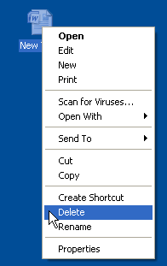

Emptying the Recycle Bin
When you delete a file from your computer, or move it to the Recycle Bin, it is not automatically deleted, but rather is temporarily stored in the Recycle Bin. This usually gives you the chance to restore the file if you decide you do not want to delete it. If you want to permanently remove files from the computer, thereby clearing the hard disk space the file is located, you need to permanently delete the files in the Recycle Bin. You can do this by emptying the entire Recycle Bin, or deleting individual files.
- Double-click the Recycle Bin icon to open it.
- Click Empty the Recycle Bin in the left pane to delete all the files.
OR
- Right-click a file or folder and choose Delete from the menu. This deletes the selected item.
Check the Internet Security Options in Your Browser
Whether you use Internet Explorer, Mozilla Firefox, Safari, or another browser, always check the Internet security options that are provided by your browser. Each browser is different, so use the Help tool in your browser to learn more about how it helps defend your computer against threats.

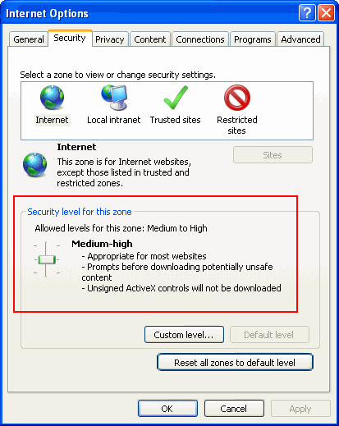
Internet Explorer Options Dialog Box
Take a look at our Internet Safety lessons to learn more about threats to your computer and what you can do to stay safe while using the Internet.

Disk Cleanup for Windows
When you install software, operate programs, and surf the Internet, temporary files are created. These files can clutter your computer and slow it down. Windows comes with a Disk Cleanup utility that removes temporary files and empties the Recycle Bin. Clearing out these files helps free up valuable hard disk space.

Windows XP
To Use Windows Disk Cleanup:
- Click Start.
- Choose Programs Accessories System Tools Disk Cleanup.
- The Select Drive dialog box asks you to "Select the drive you want to clean up."
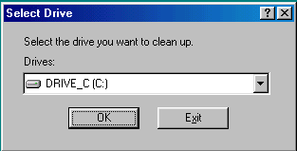
Disk Cleanup in Windows XP

- The C: drive is usually selected by default.
- Click OK to accept DRIVE_C (C:).
- The Disk Cleanup for DRIVE_C (C:) dialog box appears.
- Select Temporary Internet Files, Temporary Files and/or Recycle Bin.
- Click OK and the temp files you selected will be cleaned up.
Many other utilities are available to clean up your hard disk including CleanIt! and CleanWin. Most are freeware or shareware.

Windows Vista
To Use Windows Disk Cleanup:
- Click Start.
- Choose Programs Accessories System Tools Disk Cleanup.
- A Disk Cleanup information box appears as Windows calculates how much disk space you can free up on the C drive.
- The Disk Cleanup dialog box for drive C appears. Note: If the Disk Cleanup: Drive Selection dialog box appears, select the hard disk drive that you want to clean up, and then click OK. If not, the C drive will be chosen by default.
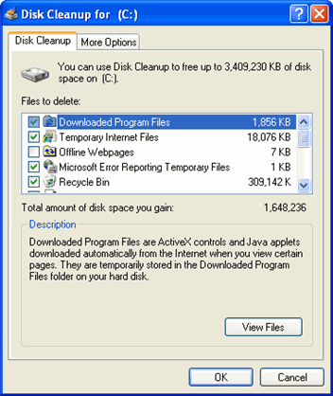

Disk Cleanup in Windows Vista
- Select the check boxes for the files you want to delete on the Disk Cleanup tab.
- Click OK when you finish selecting the files you want to delete.
- Click Delete Files to confirm the operation. Disk Cleanup will remove all the requested files from your computer.

Activity 12
- Take a look at your computer. Does it need to be cleaned?
- Based on the type of monitor you have, clean your monitor following the steps in the lesson.
- Based on the type of mouse you have, clean your mouse following the steps in the lesson.

Lesson 13 - What are some troubleshooting techniques?

The computer goes blank before the Word document was saved. The browser window freezes for no reason. You can't hear anything from the web camera or your speakers.
Most people have at one time or another experienced a computer problem like at least one of situations described, and if you haven't, chances are you will at some point.
Computer problems can be upsetting, especially if you are trying to meet a deadline for work or school. Most problems are minor and can be easily fixed, so don't panic when computer problems happen to you. Instead, work your way through some basic troubleshooting techniques and try to solve the problem.

Basic Troubleshooting Tips
For every problem there is a solution. For computer problems, it can be something as simple as a loose cord, or something more complicated. While it isn't necessary to learn how to locate and fix, or troubleshoot, every potential problem, it is a good idea to know some common pitfalls and how to handle those issues.
Here are four general tips to keep in mind when you are troubleshooting computer issues.
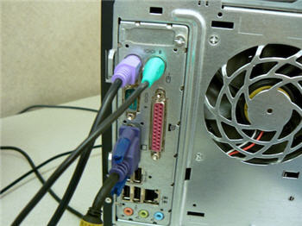

Check All Cables, Wires and Cords

- Always check the cables, wires, and cords.
A majority of computer problems are related to an issue in the cables and connections. The easiest first step you can take to troubleshoot most problems is to check all related cables and connections.

- Isolate the problem.
If it is possible to isolate the problem, then do so. For example, if you can't get the cursor to move on the screen, try to determine if the issue is with the mouse. If you have an extra mouse, you can alternate devices to see if the one plugged in is the issue, or use the arrow keys on the keyboard to help determine if the mouse is the source of the problem. When trying to isolate the problem, only make one change at a time.

- Take notes about error messages
If your computer gives you error messages, be sure to write down as much information as possible. If the basic troubleshooting steps don't work, you may need the information.

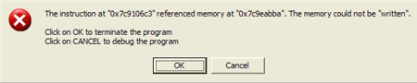

Example Error Message

- Remember the steps you've taken, or write it down.
Once you start troubleshooting, you will want to remember what you have done, so you don't repeat yourself. Also, each possible repair that you try that doesn't work is one less possible solution. If you can't remember it, then write it down. You'll be glad you did if it turns out to be a problem that you need additional assistance to solve.

Specific Troubleshooting Problems
There are many devices, parts, cords, and connections on a computer, which means that there are many possible problem areas that could arise. Additionally, your computer uses a variety of software, which can cause additional issues. However, there are some common computer problems that you may experience.

Programs Stall/Freeze While Working
- Press the Control, Alt, Delete keys. The Task Manager dialog box appears.
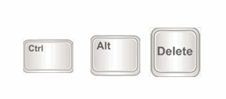
Press the Ctrl, Alt, and Delete Keys

- Select the Applications tab.
- Click a process or task to highlight it.
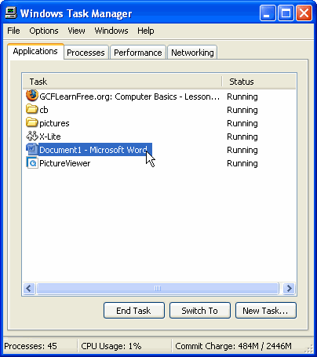

Task Manager
- Click End Task.
- Repeat, as necessary, to end multiple programs or processes.
- If the computer continues to freeze, restart it. This will clear many errors.

Power Button Will Not Start Computer
Power Cord
- If your desktop computer does not start, begin by checking the power cord to confirm that it is plugged securely into the back of the computer case and the power outlet.
- If it is plugged into an outlet, make sure it is a working outlet. Often, this will require you to plug a lamp or other electrical device into the outlet to make sure it is receiving power.
- If the computer is plugged into a surge protector, verify that it is turned on.
  - If it is, press the reset switch if it has one.
  - Confirm the outlet on the surge protector is working by plugging a lamp or other electrical device into it.

Power Cord in Surge Protector

- If you can hear the fan or drive from within the computer case, but the monitor remains blank, make sure the monitor is connected to a working outlet.
- Plug a lamp or other electrical device into the outlet to make sure it is receiving power.
- Make sure the monitor cable between the monitor and computer case is securely connected. The monitor cable has multiple pins. If one of these is broken or bent, the monitor display can be affected.
Windows Shutting Down Message Will Not Disappear
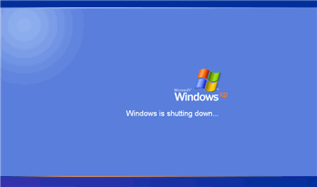
Windows Shutdown Screen
Sometimes Windows will freeze during the shutdown process. If this happens, the Windows is Shutting Down message screen will stay active on your screen. To finish shutting down the computer, press and hold the power button for about 10 seconds, or until the computer turns off.
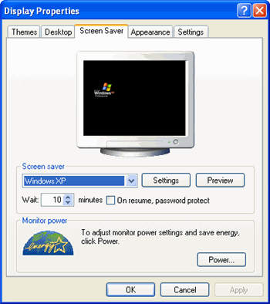
Display Properties Dialog Box

Screen Goes Blank Periodically
You may have the screen saver enabled. If the screen saver is enabled, just move your mouse back and forth and your original screen will appear. If you would like to disable the screen saver feature:
- Go to the Start menu.
- Select the Control Panel.
- Click Display.
- Choose the Screen Saver tab.
- Disable screen saver or change your screen saver settings.
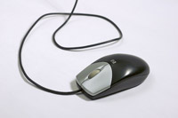
Move Mouse

No Sound
- Check the volume control on your computer.
  - The Sound icon may be in the bottom, right corner of the window.
  - If not, access the sound options from tControl Panel.
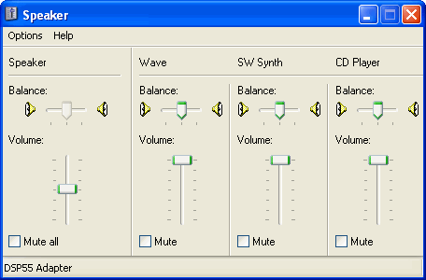
Sound Control Panel

- Verify the mute option is not selected.
- Make sure the speakers are turned on, if using external speakers.
- Make sure external speakers are connected to the correct audio port, which is usually green.
- Connect headphones to the correct audio port and determine if sound is audible from the headphones.

Computer Begins Randomly Rebooting or Crashing
- Check for overheating. Make sure the vents in the case are not blocked.
- Confirm that there is good air flow around the computer.
- Update your virus protection software to check for a virus.

Non-System Disk or Disk Error Message
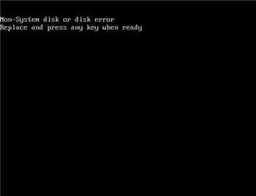
Non-System Disk Error Message
- If the monitor and computer have power and the Non-System Disk or Disk Error message appears on the screen, check the drives.
- Remove any disks that are in drives, such as CD-ROM, DVD-ROM, and USB drives.
- Restart the computer.

Operating System Won't Start
- If the computer and monitor have power, restart Windows using the original disc.
- If it starts from the disc, the problem is probably related to the hard disk drive.
- Read your instruction manual about reformatting a hard drive. You may have to buy a new one.

Existing Software Program Stops Working
- Go to the Start menu.
- Select Control Panel.
- Choose Add/Remove Programs.
- Remove the software program.
- Reinstall the software program.
- If the computer stalls or crashes, check with the company for any known problems or updates to the software.
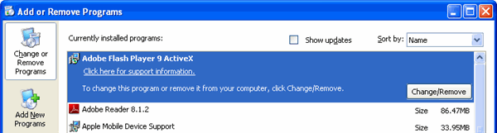Add/Remove Programs

No Picture on the Monitor
- Confirm the computer is turned on.
- Make sure the monitor cable is connected to both the monitor and the computer case.
- Check the power cable from the monitor to the wall outlet or surge protector.
  - Confirm that the wall outlet or surge protector outlet has power to it.
- Check the brightness controls, located on your computer monitor, and make sure it is at the correct position so the screen does not display dark.
If you have a computer problem that you don't know how to solve, use the Internet to search for possibly solutions. There are many other users that may have experienced the same issue as you. This is especially true for error messages with number codes. You can always search to learn more about each message.

Activity 13
- Think about times when your computer has had any of the problems described in the lesson.
- How did you handle the problem?

Lesson 14 - What is a network?

A home network is a method of connecting computers that allows them to communicate with one another. If you have two or more computers in your home, a network can let the computers share an Internet connection, devices such as printers and scanners, and files.
Let's explore the different types of home computer networks and some of the terms you need to know if you decide a home network is right for you.

Why Would You Use a Home Network?
If you have multiple computers in a home and you want to use all of them to access the Internet, print files, and play video games, a home network allows you to do that without significant extra expense. With a home network, you can share these resources.

Imagine This...
If I have a home network, I can use my laptop in the living room to shop online, while my daughter uses the computer in the home office to research her term paper online. We can share the same Internet connection at the same time and do completely different things. Her brother can even use the third computer to play games online at the same time, or do something completely different. You can even arrange the home network so it is possible for multiple computers to share the same files. This isn't as common with a basic home network arrangement, but a home network can give you this option.
Home networks aren't just for families! Even if you live alone, a home network may be right for you if you use multiple computers, such as a desktop in the home office and a laptop when you are watching television.

What Do I Need to Create a Home Network?
To create a home network, the two main items you will need are a modem and a router. Depending on your specific computer hardware, there are a few other items you may need, but these are the two main components.

Modem
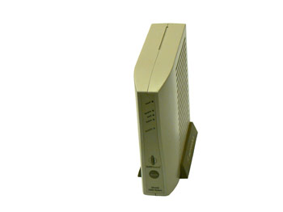
Example Cable Modem
A modem is a device that allows a computer to send data over telephone or cable lines. It is the device that basically brings the Internet into the house.
The type of Internet service you use -- dial-up, DSL, or cable, will determine the type of modem you use. If you are using DSL or cable Internet access, the modem is usually provided by your Internet Service Provider (ISP).

Router
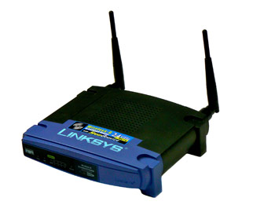
Example Router
In addition to a modem, you will need a router. A router is the device that is responsible for making sure the information that is being sent using the Internet makes it to the necessary destination. It allows two people to use the Internet at the same time without the pages being mixed up. The router directs messages so that each person is delivered the web page that he or she requested.
This device is not supplied by your ISP, so you will need to purchase one if you decide to create a home network

What Types of Networks Are There?
There are two types of networks, wired and wireless. Both types of networks have advantages and disadvantages. If you decide to create a home network, you'll have to weight the benefits and drawbacks of both types to determine which is best for your situation.

Wired Networks
Wired networks are faster than wireless networks, and are generally very affordable. If the computers are far apart and/or your house is big, you will want to consider the cost of the cable. While cable is not very expensive, the cost of having someone to install it can be.

Wireless Networks
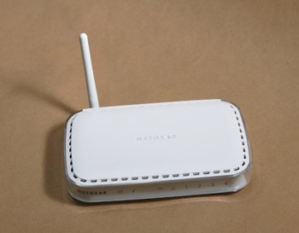
Wireless Router
Wireless networks use radio waves instead of wires to transmit information. A wireless router receives the information and then sends it to the Internet using a wired connection, an Ethernet cable.
One of the primary advantages of this type of network is that it offers you a great deal of flexibility. If you have a laptop, you can move it from room to room in the house, and sometimes right outside the house, without having to worry about connecting network cables. Also, installation is really very quick and easy.
The disadvantages of this type of network is that wireless connections are typically slower than wired connections, and can also that the connection can sometimes fail due to range issues.
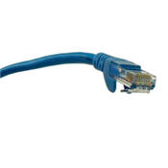
Ethernet Cable
If you compare security between the wired and wireless networks, you might guess that a wired network is more secure; however, if you use a wireless network you can take additional steps to ensure that the information you communicate over the network is safe. This is an extra step that is necessary when dealing with wireless networks.

Terms to Know
It would be nearly impossible to show you exactly how to set up a router and a network because there are many variations in the process that are dependent on the brand of router your choose and the modem you use. Additionally, if you are creating a wired home network, the size of your house, location of computers, and location of outlets will play a role in how it is set up. Your existing hardware will also play a factor.
Don't worry! The router you choose should come with clear directions as to how to install it, and generally this is a very easy process. Since the modem is usually installed by your ISP, you probably will not have to install that device.
You can become more comfortable with the process and be ready to read any setup instruction guides if you are familiar with a few key terms.
Wireless Adapter
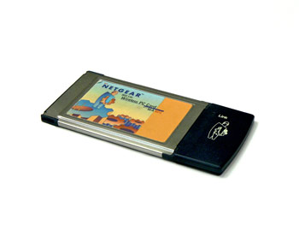
Wireless Adapter for Card Slot
If you want to create a wireless home network with your desktop or laptop, or use your laptop to surf the Internet at a public WiFi hotspot, you will need to check your computer to see if it is wireless-ready.
Most new laptops and some desktop computers are preloaded with wireless transmitters that will allow you to use the computer on a wireless network. If your laptop or desktop is not wireless-enabled and you want it to be part of a wireless network, you can buy a wireless adapter that plugs into the USB port or the card slot.
Firewall
If you have a DSL or cable modem, you will need a firewall for your home network. A firewall acts as a filter and monitors the information that is being sent over the network. Luckily, most routers offer firewall protection, so it is a good idea to choose one with this feature.
SSID
A Service Set Identifier, commonly called the SSID, is the name of a wireless network. It is a series of alphanumeric characters (numbers and letter) that you can set when you create your wireless network. It is the network's name and how you, or other users of the network, will identify it. You will want to change the default SSID, but avoid using a name that someone might guess.
Encryption passphrase
An encryption passphrase is a series of words that is used to control access to the network. It very important that you remember this information once you set it while you are installing your router.
Domain
A specific name for a network of computers.
Encryption
Encryption is the process of changing your information so that it is not readable to anyone without the encryption key. Basically, it takes your data and codes it so that it is not viewable by unauthorized people. You have to have the encryption key to decode the data. Encryption enhances security on your home network.
On wireless networks, it is very important to encrypt your data so that other people can not use you wireless signal and view your information. There are many types of encryption, but WEP, or the Wireless Encryption Protocol, is the type of encryption used in wireless networks.

Activity 14
- Do you have more than one computer at home? If so, think about how a home network would benefit you.
- Would a wired network or wireless network be right for you?
- Define the term data communication.

Lesson 15-Health, Safety and Environment

Ergonomics
Understand what elements and practices can help create a good working environment such as: appropriate positioning of monitors, keyboards and adjustable chairs, use of a mouse mat, use of a monitor filter, provision of adequate lighting and ventilation, frequent breaks away from the computer.

Ergonomics is the science of co-ordination the physical and psychological aspects of human beings with their working environment. Although computers present us with great opportunities for making our work easier, they do present some health and safety risks if used incorrectly. The science of ergonomics tells us how to use computers correctly.

Monitors
If you work with a monitor, tired, sore or blood-shot eyes indicate eye strain. The following points indicate some aspects of monitors to be aware of.
- Refresh rate: The refresh rate of a monitor is the rate at which it updates the images on the screen. When the refresh rate is too low, the screen appears to flicker. Apart from the annoyance factor, this causes eye strain. The refresh rate should be at least 72 Hz (72 times a second) and preferably higher.
- Monitor filter (Anti-glare screen): Reflections on the screen can cause eye strain. This can be overcome by using a monitor filter with an anti-glare screen or by placing a special anti-glare cover in front of the screen.
- Focus: The image on the screen should be sharp. Poor quality monitors have a slightly blurred effect. This causes the eyes to continually attempt to reduce the blur.
- Low radiation: The beam of electrons that strikes the screen to display the image also sends out electromagnetic radiation. There is some fear that this can be a health hazard, particularly to pregnant women. Use a monitor with low electromagnetic radiation.
- Position: Place the monitor in a position where you can look into the distance at regular intervals. To the side of a window is an ideal position. You need to change the focus of your eyes on a regular basis to prevent eye strain.
- Angle: The monitor should be slightly below eye level. Looking up at a monitor can cause strain in the neck.
- Rest: Take regular rest periods where you do not look at the monitor.

Keyboards and mouse
Repeated use of the same muscles and joints can result in a type of injury called RSI or
Repetitive Strain Injury. This type of injury can range from inflammation of joints, to damaged ligaments and muscles or even hairline fractures in bones. RSI is usually caused by the incorrect use of the keyboard and mouse.
- Ergonomic keyboards: Ergonomic keyboards are designed in such a way that the strain on the hands and finger are reduced.
- Touch typing: Learning to touch type can help reduce strain as it distributes the work evenly between the fingers. Users who can touch type also tend to use far less force when striking the keyboard.
- Mouse mats (pads): Mouse mats or pads are available with a cushion for the wrist to rest on. Repeated clicking of the mouse buttons can lead to inflamed finger joints.
- Resting the wrist on the cushion reduces this effect.
- Rest: Take regular breaks to rest the muscles and joints.

Desks and chairs
- Height and position of chairs: The height and position of the chair is an important
factor in reducing strain. These should be adjusted so that:
- the feet can rest flat on the floor. This maintains blood circulation.
- the thigh is horizontal to the floor.
- the head can be kept upright in line with the spinal column. If the chair is too high, the
- head will be bent. This will in turn cause backache.

A chair with adjustable height will allow you to find the most appropriate and comfortable height for your build.
- Posture: The back should be slightly bent forward. Sitting rigidly upright for long periods can cause stress in the back and shoulders.
- Support: There should be support for the lower back to avoid sitting in a hunched position.
- Rest: It is important to get up and move around on a regular basis. Ideally should do some stretching exercises to help relax tense muscles.
- Height of the desk: A common problem is having a desk which is too high. This is largely a matter of trial and error. A good test is whether the elbows are able to rest comfortable on the work surface.

Health Issues
List some common health problems which can be associated with using a computer such as: injuries to wrists caused by prolonged typing, eye strain caused by screen glare, back problems associated with poor seating or bad posture.

Lighting and ventilation
It is important to ensure that there is adequate lighting, but does not cause a glare on the screen. Another important consideration is whether there is enough air circulation in the room as computers generate a lot of heat and if a room is not adequately ventilated it can become stuffy and cause fatigue. It is also not good for the equipment so most companies make use of air conditioning.Other health problems associated with using a computer as discussed in the previous section are listed below:
- repetitive strain injury
- eye strain caused by the glare on the screen
- back problems due to poor seating or bad posture

Precautions
List some safety precautions when using a computer such as: ensuring power cables are safely secured, power points are not overloaded.

Apart from health issues, there are a number of safety issues associated with the use of Computers.

Adequate earthing
A faulty earthing system can cause electrical shock. A good system will be properly earthed and will incorporate earth-leakage detection. If the system detects a fault that could lead to electrical shock, a switch will trip before any damage can be done.

Cabling
It is common to see electrical cabling lying on the floor of offices. Apart from the fact that it looks untidy, workers can trip over cabling. Electrical cabling should be installed by electricians so that there is the minimum of open cabling. Electrical power sockets should be installed close to workstations so that there is no need to run cabling across the floor. The cabling between the power point and the computer should be secured using cable ties.

Load on power points
There should be adequate power points for the equipment. Overloaded power sockets are a fire hazard. If there is any sound of sparking in a power socket, the cause should be investigated by a qualified electrician.

The Environment
Be aware that recycling printed outputs, recycling printer toner cartridges, using a monitor that consumes less power while the computer is inactive can help the environment.

Paper
One of the goals on information technology was the paperless office. The reality is quite different and users are often careless and wasteful in the use of paper. The cost factor will be considered in the next section. From an environmental perspective, waste of paper isvery damaging. Here are some things that you can do to reduce the environmental impact.
- Do not throw paper away. Set up a storage area for paper that cannot be re-used. Have this collected on a regular basis for recycling.
- Print on both sides of the paper. Unless you are producing a document in final form, print on the reverse side of used paper.
- Alternatively, look for organisations that can make use of this paper. Many poor schools would be very glad to get supplies of paper that can still be used on one side.

Consumables
Often users throw used toner and ink cartridges away. There are two alternatives. You can have them refilled. If this is not an option because of guarantee restrictions on printers, you could resell them to companies which refurbish cartridges for resale. In either case, you reduce the waste output from your organisation.

Power
Another area where users are often careless is electrical power consumption. For example, many users switch only their monitors off at the end of the day so they do not have to boot up in the morning. Apart from the security risk, this means that the computer is running all night and wasting electrical power. Switch off any equipment that does not need to be on. When purchasing equipment, low power options could be selected. An example, would be the purchase of flat LCD screens over conventional monitors as these consume less power.

It is also possible to configure the computer to save power. When a component, such as the monitor, has not been used for a while, the computer shuts it down.

Environmental Consciousness
Understand that using electronic documents can help reduce the need for printed materials.

Using networks and email, there is little need to send printed documents. Rather send them in electronic format. In addition to avoiding printing, it is faster and more efficient. Avoid printing documents even for you own use unless it is necessary. It is quite possible to do much of your reading on-screen. Set the zoom and font size to facilitate on-screen reading.

Security
Understand the term information security and the benefits to an organisation of being proactive in dealing with security risks such as: adopting an information security policy with respect to handling sensitive data, having procedures for reporting security incidents, making staff members aware of their responsibilities with respect to information security.

Information Security
Because information and information technology are fundamental to just about all aspects of modern life, the modern era is often referred to as the Information age. By its very nature, much information is private and confidential. Information security refers to all the procedures which are used to protect information for deliberate or accidental misuse or dissemination. Technically, it refers to the maintenance of the integrity of information. Integrity means that the information remains correct at all times and cannot be accessed by unauthorised agents.

Personal privacy
If personal information such as health or finance status, personal or family issues and background details became available to unauthorised agents, this could lead to the standing of individuals being seriously compromised. In some cases it may have little more effect than a feeling of invasion of personal privacy, while in other cases in may lead to serious embarrassment, loss of status or job and even blackmail.

Company confidentiality
Business functions by trying to achieve a competitive edge. This is achieved by making better products and having better marketing strategies. If competitors found out the formulation of products or details of manufacturing or the marketing plans for new products, a company would lose its competitive edge. There is a whole dark area to business known as industrial espionage in which a variety of means are used to discover trade secrets and business dealings. Obviously, there is an absolute imperative to maintaining the confidentiality of all company information. A less obvious breach of information security occurs through industrial espionage where information is either changed or deleted to sabotage the functioning of the organisation.

Protecting company information
There are a number of procedures companies can take to protect their information and these would usually be detailed in a company policy document which would be explained to the staff on appointment. Often a personal copy of this document is given to each employee for their records.

Staff employment practices
Basic to good company security are loyal and trustworthy staff. If staff are likely to have access to sensitive information, they should be thoroughly screened before they are employed. The more sensitive the information they have access to, the more vital is this process. Promotion to more sensitive positions can be based on a good history or loyalty and trust. Part of the staff induction process and on-going staff training should inculcate in staff the importance of security and an awareness of the consequences of its violation.

Security procedures
Information should be classified on the basis of its sensitivity. Access rights to this information should be limited to those who need to know. To access certain information, an employee might need a special security clearance. All access to sensitive information should be recorded. The question of access rights is discussed further in the next section. Where sensitive information is stored in the form of paper files, these should be kept in a secure vault.

Procedures should be in place that enable staff to report breaches or suspected breaches of security. They should be able to report these without fear of reprisal. In large organisations security departments can be established specifically for the purpose of providing such channels and monitoring security on an on-going basis. This is often done in conjunction with forensic auditing. This is a special form of auditing to detect mismanagement and corruption.

Privacy Issues
Know about privacy issues associated with computers, such as adopting good password policies. Understand what is meant by user ID and differentiate between user ID and password. Understand the term access rights and know why access rights are important.

Information stored on computers
All computers from laptop computers to mainframes contain information. Much of this, whether corporate or personal, is confidential. Many thousands of laptop computers containing important company or state information have been stolen. Since most corporate records are now kept in electronic form on computer systems, procedures need to be put in place to protect the computers.
Apart from deliberate violations by people, computers are also subject to accidental damage and natural disasters.
Physical procedures
Physical access to mainframes should be restricted to operators and systems administrators. Facilities should be fire and flood proof. Highly sensitive installations should also have adequate protection from criminal and terrorist activities.

Desktop and laptop computers are very vulnerable to theft. A simple procedure is to only allow authorised people access to offices. The use of security cameras can also act as a deterrent. Desktop computers can be physically attached to the floor or a work surface. Laptop computers present the greatest risk. They are not only light and easy to pick up, but they are also more expensive and valuable than desktops. The best protection is not to let them out of site. If a manager is staying at a hotel, he or she can leave the computer in the hotel safe rather than their room.

Software procedures
Information can be stolen, altered or deleted without the computer being physically removed. The information may even be accessed across the Internet.

Firewalls
A firewall is the first line of defence against hackers. It is a computer program that is installed on a computer that connects a network to the Internet. The firewall analyses the packets that pass in and out of the network. It is programmed to follow certain rules which enable it to decide whether or not to allow a packet to pass. There is firewall software that can be installed on a stand-alone PC.

Access rights
Access rights can refer to both physical and software. In a physical sense, these refer to different members of staff who have to gain physical access to certain areas. For example, access to the room containing the mainframe may be restricted to operators. Software rights refer to the level of access different users have to different levels of data and information. For example, some users may have no access to certain data, others may only be able to read the data but not change it.

Others in turn may have full rights to create and change data. Access rights are associated with a user id and password. A user id could be a user name or a combination of letters and numbers. To log on to a system a user would need a user id and a password. As other users may know the user id of colleagues, another level of security in terms of passwords needs to be added in the form of a password. Passwords are private and should never be divulged to anyone else. Users could have
several user ids, each with a different level of security. They would log on each time with the lowest level of security they need to accomplish a given task.

Password policies
Password policies refer to guidelines or requirements on the structure and use of passwords. They can be required for access to a computer system or a group of files or a single file. The following are some guidelines for password policies:
- They should never be blank.
- They should not be the names of family members or pets or anything else that would be
easy for an intruder to try out.
- Ideally they should never be words, especially words like administrator, admin or root.
- They should never be less than five characters and preferably longer. Short passwords
can easily be determined by a brute force password cracker. This is a piece of software that repeatedly feeds in all combinations of letters and numbers until accessed is gained. With short passwords this can be done in seconds.
- A good policy is to use a meaningless combination of letters and numbers that is seven or eight characters long. What some users do is to take a meaningful word such as looking and replace the o with the number 0 and the letter i with the number 1 so that the password becomes l00k1ng. You could also make a less obvious change, for example replace k with 3 and g with 9 so that the password becomes loo3in9.
- Passwords should be changed on a regular basis. Administrators can set a policy that
automatically causes passwords to expire after a certain period of time, for example 7 days.
- When using a PC, you would need to use an operating that provides genuine access protection with a user id and password. This means using Linux or Windows NT/2000/XP/2003. In Windows 95/98/Me the logon procedure can be bypassed. If Windows NT, 2000, XP or 2003 are used, it should be in conjunction with the NTFS file system.

Data encryption
Data should be encrypted. Encryption scrambles the data and makes it unintelligible without the use of a key. The key is used to decipher the data.

Vulnerability of data (Data Backup)

Know about the purpose and value of backing up data, software to a removable storage device.

Data is vulnerable in many ways:
- The system on which it is stored can fail. For example, a hard drive may crash due to component failure.
- The medium itself may become corrupt. Where data is stored on a magnetic medium, this can become corrupt due to a number of factors including moisture, heat, magnetic fields and electromagnetic radiation. Even optical storage which is highly reliable should never be regarded as infallible.
- The system can be stolen.
- The system could be physically damaged through war, criminal activity, vandalism or carelessness.
- The system could be damaged as a result of a natural disaster such as a flood, fire or earthquake.
- The data could be deleted or changed through criminal activity, vandalism or carelessness.
- No matter what care you may take to protect a system, additional copies of data need to be
made and stored on a regular basis. Copies of data are referred to as backups. The following are some guidelines to working with backups.
- Once backups have been created, they should be store in a secure area at a different site. Never keep backups on the same site as the system. They could be stolen or destroyed along with the rest of the system.
- Backups should be made on a very regular basis. Even for a small organisation, this should be done daily. Even the loss of a single day's work would be a major problem.
- In large organisations backing up may take place on an on-going basis. A schedule of backing up should be clear policy and adhered to.
- More than one copy of data should be made. If the data is very valuable, the different copies could be stored in different secure locations.
- Different versions of the backup should be retained. The following is an example of a backup schedule that could be followed.
- The cycle of backing up starts on the first Monday of the month. At the end of each day of the week a backup is made. At the end of the week, there is a Monday, Tuesday, Wednesday ... Saturday backup. On Sunday a backup is created and labelled week 1 backup. This is kept for the rest of the month. The weekday tapes are then reused and the process repeated. At the end of the month you end up with a series of weekly backups. The last one becomes the backup for the month and the process starts over the next month. At the end of the year you then have a series of monthly backups.
- An appropriate medium for backing up must be used. In the case of companies this would generally be done using tape, although optical storage is becoming more common. For personal use, a CD or DVD makes an excellent backup. DVD writers are still quite expensive. Never use diskettes for backup purposes. They are not reliable for this purpose. Even when backing up a PC, makes multiple copies and keep them at another site for safe storage. You could, for example, use a safety deposit box at a bank.
- Often a network server has two identical hard drives, one being a mirror image of the other. This means that if one fails the other one can take over. In other words all the software on the first is identical to the software on the second.

Software can be backed up by making a copy of the cd/dvd media and then storing the originals and using the backups to install from. This is allowed by most software manufacturers. The original is kept under lock and key along with the licence numbers.

Implications of Theft

Be aware of possible implications of theft of a laptop computer, PDA, mobile phone such as: possible misuse of confidential files, loss of files, loss of important contact details if not available on a separate source, possible misuse of telephone numbers.

Highly portable devices such as cell phones, PDAs and laptop computers can containing vital and confidential information. Even if the information is not confidential, it could be vital to your work. Losing your contact list or diary will very seriously compromise your business operations.

PDAs, cell phones and laptops usually contain contact lists and diaries. Make sure that copies of these are kept elsewhere. Cell phones and PDAs come with synchronisation software. This software links the device with a personal computer or laptop and updates each of them with the latest data. In other words, if you keep your diary on your PDA, synchronising will automatically update the diary (and contacts) on the PC or laptop. You should make sure that your diary and contact list are on two different devices.

These should be kept apart so that they are unlikely to be stolen at the same time. Ideally, you should make backups of these at the end of every day and keep these backups in a safe location.
Although you can at least retain your diary, contacts and files through the use of backups, loss of these can compromise you seriously. If for example, you keep information of your bank and credit cards details on your PDA, cell phone or laptop, a criminal could make use of these if they steal these devices. Personal information and telephone numbers of friends and business colleagues could make them vulnerable to the activities of criminals.

Computer Viruses

Understand the term virus when used in computing and understand that there are different types of virus. Be aware when and how viruses can enter a computer system.

A computer virus is a program that is deliberately created to cause annoyance or alter or delete data. Some viruses cause computer systems to slow down to the point where they are not usable. One of the features of viruses is that they are designed to replicate and spread.

Types of Viruses

Trojan: A Trojan (or Trojan horse) is a virus that hides itself inside another legitimate program. When the program is used, the virus is released and can begin its work of replication and annoyance or damage.

Worm: A Worm is a program that replicates itself over and over in the computer's memory until the computer can barely function. One of the signs of invasion by a worm is the slowness of computers.

Time bomb: A time bomb is a virus which lies dormant until a certain date or time or for a period of time. At this date or time, the virus suddenly becomes active and carries out whatever task it is programmed to do. This can include the deletion of everything on the hard drive.

Logic bombs: A logic bomb is similar to a time bomb, except that instead of becoming active at a certain time, it becomes active when a particular activity happens. For example, instead of formatting a diskette, the virus causes the hard drive to be formatted.

Macro-viruses: Macro-viruses make use of a special customisation feature in applications called macros. Macros allow you to create mini-programs to carry out certain tasks in your applications.

Spread of computer viruses
Viruses are spread in a number of ways:
- Downloads from the Internet.
- Pirated software.
- Exchange of diskettes.
- In attachments to emails and in emails themselves.
- In documents. Macro-virus, described above, can be hidden in ordinary documents,
spreadsheets and presentations.

Virus Protection
Know about anti-virus measures and what to do when a virus infects a computer. Be aware
of the limitations of anti-virus software. Understand what ‘disinfecting’ files means.

The actions of computer viruses were discussed in the previous section. The measures you can take to protect yourself against viruses will be discussed in the next section. One of the main measures to protect against viruses, anti-virus software, is discussed in this section.

Anti-virus software
Anti-virus software scans files for pieces of code, called signatures, which it recognises as part of a virus. Updating anti-virus software mostly involves updating the signatures file.

This should be done on as frequent as basis as possible. This is even more the case when you receive files regularly from outside sources. The actual anti-virus program itself will be updated from time to time. These updates will include additional features and improved methods of scanning.

It is important to keep in mind that no anti-virus software is perfect. It is only as good as the techniques it uses for detecting viruses and the currency of the signature file. There is always the chance that a virus will go undetected. However, a good anti-virus system installed on your system is essential and will usually detect most viruses.

When a virus is detected, the software will attempt to remove the virus. This is called cleaning or disinfecting. It sometimes happens that the system can detect the virus but not get rid of it. In this case, you will usually be given the option of deleting or quarantining the infected file. When a file is quarantined, it is made unusable and so unable to spread the virus. A future update of the software may be able to remove the virus. If it can the quarantine is removed.

Best Practices when Downloading

Understand good practice when downloading files, accessing file attachments, such as: use of virus scanning software, not opening unrecognised e-mail messages, not opening attachments contained within unrecognised e-mail messages.

There are a number of measures you can take to protect yourself from viruses:

- Install good anti-virus software and update it on a regular basis, for example at least once a month but preferably once a week. But always remember, anti-virus software is
not perfect. It cannot be the only measure you take.
- Scan all diskettes before reading them.
- Enable the auto-protection feature on the anti-virus software to scan emails.
- Be wary of emails from unknown sources, particularly if they contain attachments.
- Some very careful users delete emails they are unsure of without opening them.
- Use an Internet Service Provider than scans emails before delivery.
- Do not download files/software from unknown Internet sites.
- Be careful of using diskettes from unknown sources.
- Do not install pirated software.

Lesson 16- Copyright and the Law

Copyright

Understand the concept of copyright when applied to software, and also to files such as: graphics, text, audio, video. Understand copyright issues involved in downloading information from the Internet.

Copyright
Copyright refers to the legally protected right to publish and distribute any literary, musical, artistic or software material. This means that only the developer and authorised sellers have the right to copy and distribute computer software, video materials, music or text.

Because there is no control over the Internet, there are hundreds of sites where software, music and videos can be downloaded. Access to permanent connections makes downloading of large files physically possible. Many of these sites are located in countries that do not protect copyright.
The fact that it is possible to do something does not make it legally and ethically right. Authors and developers are entitled to a return on their creative efforts.

Downloading pirated material is both ethically and legally wrong. By reducing revenue, piracy can hamper the development of software. Software development is expensive and part of the royalties are needed for future development. Software piracy is a form of theft. It is both a criminal and a civil offence. Developers are entitled to claim damages in cases of piracy. Increasingly they are making use of all legal avenues to reduce piracy and obtain compensation where it has occurred.

They are entitled to claim damages against not only sites, organisations and individuals who make pirated software available, but also those who make use of it. Downloading from the Internet is not the only form of software piracy. Making copies of software, other than for personal use, as well as installing software on more computers than specified in the licence agreement are both forms of piracy.

Copyright Issues

Understand copyright issues associated with using and distributing materials stored on removable media such as CD’s, Zip disks, diskettes.

When you purchase software, you are actually purchasing the right to install the software on a specified number of machines. Software usually comes out in two forms: standalone and network. When you purchase standalone software, you are purchasing the right to install it on a single machine. Generally there are further restrictions that are specified in the licence agreement. Licence agreements are covered in the next section.

When you purchase a network version of the software, you purchase the right to install the software on computers attached to a particular network. This may give you the right to install it on all the computers on the network or a certain maximum number. It is important to realise that you do not purchase the actual program. The program remains the intellectual property of the developer. The concept of intellectual property is used as the developer owns something abstract, something which is the result of considerable intellectual effort.

This also means that you do not have the right to alter the program in any way other than the configuration allowed in the installation. However, you may store the program on CD, DVD, zip disk, diskette, hard drive or tape, the program still remains the intellectual property of the developer. This does not mean that you may lend the stored program out to others, though. This would be a breach of copyright. The stored version is for that purpose only as a backup and for the licensed user only.
The section on licence agreements in the next section specifies some of the copyright issues in more detail.

Licensing Issues

Know how to check the Product ID number for a software product. Understand the terms shareware, freeware, end-user license agreement.

Licence agreements
As mentioned in the previous section, when you purchase software, you only purchase the right to use the software subject to certain conditions. These conditions are specified in the licence agreement. When you install the software onto a computer, there is always a stage where you have to make a selection that you have read and accept the terms and conditions of the licence agreement. When you do this, you are agreeing to the developer's rights under copyright law.

The terms of the licence agreement include the following:
- Clarification of the licence as meaning right to use the software not ownership of the
intellectual property.
- The number of machines on which the software may be installed.
- Restrictions on copying the distribution CD.
- Restriction on the resale of the software.
- Prohibitions on altering the code and reverse engineering. Reverse engineering involves a process of uncovering the logic and algorithms used to develop the program.

Shareware
Shareware is software, generally downloaded from the Internet, which can be freely used and distributed. However, it does require that if users would like to continue using it, they pay the developer a fee. This is nearly always done by means of a credit card transfer across the Internet. When payment is received, users get a serial number which they insert
into the software.

To attempt to enforce payment, developers usually employ a number of methods:
- Nag notices. These are notices that appear on a regular basis reminding the user that the
software has not yet been registered.
- Time limitations. The software can be used for a certain period of time. At the end of
this period it ceases to work.
- Function limitations. The shareware version may exclude certain key features.

These limitations would be removed when a valid serial number is entered.

Freeware
Freeware is software which can be freely copied and distributed. Usually there are certain restrictions such as it may not be resold or its source should be acknowledged.

Data Protection Legislation

Know about data protection legislation or conventions in your country. Understand the implications of data protection legislation for data subjects and data holders. Describe some of the uses of personal data.

Because of the all-pervading nature of information and communications technology as well as the ease with with data can be accessed and transferred, some countries have introduced legislation to protect the privacy of individuals and organisations. The purpose of data protection legislation is to specify how data may be obtained, stored and used.

This type of legislation can be very technical and complex. Some of the key points of the Data Protection Act of 1998 of the United Kingdom are set out below as an illustration of the issues covered.
- The provisions of the act refer to data in whatever way it is stored, whether electronic
or paper.
- Personal data should be obtained in a fair and lawful way.
- Data should be processed in accordance with its original purpose. If data is to be used
for purposes other than for which it is collected, safeguards need to be put in place to
avoid abuse.
- Data must be up-to-date and accurate.
- Data must not be kept for longer than is necessary.
- Appropriate security measures must be in place to prevent:

- Unlawful or unauthorized processing;
- Accidental loss;
- Damage;
- Theft.
- Personal data may not be transferred.
- Data may not be used for certain purposes such as direct marketing.

In addition, subjects of the data have certain rights. These include the right to access data
held about themselves.

Lesson 17- Working with files and folders

A file is very much like a typed document that you might find on someone's desk or in a filing cabinet; it's an item that contains a collection of related information. On a computer, examples of files include text documents, spreadsheets, digital pictures, and even songs. Every picture you take with a digital camera, for example, is a separate file, and a music CD might contain a dozen individual song files.
Your computer represents files with icons. By looking at a file's icon, you can tell at a glance what kind of file it is. Here are some common file icons:
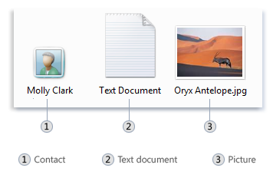
You can tell what kind of file an icon represents by its appearance
A folder is little more than a container in which you can store files. If you put thousands of paper files on someone's desk, it would be virtually impossible to find any particular one when you needed it. That's why people often store paper files in folders inside a filing cabinet. Arranging files into logical groups makes it easy to locate any particular file.
Folders on your computer work exactly the same way. This is what a typical folder icon looks like:
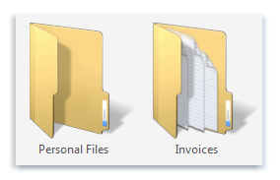
An empty folder (left); a folder containing files (right)
Not only do folders hold files, but they also can hold other folders. A folder within a folder is usually called a subfolder. You can create any number of subfolders, and each can hold any number of files and additional subfolders.

Using libraries to access your files and folders
When it comes to getting organized, you don't need to start from scratch. You can use libraries, a feature new to this version of Windows, to access your files and folders, and arrange them in different ways. Here's a list of the four default libraries and what they're typically used for:
- Documents library. Use this library to organize and arrange word-processing documents, spreadsheets, presentations, and other text-related files.
By default, files that you move, copy, or save to the Documents library are stored in the My Documents folder.
- Pictures library. Use this library to organize and arrange your digital pictures, whether you get them from your camera, scanner, or in e-mail from other people.
By default, files that you move, copy, or save to the Pictures library are stored in the My Pictures folder.
- Music library. Use this library to organize and arrange your digital music, such as songs that you rip from an audio CD or that you download from the Internet.
By default, files that you move, copy, or save to the Music library are stored in the My Music folder.
- Videos library. Use this library to organize and arrange your videos, such as clips from your digital camera or camcorder, or video files that you download from the Internet.
By default, files that you move, copy, or save to the Videos library are stored in the My Videos folder.
To open the Documents, Pictures, or Music libraries, click the Start button , and then click Documents, Pictures, or Music.
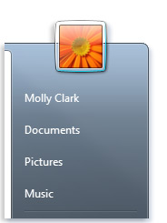

Understanding the parts of a window
When you open a folder or library, you see it in a window. The various parts of this window are designed to help you navigate around Windows or work with files, folders, and libraries more easily. Here's a typical window and each of its parts:
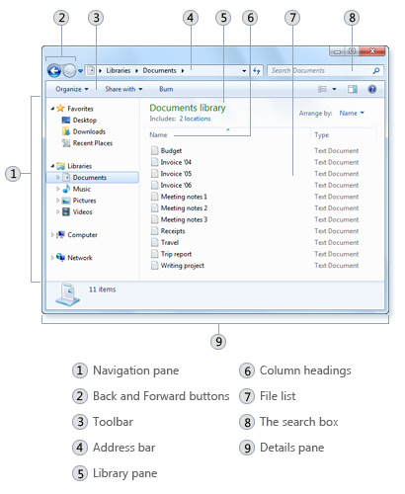

Creating a new file

Applies to Windows Vista
You can create new files in any program and give each of them a meaningful name to help you organize your work. In most programs, the File menu is where you open, save, and create new files.
- Click the File menu in the program you are using, and then click New.
If you can create more than one kind of file in the program, you might also need to select an item, such as a template, from a list.
- When you are finished working with the new file, click the File menu, and then click Save As to name the file and save it on your computer.

Create a new folder
Before you can create a folder you first need to be in the place where you are going to create that folder. In this example, you will need to be inside the MY DOCUMENTS folder (so you will be creating a sub-folder). To get inside (to open) MY DOCUMENTS either double click on your desktop User Name shortcut icon (i.e. Yoingco), if a desktop shortcut icon has been created for it, and then double click on the MY DOCUMENTS folder.....

Fig 1.0 Double Click on your User Name desktop icon.....
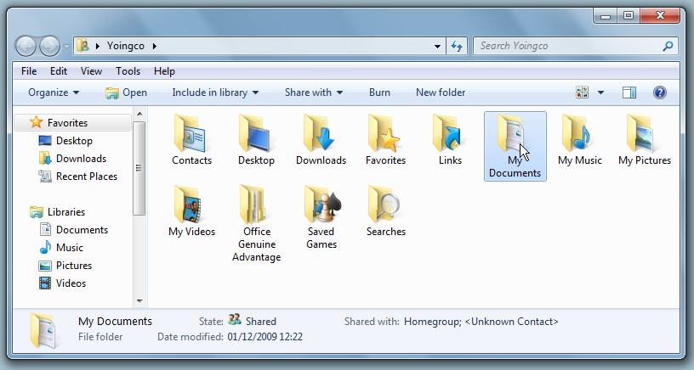
Fig 1.1.....and then double click on the MY DOCUMENTS folder to continue.....OR.....
.....OR left click on the START Menu button, move the mouse pointer over to the DOCUMENTS menu-item (shortcut icon) and then select (left click on) DOCUMENTS. Either way will take you to the folder where your main documents are stored.
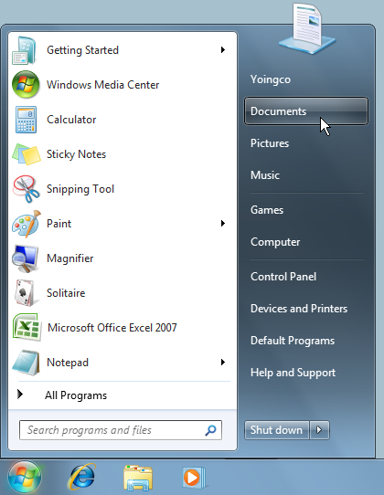
Fig 1.2.....left click on the START button, move the mouse pointer over the DOCUMENTS menu-item and then left click on DOCUMENTS.

When you left click on the START Menu button the Start Menu appears. All you need to do then is move the mouse pointer towards the DOCUMENTS menu-item (shortcut icon) until it is highlighted (Fig 1.2 above) and then click on it (select it) with the left mouse button. This will then open the DOCUMENTS folder.
With the DOCUMENTS folder open you have two methods for creating a folder. The first method is the easiest and simplest, but not neccessary the best one. It is the method of clicking on the NEW FOLDER button that is available on every standard folder's window. The reason why it is not the best method though is because it makes computer practise lazy and the NEW FOLDER button is not on every kind of window. You will see what I mean in a minute when I show you method two.
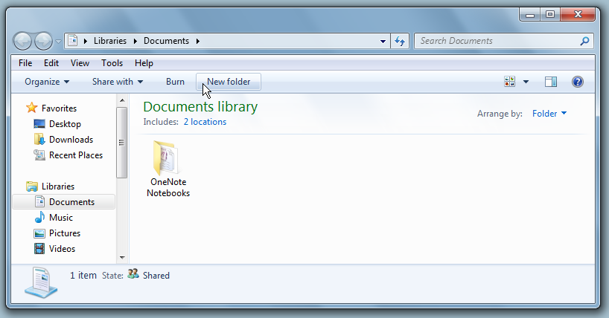
Fig 1.3 Left click on the NEW FOLDER button to create a folder
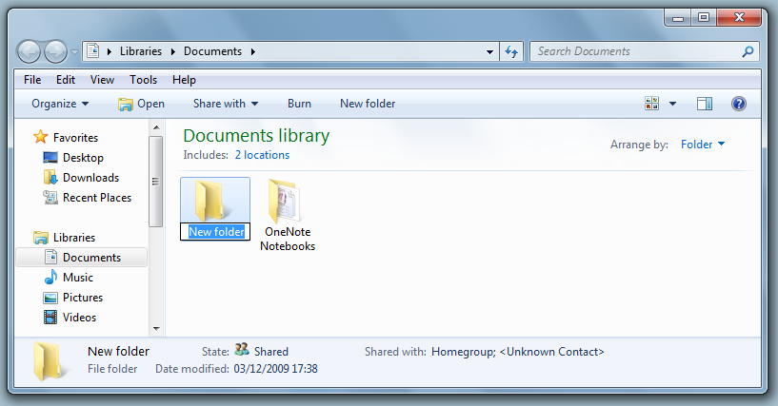
Fig 1.4 A new folder has been created with the file name: New folder

Method two uses the classic menu system, found in older versions of Windows and within software programs, to create a folder and is therefore going to give you better computer practise that will benefit you both in terms of software programs and older Windows.
To create a folder with method two begin by moving the mouse pointer towards the menu title called FILE (the File menu), which is located in the top-left corner of the DOCUMENTS folder window, so that the FILE menu becomes highlighted. From there. Click the left mouse button, whilst on the FILE menu, to reveal the FILE menu's menu-items.
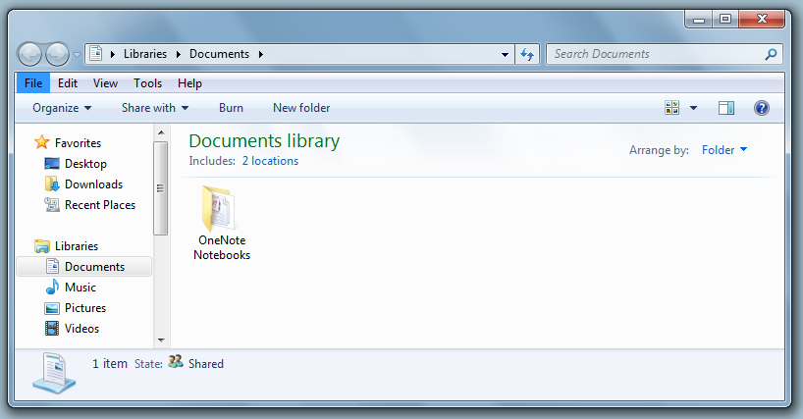
Fig 1.5 The FILE Menu

The first menu-item is called NEW. Highlight it by moving the mouse pointer down 1 position (down 1 menu-item), as shown in Fig 1.6 below, to reveal its sub-menu menu-items.
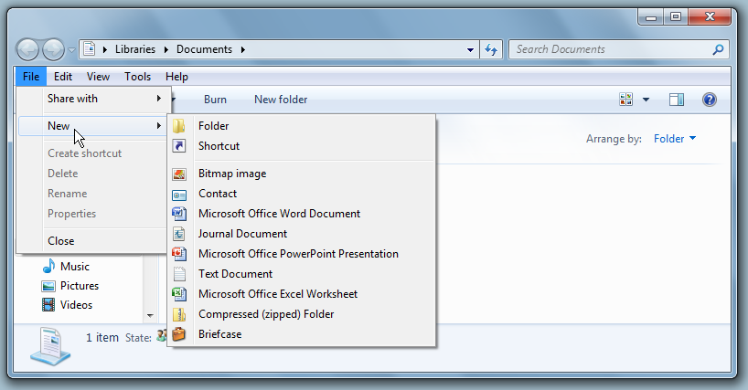
Fig 1.6 The NEW sub-menu, with its Menu-Items

Although NEW is a menu-item of the FILE menu it is also a sub-menu in its own right, with its menu-items FOLDER, SHORTCUT, BITMAP IMAGE and so on. NEW, in this case, means you want to create something new inside the DOCUMENTS folder. So if you were to now select (left click on) NEW's menu-item called MICROSOFT OFFICE WORD DOCUMENT a blank Microsoft Word 2007 document (text file) would be created inside the Documents folder. Here though you just want to create a new empty folder. So move the mouse pointer towards the right of the highlighted NEW menu-item (sub-menu) until you reach and highlight the FOLDER sub-menu menu-item (Fig 1.7). If you fall out of line with the mouse pointer it will unhighlight NEW and you will need to start again (it takes practise). Fig 1.7 shows where you should be moving the mouse pointer.
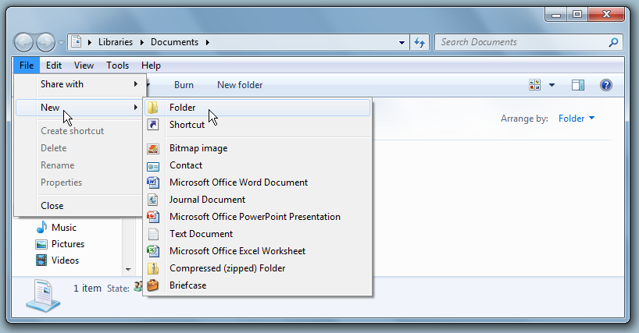
Fig 1.7 This is how you should move the mouse pointer rightwards on a menu-item

When you have reached and highlighted the FOLDER sub-menu menu-item simply click on it with the left mouse button. This will create a new (empty) folder called New folder, as shown in Fig 1.4 above and below. Remember. Although New folder is a folder in its own right it is also a sub-folder of the DOCUMENTS folder.
Fig 1.8 A new folder has been created with the file name: New folder

To create another new folder just repeat the above procedure. All newly created folders are called New folder. However. If there is already a folder called New folder your newly created folder will be called New folder (2) instead. Thereafter New folder (3), New folder (4) and so on.

Viewing and arranging files and folders
When you open a folder or library, you can change how the files look in the window. For example, you might prefer larger (or smaller) icons or a view that lets you see different kinds of information about each file. To make these kinds of changes, use the Views button in the toolbar.
Each time you click the left side of the Views button, it changes the way your files and folders are displayed by cycling through five different views: Large Icons, List, a view called Details that shows several columns of information about the file, a smaller icon view called Tiles, and a view called Content that shows some of the content from within the file.
If you click the arrow on the right side of the Views button, you have more choices. Move the slider up or down to fine-tune the size of the file and folder icons. You can see the icons change size as you move the slider.
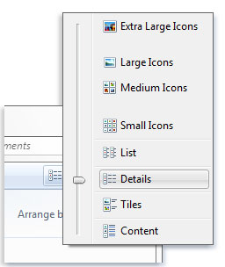

Finding files
Depending on how many files you have and how they are organized, finding a file might mean browsing through hundreds of files and subfolders—not an easy task. To save time and effort, use the search box to find your file.
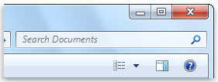The search box
The search box is located at the top of every window. To find a file, open the folder or library that makes the most sense as a starting point for your search, click the search box, and start typing. The search box filters the current view based on the text that you type. Files are displayed as search results if your search term matches the file's name, tags or other properties, or even the text inside a text document.
If you're searching for a file based on a property (such as the file's type), you can narrow the search before you start typing by clicking the search box, and then clicking one of the properties just below the search box. This adds a search filter (such as "type") to your search text, which will give you more accurate results.
If you aren't seeing the file you're looking for, you can change the entire scope of a search by clicking one of the options at the bottom of the search results. For example, if you search for a file in the Documents library but you can't find it, you can click Libraries to expand the search to the rest of your libraries.

Copying and moving files and folders
Occasionally, you might want to change where files are stored on your computer. You might want to move files to a different folder, for example, or copy them to removable media (such as CDs or memory cards) to share with another person.
Most people copy and move files using a method called drag and drop. Start by opening the folder that contains the file or folder you want to move. Then, open the folder where you want to move it to in a different window. Position the windows side by side on the desktop so that you can see the contents of both.
Next, drag the file or folder from the first folder to the second folder. That's all there is to it.
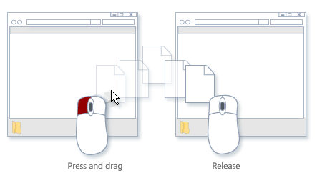To copy or move a file, drag it from one window to another
When using the drag-and-drop method, you might notice that sometimes the file or folder is copied, and at other times it's moved. If you're dragging an item between two folders that are stored on the same hard disk, then the item is moved so that two copies of the same file or folder aren't created in the same location. If you drag the item to a folder that's in a different location (such as a network location) or to removable media like a CD, then the item is copied.

