USE A GUI BASED DATABASE APPLICATION TO WORK WITH SIMPLE DATABASES
UNIT STANDARD ID: 116936
NQF LEVEL: 3
CREDITS: 3
NOTIONAL HOURS: 30

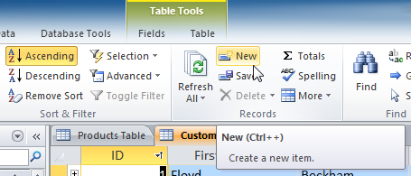

LEARNER GUIDE

Name
Contact Address
Telephone (H)
Telephone (W)
Facsimile
Cellular
E-mail

SAQA UNIT STANDARD ALIGNMENT
SPECIFIC OUTCOMES (SO) | ASSESSMENT CRITERIA (AC) | LEVEL | CREDITS
UNIT STANDARD 116936 :
Use a Graphical User Interface (GUI)-based database application to work with simple databases
 |  | Level 3 | 3 Credits
  SPECIFIC OUTCOME 1
  Understand the principles of databases.
  ASSESSMENT CRITERION 1
  A database management system is defined in terms of its purpose and use.
  ASSESSMENT CRITERION 2
  Examples of uses of databases are provided.
  ASSESSMENT CRITERION RANGE
  At least three examples.
  ASSESSMENT CRITERION 3
  Properties of databases are described in terms of their purpose and relation to the database as a whole.
  ASSESSMENT CRITERION RANGE
  Field, Record, Table, Index, Field Property, Data type.
  SPECIFIC OUTCOME 2
  Open and save a simple existing databases.
  ASSESSMENT CRITERION 1
  The database application is opened or started.
  ASSESSMENT CRITERION 2
  The parts of the database application window are described in terms of their features and use.
  ASSESSMENT CRITERION RANGE
  All of: Menu Bar, Toolbar, Status Bar, scroll bar, Object Bar.
  ASSESSMENT CRITERION 3
  An existing database is opened.
  ASSESSMENT CRITERION 4
  Data is entered into an existing database table.
  ASSESSMENT CRITERION RANGE
  At least 5 records are entered.
  ASSESSMENT CRITERION 5
  Saving a database giving it a descriptive name related to its purpose and use.
  ASSESSMENT CRITERION 6
  The database is closed.
  ASSESSMENT CRITERION 7
  The database application program is closed.
  SPECIFIC OUTCOME 3
  Produce and edit a simple database table from given specifications.
  OUTCOME RANGE
  At least 5 fields.
  ASSESSMENT CRITERION 1
  A database table is created with the required format bases on a given specification.
  ASSESSMENT CRITERION RANGE
  Data types to include at least: text, numeric, date, currency.
  ASSESSMENT CRITERION 2
  The database table is saved with a descriptive name, as per the given specification.
  ASSESSMENT CRITERION RANGE
  The name of the new database table and database must allow the database table and database to be easily identified in terms of its purpose and content.
  ASSESSMENT CRITERION 3
  A column is moved within the database table.
  ASSESSMENT CRITERION 4
  Column widths of columns in the database table are changed.
  ASSESSMENT CRITERION RANGE
  At least 2 columns.
  ASSESSMENT CRITERION 5
  A database table is deleted.
  ASSESSMENT CRITERION 6
  The database table is saved and closed.
  SPECIFIC OUTCOME 4
  Data is entered into a simple database table from given specifications.
  OUTCOME RANGE
  At least 5 fields.
  ASSESSMENT CRITERION 1
  A new record is added to the database table.
  ASSESSMENT CRITERION RANGE
  At least 2 records are added.
  ASSESSMENT CRITERION 2
  Data in the database table is modified.
  ASSESSMENT CRITERION RANGE
  At least 3 records are modified.
  ASSESSMENT CRITERION 3
  Data in the database table is deleted.
  ASSESSMENT CRITERION 4
  A record is deleted from the database table.
  SPECIFIC OUTCOME 5
  Modify the design of a database table.
  ASSESSMENT CRITERION 1
  An existing database table is opened in design view.
  ASSESSMENT CRITERION 2
  The consequences of changing a field size are discussed.
  ASSESSMENT CRITERION 3
  Field formats are modified.
  ASSESSMENT CRITERION RANGE
  Field size, Number field, Date field.
  ASSESSMENT CRITERION 4
  A field is moved in the database table.
  ASSESSMENT CRITERION 5
  A new field is added to the database table.
  ASSESSMENT CRITERION 6
  A field is deleted from the database table.
  ASSESSMENT CRITERION 7
  The consequences of the changes made are explained and corrected if necessary.
  ASSESSMENT CRITERION RANGE
  Type conversions.
  SPECIFIC OUTCOME 6
  Sort and search for records in a database table.
  ASSESSMENT CRITERIA
  ASSESSMENT CRITERION 1
  A record in a database table is sorted according to one field.
  ASSESSMENT CRITERION RANGE
  Ascending, descending.
  ASSESSMENT CRITERION 2
  A record is located in a database table, by searching for specific data within the table.

Table of Contents
Introduction to Access 2010 10
Lesson 1 - Why Do I Need a Database? 10
What is a Database? 10
Why Use a Database? 12
Properties of a database 13
Forms, Queries, and Reports 15
Activity 1 18
Lesson 2-Opening and saving a database 19
Opening a Database 20
Working with Your Access Environment 20
Creating a database 29
Adding Records and Entering Data to an existing table 33
Closing database 35
Activity 2 35
Lesson 3 – Producing and editing database table 36
Creating database tables 38
Saving a table 40
Changing the Width of a Column 41
Moving a Column 42
Deleting a table 43
Saving and closing the table 43
Activity 3 43
Lesson 4 – Entering data in a table 44
Adding Records and Entering Data 44
Editing Records 47
Deleting data from a table 50
To Delete a Record 51
Activity 4 52
Lesson 5 – Modifying tables 53
To Open an Existing Table 53
Adding and Rearranging Fields 54
To Change the Data Type for Existing Fields: 57
Field Character Limits 59
Deleting a fields 60
Activity 5 60
Lesson 6 – Sorting and searching for records in a table 61
Sorting Records 61
Filtering Records 64
Creating a Filter from a Search Term 67
Activity 6 77

Introduction to Access 2010
Access 2010 is the database software in the Microsoft 2010 Office Suite. It allows you to order, manage, search, and report large amounts of information.
This tutorial will show you how to build a database from scratch, including how to plan and set up tables and fields, create and use forms to enhance data integrity, design and run meaningful queries, and create useful and attractive reports.

Lesson 1 - Why Do I Need a Database?
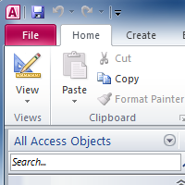
Access 2010 is a program that allows you to create and manage databases. A database is a place where you can store information related to a specific topic. How you intend to use the information will determine whether you need an Access database or a different program to create and manage your data.
In this lesson, we will discuss what a database does and how to decide whether you need a database to manage your information.

What is a Database?
A database is a collection of data that is stored in a computer system. Databases allow their users to enter, access, and analyze their data quickly and easily. They are such a useful tool that you see them all the time. Ever waited while a doctor’s receptionist entered your personal information into a computer, or watched a store employee use a computer to see whether an item was in stock? Then you’ve seen a database in action.
The easiest way to understand a database is to think of it as a collection of lists. Think about one of the databases we mentioned above-the database of patient information at a doctor’s office. What lists are contained in a database like that? Well, to start with, there’s a list of the customer names. Then, there’s a list of past appointments, a list with medical history for each patient, a list of contact information... and so on, and so on.
This is true of all databases, from the simplest to the most complex. For instance, if you like to bake, you might decide to keep a database containing the types of cookies you know how to make and the friends you give those cookies to. This is one of the simplest databases imaginable. It contains two lists: a list of your friends, and a list of cookies.
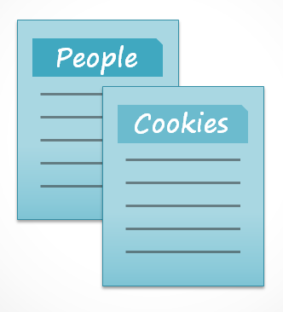
However, if you were a professional baker, you would have many more lists to keep track of: a list of customers, a list of products sold, a list of prices, a list of orders... it goes on and on. The more lists you add, the more complex the database will be.
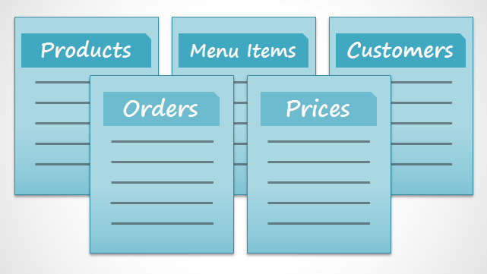
In Access, lists are a little more complex than the ones you write on paper. Access stores its lists of data in tables, which allow you to store even more detailed information. In the table below, the “People” list in the amateur baker’s database has been expanded to include other relevant information about the baker’s friends.
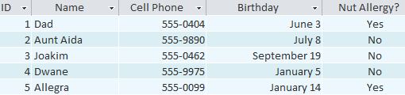
If you are familiar with other programs in the Microsoft Office suite, this might remind you a lot of Excel, which allows you to organize data in a similar way. And in fact, you could build a very similar table in Excel.

Why Use a Database?
If a database is essentially a collection of lists stored in tables, and you can build tables in Excel, why do you need a real database in the first place? While Excel is great at storing and organizing numbers, Access is far stronger at handling non-numerical data, like names and descriptions. Non-numerical data plays a big role in almost any database, and it's important to be able to sort and analyze it.
However, the thing that really sets databases apart from any other way of storing data is connectivity. We call a database like the ones you’ll work with in Access a relational database. A relational database is able to understand how lists and the objects within them relate to one another. To explore this idea, let's go back to the simple database with two lists: names of your friends, and the types of cookies you know how to make. You decide to create a third list to keep track of the batches of cookies you make and who they’re for. Since you are only making cookies you know the recipe for, and you are only going to give them to your friends, this new list will get all its information from the lists you made earlier.
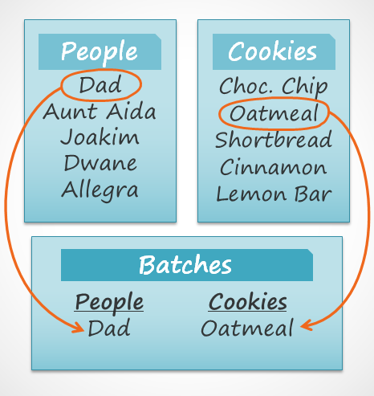
See how the third list uses words that appeared in the first two lists? A database is capable of understanding that the "Dad" and "Oatmeal" cookies in the "Batches" list are the same things as the "Dad" and "Oatmeal" in the first two lists. This relationship seems obvious, and a person would understand it right away. However, an Excel workbook wouldn’t.
Excel would treat all of those things as distinct and unrelated pieces of information. In Excel, you'd have to enter every single piece of information about a person or type of cookie all over again each time you mentioned it, because that database wouldn't be relational like an Access database is. Simply put, relational databases can recognize what a human can: that if the same words appear in multiple lists, they refer to the same thing.
The fact that relational databases can handle information this way allows you to enter, search, and analyze data in more than one table at a time. All of these things would be very difficult to do in Excel, but in Access, even complicated tasks can be simplified and made fairly user-friendly.

Properties of a database
Databases in Access 2010 are composed of four objects: tables, queries, forms, and reports. Together, these objects allow you to enter, store, analyze, and compile your data as you wish.
Tables, queries, forms, and reports are the framework for any database you create in Access. Understanding how each of these objects works will help you create a database that will be useful and will help you retrieve the information you need.
Tables:
By this point, you should already understand that a database is a collection of data organized into many connected lists. In Access, all data is stored in tables, which put tables at the heart of any database.
You might already know that tables are organized into vertical columns and horizontal rows.
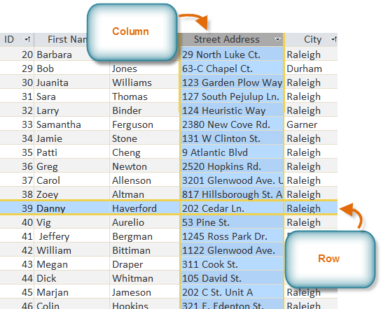
In Access, rows and columns are referred to as Records and Fields. A field is more than just a column: it’s a way of organizing information by the type of data it is. Every piece of information within a field is of the same type. For example, every entry in a field called “First Name” would be a name, and every entry in field called “Street Address” would be an address.
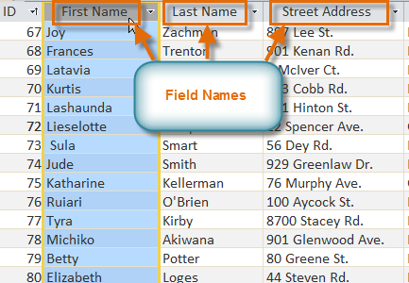
Likewise, a record is more than just a row; it’s a unit of information. Every cell in a given row is part of that row’s record.
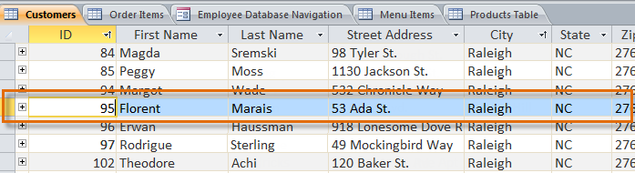
Notice how each record spans several fields. Even though the information in each record is organized into fields, it belongs with the other information in that record. See the number at the left of each row? That’s the ID number that identifies each record. The ID number for a record refers to every piece of information contained on that row.
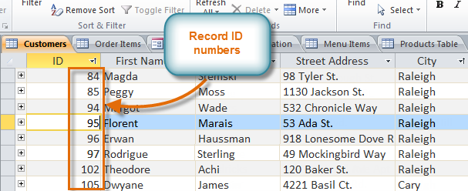
Tables are good for storing closely related information. Say that you own a bakery and have a database that includes a table with your customers' names and information like their phone numbers, home addresses, and email addresses. Since these pieces of information are all details about your customers, you’d include them all in the same table. Each customer would be represented by a unique record, and each type of information about those customers would be stored in its own field. If you decided to add any more information-say, the customer's birthday-you would simply create a new field within the same table.

Forms, Queries, and Reports
Although tables store all of your data, the other three objects offer you ways to work with it. They are: forms, queries, and reports. Each of these objects interacts with the records stored in your database's tables.
Forms
Forms are used for entering, modifying, and viewing records. You have probably had to fill out forms on many occasions, like when visiting a doctor's office, applying for a job, or registering for school. The reason forms are used so often is that they're an easy way to guide people into entering data correctly. When you enter information into a form in Access, that data goes exactly where the database designer wants it to go- in one or more related tables.
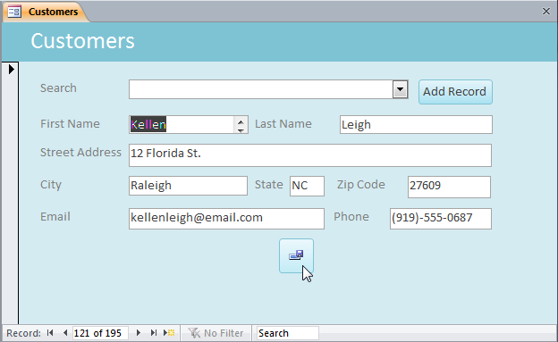
Forms make entering data easier. Working with extensive tables can be confusing, and when you have connected tables, you might need to work with more than one at once to enter a set of data. However, with forms, it's possible to enter data into multiple tables at once, all in one place. Database designers can even set restrictions on individual form components to ensure that all of the needed data is entered in the correct format. All in all, forms help keep data consistent and well-organized, which is essential for an accurate and powerful database.
Queries
Queries are a way of searching for and compiling data from one or more tables. Running a query is like asking a detailed question of your database. When you build a query in Access, you are defining specific search conditions to find exactly the data you want.
Queries are far more powerful than the simple searches you might carry out within a table. While a search would be able to help you find the name of one customer at your business, you could run a query to find the name and phone number of every customer who's made a purchase within the past week. A well-designed query can give information that you might not be able to find out just by looking through the data in your tables.
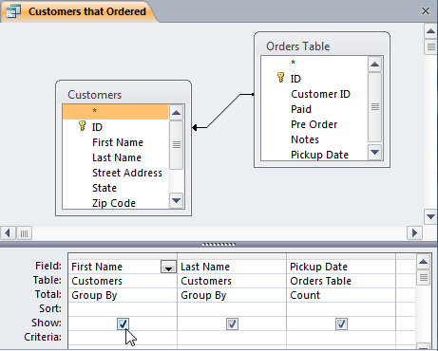
Reports
Reports offer you the ability to present your data in print. If you've ever received a computer printout of a class schedule or a printed invoice of a purchase, you've seen a database report. Reports are useful, because they allow you to present components of your database in an easy-to-read format. You can even customize a report's appearance to make it visually appealing. Access offers you the ability to create a report from any table or query.
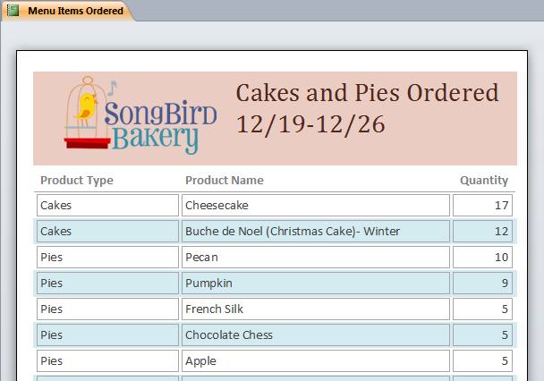

Activity 1
Try to answer these questions:
- What is a database?
- What type of software program is Microsoft Office Excel?
- What type of software program is Microsoft Office Access?
- Think of at least two differences between Access and Excel.
- Describe the properties of a database

Lesson 2-Opening and saving a database
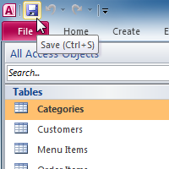

Think about all the information we encounter on a typical day that might be organized by a database. For example, if you go shopping at a department store for a toaster, the store inventory of products is information that has to be stored somewhere, along with the price of each product.
When you make a purchase, the store needs to be able to store the sales information to determine the daily sales total and how to track the decrease in inventory. A database could store this information, and also allow the store to quickly determine how many Brand X toasters are in the inventory without needing to count the inventory on the shelves.
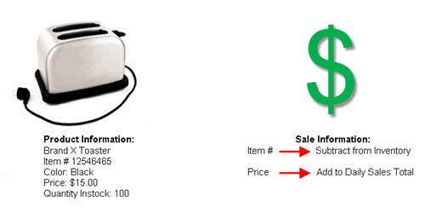
Real World Example
While this information could be managed without a database, it would be easier and more efficient to use one. Databases have an enormous impact in almost every area of our lives.
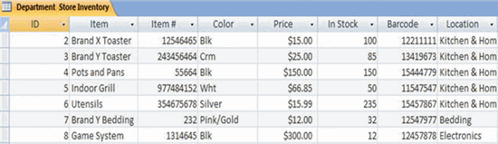Inventory in Access Database

Think About It
Think about what is going on around you in everyday situations and whether there might be a database at work.
- Grocery Store: The grocery store is stocked with items. The items have to be ordered, shipped, and stocked in the store. The store has to pay for the items. Then, when the customer buys the items, the cash register retrieves prices and the customer pays for products. Where might databases be involved in the situation?

- Restaurant: Where does the food come from? How does management know when to reorder a product? How are bills paid?

- Traffic Lights: Who or what controls when the lights turn red or green?
A database maintains order and structure in our lives. Databases are created using programs such as Microsoft Office Access 2010, which is a relational database program.

Opening a Database
When you first start Access, or if you close a database without closing Access, Microsoft Office Backstage view is displayed. Backstage view is a starting point from which you can create a new database, open an existing database, view featured content from Office.com- anything you can use Access to do to a database file or outside of a database, as opposed to within a database.

If you are familiar with Access 2007, then you will notice that there are not too many changes to the 2010 interface, other than the addition of the Backstage view.

Working with Your Access Environment
The Ribbon and the Quick Access Toolbar are where you will find the commands you will use to do common tasks in Access. If you are familiar with Access 2007, you will find that the main difference in the Access 2010 Ribbon is that commands such as Open and Print are now housed in Backstage view.
The Ribbon
The Ribbon contains multiple tabs, each with several groups of commands. Some tabs, like Form Layout Tools or Table Tools, may appear only when you are working with certain objects like forms or tables. These tabs are called contextual tabs, and are highlighted in a contrasting color to distinguish them from normal tabs.
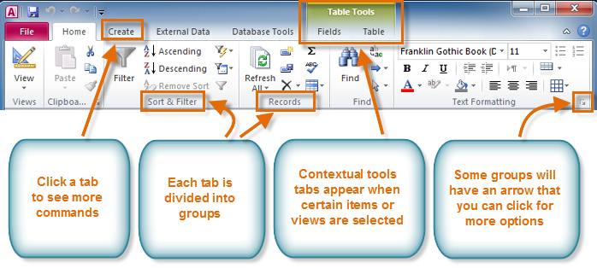
To Minimize and Maximize the Ribbon:
The Ribbon is designed to be easy to use and responsive to your current task, but if you feel that it's taking up too much of your screen space, you can minimize it.
- Click the arrow in the upper-right corner of the Ribbon to minimize it.
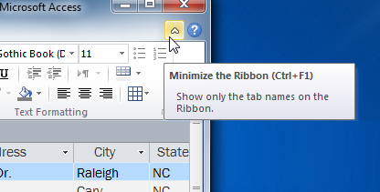
- To maximize the Ribbon, click the arrow again.
When the Ribbon is minimized, you can make it reappear by clicking on a tab. However, the Ribbon will disappear again when you are not using it.
The Quick Access Toolbar
The Quick Access Toolbar is located above the Ribbon, and it lets you access common commands no matter which tab you are on. By default, it shows the Save, Undo, and Repeat commands. If you'd like, you can customize it by adding additional commands.
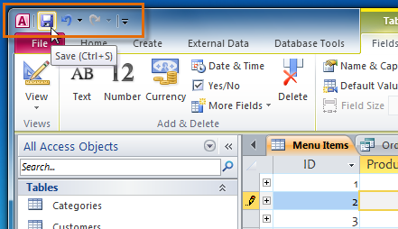
Note that the Save command only saves the current open object. In addition, the Undo command will not undo certain actions, like adding a record. Pay close attention to your information when using the Undo command to make sure it has the desired effect.
Backstage View
Backstage view gives you various options for opening, saving, printing, and viewing more information about your database. It is similar to the Office Button Menu from Access 2007 or the File Menu from earlier versions of Access. However, unlike those menus, it is a full-page view, which makes it easier to work with.
To Get to Backstage View:
- Click the File tab.
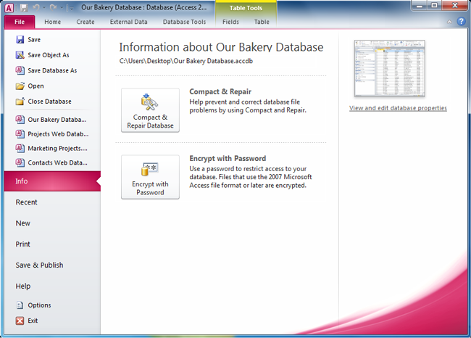
- You can choose an option on the left side of the page.
- To get back to your database objects, just click any tab on the Ribbon.
The Navigation Pane
The Navigation Pane is a list containing every object in your database. For easier viewing, the objects are organized into groups by type. You can open, rename, and delete objects using the Navigation Pane.
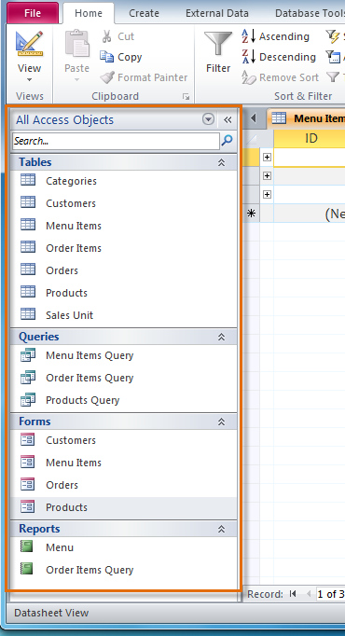
To Minimize and Maximize the Navigation Pane:
The Navigation Pane is designed to help you manage all your objects, but if you feel that it takes up too much of your screen space, you can minimize it.
- Click the double arrow in the upper-right corner of the Navigation Pane to minimize it.
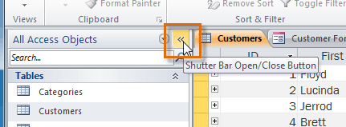
- To make the Navigation Pane visible again, click the double arrow to maximize it.
If you would like to make the Navigation Pane smaller without fully minimizing it, you can resize it. Simply click and drag the right border of the Navigation Pane. When it is the desired size, release your mouse.
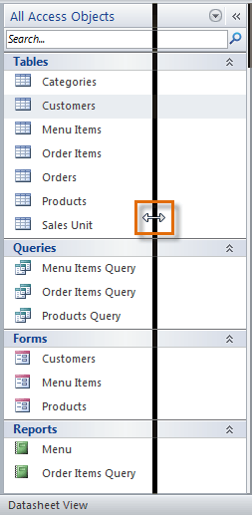
To Sort the Objects in the Navigation Pane:
By default, your objects are sorted by type, with the tables in one group, the forms in another, and so on. However, if you wish, you can sort the objects in the Navigation Pane into groups of your choosing.
- Click the drop-down arrow to the right of the words All Access Objects.
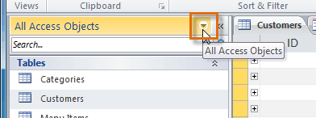
- In the drop-down menu, select the desired sort.
  - Select Custom to create a custom group for sorting the objects. After applying the sort, simply drag the desired objects to the new group.
  - Select Object Type to group the objects by type. This is the default setting.
  - Select Tables and Related Views to group forms, queries, and reports together with the tables they refer to.
  - Select Created Date or Modified Date to sort the objects from most to least recently created or modified.
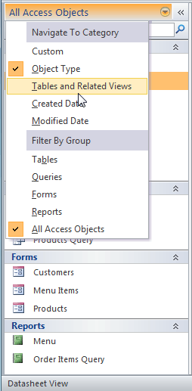
- The objects in the Navigation Pane will now be sorted to reflect your choice.
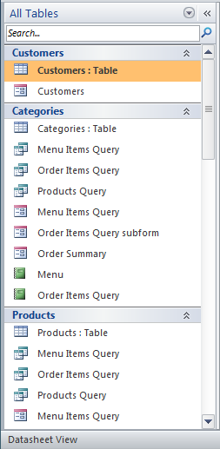
To further customize the appearance of the Navigation Pane, you can also minimize groups of objects you don't want to see. Simply click the upward double arrow next to the name of the group. To restore the group to its full size, click the downward double arrow .
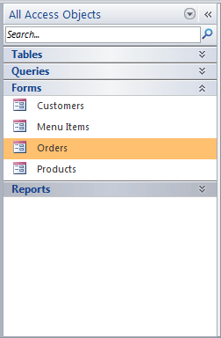
Databases with Navigation Forms
Some databases include a navigation form that opens automatically when the database is opened. Navigation forms are designed as a user-friendly replacement for the Navigation Pane. They contain tabs that allow you to view and work with common forms, queries, and reports. Having your frequently-used objects available to you in one place lets you access them quickly and easily.
To open an object from a navigation form, simply click on its tab. The object will be displayed within the navigation form. Once an object is open, you can work with it as you normally would.
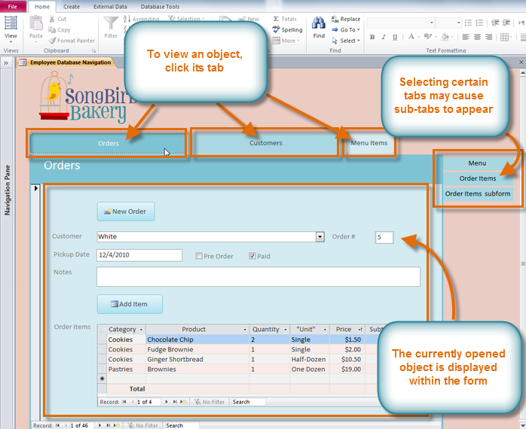
Generally, navigation forms include only the objects a typical user will need to work with fairly regularly, which is why your navigation form may not include every single form, query, or report. This makes it easier to navigate around the database. By hiding tables and rarely used forms, queries, and reports, it also reduces the chance of the database being damaged by users accidentally editing or deleting necessary data.
For this reason, it's important to ask your database designer or administrator before you work with objects that are not available in your navigation form. Once you have the go-ahead, you can simply maximize the Navigation Pane and open the objects from there.

Creating a database

When you open Access, Backstage view displays the New tab. The New tab provides several ways that you can create a new database:
- A blank database You can start from scratch if you want. This is a good option if you have very specific design requirements or have existing data that you need to accommodate or incorporate.
- A template that is installed with Access Consider using a template if you are starting a new project and would like a head start. Access comes with several templates installed by default.
- A template from Office.com In addition to the templates that come with Access, you can find many more templates on Office.com. You don't even have to open a browser, the templates are available from the New tab.
Adding to a database
Once you are working in a database, you can add fields, tables or application parts. Application parts are a new feature that let you use several related database objects together as if they were one. For example, an application part might consist of a table and a form that is based on the table. You can add the table and the form at the same time by using the application part. You can also create queries, forms, reports, macros - all the database objects that you are used to working with.

Create a database by using a template
Access comes with a variety of templates that you can use as-is or as a starting point. A template is a ready-to-use database that contains all the tables, queries, forms, and reports needed to perform a specific task. For example, there are templates that you can use to track issues, manage contacts, or keep a record of expenses. Some templates contain a few sample records to help demonstrate their use. If one of these templates fits your needs, using it is usually the fastest way to get a database started. However, if you have data in another program that you want to import into Access, you might decide it is better to create a database without using a template. Templates have a data structure already defined, and it might require a lot of work to adapt your existing data to the template's structure.
- If you have a database open, on the File tab, click Close Database. Backstage view displays the New tab.
- Several sets of templates are available in the New tab, some of which are built into Access. You can download additional templates from Office.com. See the next section in this article for details.
- Select the template that you want to use. The template icon appears in the pane on the right, just above the File Name box.
- Access suggests a file name for your database in the File Name box — you can change the file name, if you want. To save the database in a different folder from the one displayed below the file name box, click, browse to the folder in which you want to save it, and then click OK. Optionally, you can create and link your database to a SharePoint Foundation site.
- Click Create.

Access creates a database from the template that you chose, and then opens the database. For many templates, a form is displayed in which you can begin entering data. If your template contains sample data, you can delete each record by clicking the record selector (the shaded box or bar just to the left of the record), and then doing the following:
On the Home tab, in the Records group, click Delete.
- To begin entering data, click in the first empty cell on the form and begin typing. Use the Navigation Pane to browse for other forms or reports that you might want to use.

Create a database without using a template
If you are not interested in using a template, you can create a database by building your own tables, forms, reports, and other database objects. In most cases, this involves one or both of the following:
- Entering, pasting, or importing data into the table that is created when you create a new database, and then repeating the process with new tables that you create by using the Table command on the Create tab.
- Importing data from other sources and creating new tables in the process.

Create a blank database
- On the File tab, click New, and then click Blank Database.
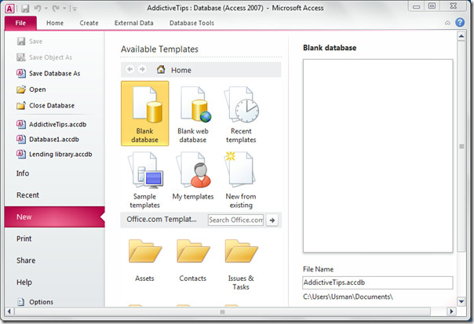
- In the right pane, under Blank Database, type a file name in the File Name box. To change the location of the file from the default, click Browse for a location to put your database (next to the File Name box), browse to the new location, and then click OK.
- Click Create.

Access creates the database with an empty table named Table1, and then opens Table1 in Datasheet view. The cursor is placed in the first empty cell in the Click to Add column.
- Begin typing to add data, or you can paste data from another source

Entering data in Datasheet view is designed to be very similar to working in an Excel worksheet. The table structure is created while you enter data. When you add a new column to the datasheet, a new field is defined in the table. Access automatically sets each field's data type, based on the data that you enter.

To Open an Existing Database:
- On the File tab, click Open.
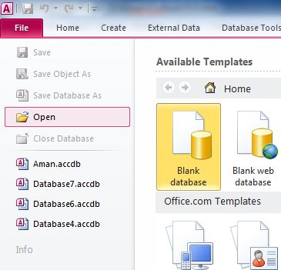

- In the Open dialog box, browse to the database that you want to open.
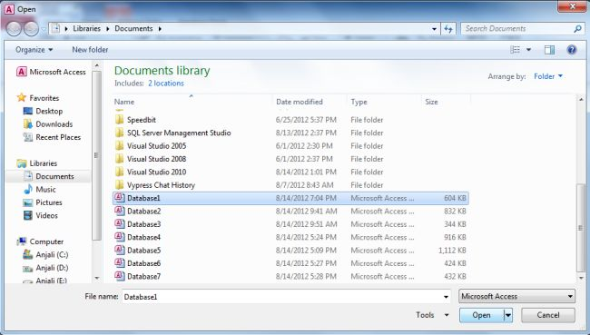
- Do one of the following:
  - Double-click the database to open it in the default mode specified in the Access Options dialog box or the mode that was set by an administrative policy.
  - Click Open to open the database for shared access in a multiuser environment so that you and other users can read and write to the database.
  - Click the arrow next to the Open button and then click Open Read-Only to open the database for read-only access so that you can view but not edit it. Other users can still read and write to the database.
  - Click the arrow next to the Open button and then click Open Exclusive to open the database by using exclusive access. When you have a database open with exclusive access, anyone else who tries to open the database receives a "file already in use" message.
  - Click the arrow next to the Open button and then click Open Exclusive Read-Only to open the database for read-only access. Other users can still open the database, but they are limited to read-only mode.
Tips
- To open one of the most recently opened databases, on the File tab, click Recent, and then click the file name for that database. Access opens the database by using the same option settings that it had the last time that you opened it. If the list of recently used files is not displayed, on the File tab, click Options. In the Access Options dialog box, click Client Settings. Under Display, enter the number of documents to display in the Recent Documents list, up to a maximum of 50.

You can also show recent databases in the navigation bar of Backstage view, for two-click access: 1) the File tab, 2) the recent database that you want to open. Near the bottom of the Recent tab, select the Quickly access this number of Recent Databases check box, and then adjust the number of databases to show.

- If you are opening a database by clicking the Open command on the File tab, you can view a list of shortcuts to databases that you have previously opened by clicking My Recent Documents in the Open dialog box.

Adding Records and Entering Data to an existing table
Entering data into tables in Access is very similar to entering data in Excel. To work with records, you'll have to enter data into cells.

To Add a New Record:
There are three ways to add a new record to a table:
- In the Records group on the Home tab, click the New command.

- On the Record Navigation bar at the bottom of the window, click the New Record button.
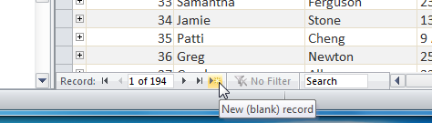

- Simply begin typing in the row below your last added record.
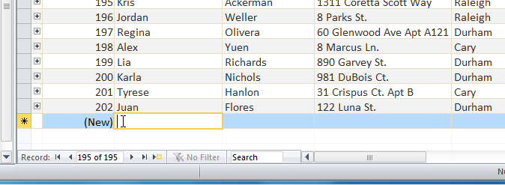

Occasionally when you enter information into a record, a window will pop up to tell you that the information you've entered is invalid. That means the field you're working with has a validation rule, which is a rule about the type of data that can appear in that field. Click OK, then follow the instructions in the pop-up window to re-enter your data.
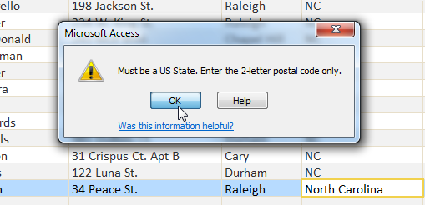

To Save a Record:
- Select the Home tab, and locate the Records group.
- Click the Save command.
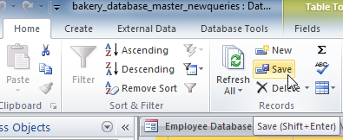
Be sure to save any unsaved records before closing a table. Access will not prompt you to save them when you close the table.

Closing database

- To close your database, go to file and select close database

- To close the database application, click the close button on the ribbon.

Activity 2
- Where is the Ribbon in the Access window?
- Where is the Navigation Pane located?
- What is the purpose of each of the four objects in an Access database?
- Open an existing database and add data to the existing table
- Create and save a new database
- Close the database
- Close the database application

Lesson 3 – Producing and editing database table

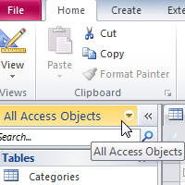
Databases in Access 2010 are composed of four objects: tables, queries, forms, and reports. Together, these objects allow you to enter, store, analyze, and compile your data as you wish. Tables, queries, forms, and reports are the framework for any database you create in Access. Understanding how each of these objects works will help you create a database that will be useful and will help you retrieve the information you need.
Understanding Tables
All tables are composed of horizontal rows and vertical columns, with small rectangles called cells in the places where rows and columns intersect. In Access, rows and columns are referred to as records and fields.
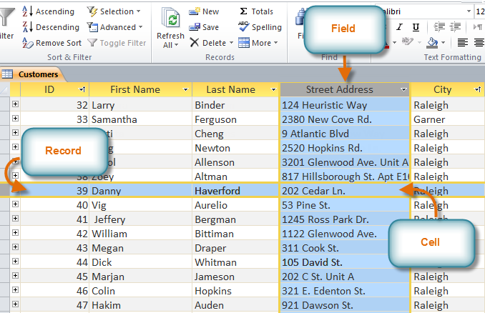
A field is a way of organizing information by type. Think of the field name as a question, and every cell within that field as a response to that question.
A record is one unit of information. Every cell on a given row is part of that row's record. Each record has its own ID number. Within a table, each ID number is unique to its record, and refers to all the information within that record. The ID number for a record cannot be changed.
Each cell of data in your table is part of both a field and a record. For instance, if you had a table of names and contact information, each person would be represented by a record, and each piece of information about them-their name, phone number, address, and so on-would be contained within a distinct field on that record's row.

Creating database tables

Access gives you several ways to create tables. There are 3 ways of doing this;
- In Datasheet view, you build a table by entering field names and setting data types manually. All you have to do is click and type.

- Quick start fields are pre-made tables that meet several common business needs. The fields capture data for common business needs, and all field names and data types are set for you.

- Design view lets you control every field and property in the table. In this course, you'll use it to create a table and to change the values in a lookup field -a field that contains a list of choices.

A. Datasheet view
Datasheet view provides a visual way to create a table.
- You start by creating a new, blank database or by adding a new table to an existing database. Either method opens a new table in Datasheet view.

- Notice that the new table contains a field called ID. That's your primary key, so you don't need to create one.

- To add your fields, click the first blank field header – the words Click to Add. That starts a menu of data types, and you select a data type for the field. After that, the field header then becomes available for writing, so...

- You just type the field name and press ENTER. Doing that shifts the focus to the next field, where you repeat the process. As you work, remember that if your field names contain more than one word, don't use spaces between the words. Spaces make it harder to write Visual Basic for Applications code and a type of formula called an expression. It's a common practice to remove spaces entirely, or separate each word with an underscore. Also, at this stage, don’t add any foreign key fields or lookup fields. You’ll add one type of lookup field later in this course, and you’ll add foreign keys when you create your table relationships, and that’s the next course in this series.

- When you have finished, press CTRL+S, or go to the Quick Access Toolbar and click Save-that starts a Save As dialog box. In the Save As dialog box, enter a name for the table and click OK.

See illustration that follows,
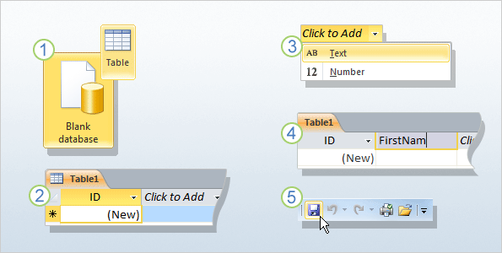

B. Quick start fields
Quick Start fields are a faster way to build parts of a new table. The fields capture data for common business needs, and all field names and data types are set for you.
- With a table open in Datasheet view, click the Fields tab, and in the Add & Delete group, click More Fields. A list appears.

- Scroll down the list until you see the Quick Start section, click the type of fields you want to use, such as Address, or Name, and...

- Access adds the fields for you, with field names data types already set.
You can use the new fields right away- just start entering data- or you can rename them, and remove fields you don't need. Also, you may have noticed what seem to be spaces in the field names. Don’t worry; you are not looking at the actual field names. Instead, you are looking at captions, user-friendly text associated with each field name. You will see how to set captions, and how to add and remove fields, during the practice.
C. Design view
Design view allows you to build a table from scratch and set or change every available property for each field. You can also open existing tables in Design view and add, remove, or change fields.
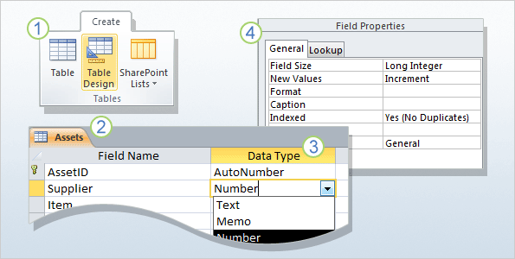
- On the Create tab, in the Tables group, click Table Design.

- In the Field Name column of the designer, enter the names of your table fields. As a rule, the first field you create should be your primary key field. And remember that you don't need to add any foreign key fields now. You can do that when you create your relationships.

- In the Data Type column, use the list next to a field name to choose a data type for that field.

- Optionally, use the Field Properties pane to set properties for individual fields. For example, you can use the pane to change the values in a lookup field, and you'll get a chance to do that in the practice session.

Saving a table
Like everything that is part of a database, a table must have a name that can be used to refer to that object throughout the database and in other files that can be linked to the table. There are two main ways you can specify the name of a table, either when you save it for the first time or if you decide to rename it.
To save a table you have just created:
- You can click File and click Save
- You can right-click the Table_X (such as Table1) tab and click Save
- You can press Ctrl + S
- You can start closing the table. You would be prompted to save the change (if its structure has been changed from the structure it had before it was opened)
If a table has not been saved before, you will be asked to provide a name for the table. A table can have almost any name: Employees, 2&&4DG, Pestes, verTT#@tg, etc. Because you and your users should be able to easily identify a table, there are suggestions you should follow when naming it:
- The name of a table should reflect the kind of data it is holding
- You can name a table with a few words, with spaces
- You can use a prefix that identifies the table as such, a table. The name of a table would be preceded with tbl. If the name includes one word, such as Musicians, you can give the table a name like tblMusicians, another name would be tblStudents
- If the name of the table reflects a combination of words, such as Bank Accounts or Students Academic Numbers, you should start each new word with an uppercase. Here are examples: tblBankAccounts, tblStudentAcademicNumbers, tblMemberRegistrations

Changing the Width of a Column
If you create a table using one of the Table Templates or if you get a table from a Database Template, the columns of the tables are wide enough to show their names. If you create a table from scratch in the Datasheet View, Microsoft Access assigns it a default width. That width can appear to be too narrow or too wide. For example, when data exceeds the regular width of a column, part of the information would be hidden. If a particular column contains data that you want to display at all times, you can enlarge the column. On the other hand, if a column displays tinny pieces of information, you can narrow the column to let it just fit the data as desired. There are various techniques you can follow to widen or narrow a column.
To change the width of a column:
- You can position the mouse on the right border of a column header. The mouse pointer would change into a horizontal double arrow crossed by a vertical line:
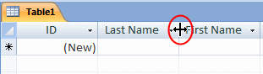
If you double-click, the column would be resized to the widest value of the column, provided the widest value is wider than the column header. If the widest value is narrower than the column header, the column width would be widened enough to display the name of the column.
- You can click the column's right border and drag in the desired direction, left or right until you get the desired width
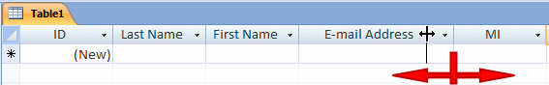
- You can right-click a column's name and click Column Width... This would open the Column Width dialog box where you can type the desired value and click OK
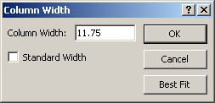

Moving a Column
If you find out that a particular column is misplaced in a table, you can change its position.
To move a column in Datasheet View, first select it. Click and hold your mouse on it. Then, start dragging left or right in the desired direction. While your mouse is moving, a thick vertical line will guide you. Once the vertical line is positioned to the desired location, release the mouse:
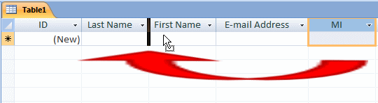
To move a group of columns, first select them as we reviewed earlier. Click and hold the mouse on one of the selected columns. Start dragging left or right in the desired direction until the thick vertical guiding line is positioned in the desired location, then release the mouse:
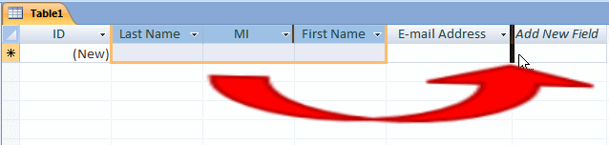

Deleting a table
If you have a table you don't need any more, you can remove it from your database. Because you cannot delete a table if it is opened, you must first close it.
To remove a table from your database:
- In the Navigation Pane, right-click the table and click Delete
- In the Navigation Pane, click the table to select it. Then, on the Ribbon, click Home. In the Record section, click Delete
- In the Navigation Pane, click the table to select it and press Delete

In each case, you will receive a warning to confirm what you want to do. It is important to know that if you delete a table, because it is not a file, it does not go into the Recycle Bin: it is lost, including its records. Therefore, before deleting a table, make sure you really want to get rid of it. When in doubt, do not delete it.

Saving and closing the table
Use the instructions describe above to save the table
Closing the table
After using a table, you can close it. Before closing a table, first select its tab. Then, to close a table:
- You can click the close button on the right side of the tabs
- You can press Ctrl + Shift + F4

Activity 3
- Create 3 database tables that include the following, text, numeric, date or currency
- Save your tables
- Move a column within the database table
- Change column widths of columns in the database table
- Delete one database table
- Save and close the database table

Lesson 4 – Entering data in a table
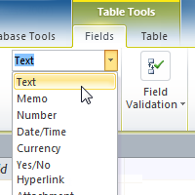
A table is a database object that you use to store data about a particular subject, such as employees or products. A table consists of records and fields. Each record contains data about one instance of the table subject, such as a particular employee. A record is also commonly called a row or an instance. Each field contains data about one aspect of the table subject, such as first name or e-mail address. A field is also commonly called a column or an attribute.
A record consists of field values, such as Contoso, Ltd. or someone@example.com. A field value is also commonly called a fact.
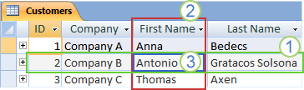
- A record
- A field
- A field value
A database can contain many tables, each storing information about a different subject. Each table can contain many fields of different types of data, such as text, numbers, dates, and hyperlinks. Now that we have a handle on what the database should look like, we need to work on setting up our tables and the fields within those tables.

Adding Records and Entering Data
Entering data into tables in Access is very similar to entering data in Excel. To work with records, you'll have to enter data into cells.
To Add a New Record:
There are three ways to add a new record to a table:
- In the Records group on the Home tab, click the New command.
- On the Record Navigation bar at the bottom of the window, click the New Record button.
- Simply begin typing in the row below your last added record.
Occasionally when you enter information into a record, a window will pop up to tell you that the information you've entered is invalid. That means the field you're working with has a validation rule, which is a rule about the type of data that can appear in that field. Click OK, then follow the instructions in the pop-up window to re-enter your data.
External data
You can link to a variety of external data sources, such as other databases, text files, and Excel workbooks. When you link to external data, Access can use the link as if it were a table. Depending on the external data source and the way that you create the link, you can edit the data in the linked table, and can create relationships that involve the linked table. However, you cannot change the design of the external data by using the link.
Data types
Every field has a data type. A field's data type indicates the kind of data that the field stores, such as large amounts of text or attached files.
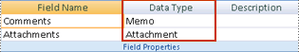
A data type is a field property, but it differs from other field properties as follows:
- You set a field's data type in the table design grid, not in the Field Properties pane.
- A field's data type determines what other properties the field has.
- You must set a field's data type when you create the field.

NOTE: You can create a new field in Access by entering data in a new column in Datasheet view. When you create a field by entering data in Datasheet view, Access automatically assigns a data type for the field, based on the value that you enter. If no other data type is implied by your input, Access sets the data type to Text. If needed, you can change the data type by using the Ribbon, part of the new Microsoft Office Fluent user interface.

Editing Records
To quickly edit any record within a table, you can just click on it and type in your changes. However, Access also offers you the ability to find and replace a word within multiple records and to delete records entirely.
To Replace a Word within a Record:
You can edit multiple occurrences of the same word by using Find and Replace, which searches for a term and replaces it with another term.
- Select the Home tab and locate the Find group.
- Select the Replace command. The Find and Replace dialog box will appear.
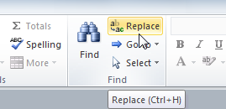
- Click the Find What: box and type the word you would like to find.
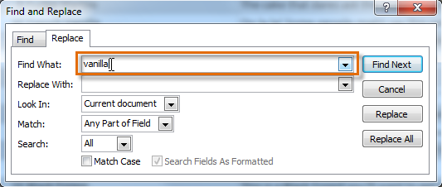
- Click the Replace With: box and type the word you would like to replace the original word.
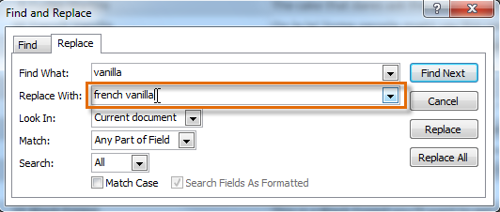
- Click the Look In: drop-down arrow to select the area you would like to search.
  - Select Current Field to limit your search to the currently selected field.
  - Select Current Document to search within the entire table.
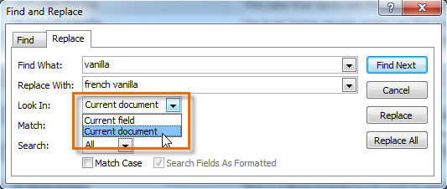
- Click the Match: drop-down arrow to select how closely you'd like results to match your search.
  - Select Any Part of Field to search for your search term in any part of a cell.
  - Select Whole Field to search only for cells that match your search term exactly.
  - Select Beginning of Field to search only for cells that start with your search term.
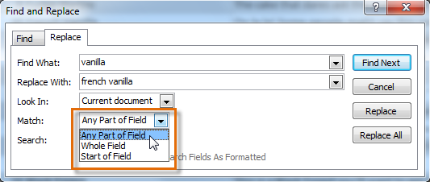
- Click Find Next to find the next occurrence of your search term.
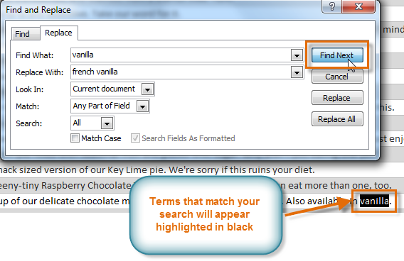
- Click Replace to replace the original word with the new one.
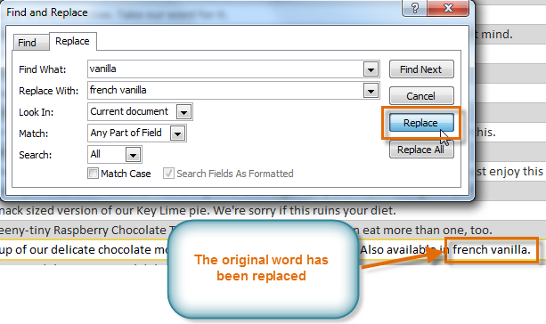
While you can use Replace All to replace every instance of a term, replacing them one at a time allows you to be absolutely certain that you edit only the data you want. Replacing data unintentionally can have a negative impact on your database.
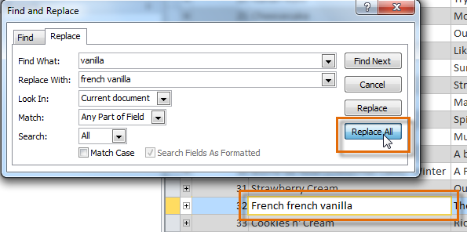
To Save a Record:
- Select the Home tab, and locate the Records group.
- Click the Save command.
Be sure to save any unsaved records before closing a table. Access will not prompt you to save them when you close the table.

Deleting data from a table
Delete data from the Access table in your database by using action queries. Action queries allow you to perform actions on your database. There are four action queries: update, make take, delete and append. Action queries are created when you are working with queries in the design view. After the query is executed, you must confirm it in your database. In the case of a "delete" action query, you must confirm the deletion of records from your database.
- Open Access 2010 and select the database. Click the "File" tab and select the "Open" button. Browse your files and locate the database. Click the database and select the "Open" button. The database opens.
- Click the "Create" tab and select the "Query Design" icon. The Show Table dialog box appears. Add a table to this dialog box by clicking the table name and selecting the "Add" button. Close the Show Table dialog box by clicking the "Close" button.
- Click the "Delete" button on the ribbon. Add fields to the query by clicking the field names and dragging them to the query. Add a criterion for your deletion. For example, if you want to remove all yellow widgets from your table, enter the following criterion in the Widget Color field: "yellow."
- Run the query by clicking the "Run" icon on the ribbon. Access asks you to confirm a quantity of records from the database. Click "Yes."
- Open the table from the Navigation Pane by double-clicking the table name. Notice the reduction of records in the table.

To Delete a Record
- Select the entire record by clicking the gray border at the left side of the record.
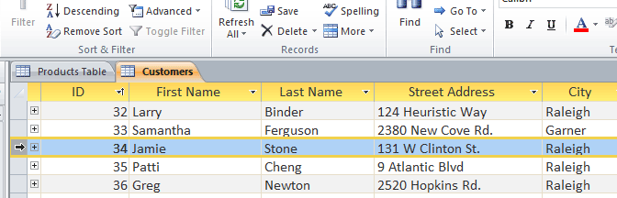
- Select the Home tab and locate the Records group.
- Click the Delete command. The record will be permanently deleted.
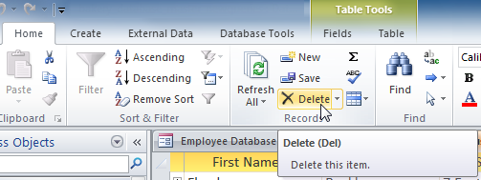
The ID numbers assigned to records stay the same even after you delete a record. For example, if you delete the 34th record in a table, the sequence of record ID numbers will read "...32, 33, 35, 36...", rather than "...32, 33, 34, 35, 36...".
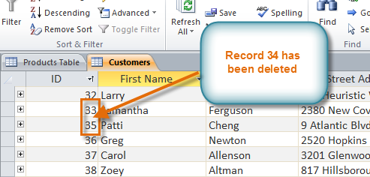

Activity 4

- Open a database
- Add a new record to the database table
- Modify data in the database table
- Delete data in the database table
- Delete a record from the database table

Lesson 5 – Modifying tables
After working with your database, you might find that you need to make some changes to the tables that store your data. Access makes it easy to modify your tables to suit your database's needs. In this lesson explains how to modify database table.

To Open an Existing Table
- Open your database and locate the Navigation Pane.
- In the Navigation Pane, locate the table you would like to open. Tables are marked with the icon.
- Double-click the name of the table. It will open and appear as a tab in the Document Tabs bar.

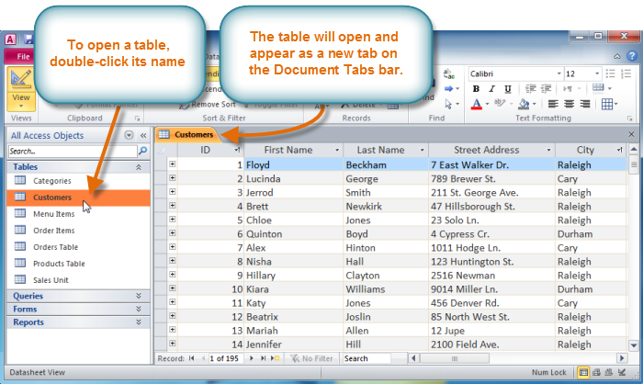
- To open an existing table in Design View, in the Navigation Pane, right-click it and click Design View
- If a table is already opened, to switch it to Design View, right-click its tab and click Design View
- If a table is currently opened, to switch it to Design View, on the right side of the status bar, click the Design View button
A table in Design View is divided in two sections: one in the upper area and another in the bottom:
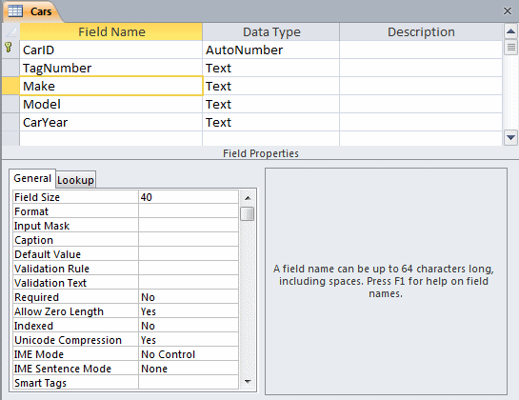
- The top area is made of columns (named Field Name, Data Type, and Description) and rows. When necessary, you will be directed to type or select something in one of the cells. The name of the column under which you must type or select will be specified in the lessons.
- The lower portion of the window is made of two sections. To access the lower portion while the top section has focus, you can press F6 or click the lower item you want.

Adding and Rearranging Fields
Access makes it easy to rearrange existing fields and add new ones. When you add a new field, you can even set the data type, which dictates which type of data can be entered into that field.
To Add a New Field to an Existing Table:
- Open the table, then click the header with the text Click to Add. If you already have many fields, you may have to scroll all the way to the right to see this.
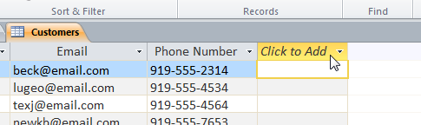
- A drop-down menu will appear. Select the data type you'd like for the new field.
  - Text: The default option, and best for text. You should also choose it for numbers you don't plan to do math with, like postal codes and phone numbers.
  - Number: Best for numbers you might want to do calculations with, like quantities of an item ordered or sold.
  - Currency: Automatically formats numbers in the currency used in your region.
  - Date & Time: Allows you to choose a date from a pop-out calendar.
  - Yes/No: Inserts a checkbox into your field.
  - Memo: Ideal for large amounts of text, like product descriptions. You can format text entered in Memo fields.
  - Attachment: Allows you to attach files, like images.
  - Hyperlink: Creates a link out of web or email addresses.
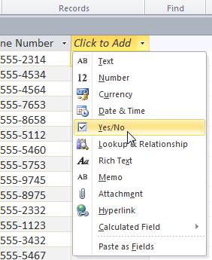
- Type a name for your field, then press the Enter key.
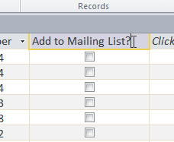
To Move a Field:
- Locate the field you wish to move, then hover your mouse over the bottom border of the field header. Your cursor will become a four-sided arrow .
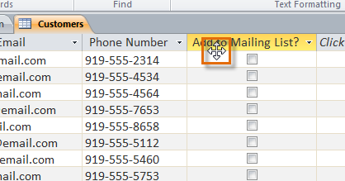
- Click and drag the field to its new location.
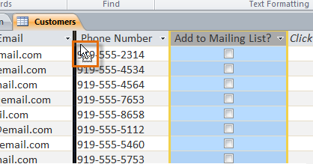
- Release your cursor. The field will appear in the new location.
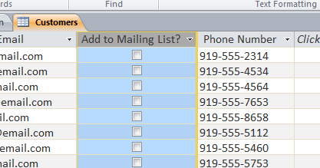
Advanced Field Options
On the last page, you learned about setting the data type for new fields. When you set field data type, you are really setting a rule for that field. Databases often include rules, because they are a way of guaranteeing that users enter the correct type of data.
Why is this important? Computers aren't as smart as humans about certain things. While you might recognize that "two" and "2" or "CP" and "Cape Town" are the same thing, Access will not and therefore won't group these things together. Making sure to enter your data in a standard format will help you better organize, count, and understand it.
Rules can also determine what options you have for working with that data. For example, you can only do math with data entered in number or currency fields, and you can only format text entered in memo fields.
There are three main types of rules you can set for a field: data type, character limit, and validation rules.
To Change the Data Type for Existing Fields:
- Select the field whose data type you wish to change.
- On the Ribbon, select the Fields tab and locate the Formatting group. Click the Data Type drop-down arrow.
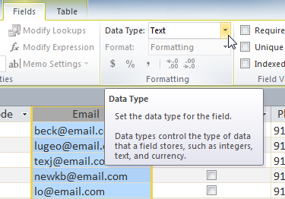
- Select the desired data type.
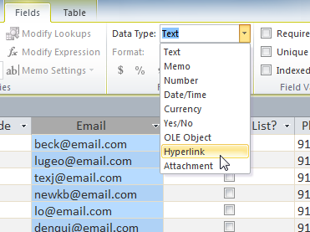
- The field data type will be changed. Depending on the data type you chose, you may notice changes to your information. For instance, since we set the data type for the Email field to Hyperlink, all of the email addresses in the field are now clickable links.
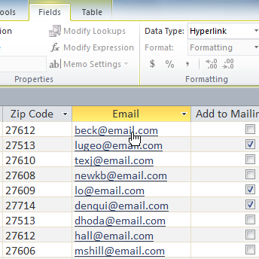
You shouldn't change field data type unless you are certain your field data is in the correct format for the new data type. Changing a field containing only text to the Number type, for instance, will delete all of your field data. This process is often irreversible.

Field Character Limits
Setting the character limit for a field sets a rule about how many characters-letters, numbers, punctuation, even spaces-can be entered in that field. This can be useful to keep the data in your records concise, or even to force the user to enter the data a certain way.
For instance, in the example below, the user is entering records which include addresses. If you set the character limit in the "state" field as "2," the user can only enter 2 characters of information. This means that he must enter postal abbreviations for the states instead of the full name-here, CPT instead of Cape Town. Note that you can only set a character limit for fields defined as text.
To Set a Character Limit for a Field:
- Select the desired field.
- Click the Fields tab in the Table Tools tab group, then locate the Properties group.
- In the box next to Field Size, type the maximum number of characters you would like to allow in your field.
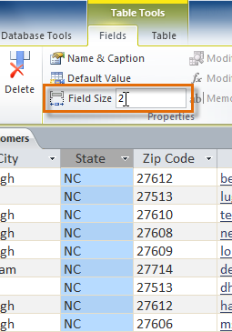
- Save your table.

Deleting a fields
- Right-click the header row of the column that you want to remove.
- Click Delete Column on the shortcut menu.
- Click Yes to confirm the deletion.
- Save your changes.
To delete a row
- On the Access status bar, click Design View.
- Select the field (the row) that you want to delete.
- On the Design tab, in the Tools group, click Delete Rows.
Or
Press DELETE.
- Save your changes.

Activity 5
- Open a database
- Open a table in design view
- Modify field formats
- Discuss the consequences of changing a field size
- Add a new field to the database table
- Move a field in the database table
- Delete a field from the database table
- Discuss the consequences of type conventions

Lesson 6 – Sorting and searching for records in a table

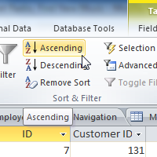
Access 2010 gives you the ability to work with enormous amounts of data, which means it can be hard to learn anything about your database just by glancing at it. Sorting and filtering are two tools that let you customize how you organize and view your data making it more convenient to work with. In this lesson, you will learn how to sort and filter records.
Essentially, sorting and filtering are tools that let you organize your data. When you sort data, you are putting it in order. Filtering data lets you hide unimportant data and focus only on the data you're interested in.

Sorting Records
When you sort records, you are putting them into a logical order, with like data grouped together. As a result, sorted data is often simpler to read and understand than unsorted data. By default, Access sorts records by their ID numbers. However, there are many other ways records can be sorted. For example, the information in a database belonging to a bakery could be sorted in a number of ways:
- Orders could be sorted by order date or by the last name of the customers who placed the orders.
- Customers could be sorted by name or by the city or zip code where they live.
- Products could be sorted by name, category (e.g., pies, cakes, cupcakes, etc.), or price.
You can sort both text and numbers in two ways: in ascending order or descending order. "Ascending" means "going up," so an ascending sort will arrange numbers from smallest to largest and text from A to Z. "Descending" means "going down," or largest to smallest for numbers and Z to A for text. The default ID number sort that appears in your tables is an ascending sort, which is why the lowest ID numbers appear first.
In our example, we will be performing a sort on a table. However, you can sort records in any Access object. The procedure is largely the same.
To Sort Records:
- Select a field in the cell you wish to sort by. In this example, we will sort by customers' last names.
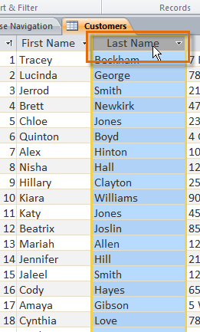
- Click the Home tab on the Ribbon and locate the Sort & Filter group.
- Sort the field by selecting the Ascending or Descending command.
  - Select Ascending to sort text A to Z or to sort numbers from smallest to largest. We will select this in our example, since we want the last names to be in A to Z order.
  - Select Descending to sort text Z to A or to sort numbers from largest to smallest.
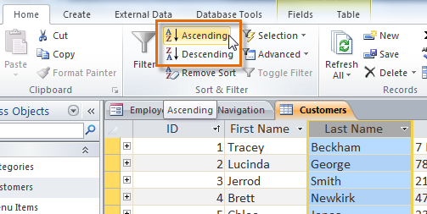
- The table will now be sorted by the selected field.
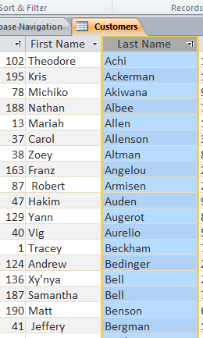
- To save the new sort, click the Save command on the Quick Access toolbar.
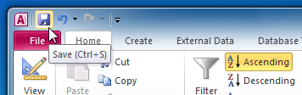
After you save the sort, the records will stay sorted that way until you perform another sort or remove the current one. To remove a sort, simply click the Remove Sort command.
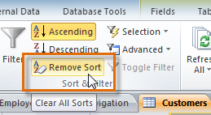

Filtering Records
Filters allow you to view only the data you want to see. When you create a filter, you set criteria for the data you want to display. The filter then searches all of the records in the table, finds the ones that meet your search criteria, and temporarily hides the ones that don't.
Filters are useful, as they allow you to focus in on specific records without being distracted by the data you're uninterested in. For instance, if you had a database that included customer and order information, you could create a filter to display only customers living within a certain city, or only orders that contain a certain product. Viewing this data with a filter would be far more convenient than searching for it in a large table.
In our examples and explanations, we will be applying filters to tables. However, you can apply filters to any Access object. The procedure is largely the same.
To Create a Simple Filter:
- Click the drop-down arrow next to the field you would like to filter by. We will filter by city, as we want to see a list of customers who live in a certain city.
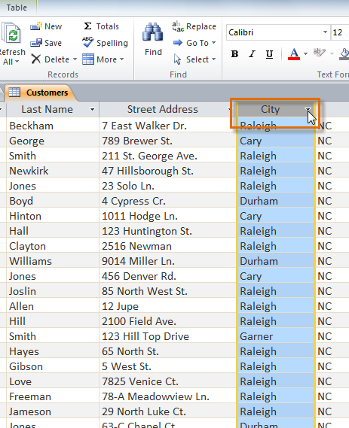
- A drop-down menu with a checklist will appear. Only checked items will be included in the filtered results. Use the following options to determine which items will be included in your filter:
  - Select and deselect items one at a time by clicking their checkboxes. Here, we will deselect all of the options except for Cary.
  - Click Select All to include every item in the filter. Clicking Select All a second time will deselect all items.
  - Click Blank to set the filter to find only the records with no data in the selected field.
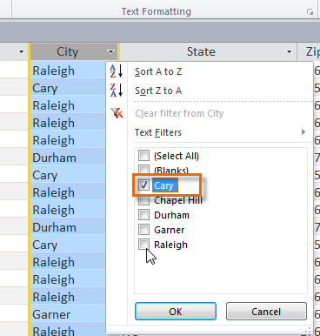
- Click OK. The filter will be applied. Our customers table now displays only customers who live in Cary.
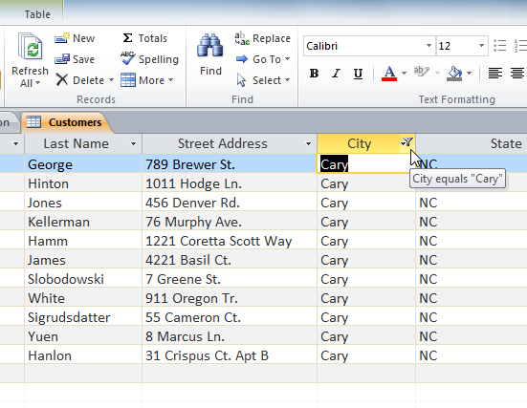 Toggling your filter allows you to turn it on and off. To view the records without the filter, simply click the Toggle Filter command. To restore the filter, simply click it again.
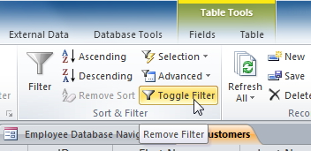

Creating a Filter from a Search Term
You can also create a filter by entering a search term and specifying the way Access should match data to that term. Creating a filter from a search term is similar to creating a filter from a selection.
Filtering Text by a Search Term
When filtering text by entering a search term, you can use some of the same options you use when filtering by a selection, like Equals, Does not Equal, Contains, and Does Not Contain. You can also choose from the following options:
- Begins With, which includes only records whose data for the selected field begins with the search term
- Does Not Begin With, which includes all records except those whose data for the selected field begins with the search term
- Ends With, which includes only records whose data for the selected field ends with the search term
- Does Not End With, which includes all records except those whose data for the selected field ends with the search term
To Filter Text by a Search Term:
- Click the drop-down arrow next to the field you would like to filter by. We want to filter the records in our orders table to display only those that contain notes with certain information, so we'll click the arrow in the Notes field.
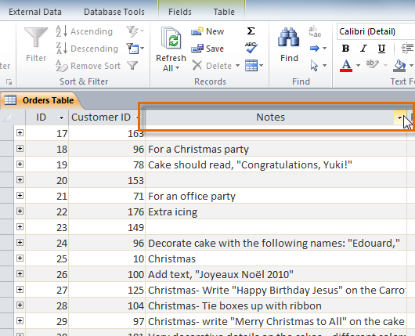
- In the drop-down menu, hover your mouse over the words Text Filters. From the list that appears, select the way you would like the filter to match the term you enter. In this example, we want to view only records whose notes indicate the order was placed for a party. We'll select Contains, so that we can search for records that contain the word "party."
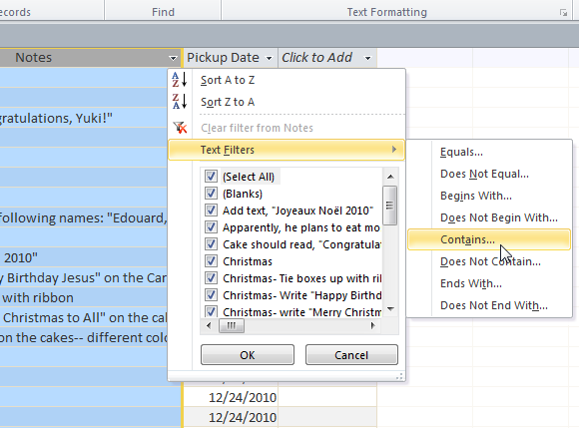
- The Custom Filter dialog box will appear. Type in the word you would like to use in your filter.
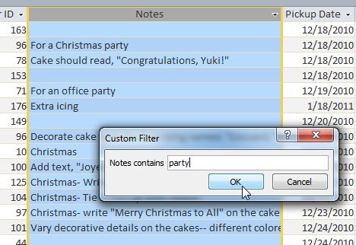
- Click OK. The filter will be applied.
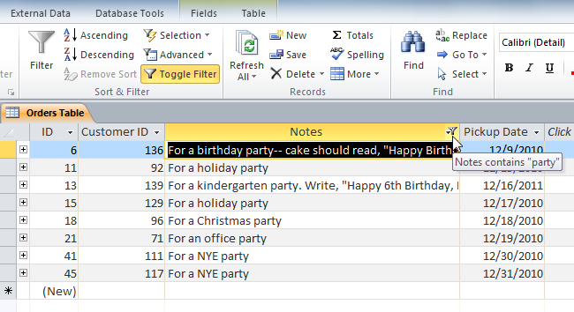
Filtering Numbers with a Search Term
The process for filtering numbers with a search term is very similar to the process for filtering text. However, different filtering options are available to you when working with numbers. In addition to the Equals and Does not Equal, you can also choose:
- Greater Than to include only records with numbers in that field greater than or equal to the number you enter
- Less Than to include only records with numbers in that field less than or equal to the number you enter
- Between to include records with numbers that fall within a certain range
To Filter Numbers by a Search Term:
- Click the drop-down arrow next to the field you would like to filter by. We want to filter the records in our menu items table by price, so we'll click the arrow in the Price field.
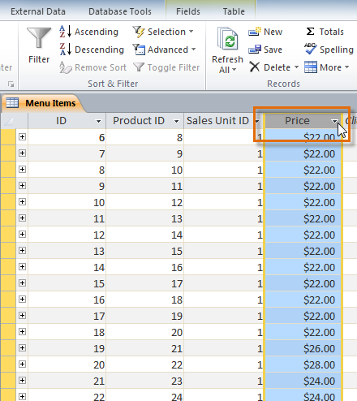
- In the drop-down menu, hover your mouse over the words Number Filters. From the list that appears, select the way you would like the filter to match your search term. In this example, we want to create a filter that will show us inexpensive items only. We want to see items that are under a certain price, so we'll select Less Than.
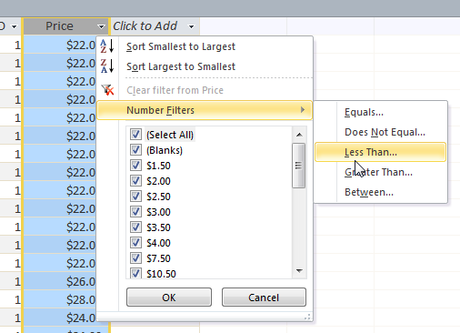
- The Custom Filter dialog box will appear. Type in the number or numbers you would like to use in your filter. We'll type "5" so that the filter will show us only menu items that cost $5 or less.
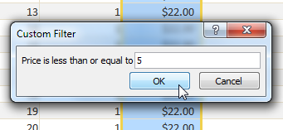
- Click OK. The filter will be applied.
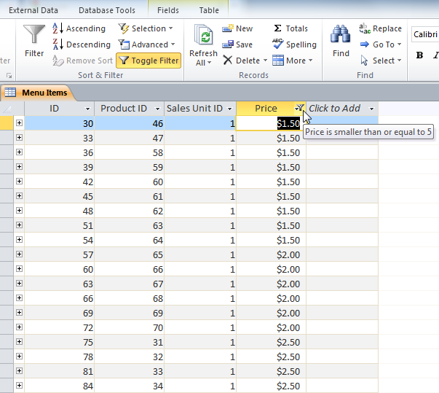
Specific types of numbers may include other filtering options. For instance, dates stored in numerical form (mm/dd/yy-e.g., 12/01/2010) include options to filter by periods of time.
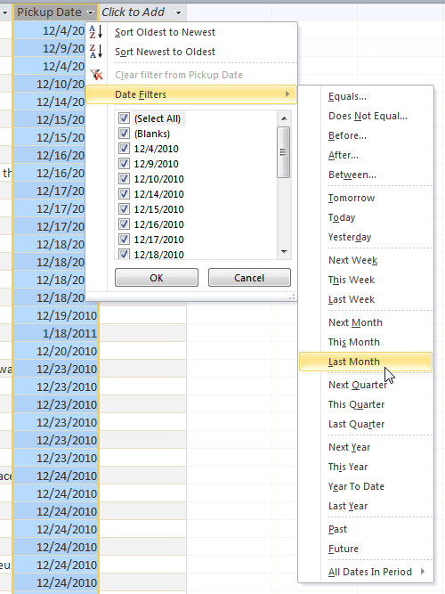

Creating a Filter from a Selection
Filtering by selection allows you to select specific data from your table and find data that is similar or dissimilar to it. For instance, if you were working with a bakery's database and wanted to search for all products whose names contained the word "chocolate," you could select that word in one product name and create a filter with that selection. Creating a filter with a selection can be more convenient than setting up a simple filter if the field you're working with contains many items.
To Create a Filter from a Selection:
- Select the cell or data you would like to create a filter with. We want to see a list of all of our products that contain the word "chocolate" in their names, so we'll select the word "chocolate" in the Product Name field.
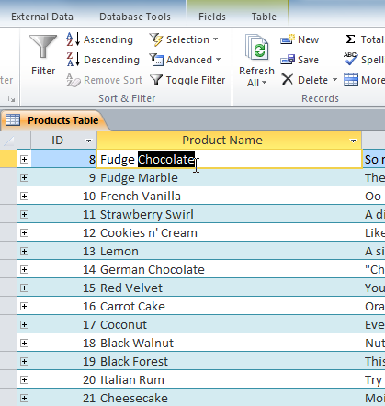
- Select the Home tab on the Ribbon and locate the Sort & Filter group.
- Click the Selection drop-down arrow.
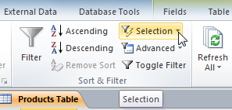
- Select the type of filter you would like to set up:
  - Selecting Equals will include only records with data that is identical to the selected data.
  - Selecting Does Not Equal will include all records except the data that is identical to the selection.
  - Selecting Contains will include only records with cells that contain the selected data. We'll select this, since we want to see records that contain the word "chocolate" anywhere in the title.
  - Selecting Does Not Contain will include all records except those with cells that contain the selected data.
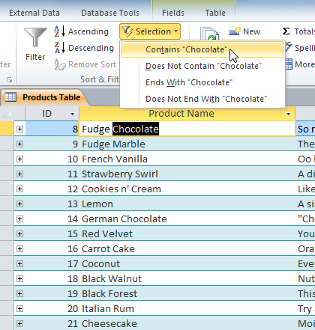
- The filter will be applied. Our table now displays only products with the word "chocolate" in their names.
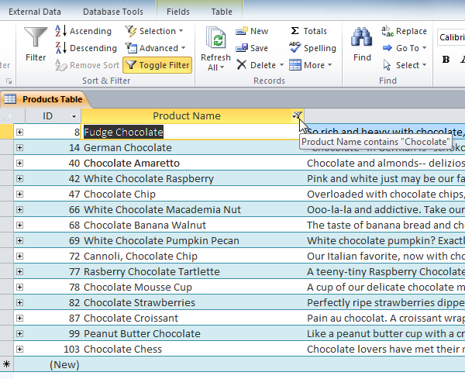

Activity 6

- Open a database
- Open a table in your database
- Sort a record in your database table in descending order
- Use filter by a search term to locate a record in your database table

